Rapid Feedback Data Processing at Diamond Light Source
Authors: Graeme Winter, Alun Ashton, Katherine Mcauley, Martin Walsh (Diamond Light Source) Johan Turkenburg (University of York) David Brown (Pfizer)

Introduction
Processing of diffraction data during or soon after data collection is critical for the assessment of data quality and for feedback to the experiment (FIXME CITE – suggestions welcome!). With the development of rapid sample changers (FIXME CITE – suggestions also welcome!) and intense third-generation synchrotron beamlines (FIXME CITE – same) achieving this requirement can already prove to be challenging. The new generation of pixel-array detectors that enable shutterless operation and emphasise fine phi slicing (in turn resulting in many more images per data set) magnify this challenge. These presented a need for a system to provide very rapid data processing and analysis.
In tandem with the reduced time for individual data collections, the overall throughput has increased. For a well organised group it is routine as many as 100 complete data sets within a 24 hour beamline shift (for example: Pfizer visit to I04; in1246-8; is this welcome?). In these circumstances it is helpful to have the data processing completely automated for the majority of cases to ensure that all data are analysed during the shift and allowing additional attention to be focussed on more challenging data sets. In some cases, for example ligand binding studies, the subsequent analysis steps may also be automated to further reduce the demands on the user. This aspect will be described in a subsequent paper.
At Diamond Light Source the benefits of automation were realised a long time ago, and we have been running xia2 automatically for three years. In many cases, however, more rapid feedback to the experiment is needed.
Finally, with the rapid pace of data collection it becomes difficult to visually inspect every image during the data collection, to monitor trends such as radiation damage during the experiment. To this end we also perform near real-time analysis of every image, to provide a continuous graphical summary during the experiment that may show these trends.
Here we present the systems we have developed at Diamond Light Source to meet these requirements, namely near real-time per-image feedback and automated and rapid data processing.

Strategy
As there are a number of disparate requirements for the feedback there will be a need for multiple tools to meet them. There are however two common elements: the tasks must be launched automatically and the results must be presented to the user. In terms of launching the tools, only the data acquisition software – GDA at Diamond Light Source – knows when this should be done, so must be responsible. There are also only two relevant points during the data collection to launch the tools, after each image and at the end of the collection of the data set. Two “hooks” have therefore been added to GDA that launch the analysis tools via scripts, allowing for straightforward extension in the future.

Per-image analysis
To perform the near real-time analysis of every image as it is recorded, we employ the DISTL package, originally developed as spotfinder and now included in the PHENIX distribution as part of LABELIT. The results from this analysis are recorded in our beamline database ISPyB (https://forge.ill.fr/projects/show/ispyb). After the analysis is completed, all measurements thus far for this sweep are extracted from the database and plotted, as shown in FIXME FIGURE. At this point a JPEG representation of the image is also generated, using MOSFLM (Leslie, AGW (1992) Joint CCP4 and ESFEACMB Newsletter on Protein Crystallography 26) to assist remote users.
+ show HTML pages.

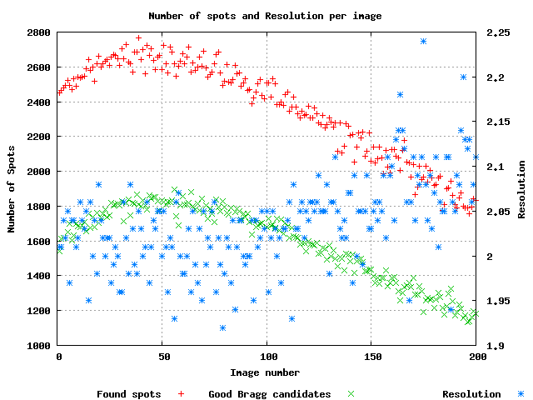

Rapid Data Processing
To meet the requirement for very rapid feedback (i.e. much more rapid than xia2 and shorter than the time taken for the experiment) data processing we have implemented a new data processing pipeline, fast_dp, which employs XDS. XDS was chosen as it is well suited to automatic operation and has already been parallelised to operate across multiple processors in a machine via OpenMP (xds_par) and across multiple computers in a cluster using the forkintegrate mechanism. The details of the implementation of fast_dp are described below.

Thorough Data Processing
For the last three years we have employed xia2 to automatically process user’s diffraction data. Rather than providing a user interface where the user is required to specify the automated processing parameters such as spacegroup, we simply run three xia2 jobs to cover a reasonable range of data processing options, as follows:
- xia2 -2d …
- xia2 -3d …
- xia2 -3dii …
The first of these, the “2d integration” pipeline, employs Mosflm and Scala for the integration and scaling respectively. The second pipeline, for 3d integration, uses XDS and XSCALE. The final pipeline, 3dii, is identical to the 3d pipeline except that all images in the data set are used for autoindexing. While this is expensive in terms of time and unnecessary in the majority of data sets, it will succeed with weak data where the others may fail.
In terms of algorithm coverage, FFT and difference vector autoindexing schemes are used, followed by two and three-dimensional profile fitting methods for integration. As such, the key algorithms in MX data reduction are covered, though we are open to user requirements for the inclusion of additional algorithms. After the processing has been completed, a HTML report is generated (FIXME FIGURE) using the xia2html tool included in the xia2 distribution. This includes HTML versions of the key log files, which have interactive graphs for the visualisation of the analysis results through a web browser.
As this framework is in place, it is straightforward to include additional data reduction pipelines, for example Elves provided that there is user demand. Currently the xia2 tasks typically take 10 – 20 minutes when restricted to a single compute cluster node. Clearly, when a complete data set can be recorded in ~ 5 minutes this is rather too slow for interactive feedback, and more rapid analysis is needed.

Computing hardware
At Diamond Light Source we have a high performance parallel data store using the lustre file system [http://www.lustre.org] for all experimental data, which is accessed through 6 storage servers to give an aggregate throughput of 3 GBytes/s. Connected to this via 10GB/s ethernet we have a compute cluster which is shared among all beamlines, consisting of 40 × 8 cpu compute nodes managed with a Sun Grid Engine queuing system [http://gridengine.sunsource.net/]. This combination ensures that all cluster nodes can access the data store in parallel without suffering a significant I/O bottleneck. In particular, for the analysis of X-ray diffraction data every node may be simultaneously used for integration while maintaining the overall throughput of the system.

Fast_dp Implementation
The workflow for the fast data processing has been designed around the principle that the data should only be integrated once. To this end all decisions are delayed to the latest possible moment. Specifically the resolution limit, crystal lattice and pointgroup are only determined and applied after the integration has been completed. It was found during the development of xia2 (FIXME CITE GW Ph.D. thesis) that this approach typically has a minimal impact on the quality of the results.
While XDS can perform these tasks as part of a single “run”, we split the analysis into four steps:
- indexing,
- integration with a triclinic basis,
- pointgroup determination and
- postrefinement and scaling,
for three reasons. Firstly, it was found to be more reliable, in particular because the XDS indexing step will frequently stop due to “insufficient reflections indexed” despite the apparent success of the indexing procedure, as is acknowledged in the program output. Secondly this allows us to more carefully configure the allocation of resources for each step, using the cluster for the integration. Finally, and most importantly, it allowed us to implement a more sophisticated pointgroup selection procedure than the algorithm now included in XDS. An overall flow diagram showing the flow of the analysis is shown in FIXME FIGURE.

Indexing
For data from a well calibrated beamline, there should be no substantial errors in the position of the direct beam centre or the detector distance. At Diamond Light Source the beam centres are calibrated at the start of the run and stored in lookup tables as a function of distance, which are then read for each data collection. As such, expensive autoindexing procedures including grid searches, for example LABELIT are not needed. Instead the native XDS autoindexing is used, with small wedges of data near phi_start, phi_start + 45 and phi_start + 90, or as close as can be reached within the data set. These wedges were identified during the development of xia2 to generally give the most accurate autoindexing results.

Integration
For integration, the data set is split into small wedges, each of at least 5 degrees, and submitted to the cluster described above using a modification of the forkintegrate script included in the XDS distribution and included in the appendix. The integration step is therefore performed in parallel across a number of computers, using multiple CPU cores within each machine via the OpenMP parallelised version of XDS. Thanks to this parallelism, the integration is not the rate limiting step in the analysis, as illustrated in FIXME TABLE. [CAPTION: Times taken for key XDS processing steps for a high resolution Thaumatin data set recorded as 90 x 1 degree (wide) oscillations and 360 x 0.25 degree (fine sliced) oscillations. From these values it is clear that the increase in processing time is modest in comparison with the four fold increase in data volume. The quality of the resulting merging statistics and measurements were comparable (not shown.)]
 | Coarse Phi | Fine Phi
Index | 24.3 | 30.2
Integration | 18.8 | 23.0
Scale | 19.8 | 22.7
 | 90 @ 1 degree | 360 @ 0.25 degree
Total | 103 | 121

Pointgroup analysis
After the data have been integrated with a triclinic basis it is necessary to determine the correct crystal lattice and pointgroup prior to scaling and merging. These should be consistent with both the observed symmetries in the measured intensities and the results of the global postrefinement in XDS. The procedure implemented in fast_dp is therefore to perform a preliminary postrefinement and scaling in P1, noting those solutions where the deviations from the lattice constraints are small, then to analyse the corrected measurements in POINTLESS. The highest symmetry solution from POINTLESS which corresponds to an acceptable lattice from postrefinement is accepted for subsequent scaling.

Postrefinement, scaling & merging
After the pointgroup has been determined, the data are rescaled and the postrefinement repeated with the correct lattice symmetry applied. In scaling with XDS, all corrections are applied and the resolution limit is set to the point where the unmerged I/sigma ~ 1, determined from the initial scaling in P1. XDS internally adjusts the sigma estimates of the measured intensities to give chi^2 ~ 1. After scaling, the unmerged measurements are transformed to MTZ format using POINTLESS and merged with SCALA (Evans, P.R. (1997) Proceedings of CCP4 Study Weekend) applying no further scaling or error adjustment. This provides additional outlier rejection, a helpful summary of the data quality statistics and a convenient mechanism to obtain a merged set of intensities in MTZ format.

Summary.
The data reduction protocol used in the fast_dp pipeline has been described. This, combined with the computing infrastructure described earlier and the modifications to the forkintegrate script included in the appendix allow data to be reduced from images to scaled intensities and merging statistics typically within two minutes. The intention behind this protocol is to ensure that the most expensive step, the integration of the images, happens only once. Clearly these results would be impossible without the efforts the XDS authors have made to parallelize the software.

Usage
To illustrate the effect that the fast_dp system on how users behave at our beamlines, we will describe three case studies drawn from academic and commercial users and beamline staff. In each case the availability of rapid automated processing of diffraction data has changed the way that the beamlines are used, leading to more effective use of the allocated beamtime.
Academic user
Johan should ideally write this bit!
Include example we used for the user meeting. Include this in the examples section below.

Johan example
This would be good as it compares processing with fast_dp, xia2, JPT with HKL2000. Can show the CC's within a couple of minutes of the end of data collection. Fast dp ran in 2m5s btw. xia2 in 27m41s. Johan > 1 hour.
Numbers:
User / package | Shelx CC/CCweak | #residues built
JPT + HKL2000 | 55/36 | 110/200
Fast_dp | 57/38 | 117/200
Xia2 | 56/37 | 102/200
Merging statistics - overall / high / low
JPT + HKL2000: 2.8A | Overall | High | Low
Rmerge | 13.0 | 68.4 | 6.1
I/sigma | 22.2 | 4.7 | 48.9
Completeness | 100.0 | 99.9 | 99.4
Multiplicity | 26.5 | 20.8 | 23.6
Fast_dp 2.85A
Rmerge | 12.9 | 82.9 | 3.5
I/sigma | 32.3 | 4.5 | 78.9
Completeness | 94.7 | 97.1 | 92.8
Multiplicity | 27.8 | 24.4 | 19.9
XIA2 2.82A
Rmerge | 12.5 | 85.2 | 3.6
I/sigma | 30.3 | 5.7 | 57.5
Completeness | 99.9 | 99.8 | 98.7
Multiplicity | 28.0 | 29.1 | 18.7

Industrial user
Should we ask Dave Brown to write this section? Yes, I did and he was happy to do so!

Beamline scientist
Should I ask a beamline scientist to write this section? Who? Katherine?

Example

Thermolysin
N.B. Data collection took 8 minutes. Fast_dp then took 1m50s. Shelx c/d/e + conversion of files to get MTZ format map then took a further 1m20s. Total time from data collection to map, 3m10s. Using beta-test chain tracing in shelxe…
To demonstrate the efficacy of fast_dp in quickly establishing the results of a diffraction experiment a data set consisting of 200 0.5 degree images was recorded from a thermolysin crystal at the zinc edge, on Diamond beamline I03. FIXME STATS. Substructure determination using SHELXC and SHELXD quickly indicated the success of the experiment with CC/.CCweak of 43.6/28.0. Subsequent phasing and chain tracing with SHELXE found the C-alpha backbone for more than 90% of the structure, within 15 minutes of the experiment.
FIXME where are the merging statistics for this one? Will need to dig it out. Also time from end of data collection to initial map.
Starting image: /dls/i03/data/2010/cm1892-4/0806/therm15_200/therm_sad_collect_M1S15_3_0001.img
Running on: cs04r-sc-com01-04
Number of jobs: 20
Processing images: 1 -> 200
Template: therm_sad_collect_M1S15_3_####.img
Working in: /dls/i03/data/2010/cm1892-4/processed/0806/therm15_sad/therm_sad_collect_M1S15_3_/fdp_200
All autoindexing results:
sg# a b c alpha beta gamma
1 93.70 93.70 140.40 90.00 90.00 119.90
3 93.70 140.40 93.70 90.00 119.90 90.00
5 162.40 93.70 140.40 90.00 90.10 90.00
21 93.70 162.40 140.40 90.00 90.00 90.00
143 93.70 93.70 140.40 90.00 90.00 120.00
Happy with sg# 177
93.75 93.75 140.40 90.00 90.00 120.00
--------------------------------------------------------------------------------
Low resolution 28.11 28.11 1.77
High resolution 1.73 7.72 1.73
Rmerge 0.059 0.022 0.677
I/sigma 27.80 72.20 3.10
Completeness 99.8 97.3 97.3
Multiplicity 11.4 9.6 11.1
Anom. Completeness 99.7 99.3 96.2
Anom. Multiplicity 6.1 6.6 5.8
Mid-slope 1.361
--------------------------------------------------------------------------------
Merging point group: P 6 2 2
Unit cell: 93.73 93.73 140.41 90.00 90.00 120.00
Processing took 00h 01m 51s (111 s) [443621 reflections]

Discussion & Future Plans

Wedged MAD and Inverse Beam SAD
The fast processing described above has been optimised around the analysis of data from a single scan. In many cases, particularly for phasing experiments, more optimal measurements may be obtained by reordering the data collection to optimise either the anomalous or dispersive differences, In this situation it will be helpful to be able to obtain an indication of the quality of the phasing information as quickly as possible, taking into account the strategy used for data collection. We therefore intend to include this additional functionality, already available in xia2, in fast_dp.

Kappa goniometry etc.
In addition to more sophisticated experimental strategies, we are also commissioning kappa goniometers for our MX beamlines. Once again, to optimise the opportunities for improvement in the measurements this will need to be supported in fast_dp. As for the wedged MAD and inverse-beam SAD the protocols for this are already established in xia2.

Acknowledgements
The authors would like to acknowledge that this work would be impossible without the develoments made in XDS to support parallel operation. Equally, the contribution from our IT support team in commissioning the computing infrastructure and making modifications to the system to support this system were critical to the success of this project. We would finally like to acknowledge the feedback during the development of this system from the Diamond Light Source users and staff.

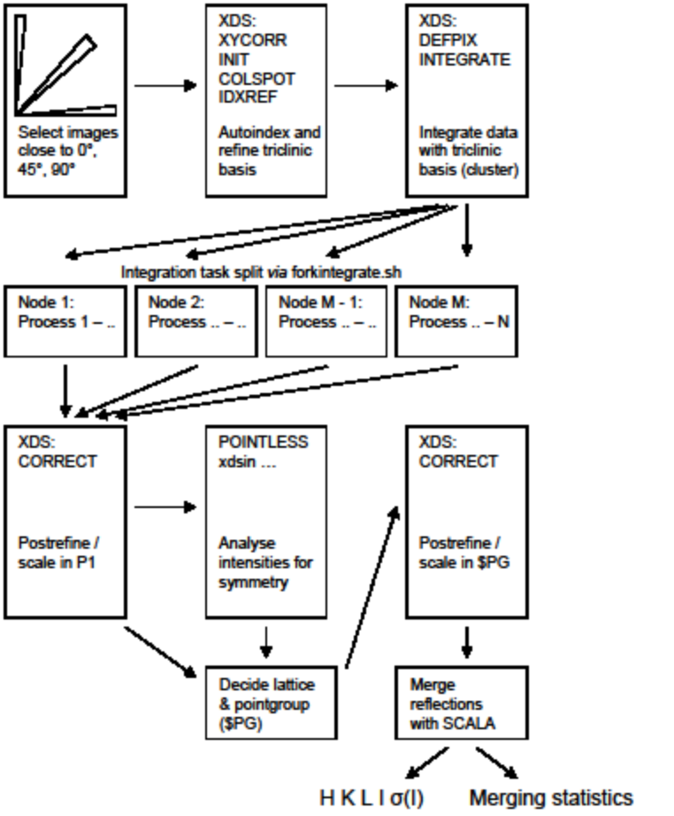

Appendix

modifications to cluster & forkintegrate (to appendix)
Should this be an appendix? Needed to make each cluster node a submit host, then also adjust forkintegrate to use sge to aubmit a task, which will in turn run the mintegrate_par package.

if test $USER = 'gda' ; then
queue=high.q
else
queue=medium.q
fi

fframe=$1 #id number of the first image
ni=$2 #number of images in the data set
ntask=$3 #total number of jobs
niba0=$4 #minimum number of images in a batch
maxcpu=$5 #maximum number of processors used by each job
#maxcpu=1: use 'mintegrate' (single processor)
#maxcpu>1: use 'mintegrate_par' (openmp version)

minitask=$(($ni / $ntask)) #minimum number of images in a job
mtask=$(($ni % $ntask)) #number of jobs with minitask+1 images
pids="" #list of background process ID's
nba=0
litask=0
itask=1
while test $itask -le $ntask
do
if [ $itask -gt $mtask ]
then nitask=$minitask
else nitask=$(($minitask + 1))
fi
fitask=`expr $litask + 1`
litask=`expr $litask + $nitask`
if [ $nitask -lt $niba0 ]
then n=$nitask
else n=$niba0
fi
if [ $n -lt 1 ]
then n=1
fi
nbatask=$(($nitask / $n))
nba=`expr $nba + $nbatask`
image1=$(($fframe + $fitask - 1)) #id number of the first image

if [ $maxcpu -gt 1 ]
then qsub -sync y -V -q $queue -l h_rt=0:20:00 -cwd -pe smp 8 \
forkintegrate_job \
$image1 $nitask $itask $nbatask >> qsub.log 2>&1 &
else echo "$image1 $nitask $itask $nbatask" | \
qrsh -V -q $queue -cwd "mintegrate" &
fi
pids="$pids $!" #append id of the background process just started

itask=`expr $itask + 1`
done
trap "kill -15 $pids" 2 15 # 2:Control-C; 15:kill
wait #wait for all background processes issued by this shell
rm -f mintegrate.tmp #this temporary file was generated by mintegrate

#!/bin/ksh

image1=$1
nitask=$2
itask=$3
nbatask=$4

host=`uname -a | awk '{print $2}'`
echo $image1 $nitask $itask $nbatask $host >> jobs.log
echo $image1 $nitask $itask $nbatask | mintegrate_par

Results:
Starting image: /dls/i02/data/2010/cm1891-4/100809/Thaumatin/collect_wide_2_001.img
Running on: cs04r-sc-com01-17
Number of jobs: 9
Processing images: 1 -> 90
Template: collect_wide_2_###.img
Working in: /dls/i02/data/2010/cm1891-4/processed/100809/Thaumatin/collect_wide_2_/fast_dp
All autoindexing results:
sg# a b c alpha beta gamma
1 57.80 57.80 150.00 90.00 90.00 90.00
3 57.80 57.80 150.00 90.00 90.00 90.00
5 81.70 81.70 150.00 90.00 90.00 90.00
16 57.80 57.80 150.00 90.00 90.00 90.00
21 81.70 81.70 150.00 90.00 90.00 90.00
75 57.80 57.80 150.00 90.00 90.00 90.00
Happy with sg# 89
57.80 57.80 150.00 90.00 90.00 90.00
--------------------------------------------------------------------------------
Low resolution 28.37 28.37 1.22
High resolution 1.19 5.34 1.19
Rmerge 0.028 0.017 0.105
I/sigma 31.70 68.90 2.80
Completeness 82.0 95.9 9.2
Multiplicity 5.5 5.9 1.2
Anom. Completeness 68.3 95.2 1.0
Anom. Multiplicity 3.2 3.5 1.2
Mid-slope 1.044
--------------------------------------------------------------------------------
Merging point group: P 4 2 2
Unit cell: 57.77 57.77 150.00 90.00 90.00 90.00
Processing took 00h 01m 43s (103 s) [366271 reflections]
RPS: 3539.2

Starting image: /dls/i02/data/2010/cm1891-4/100809/Thaumatin/collect_fine_1_001.img
Running on: cs04r-sc-com01-05
Number of jobs: 18
Processing images: 1 -> 360
Template: collect_fine_1_###.img
Working in: /dls/i02/data/2010/cm1891-4/processed/100809/Thaumatin/collect_fine_1_/fast_dp
All autoindexing results:
sg# a b c alpha beta gamma
1 57.80 57.80 150.10 90.00 90.00 90.00
3 57.80 57.80 150.10 90.00 90.00 90.00
5 81.80 81.70 150.10 90.00 90.00 90.00
16 57.80 57.80 150.10 90.00 90.00 90.00
21 81.80 81.70 150.10 90.00 90.00 90.00
75 57.80 57.80 150.10 90.00 90.00 90.00
Happy with sg# 89
57.80 57.80 150.00 90.00 90.00 90.00
--------------------------------------------------------------------------------
Low resolution 28.38 28.38 1.23
High resolution 1.19 5.34 1.19
Rmerge 0.038 0.030 0.095
I/sigma 24.50 42.70 2.70
Completeness 83.4 95.6 10.2
Multiplicity 5.5 5.9 1.2
Anom. Completeness 69.5 95.5 1.0
Anom. Multiplicity 3.2 3.5 1.2
Mid-slope 0.977
--------------------------------------------------------------------------------
Merging point group: P 4 2 2
Unit cell: 57.80 57.80 150.06 90.00 90.00 90.00
Processing took 00h 02m 01s (121 s) [374413 reflections]
RPS: 3072.9

N.B. apparent differences in data quality probably owe something to slightly differing exposure time per degree.
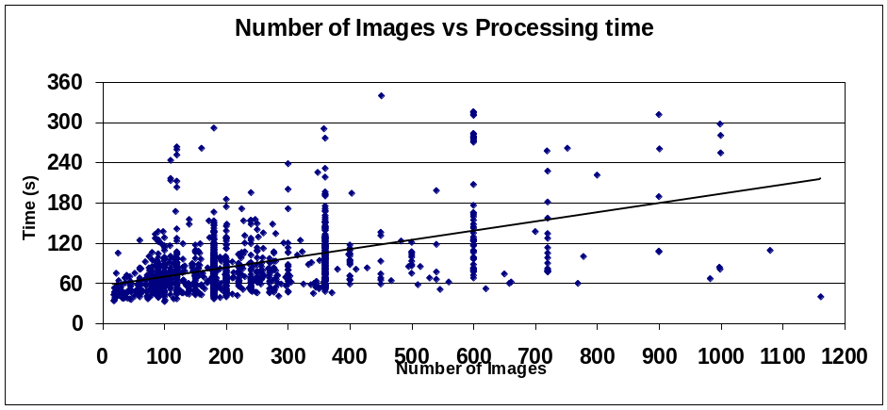

Broennimann, C., E. F. Eikenberry, et al. (2006). "The PILATUS 1M detector." Journal of Synchrotron Radiation 13(2): 120-130.
The PILATUS 1M detector is a hybrid pixel array detector with over one million pixels that operate in single photon counting mode. The detector, designed for macromolecular crystallography, is the largest pixel array detector currently in use at a synchrotron. It is a modular system consisting of 18 multichip modules covering an area of 21 cm x 24 cm. The design of the components as well as the manufacturing of the detector including the bump-bonding was performed at the Paul Scherrer Institute (PSI). The use of a single photon counting detector for protein crystallography requires detailed studies of the charge collection properties of the silicon sensor. The 18 modules are read out in parallel, leading to a full frame readout-time of 6.7 ms. This allows crystallographic data to be acquired in fine-[varphi]-slicing mode with continuous rotation of the sample. The detector was tested in several experiments at the protein crystallography beamline X06SA at the Swiss Light Source at PSI. Data were collected both in conventional oscillation mode using the shutter, as well as in a fine-[varphi]-slicing mode. After applying all the necessary corrections to data from a thaumatin crystal, the processing of the conventional data led to satisfactory merging R-factors of the order of 8.5%. This allows, for the first time, determination of a refined electron density map of a macromolecular biological crystal using a silicon pixel detector.

Evans, P. (2006). "Scaling and assessment of data quality." Acta Crystallographica Section D 62(1): 72-82.
The various physical factors affecting measured diffraction intensities are discussed, as are the scaling models which may be used to put the data on a consistent scale. After scaling, the intensities can be analysed to set the real resolution of the data set, to detect bad regions (e.g. bad images), to analyse radiation damage and to assess the overall quality of the data set. The significance of any anomalous signal may be assessed by probability and correlation analysis. The algorithms used by the CCP4 scaling program SCALA are described. A requirement for the scaling and merging of intensities is knowledge of the Laue group and point-group symmetries: the possible symmetry of the diffraction pattern may be determined from scores such as correlation coefficients between observations which might be symmetry-related. These scoring functions are implemented in a new program POINTLESS.

Holton, J. and T. Alber (2004). "Automated protein crystal structure determination using ELVES." Proc Natl Acad Sci U S A 101(6): 1537-1542.
Efficient determination of protein crystal structures requires automated x-ray data analysis. Here, we describe the expert system ELVES and its use to determine automatically the structure of a 12-kDa protein. Multiwavelength anomalous diffraction analysis of a selenomethionyl derivative was used to image the Asn-16-Ala variant of the GCN4 leucine zipper. In contrast to the parallel, dimeric coiled coil formed by the WT sequence, the mutant unexpectedly formed an antiparallel trimer. This structural switch reveals how avoidance of core cavities at a single site can select the native fold of a protein. All structure calculations, including indexing, data processing, locating heavy atoms, phasing by multiwavelength anomalous diffraction, model building, and refinement, were completed without human intervention. The results demonstrate the feasibility of automated methods for determining high-resolution, x-ray crystal structures of proteins.

Kabsch, W. (2010). "XDS." Acta Crystallographica Section D 66(2): 125-132.
The usage and control of recent modifications of the program package XDS for the processing of rotation images are described in the context of previous versions. New features include automatic determination of spot size and reflecting range and recognition and assignment of crystal symmetry. Moreover, the limitations of earlier package versions on the number of correction/scaling factors and the representation of pixel contents have been removed. Large program parts have been restructured for parallel processing so that the quality and completeness of collected data can be assessed soon after measurement.

Sauter, N. K., R. W. Grosse-Kunstleve, et al. (2004). "Robust indexing for automatic data collection." Journal of Applied Crystallography 37(3): 399-409.
Improved methods for indexing diffraction patterns from macromolecular crystals are presented. The novel procedures include a more robust way to verify the position of the incident X-ray beam on the detector, an algorithm to verify that the deduced lattice basis is consistent with the observations, and an alternative approach to identify the metric symmetry of the lattice. These methods help to correct failures commonly experienced during indexing, and increase the overall success rate of the process. Rapid indexing, without the need for visual inspection, will play an important role as beamlines at synchrotron sources prepare for high-throughput automation.

Sheldrick, G. (2008). "A short history of SHELX." Acta Crystallographica Section A 64(1): 112-122.
An account is given of the development of the SHELX system of computer programs from SHELX-76 to the present day. In addition to identifying useful innovations that have come into general use through their implementation in SHELX, a critical analysis is presented of the less-successful features, missed opportunities and desirable improvements for future releases of the software. An attempt is made to understand how a program originally designed for photographic intensity data, punched cards and computers over 10000 times slower than an average modern personal computer has managed to survive for so long. SHELXL is the most widely used program for small-molecule refinement and SHELXS and SHELXD are often employed for structure solution despite the availability of objectively superior programs. SHELXL also finds a niche for the refinement of macromolecules against high-resolution or twinned data; SHELXPRO acts as an interface for macromolecular applications. SHELXC, SHELXD and SHELXE are proving useful for the experimental phasing of macromolecules, especially because they are fast and robust and so are often employed in pipelines for high-throughput phasing. This paper could serve as a general literature citation when one or more of the open-source SHELX programs (and the Bruker AXS version SHELXTL) are employed in the course of a crystal-structure determination.

Winter, G. (2010). "xia2: an expert system for macromolecular crystallography data reduction." Journal of Applied Crystallography 43(1): 186-190.
An expert system for macromolecular crystallography data reduction is presented, which builds on existing software to automate the complete data reduction process from images to merged structure factor amplitudes. This can automatically identify multi-wedge, multi-pass and multiwavelength data sets and includes explicit procedures to test for crystallographic special cases. With the push towards high-thoughput crystallography at synchrotron beamlines and automation of structure solution, the ability to reduce data with no user input fills an important gap in the pipeline.

Zhang, Z., N. K. Sauter, et al. (2006). "Automated diffraction image analysis and spot searching for high-throughput crystal screening." Journal of Applied Crystallography 39(1): 112-119.
A new software package, DISTL (Diffraction Image Screening Tool and Library), for the rapid analysis of X-ray diffraction patterns collected from macromolecular crystals is presented. Within seconds, the program characterizes the strength and quality of the Bragg spots, determines the limiting resolution of the image, and identifies deleterious features such as ice-rings and intense salt reflections. The procedure also generates a reliable set of intense peaks for auto-indexing. The ability to classify a large number of crystals quickly will be especially useful at synchrotron and home-laboratory X-ray sources where automated crystal screening and data collection systems have been implemented.

