Project: Amazon Online Sales Store

1. **Description**:

This project attempts to implement a very simple online sales store which resembles Amazon.com website. A user can sign up in the website providing their username, first name, last name, email, password, and phone number. Validation on user inputs for registration is both done on the server and the client side, respectively. The website is also resistant to SQL injection attacks.

In order to shop in the website, the user should login to the website using their username and password. On the main page, they see the list of all available products (pagination is also supported). They also can filter the results with either the category of the products or the name of them or both. Once they click on an item, they are redirected to a new webpage for seeing additional information about the product, and then, they can choose the quantity of the item that they want to add to their cart and pressing the “add to cart” button. By pressing the button, they are redirected to another webpage called cart.php which shows all the items in their cart. Here, they can remove any of the items in the cart or update their quantity. By pressing the “Place the order” button, the user buys all the items in the cart.

When logged in, users can see their order history by clicking on “Order History” link on the side bar. In order history webpage, users see all of their orders and by clicking on any of them, they are redirected to another webpage, where they can see the order details.

The website also supports an admin panel which is very much alike the customers’ interface. Admin, however, has some privileges over the customers, such as updating the products or deleting them from the website.

1. **Database Design:**

In the following figure, you can see the database designed for this project. The definitions of the databse relations and their relationship with each other is denoted in this picture.

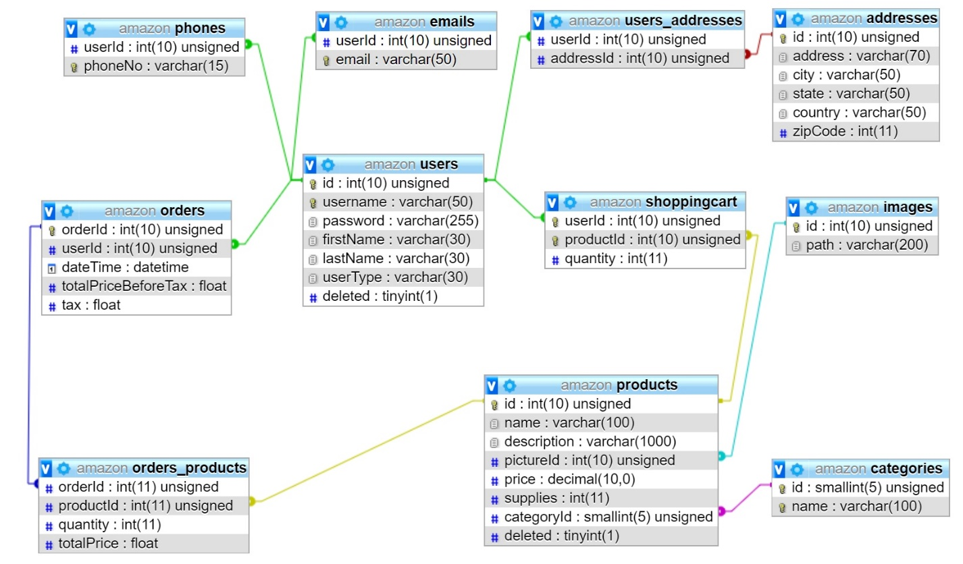

1. **Languages, frameworks and technologies used for implementation**:
2. PHP
3. PHP Data Objects (PDO)
4. MySQL
5. Javascript
6. JQuery
7. AJAX
8. HTML
9. CSS
10. **Screenshots of main functioanlities:**

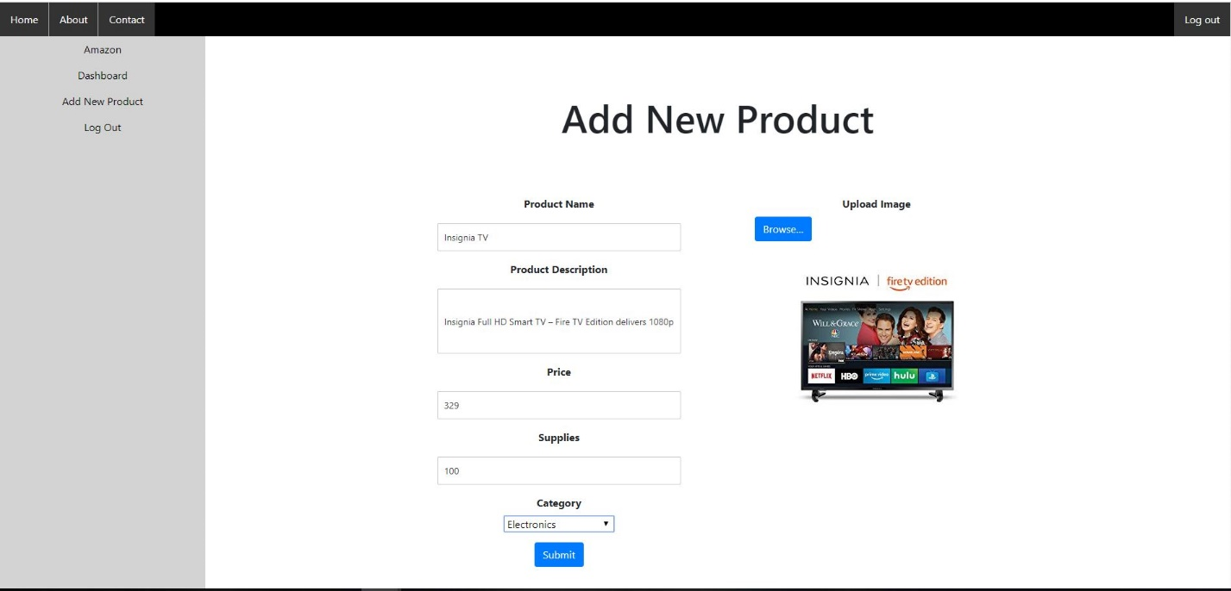

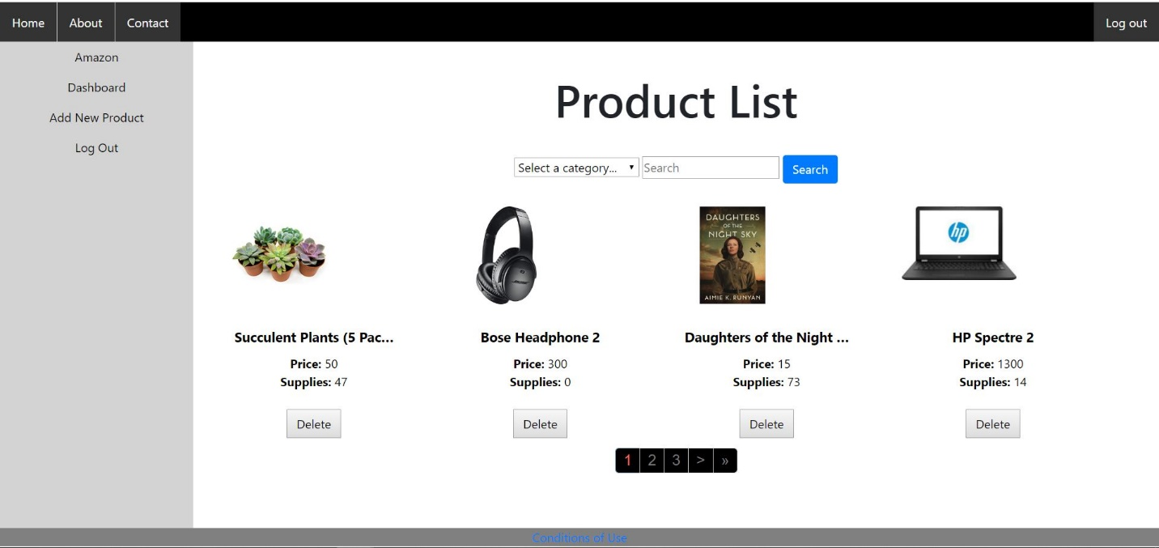

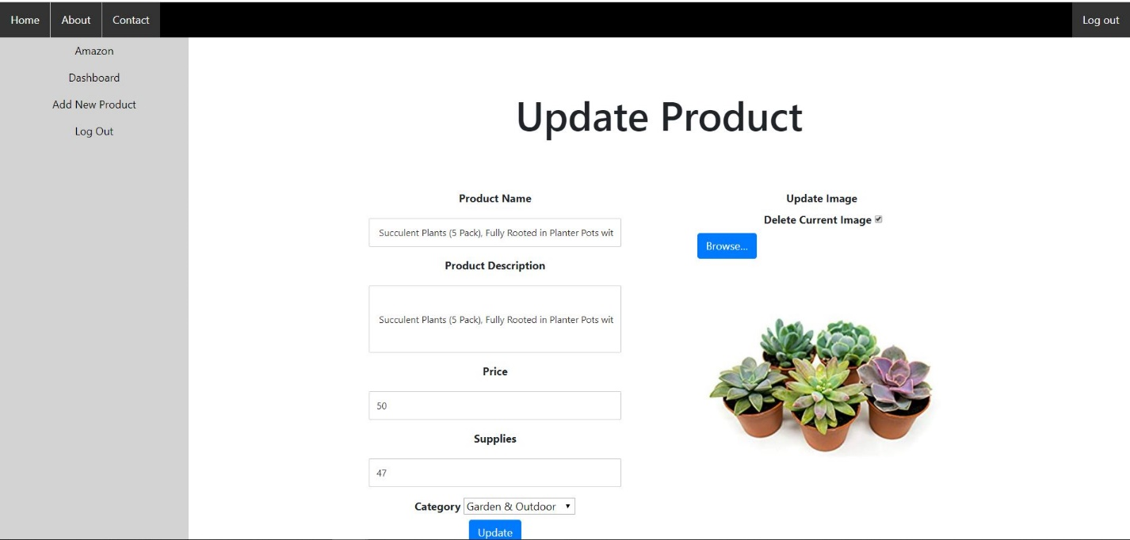

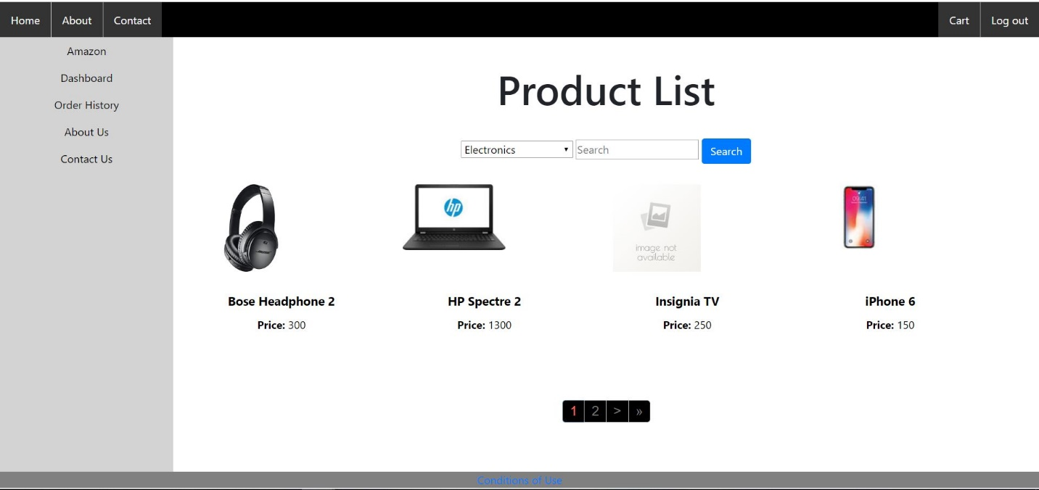

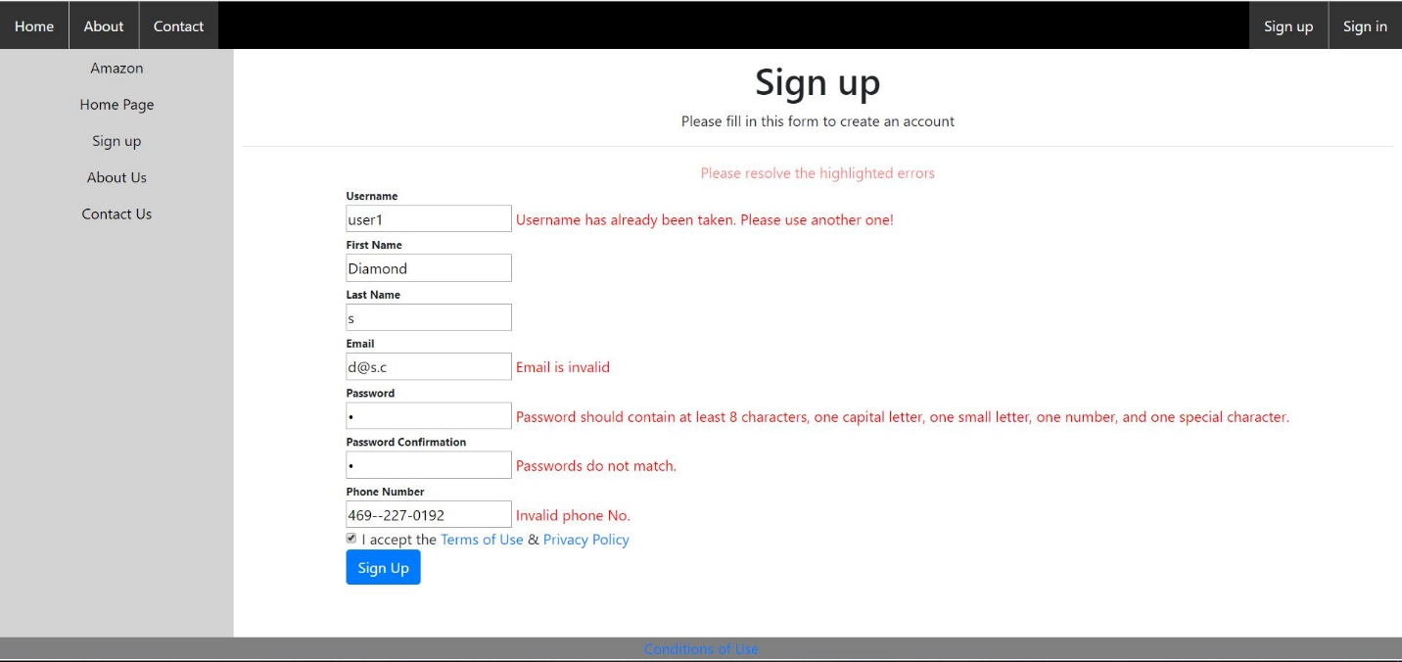

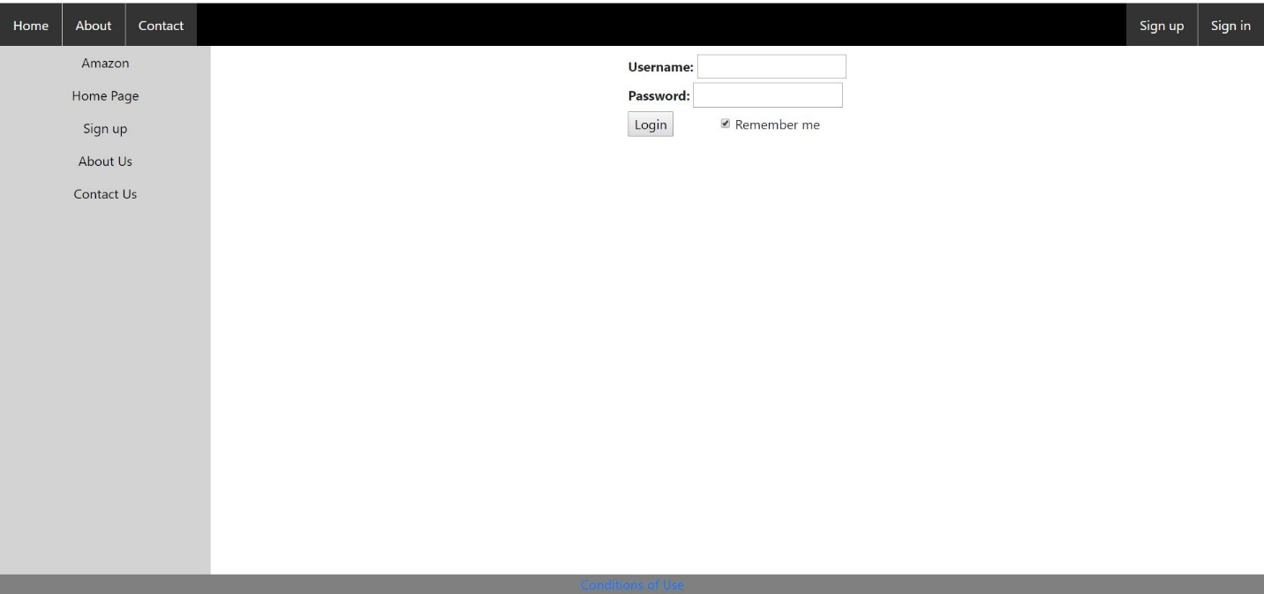

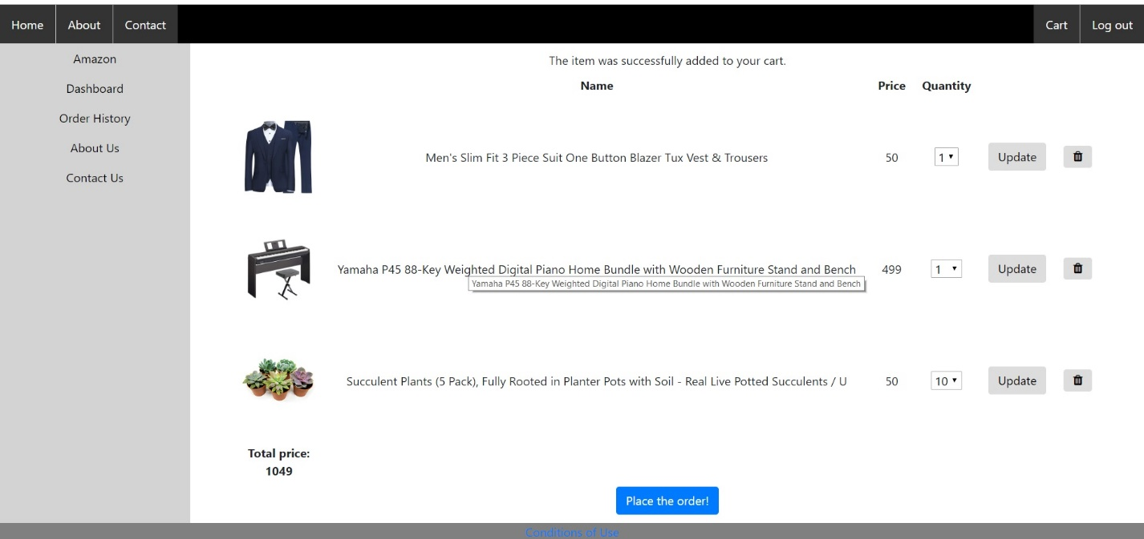

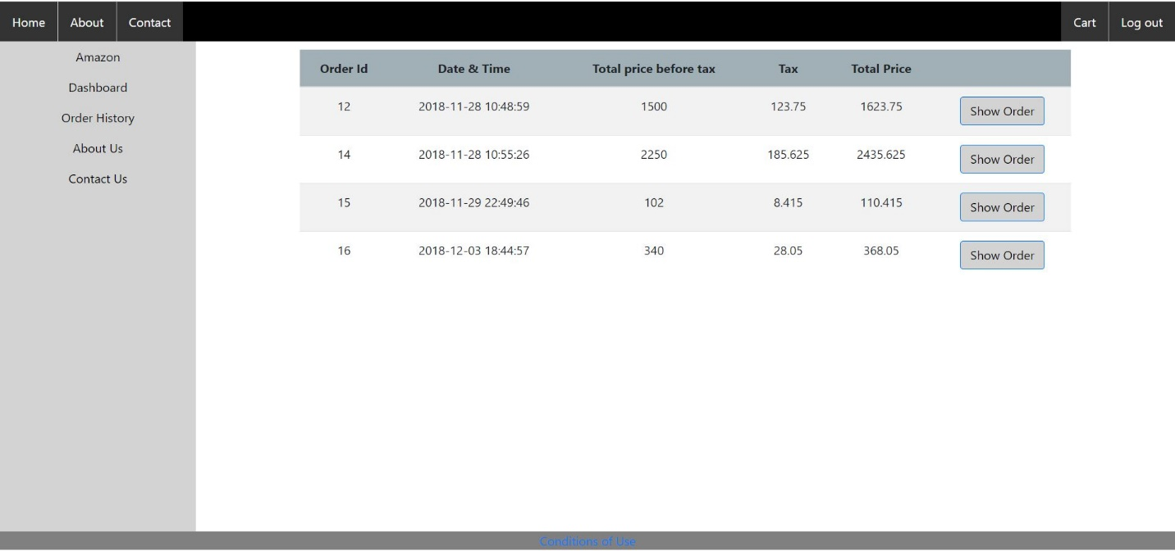

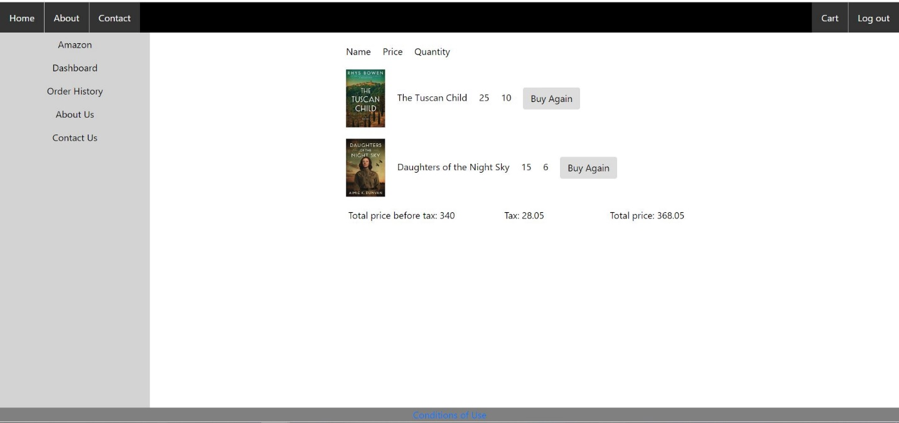

1. **Developer:**

MohammadSaleh Hosseini

Net ID: sxh175430