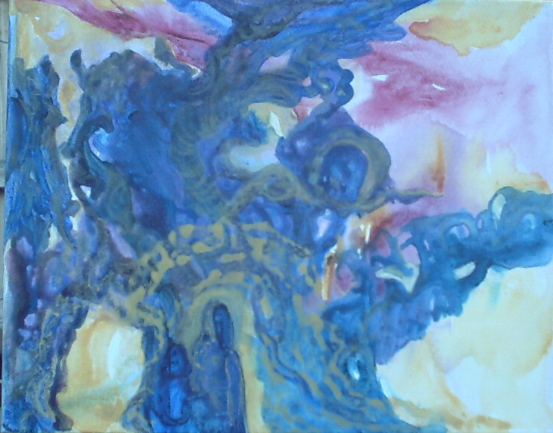

Paths
Even in darkness there is light. Move closer and you will see more. There are so many things to see in this painting. Do you see the native entering the bright tunnel? How about the screaming woman? Do you see the ladies aura as she is leaving the tunnel of light?

