BIG CASE 2 PYTHON RESULTS

#Lowercase letter

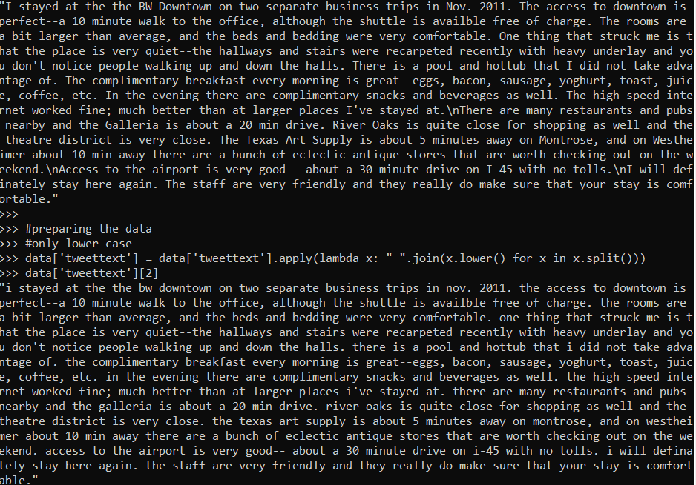

#remove numerical value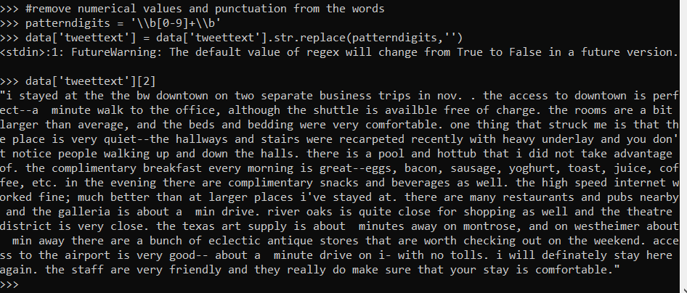

#remove punctuation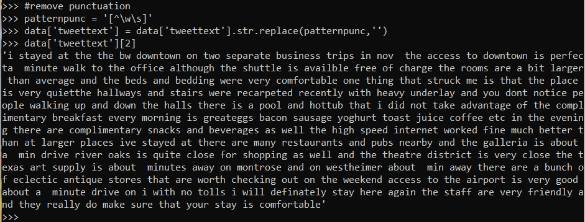

#remove stop word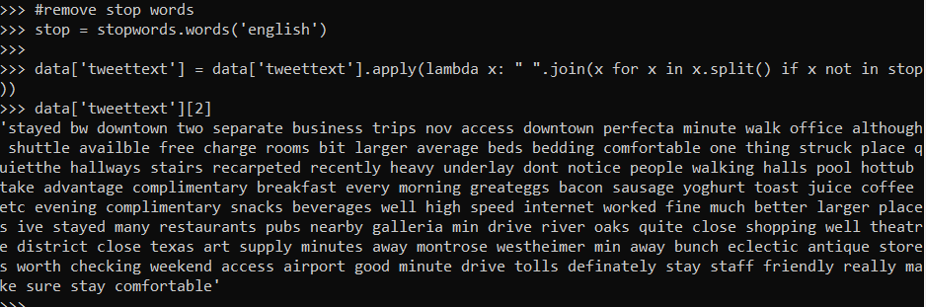

#stem the word

#token data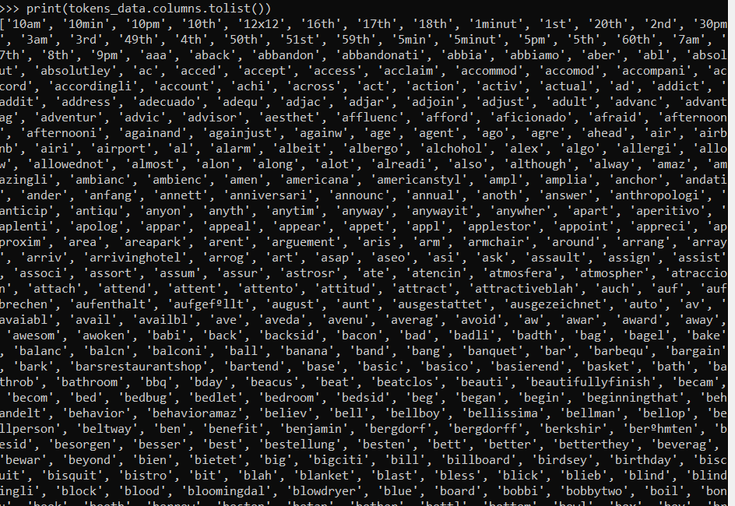

#top 10 terms

#Text

Description automatically generated

#matrix shape

#matrix terms

#print count word

# count the word

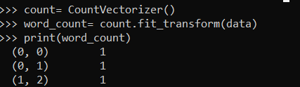

#invert document frequency

#