**There’s more to Sentimental Analytics on Seafood than just the numbers**

As there are 5 major types of proteins, meat, poultry, seafood, beans and peas, eggs, processed soy products, nuts, and seeds are considered part of the Protein Foods Group. As dining out has almost become a celebration/gathering of a special occasion and get together, I would would say the general public would choose seafood over meat in the restaurant.



Hi, my name is Le Roy, and I work for a seafood company. And I know, I know-when you hear the word “seafood” you probably picture me working on a fishing boat braving the waves, unfortunately I do get seasick quite easily. So I am working at the desk importing seafood from all over the world for a living.

But did you know that my work helps to impact the brands and products you find on the frozen counter (and how they’re vacuum packed and boxed up)? I was one of the team member who coordinates and distributes to other retailers like Wholefoods, Wegmans and many more…

So yes, while the truth is that data drives powerful and meaningful insights, there is so much more to analytics than you’d think (especially at how the world is implementing data as a Visual aid). Here’s why…As analyzing data is also a passion of mine. I am interested to develop a project to find out more on how seafood customer’s behavior and attitude would be.

**Sustainable Source of Protein**

Hypothesis: Seafood lovers are more picky and educated than meat eaters

To give you a “taste” of my thought process, I have put together a series of analysts consisting of graphs that are created using Excel, Python, Matpoltlib, Seaborn and PostgresSQL. I have applied Yelp’s data and gathered the below analysis.

The challenge that I faced is overcoming data paralysis when there is a massive amount of data at my fingertips. I have searched through 1000 returned results of restaurants with the words “sea bass”.

Below are the analysis that I have found out.

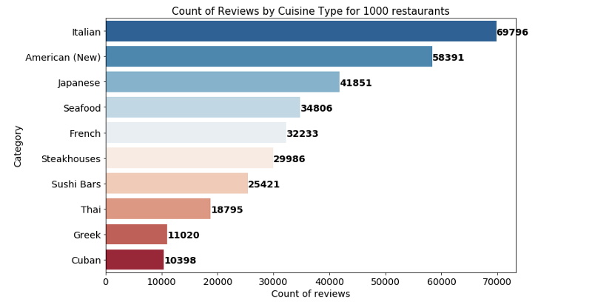Source: Python-Seaborn

My first thought is usually the most reviewed restaurants will be closely related to the search terms. Above shows the Top 10 cuisines that came up with “sea bass” in NYC. Italian restaurants has the most customers’s reviews and followed by American and Japanese.

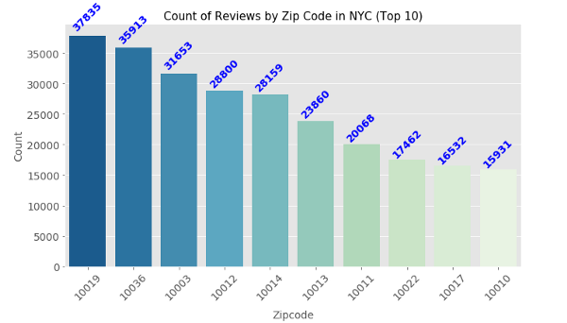Source: Python-Seaborn

Left: shows the most reviewed NYC restaurants by zip code that came up with “sea bass”

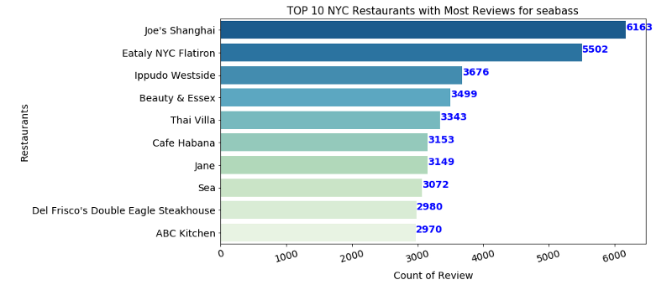Source: Python-Seaborn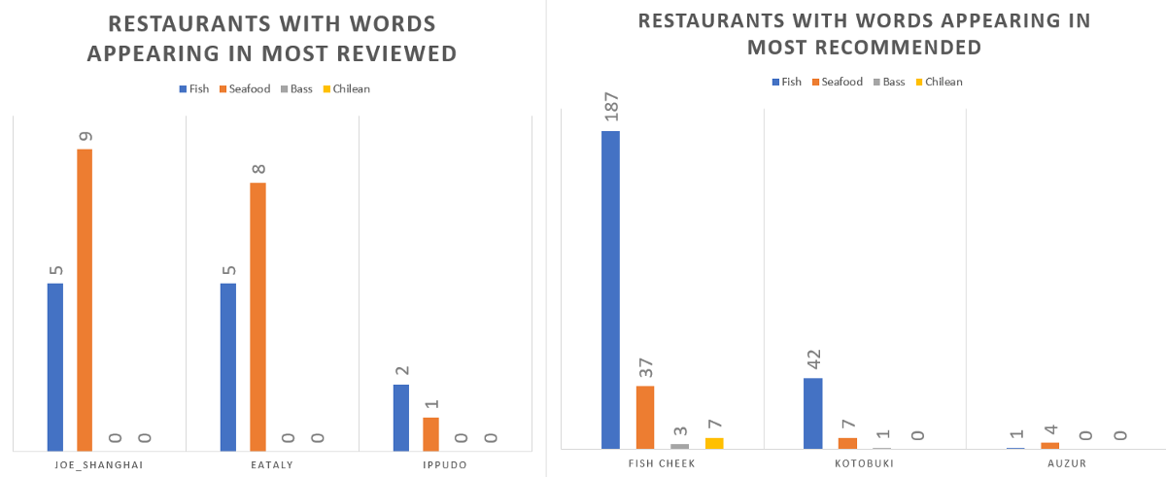

As the search results by default is sorted through most recommended. I am curious to see if most reviewed has the best results. However, it turns out to be the search under most recommended returned the best results for the search terms “sea bass” with words like fish and seafood appearing the most among 300 user reviews. With Midtown Catch having the most number of words relating to “Sea bass” appearing.

**Interpreting the Numbers & Bring Them to Life through Impactful Stories**

Speaking of data, I was digging further into user’s sentiment towards a restaurant with the most number of reviews would be. Upon gathering the data, cleaning and all of these tools and data sets are like a million little pieces to a giant puzzle. By identifying the most important pieces of data, synthesizing them, adding context, and bringing them to life through powerful visualizations and impactful storytelling. I have a list of positive and negative words and matched against the 300 users’ review for the most recommended Restaurant “Fish Cheeks”. It shows that there are more positive outcome relating to the following search on Yelp.

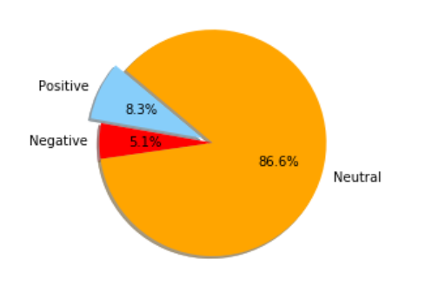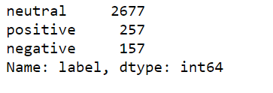

There is 257 positive words out of 3091 words. Overall it is showing that customers are mostly happy about the Fish Cheek restaurant.

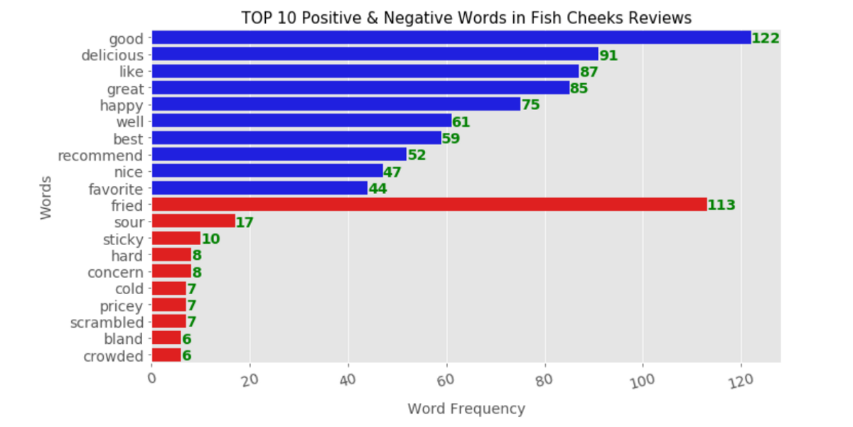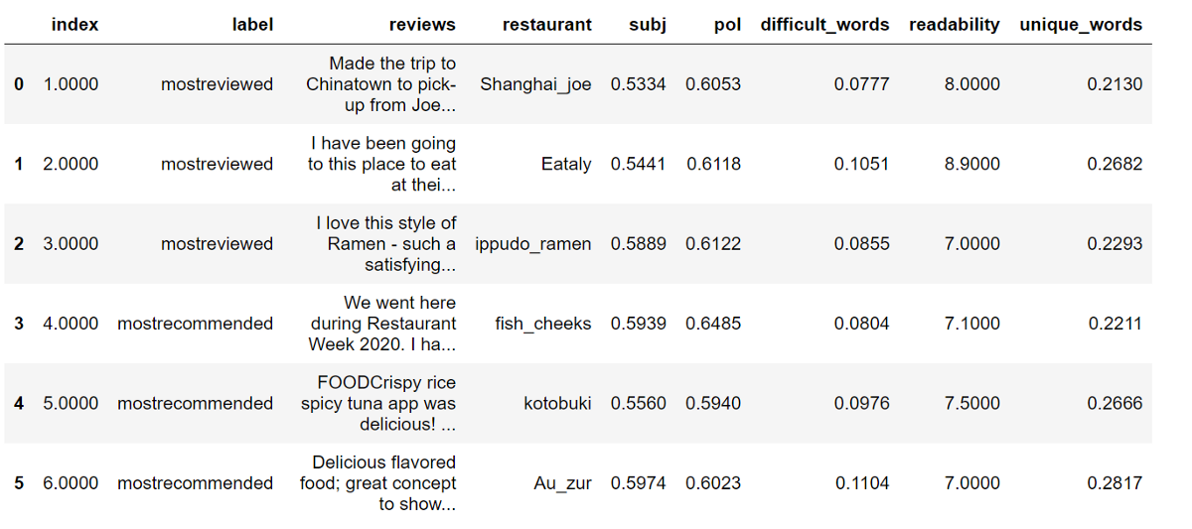

**Findings**

In general, I found out that for most restaurant types, “good” ranks first among all positive words, indicating that tastes might weight more than other factors like service and price when people are judging in a “sea bass” restaurant setting.

From the negative word list, we could observe that “cold” is one of the main issues for the Fish Cheek restaurant, which means customers expect food to be hot in the Asian restaurant settings.

The most reviewed restaurants may not seem to correlate to the search terms whereas the recommended restaurants are.

Since our analysis may help to extract specific features from any set of reviews, restaurant owners can make good use of it for essential information once they received a certain amount of Yelp reviews. From those reviews they can understand why customers love or dislike their restaurants, maybe great reviews primarily due to fresh food, or perhaps unsatisfied reviews caused by too high price. Meanwhile they can also compare the restaurant with similar restaurants within the same type.