CareFlow
Architecture Blueprint & System Diagrams

Technical documentation · generated from the live repository 28 June 2026
What this is. A high-level map of how CareFlow’s existing parts fit together, plus ready-to-use Mermaid.js source for the system-architecture and entity-relationship diagrams. It was written from the actual codebase — the pnpm/Turborepo workspaces, packages/db/schema.sql, and the services/ + lib/supabase/ layers — so it matches the code as built.
Diagrams. Each diagram below appears as a rendered image followed by its Mermaid source. Paste any block into a ```mermaid fence on GitHub/GitLab, into mermaid.live, or the VS Code “Markdown Preview Mermaid” extension to reproduce or edit it.

Part 1 — Architecture Blueprint

1.1 The system at a glance
CareFlow is a pnpm + Turborepo monorepo with two deployable Next.js 16 apps and two shared packages. apps/web is the hospital-facing PWA that clinical and admin staff use; apps/owner-console is a separate platform-administration app (port 3001) for the CareFlow operator. Both depend on packages/shared (TypeScript domain types + Zod validation) and packages/db (schema.sql — the single source of truth for the database).
The backend is Supabase (Postgres · Auth · Storage), so there is no bespoke API server. The browser talks to Supabase directly through the anon client under Row-Level Security; privileged work runs in Next.js Server Actions and the owner console through a service-role client. This keeps the moving parts few: a local-first client, a managed backend that also enforces access control, and a small server surface for the things a browser must not do.

Workspace | Type | Responsibility
@careflow/web | Next.js app | Hospital operations PWA — the clinical + admin workflow, local-first, offline-capable
@careflow/owner-console | Next.js app (:3001) | Platform operator console — cross-tenant oversight (suspend/reactivate, usage)
@careflow/db | Package | schema.sql — tables, RLS, functions, triggers, views (source of truth)
@careflow/shared | Package | Domain TypeScript types + Zod validation, imported by both apps

1.2 The local-first core (how the UI interacts with data)
The defining trait of apps/web is that it is local-first. The UI never blocks on the network: it reads and writes an in-browser cache (services/mockStorage.ts, persisted to localStorage), so every interaction is instant and the app keeps working through the power and connectivity gaps common in its target setting. Three modules turn that cache into a synchronized client:
- Hydrate (download) — supabaseData.hydrateFromSupabase() pulls the signed-in hospital’s rows into the cache on sign-in, RLS-scoped and paged at 1000 rows per table.
- Outbox (capture) — every mutation is also recorded as a durable OutboxChange in services/syncQueue.ts (its own localStorage key), so it survives refreshes and offline use.
- Drain (upload) — the SyncEngine replays the outbox to Postgres in the background, emitting OUTBOX_EVENT (the sync-status chip) and CONFLICT_EVENT when a write loses an optimistic-concurrency check.
Telemetry rides the same client but is deliberately separate: services/telemetry.ts buffers metadata-only usage_events and flushes them fire-and-forget, never blocking clinical UX. The read/write/sync choreography is drawn in §2.2.

1.3 The backend (Supabase)
Supabase provides three managed services. Auth holds credentials and issues the session JWT. Postgres is the source of truth — 24 tables and three reporting views, plus functions and triggers — reached directly from the browser via the anon client, with Row-Level Security doing the access control the app would otherwise need an API tier for. Storage keeps clinical attachments (scanned results, patient documents) in two private buckets. The entire schema, including every policy, lives in packages/db/schema.sql.

1.4 Multi-tenancy & security model
CareFlow is pooled multi-tenancy: one Postgres database holds every hospital’s data, and isolation is enforced by RLS rather than separate databases. Every domain table carries a hospital_id, and every policy ANDs in hospital_id = current_hospital_id() — a SECURITY DEFINER helper that resolves the caller’s hospital from their single staff row. Reads are open to any active staff member of the tenant; writes are gated by role:
- Doctors — consultations, diagnoses, orders, prescriptions, admissions.
- Nurses — vitals (treatment_records), medication administration (MAR), care plans, transfers, allergies.
- Lab techs — results; Pharmacists — prescription status; Receptionists/Admin — patients, visits, billing.
Four mechanisms harden it: an append-only audit_log written by a SECURITY DEFINER trigger on every sensitive table (admin-readable, client-tamper-proof); optimistic concurrency (a version column bumped by trigger; the sync layer guards updates on the base version and surfaces conflicts); defense-in-depth CHECK constraints that mirror the app’s Zod validation; and tenant-prefixed storage — every object path must start with the hospital_id, so files are isolated exactly like rows.

1.5 Authentication & onboarding
Staff sign in with a username + password, not email. Because Supabase Auth is email-keyed, each username maps to a synthetic, non-deliverable address (<username>@careflow.local); the staff identity travels in the user’s metadata. Founding admins instead verify identity first — Google OAuth (PKCE, returning to /auth/callback) or a 6-digit email OTP — then call the create_hospital_and_admin SECURITY DEFINER RPC, which atomically creates the hospital (trial) and the founder’s admin staff row and refuses a second hospital for the same owner. Provisioning additional staff logins needs the service_role key, so it runs only in the server action app/actions/auth.ts, never in the browser.

1.6 Platform / owner plane
A thin platform layer supports the operator without weakening tenant isolation. apps/web emits metadata-only usage_events (logins, registrations, feature use — never patient content) write-only: staff can insert events for their own hospital and read nothing back. apps/owner-console reads across tenants only through the service-role client, behind requirePlatformAdmin() — a server-side email allowlist (PLATFORM_ADMIN_EMAILS) that also records the admin in platform_admins. From there the operator can, for example, suspend or reactivate a hospital’s subscription. platform_admins and cross-tenant reads are invisible to the normal authenticated/anon roles (RLS on, no policies — only the service role sees them).

1.7 Frontend composition
The hospital app uses the Next.js App Router with two route groups: (marketing) for the public landing, login, signup, onboarding and OAuth callback; and (app) for the authenticated workspace — dashboard (live journey board), intake, diagnostics, medications, care-plans, floor-map, departments, billing, reports, staff and reconciliation. It is bilingual (custom EN/FR i18n), themeable (light/dark via next-themes and semantic tokens), installable and offline-capable (web manifest + a service worker that precaches an app shell), charts with recharts, and exports reports via jspdf / xlsx.

1.8 Component interaction reference
Component | Responsibility | Talks to
apps/web · UI (App Router) | Renders the workflow screens; reads/writes the cache for instant UX | mockStorage · syncQueue · supabaseAuth
services/mockStorage | In-browser local-first cache (localStorage); the one store the UI reads | hydrated by supabaseData; mutations → syncQueue
services/supabaseData | hydrateFromSupabase(): RLS-scoped download into the cache on sign-in | Supabase Postgres (anon)
services/syncQueue | Durable outbox + SyncEngine; optimistic concurrency; conflict/outbox events | Supabase Postgres (anon)
services/telemetry | Fire-and-forget, write-only usage metadata | Supabase Postgres (anon)
lib/supabase/client | Singleton anon browser client (PKCE session) | Supabase Auth/Postgres/Storage
lib/supabase/admin | Service-role client (server-only; bypasses RLS) | Supabase Auth/Postgres
lib/supabase/storage | Tenant-prefixed upload + signed download URLs | Supabase Storage (private buckets)
app/actions (auth · otp) | Server Actions: provision logins/hospital, request OTP | admin client · Resend
services/supabaseAuth | Username / Google / OTP sign-in; create_hospital_and_admin RPC | Supabase Auth/Postgres
apps/owner-console | Cross-tenant admin (SSR); suspend/reactivate; read telemetry | service-role · platform_admins · usage_events
packages/db (schema.sql) | Tables, RLS, functions, triggers, views — provisions Postgres | Supabase Postgres
packages/shared | Domain types + Zod validation | imported by both apps
manifest.ts · public/sw.js | Installable PWA + offline app shell | browser cache

1.9 Technology stack
Layer | Technology
Monorepo | pnpm workspaces + Turborepo
Frontend | Next.js 16.2 (App Router · Turbopack) · React 19.2
UI | shadcn + Base UI · Tailwind v4 · next-themes · lucide-react · recharts
Auth | Supabase Auth (@supabase/supabase-js; @supabase/ssr in owner-console)
Data | Supabase Postgres + Row-Level Security
Storage | Supabase Storage (private buckets, tenant-prefixed)
Validation | Zod (packages/shared)
Email | Resend (OTP / invitations)
Reporting / export | jspdf · jspdf-autotable · xlsx
i18n / PWA | custom EN/FR · web manifest + service worker (offline)
Testing | Vitest (+ RLS / onboarding / storage / concurrency integration suites)

1.10 Key data-flow narratives
- Read / hydrate — sign-in → hydrateFromSupabase() → RLS-scoped SELECT * per table → cache replaced → UI renders from cache.
- Write / sync — UI writes cache (instant) + enqueues outbox → SyncEngine drains → versioned UPDATE … .eq('version', base); stale ⇒ refetch + CONFLICT_EVENT; append-only ⇒ insert/upsert.
- File upload — build <hospital_id>/…/file path → upload to a private bucket (RLS checks the prefix) → store attachment_path → later read via a short-lived signed URL.
- Onboarding — verify (Google/OTP) → create_hospital_and_admin RPC → hospital (trial) + founder admin row → staff provisioned later via the service-role server action.

Part 2 — System Diagrams (Mermaid.js)
Four diagrams: the system architecture, the local-first sync sequence, and the data model at two levels of detail. Rendered image first, then the Mermaid source.

2.1 System Architecture Diagram
How the frontend, server actions, owner console, Supabase services, shared packages and the email provider connect. The browser is local-first; the anon client is the single gateway to the backend under RLS; the service-role paths (server actions, owner console) are the only cross-cutting, RLS-bypassing surfaces.
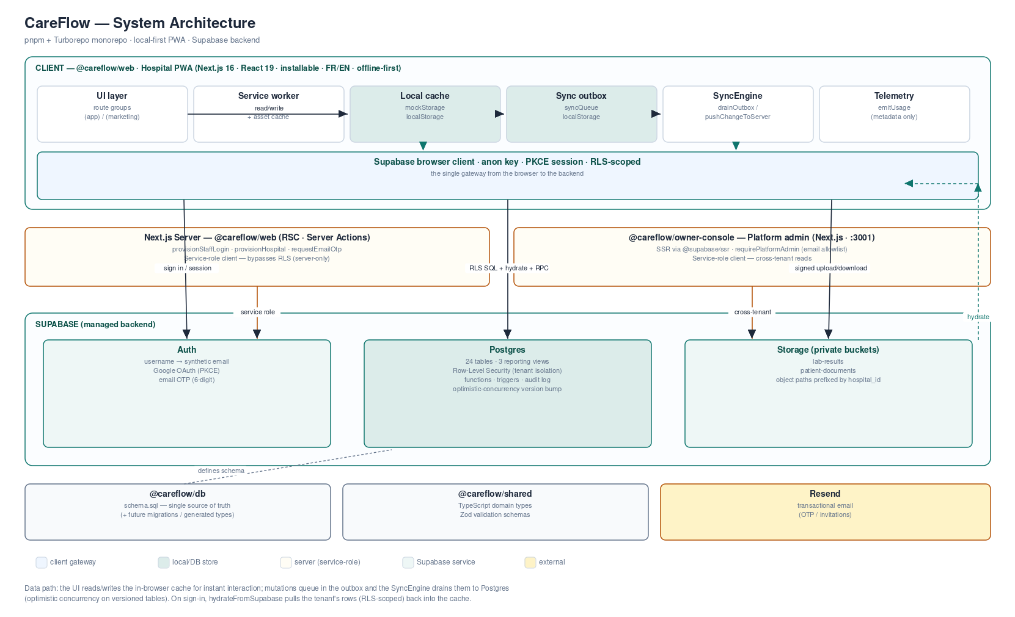
Mermaid source — flowchart (system architecture):
flowchart TB
%% ============ CLIENT: Hospital PWA ============
subgraph WEB["@careflow/web — Hospital PWA (Next.js 16 - React 19 - installable - FR/EN - offline)"]
direction TB
UI["UI layer<br/>route groups: (app) / (marketing)<br/>shadcn + Base UI - recharts - next-themes"]
SW["Service worker<br/>offline shell + asset cache"]
CACHE[("Local-first cache<br/>mockStorage - localStorage")]
OUTBOX[("Sync outbox<br/>syncQueue - localStorage")]
SYNC["SyncEngine<br/>drainOutbox / pushChangeToServer"]
TELE["Telemetry buffer<br/>emitUsage (metadata only)"]
ANON["Supabase browser client<br/>anon key - PKCE session"]
end

%% ============ SERVER: web server actions ============
subgraph SRV["Next.js server — @careflow/web (RSC - Server Actions)"]
ACT["Server Actions<br/>provisionStaffLogin - provisionHospital - requestEmailOtp"]
ADMIN["Service-role client<br/>bypasses RLS - server-only"]
end

%% ============ OWNER CONSOLE ============
subgraph OWNER["@careflow/owner-console — Platform admin (Next.js - port 3001)"]
OC["SSR pages - @supabase/ssr<br/>requirePlatformAdmin (email allowlist)"]
OCADM["Service-role client<br/>cross-tenant reads"]
end

%% ============ SUPABASE BACKEND ============
subgraph SUPA["Supabase (managed backend)"]
AUTH["Auth<br/>username to synthetic email<br/>Google OAuth - email OTP"]
PG[("Postgres<br/>24 tables - RLS tenant isolation<br/>functions - triggers - views")]
STOR[("Storage<br/>lab-results - patient-documents<br/>private - tenant-prefixed")]
end

%% ============ SHARED PACKAGES + EXTERNAL ============
subgraph PKG["Shared workspace packages"]
DBP["@careflow/db<br/>schema.sql (source of truth)"]
SH["@careflow/shared<br/>types + Zod validation"]
end
RESEND["Resend<br/>transactional email"]

%% ---- client internals ----
UI <-->|"instant read / write"| CACHE
UI -->|"mutations enqueue"| OUTBOX
SW -.->|"serves shell offline"| UI
OUTBOX --> SYNC
UI --> TELE

%% ---- client to backend ----
ANON -->|"sign in / session"| AUTH
SYNC -->|"drain - upsert/insert/delete<br/>optimistic concurrency"| ANON
ANON -->|"RLS-scoped SQL"| PG
PG -->|"hydrateFromSupabase<br/>(RLS-scoped, paged)"| CACHE
ANON -->|"create_hospital_and_admin RPC"| PG
ANON -->|"signed upload / download"| STOR
TELE -->|"write-only usage_events"| ANON

%% ---- server actions ----
ACT --> ADMIN
ADMIN -->|"auth.admin.createUser"| AUTH
ADMIN -->|"service role"| PG
ACT -->|"OTP / invite email"| RESEND

%% ---- owner console ----
OC --> OCADM
OCADM -->|"cross-tenant: hospitals - usage_events - platform_admins"| PG

%% ---- packages ----
DBP -.->|"defines schema"| PG
UI -.->|"imports"| SH
OC -.->|"imports"| SH

classDef store fill:#e2e8f0,stroke:#475569,color:#0f172a;
classDef ext fill:#fef9c3,stroke:#a16207,color:#0f172a;
class CACHE,OUTBOX,PG,STOR store;
class RESEND ext;

2.2 Local-first Sync & Data Flow (sequence)
The read/hydrate, offline write, and background-drain choreography — including the optimistic-concurrency conflict path that powers the sync-status chip.
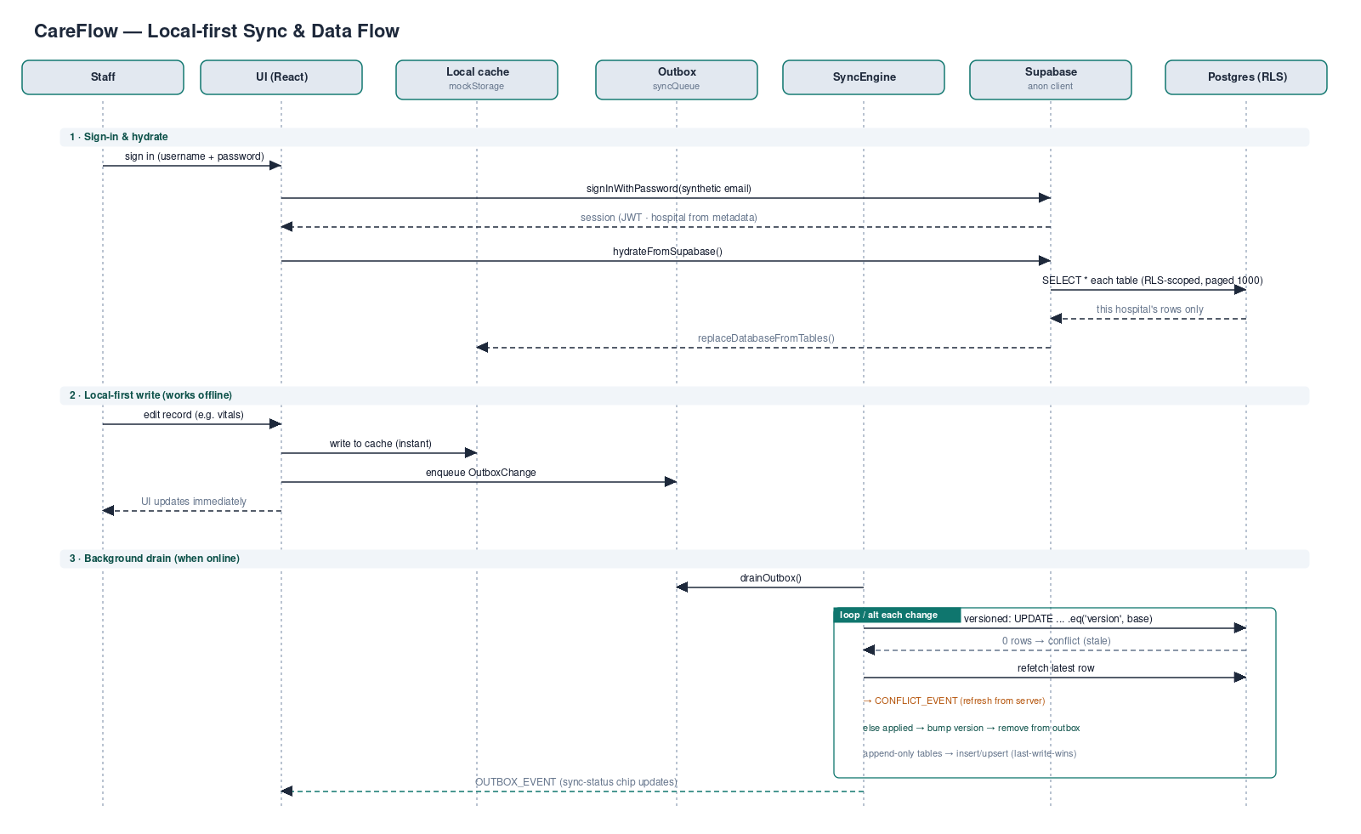
Mermaid source — sequenceDiagram (sync & data flow):
sequenceDiagram
autonumber
actor Staff
participant UI as UI (React)
participant Cache as Local cache<br/>(mockStorage)
participant Outbox as Outbox<br/>(syncQueue)
participant Sync as SyncEngine
participant SB as Supabase<br/>(anon client)
participant PG as Postgres (RLS)

Note over Staff,PG: Sign-in and hydrate
Staff->>UI: sign in (username + password)
UI->>SB: signInWithPassword (synthetic email)
SB-->>UI: session (JWT, hospital from metadata)
UI->>SB: hydrateFromSupabase()
SB->>PG: SELECT * each table (RLS-scoped, paged 1000)
PG-->>SB: this hospital's rows only
SB-->>Cache: replaceDatabaseFromTables()

Note over Staff,PG: Local-first write (works offline)
Staff->>UI: edit record (e.g. vitals)
UI->>Cache: write (instant)
UI->>Outbox: enqueue OutboxChange
UI-->>Staff: UI updates immediately

Note over Outbox,PG: Background drain when online
Sync->>Outbox: drainOutbox()
loop each pending change
alt versioned table (optimistic concurrency)
Sync->>PG: update ... .eq('version', base)
alt 0 rows matched (stale version)
PG-->>Sync: conflict
Sync->>PG: refetch latest row
Sync->>UI: CONFLICT_EVENT (refresh from server)
else applied
PG-->>Sync: bumped version
Sync->>Outbox: remove change
end
else append-only clinical table
Sync->>PG: insert / upsert (last-write-wins)
PG-->>Sync: ok
Sync->>Outbox: remove change
end
end
Sync-->>UI: OUTBOX_EVENT (sync-status chip updates)

2.3 Entity-Relationship Diagram — Overview
The readable spine of the data model. The visit is the centre of the record; clinical detail, admission, and billing all hang off it. Every domain table also carries hospital_id → hospitals (tenant isolation), omitted here for clarity.
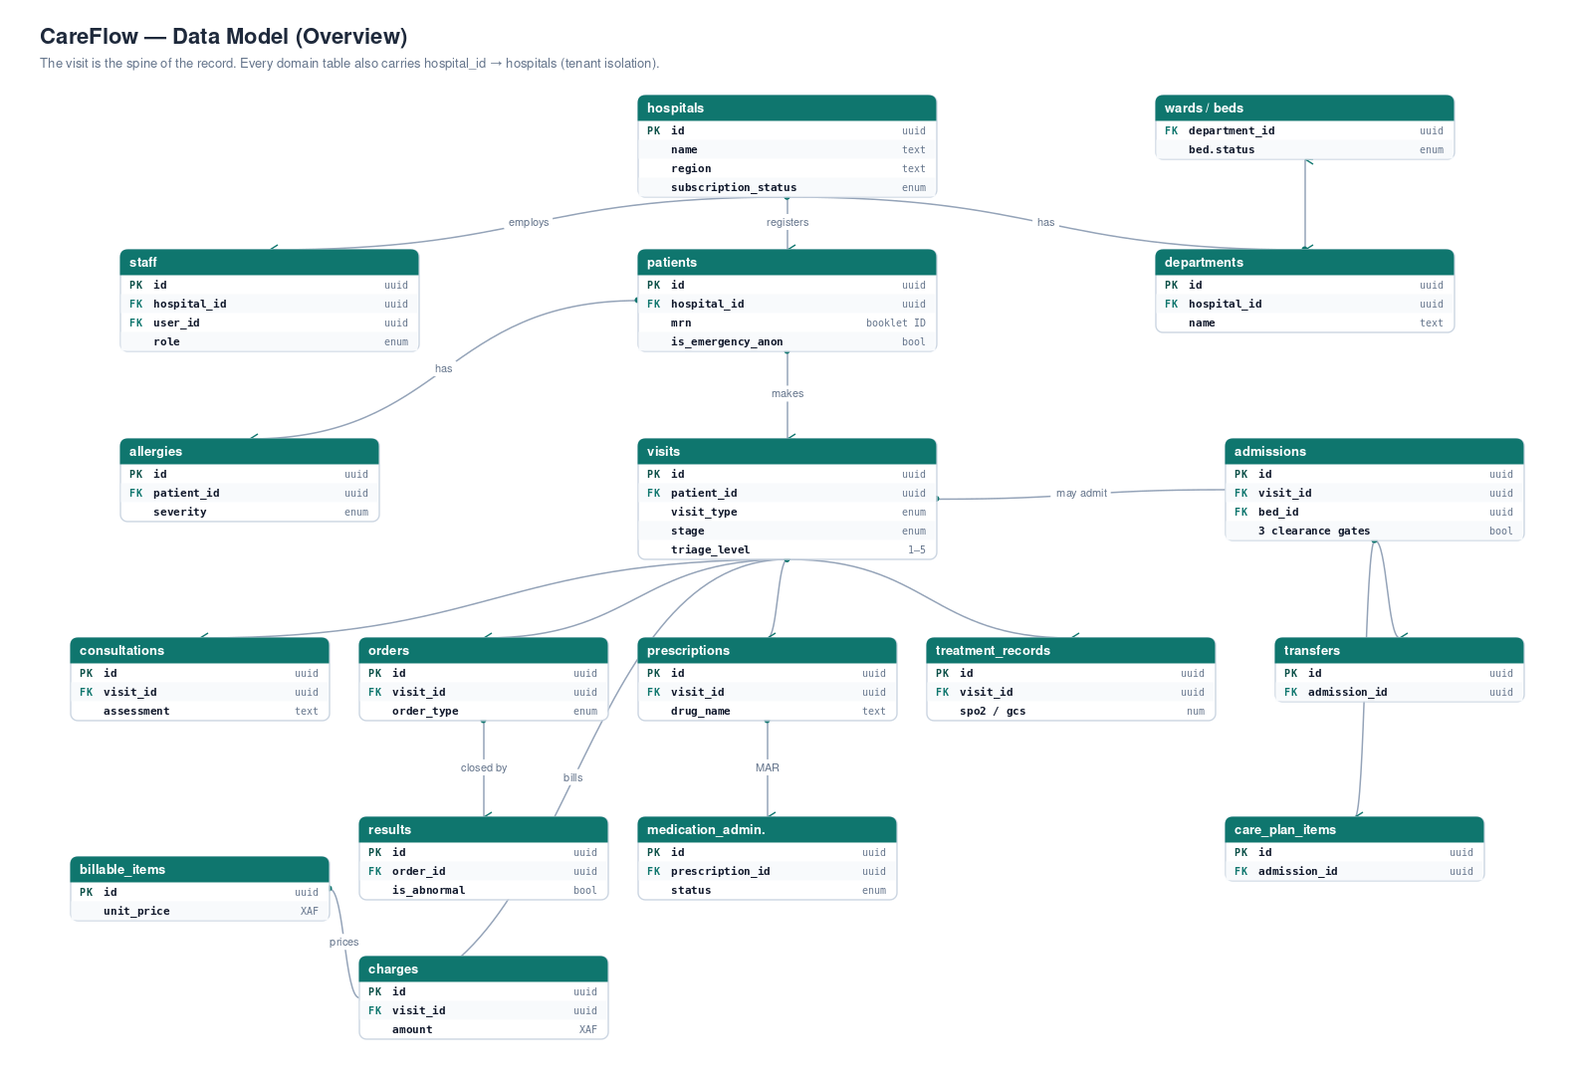
Mermaid source — erDiagram (overview):
erDiagram
hospitals ||--o{ departments : "has"
hospitals ||--o{ staff : "employs"
hospitals ||--o{ patients : "registers"
departments ||--o{ wards : "contains"
wards ||--o{ beds : "holds"
patients ||--o{ allergies : "has"
patients ||--o{ visits : "makes"
visits ||--o{ consultations : "documents"
visits ||--o{ diagnoses : "yields"
visits ||--o{ orders : "requests"
orders ||--o{ results : "closed by"
visits ||--o{ prescriptions : "prescribes"
prescriptions ||--o{ medication_administrations : "given as"
visits ||--o{ treatment_records : "vitals"
visits ||--o{ admissions : "may admit"
admissions ||--o{ transfers : "moves via"
admissions ||--o{ care_plan_items : "plans"
care_plan_items ||--o{ care_plan_entries : "logged as"
admissions }o--|| wards : "placed in"
admissions }o--o| beds : "occupies"
visits ||--o{ charges : "bills"
billable_items ||--o{ charges : "prices"

hospitals {
uuid id PK
text name
text region
enum subscription_status
jsonb feature_flags
}
staff {
uuid id PK
uuid hospital_id FK
uuid user_id FK "auth.users"
enum role
text full_name
}
patients {
uuid id PK
uuid hospital_id FK
text mrn "Cameroon booklet ID"
text full_name
bool is_emergency_anonymous
}
visits {
uuid id PK
uuid hospital_id FK
uuid patient_id FK
enum visit_type
enum stage "care journey"
smallint triage_level
}
admissions {
uuid id PK
uuid visit_id FK
uuid bed_id FK
bool is_medical_cleared
bool is_financial_cleared
bool is_pharmacy_ready
}
charges {
uuid id PK
uuid visit_id FK
enum source
int amount "XAF"
enum status
}

2.4 Entity-Relationship Diagram — Full reference (24 tables)
Every table with its key columns (PK primary key, FK foreign key), grouped by domain. The Mermaid source below is the exact, complete relationship set. Note: every domain table carries hospital_id → hospitals (RLS); staff is the actor referenced by the *_by_id columns — listed as columns and, in the code, only the structural edges are drawn to keep the graph legible.
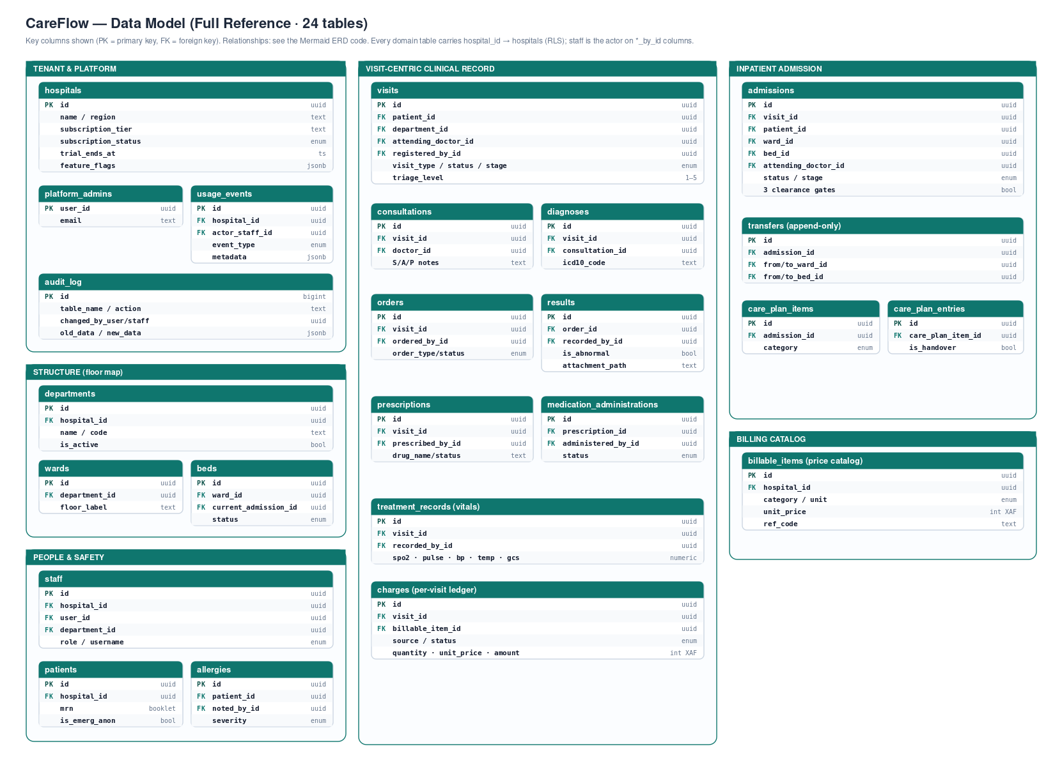
Mermaid source — erDiagram (full reference):
erDiagram
%% ===== Tenant root (every domain table also carries hospital_id FK -> hospitals) =====
auth_users ||--o| staff : "authenticates"
auth_users ||--o| platform_admins : "authorizes"
hospitals ||--o{ departments : ""
hospitals ||--o{ staff : ""
hospitals ||--o{ patients : ""
hospitals ||--o{ visits : ""
hospitals ||--o{ billable_items : ""
hospitals ||--o{ usage_events : ""

%% ===== Structure / floor map =====
departments ||--o{ wards : ""
departments ||--o{ staff : "assigned"
wards ||--o{ beds : ""

%% ===== People / safety =====
patients ||--o{ allergies : ""
patients ||--o{ visits : ""
patients ||--o{ admissions : ""

%% ===== Visit-centric clinical record =====
visits ||--o{ consultations : ""
visits ||--o{ diagnoses : ""
consultations ||--o{ diagnoses : ""
visits ||--o{ orders : ""
orders ||--o{ results : ""
visits ||--o{ prescriptions : ""
prescriptions ||--o{ medication_administrations : ""
visits ||--o{ treatment_records : ""
visits ||--o{ admissions : ""
visits ||--o{ charges : ""

%% ===== Inpatient admission =====
admissions ||--o{ transfers : ""
admissions ||--o{ care_plan_items : ""
admissions ||--o{ care_plan_entries : ""
care_plan_items ||--o{ care_plan_entries : ""
admissions }o--|| wards : "ward"
admissions }o--o| beds : "bed"

%% ===== Billing =====
billable_items ||--o{ charges : ""

%% =====================================================================
hospitals {
uuid id PK
text name
text region
text subscription_tier
enum subscription_status
ts trial_ends_at
jsonb feature_flags
}
departments {
uuid id PK
uuid hospital_id FK
text name
text code
bool is_active
}
wards {
uuid id PK
uuid hospital_id FK
uuid department_id FK
text name
text floor_label
}
beds {
uuid id PK
uuid hospital_id FK
uuid ward_id FK
uuid current_admission_id FK
text label
enum status
}
staff {
uuid id PK
uuid hospital_id FK
uuid user_id FK "auth.users"
uuid department_id FK
text full_name
enum role
text username
}
patients {
uuid id PK
uuid hospital_id FK
text mrn "booklet ID"
text full_name
enum sex
bool is_emergency_anonymous
bool no_known_allergies
}
allergies {
uuid id PK
uuid hospital_id FK
uuid patient_id FK
uuid noted_by_id FK "staff"
text substance
enum category
enum severity
}
visits {
uuid id PK
uuid hospital_id FK
uuid patient_id FK
uuid department_id FK
uuid attending_doctor_id FK "staff"
uuid registered_by_id FK "staff"
enum visit_type
enum status
enum stage
smallint triage_level
}
consultations {
uuid id PK
uuid hospital_id FK
uuid visit_id FK
uuid doctor_id FK "staff"
text subjective
text assessment
text plan
}
diagnoses {
uuid id PK
uuid hospital_id FK
uuid visit_id FK
uuid consultation_id FK
uuid diagnosed_by_id FK "staff"
text icd10_code
bool is_primary
}
orders {
uuid id PK
uuid hospital_id FK
uuid visit_id FK
uuid ordered_by_id FK "staff"
enum order_type
enum status
}
results {
uuid id PK
uuid hospital_id FK
uuid order_id FK
uuid recorded_by_id FK "staff"
text value
bool is_abnormal
text attachment_path
}
prescriptions {
uuid id PK
uuid hospital_id FK
uuid visit_id FK
uuid prescribed_by_id FK "staff"
text drug_name
enum status
}
medication_administrations {
uuid id PK
uuid hospital_id FK
uuid prescription_id FK
uuid administered_by_id FK "staff"
enum status
ts scheduled_for
}
treatment_records {
uuid id PK
uuid hospital_id FK
uuid visit_id FK
uuid recorded_by_id FK "staff"
numeric spo2
numeric pulse
int gcs_score
}
admissions {
uuid id PK
uuid hospital_id FK
uuid visit_id FK
uuid patient_id FK
uuid ward_id FK
uuid bed_id FK
uuid attending_doctor_id FK "staff"
enum status
enum stage
bool is_medical_cleared
bool is_financial_cleared
bool is_pharmacy_ready
}
transfers {
uuid id PK
uuid hospital_id FK
uuid admission_id FK
uuid patient_id FK
uuid from_ward_id FK
uuid to_ward_id FK
uuid from_bed_id FK
uuid to_bed_id FK
}
care_plan_items {
uuid id PK
uuid hospital_id FK
uuid admission_id FK
uuid patient_id FK
enum category
enum status
text goal
}
care_plan_entries {
uuid id PK
uuid hospital_id FK
uuid admission_id FK
uuid care_plan_item_id FK
text note
bool is_handover
}
billable_items {
uuid id PK
uuid hospital_id FK
enum category
text name
enum unit
int unit_price "XAF"
text ref_code
}
charges {
uuid id PK
uuid hospital_id FK
uuid visit_id FK
uuid billable_item_id FK
enum source
text source_ref_id
int quantity
int amount "XAF"
enum status
}
audit_log {
bigint id PK
text table_name
text record_id
text action
uuid changed_by_user
uuid changed_by_staff
uuid hospital_id
jsonb old_data
jsonb new_data
}
usage_events {
uuid id PK
uuid hospital_id FK
uuid actor_staff_id FK "staff"
enum event_type
jsonb metadata
}
platform_admins {
uuid user_id PK "auth.users"
text email
text full_name
}
auth_users {
uuid id PK "Supabase Auth"
text email
}

2.5 Rendering the Mermaid source
- GitHub / GitLab — paste a block inside a ```mermaid fenced code block in any .md file; it renders automatically.
- mermaid.live — the official live editor; paste, preview, and export SVG/PNG.
- VS Code — the “Markdown Preview Mermaid Support” extension renders it in preview.
- CLI — npx @mermaid-js/mermaid-cli -i diagram.mmd -o diagram.svg for scripted exports.

Appendix — Source-of-truth map & notes

Where each thing lives in the repo
Concern | File / path
Database schema (ERD source) | packages/db/schema.sql
Domain types | packages/shared/types/healthcare.ts
Validation (Zod) | packages/shared/validation/*
Local cache | apps/web/services/mockStorage.ts
Hydrate (download) | apps/web/services/supabaseData.ts
Sync outbox (upload) | apps/web/services/syncQueue.ts
Telemetry | apps/web/services/telemetry.ts
Auth (browser) | apps/web/services/supabaseAuth.ts
Supabase clients / storage | apps/web/lib/supabase/{client,admin,identity,storage}.ts
Server Actions | apps/web/app/actions/{auth,otp}.ts
Routes | apps/web/app/(app)/* · apps/web/app/(marketing)/*
Owner console | apps/owner-console/*
PWA / offline | apps/web/app/manifest.ts · apps/web/public/sw.js

Notes & assumptions
- Reflects the repository post-monorepo migration, including the Phase 19.1 telemetry tables (usage_events, platform_admins).
- The ERDs show key columns; every domain table also has created_at/updated_at, and mutable tables a version column — the complete column list is in schema.sql.
- “Service” here means the service-layer modules (services/, lib/supabase/), not separate microservices — the architecture is one Next.js app + Supabase + a separate owner-console app.

