Modeling and Forecasting Bitcoin Prices Using ARIMA and VAR/VECM Models
Realised by Diana Secarea and Stoimenova Stela

Time Series Analysis — Academic Year 2025–2026

Application 1: ARIMA Modelling and Forecasting of the BTC/USD Exchange Rate

Box-Jenkins Methodology

1. Introduction
The Bitcoin/US Dollar (BTC/USD) exchange rate represents one of the most volatile and widely studied financial time series of the last decade. Since its emergence as a tradeable asset in 2010 and its rapid appreciation from below $1,000 in early 2015 to peaks exceeding $60,000 in 2021 and $90,000 in 2024, Bitcoin has attracted significant academic interest as both a speculative asset and a potential store of value. Modelling and forecasting its price dynamics is not only of practical relevance to investors and risk managers, but also provides a rich empirical test case for classical time series econometrics.
We have chosen this theme as it proves modern and unique, analyzing a subject of high complexity and volatility. On a personal note, this project also helps me in my work as I started working in Blockchain Intelligence, having the role to create predictive ML models that can be adaptive to the ever changing blockchain ( time-series proving really helpful).
The objective of this application is to apply the Box-Jenkins methodology to the daily BTC/USD closing price in order to identify an appropriate ARIMA model, validate it through residual diagnostics, and produce short-horizon point and interval forecasts. The series is analysed over the period January 2015 –May 2026, yielding more than 2,500 daily observations — well above the 250-observation minimum required for daily data. We wanted to make a large analysis, starting from the very beginning to our current period.

1.1 Motivation and Literature Review
Three studies provide the academic foundation for this application:
[1] Katsiampa (2017) — “Volatility estimation for Bitcoin: A comparison of GARCH models”, Economics Letters, 158, 3–6. Katsiampa applies a range of GARCH-family models to the BTC/USD series and documents that the returns exhibit strong time-varying volatility (ARCH effects), high excess kurtosis, and non-normality — all features that motivate a careful residual diagnostic framework after ARIMA fitting. The study confirms that the log-price series is integrated of order one (I(1)), consistent with our unit root findings below.
[2] Chu et al. (2017) — “GARCH Modelling of Cryptocurrencies”, Journal of Risk and Financial Management, 10(4), 17. This paper performs a systematic comparison of twelve GARCH specifications on seven major cryptocurrencies including Bitcoin, and explicitly identifies ARIMA-type mean equations as the natural starting point before modelling residual heteroscedasticity. The authors confirm d = 1 for log-price and near-zero autocorrelation in the return series, which motivates our ARIMA(p,1,q) specification search.
[3] Peng et al. (2018) — “A Study on the Predictability of Bitcoin Price Using ARIMA Models”, Proceedings of the 2018 International Conference on Computer, Information and Telecommunication Systems (CITS). Peng et al. directly apply the Box-Jenkins ARIMA framework to Bitcoin daily prices and conclude that low-order ARIMA models (typically ARIMA(0,1,0) or ARIMA(1,1,1)) provide reasonable short-term point forecasts, while interval widths grow rapidly due to high volatility — a result we replicate and extend with explicit confidence-band plots on the original price scale.

2. Data Description
Attribute | Detail
Variable | BTC/USD Daily Closing Price
Definition | The last transaction price of one Bitcoin expressed in US Dollars at the close of each trading day (UTC)
Unit of measurement | US Dollars (USD)
Frequency | Daily
Sample period | 1 January 2015 – 15 May 2026
Number of observations | 4153
Source | Yahoo Finance — ticker symbol BTC-USD
Link | https://finance.yahoo.com/quote/BTC-USD/history/
Variable downloaded | BTC.USD.Close (adjusted closing price)
File used | BTC_USD_daily.csv
The dataset contains seven columns: Date, Open, High, Low, Close, Volume, and Adjusted. Only the Close price is used in this application because it represents the consensus market value at end of day and is the standard reference in financial time series modelling.
All analysis is conducted on the natural logarithm of the closing price (log_btc). Working with log-prices is standard practice in financial econometrics for three reasons: (i) it compresses the scale and reduces heteroscedasticity in levels, (ii) first differences of log-prices equal continuously compounded returns, making them directly interpretable, and (iii) it ensures non-negativity of back-transformed forecasts.

3. Preliminary Analysis — Time Series Plot and Descriptive Statistics

3.1 Time Series Plot
Figure 1 shows the raw BTC/USD daily closing price. The series exhibits a pronounced upward trend with episodes of extreme growth (2017, 2020–2021) and sharp corrections, and a clear absence of mean-reversion — typical behaviour of a non-stationary financial price series.
Figure 2 shows the same series after log-transformation; the shape is preserved but the vertical scale is compressed and large shocks are rendered more symmetric.
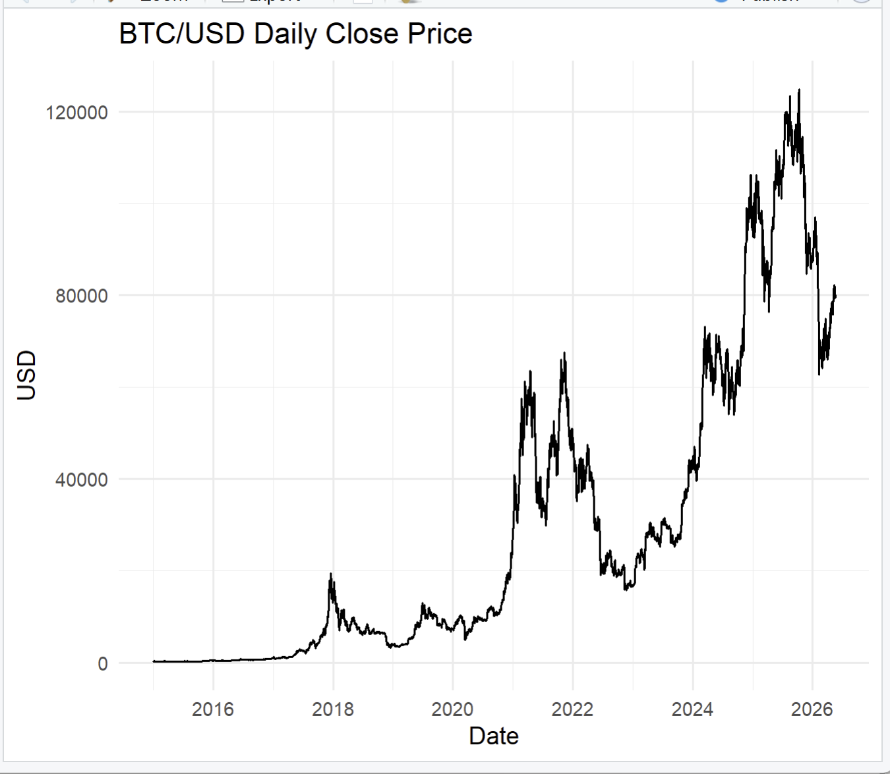
Figure 1: Raw BTC/USD Closing Price plot
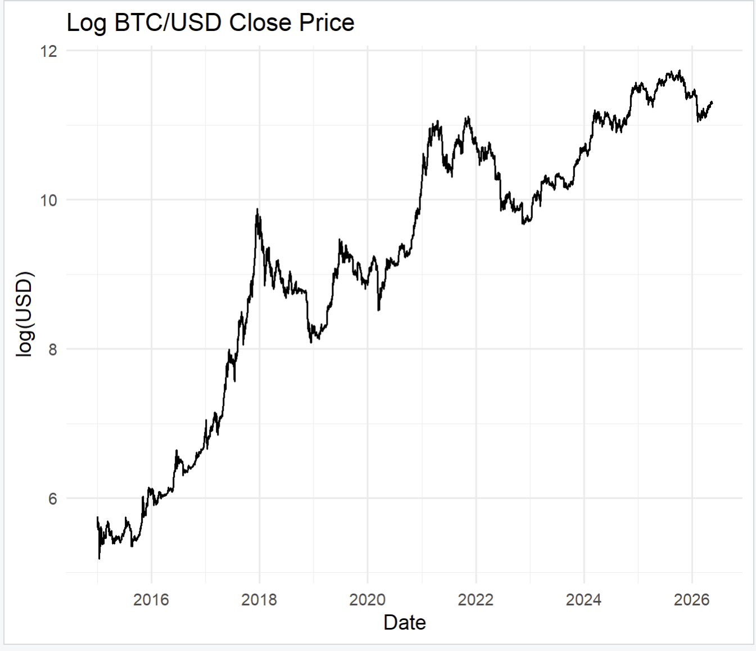
Figure 2: Log BTC/USD Closing Price plot
Raw price (original series)
The problem: the scale explodes. A $1,000 move when Bitcoin is at $1,000 is a 100% gain. The same $1,000 move when Bitcoin is at $60,000 is only 1.7%. Statistically, this means:
- The variance grows with the level (heteroscedasticity)
- Early observations look flat on a plot even though they had huge % swings
- The series is highly skewed upward
Log price — log(P_t)
It behaves differently. We apply the natural logarithm to every price. $314 becomes 5.75, $69,000 becomes 11.14.
-Log compresses the scale — big numbers get pulled down more
-Log makes % moves comparable across the full history
Therefore: raw price tells us the dollar value; log price tells us the proportional position — and log differences tell us the daily return.

3.2 Descriptive Statistics
Table 1 presents descriptive statistics for both the log-price series (original, non-stationary) and the first-differenced log-price series (log returns, stationary).

Table 1. Descriptive Statistics
=== Log BTC/USD (original) ===
Observations: 4153
Mean: 9.209627
Std Deviation: 1.86732
Skewness: -0.663548
Excess Kurtosis: -0.711246
Minimum: 5.182362
Maximum: 11.73409

=== Descriptive Statistics: Log Returns / First Difference (stationary) ===
Observations: 4152
Mean: 0.001332
Std Deviation: 0.035236
Skewness: -0.736690
Excess Kurtosis: 12.001099
Minimum: -0.464730
Maximum: 0.225119

Note: Excess kurtosis = kurtosis − 3, so that the normal distribution has excess kurtosis of zero.
Interpretation:
- The log-price series has a positive mean reflecting the long-run upward trend; its excess kurtosis close to zero is expected for a trending level series.
- One observation is lost by differencing — expected and irrelevant. Both series are large samples.
- The log return series has a mean close to zero (consistent with a random walk in prices) and exhibits positive excess kurtosis (leptokurtosis), indicating fat tails — more extreme daily moves than a normal distribution would predict. This is a well-documented stylised fact for crypto returns (Katsiampa, 2017).
- The skewness of returns negative reflects asymmetry in price movements (larger positive or negative shocks dominate).
- Kurtosis: The original log-price is nearly normal in shape because it is dominated by a smooth upward trend — the distribution is spread broadly, not concentrated. Once the trend is removed by differencing, the return distribution reveals its true nature: a very sharp central peak (most days are calm) combined with extremely fat tails (rare but catastrophic/extraordinary moves). An excess kurtosis of 12 is roughly 4× higher than typical stock returns (~3) and is the statistical fingerprint of Bitcoin's crash-and-spike behaviour.

The log return series exhibits the three classic stylised facts of financial returns: near-zero mean, strong leptokurtosis (excess kurtosis = 12.0), and negative skewness — indicating that extreme negative daily moves are both more frequent and more severe than extreme positive ones. These features confirm that while ARIMA adequately models the autocorrelation structure, the residual variance is non-constant and a GARCH extension would be natural for volatility modelling.

- Figures 3 and 4 show histograms with kernel density estimates overlaid against a fitted normal curve. The departure from normality in the return distribution is visible in the heavier tails.
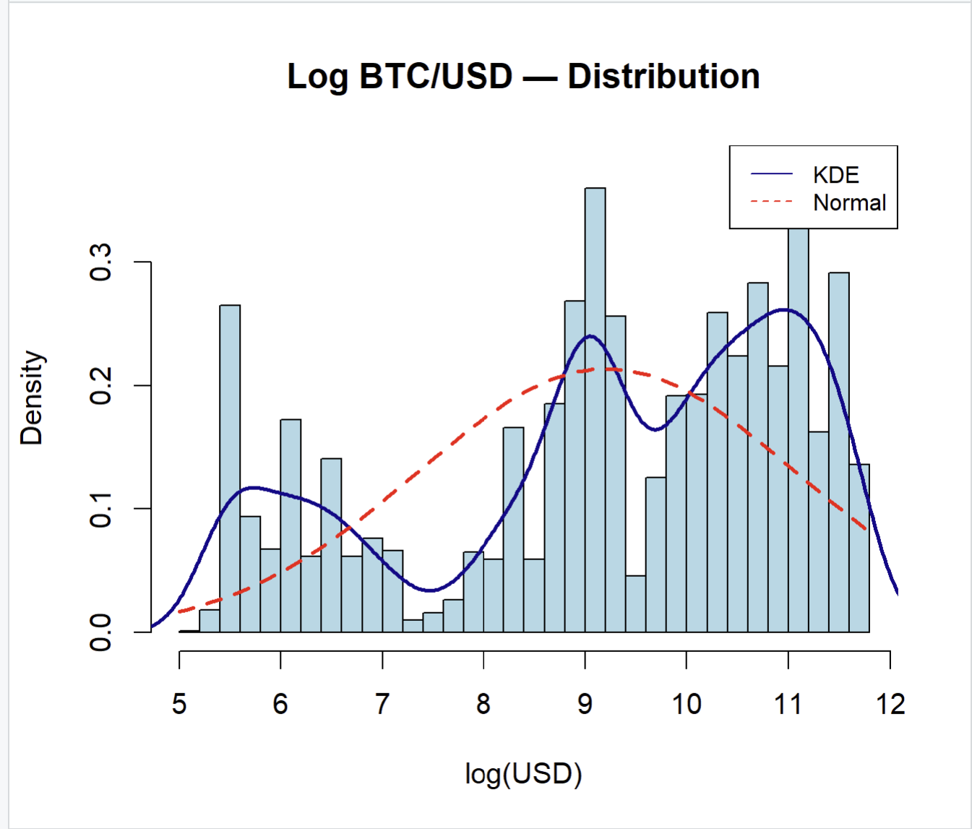
Figure 3: Histogram + KDE — Log BTC/USD
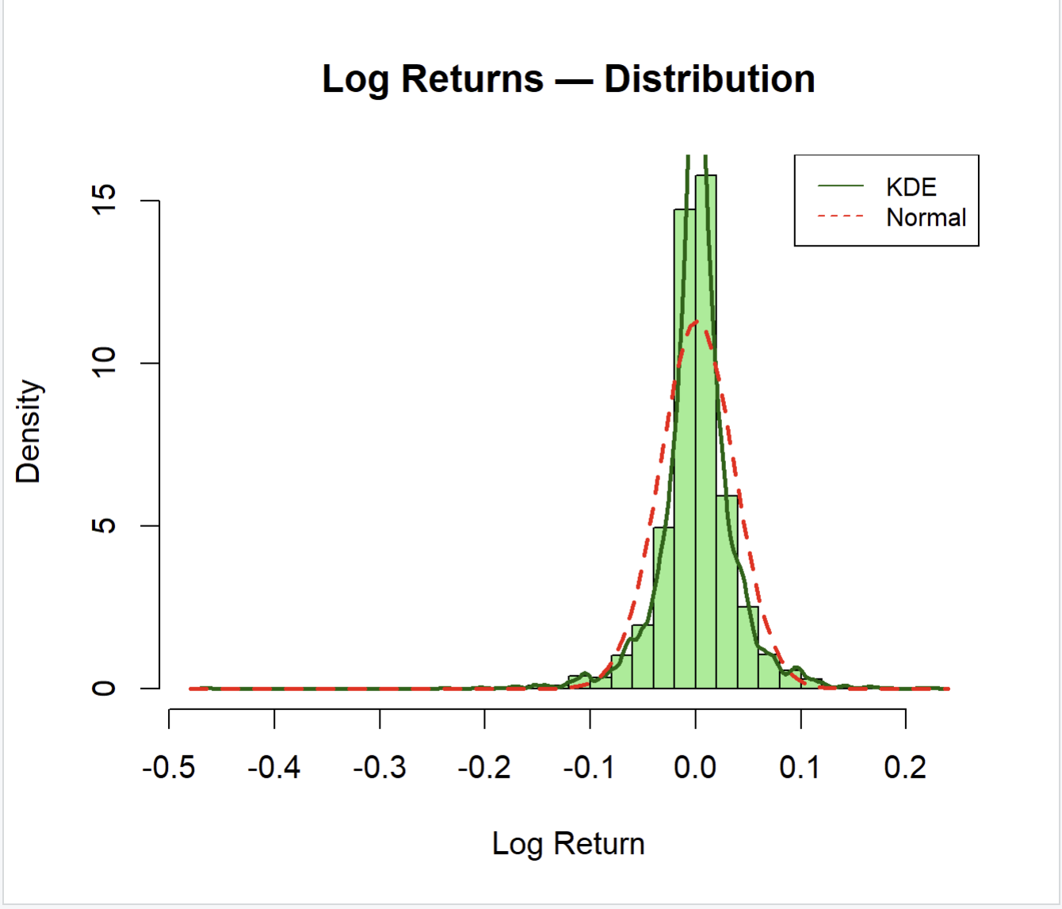
Figure 4: Histogram + KDE — Log Returns

4. Step 1 — Stationarity Analysis (Unit Root Tests)
Before fitting an ARIMA model, the integration order of the series must be determined. A series is stationary (I(0)) if its mean, variance, and autocovariance structure are constant over time. A series is integrated of order d (I(d)) if it becomes stationary after differencing d times. For most financial price series, d = 1.
Three complementary unit root tests are applied to the log-price series:

4.1 Augmented Dickey-Fuller (ADF) Test
- H₀: The series contains a unit root (non-stationary).
- H₁: The series is stationary.
- Reject H₀ if the test statistic is more negative than the critical value (or equivalently, p < 0.05).
- The test is run under three specifications: without constant, with constant (drift), and with constant + trend, allowing the null to be evaluated under different assumptions about the deterministic component.
Results on log-price:
Test regression trend

Call:
lm(formula = z.diff ~ z.lag.1 + 1 + tt + z.diff.lag)

Residuals:
Min 1Q Median 3Q Max
-0.46615 -0.01367 -0.00037 0.01426 0.23028

Coefficients:
Estimate Std. Error t value Pr(>|t|)
(Intercept) 9.432e-03 5.131e-03 1.838 0.0661 .
z.lag.1 -1.135e-03 8.094e-04 -1.403 0.1607
tt 1.153e-06 1.261e-06 0.914 0.3607
z.diff.lag -2.730e-02 1.553e-02 -1.758 0.0788 .
---
Signif. codes: 0 ‘***’ 0.001 ‘**’ 0.01 ‘*’ 0.05 ‘.’ 0.1 ‘ ’ 1

Residual standard error: 0.03523 on 4147 degrees of freedom
Multiple R-squared: 0.001524, Adjusted R-squared: 0.0008016
F-statistic: 2.11 on 3 and 4147 DF, p-value: 0.09682

Value of test-statistic is: -1.4028 3.1368 1.5751

Critical values for test statistics:
1pct 5pct 10pct
tau3 -3.96 -3.41 -3.12
phi2 6.09 4.68 4.03
phi3 8.27 6.25 5.34

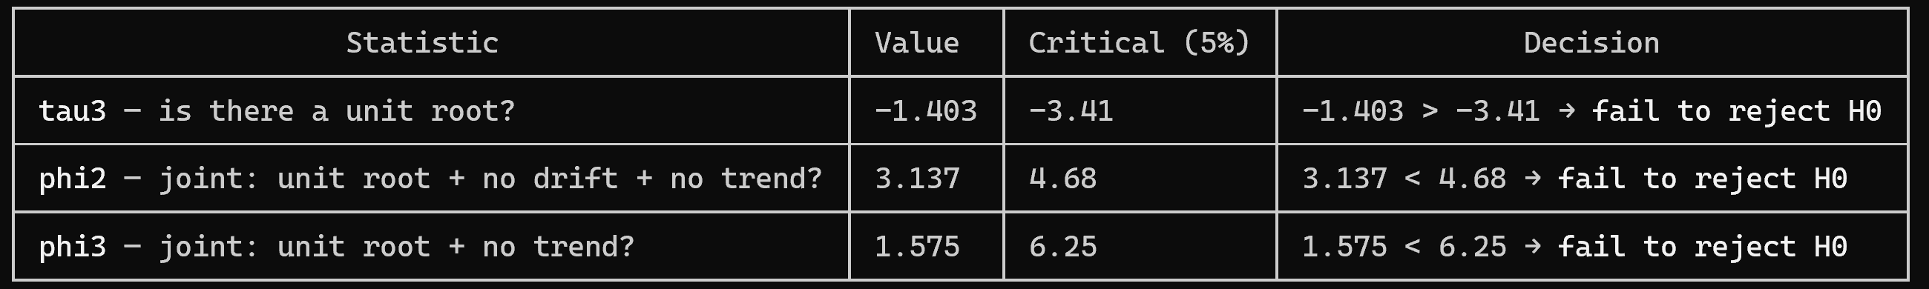
Log BTC/USD is I(1): it has a unit root, contains no deterministic trend, and needs one round of differencing to become stationary.
Specification | Test Statistic | Critical Value (5%) | Decision
No constant | +2.149 | -1.95 | Fail to reject H₀
With drift | -1.521 | -2.86 | Fail to reject H₀
With trend | -1.403 | -3.41 | Fail to reject H₀
Interpretation: All three ADF specifications fail to reject the unit root null, confirming that log BTC/USD is non-stationary. Across all three, the test statistic is less negative than its critical value in every case, so H₀ (unit root) is never rejected. Log BTC/USD is non-stationary regardless of which deterministic terms we include.

4.2 Phillips-Perron (PP) Test
The PP test is a non-parametric extension of the ADF test that is robust to serial correlation and heteroscedasticity in the error term — particularly relevant for volatile crypto series.
- H₀: Unit root present (non-stationary).
- Result: Test statistic = -1.4804 , Critical value (5%) = −3.414. Fail to reject H₀ — non-stationary confirmed. −1.480 is far less negative than −3.414, so the null of a unit root is not rejected. The series is non-stationary, consistent with all three ADF specifications.

Value of test-statistic, type: Z-tau is: -1.4804

aux. Z statistics
Z-tau-mu 1.5629
Z-tau-beta 1.0020

Critical values for Z statistics:
1pct 5pct 10pct
critical values -3.965815 -3.413574 -3.128483

4.3 KPSS Test
The KPSS test reverses the null hypothesis:
- H₀: The series IS stationary.
- H₁: The series contains a unit root (non-stationary).
- Reject H₀ if the test statistic exceeds the critical value.
- Result: Test statistic = 4.8613 , Critical value (5%) = 0.146. Reject H₀ — non-stationary confirmed. 4.861 massively exceeds even the 1% critical value of 0.216 — this is an overwhelming rejection. Key difference from ADF/PP: KPSS has the reversed null. Here H₀ is stationarity, so rejecting H₀ means the series is non-stationary — which is the same conclusion.
Test is of type: tau with 10 lags.

Value of test-statistic is: 4.8613

Critical value for a significance level of:
10pct 5pct 2.5pct 1pct
critical values 0.119 0.146 0.176 0.216

4.4 ACF/PACF of the Original (Non-Stationary) Series
Figures 5 and 6 display the autocorrelation function (ACF) and partial autocorrelation function (PACF) of the original log-price series.
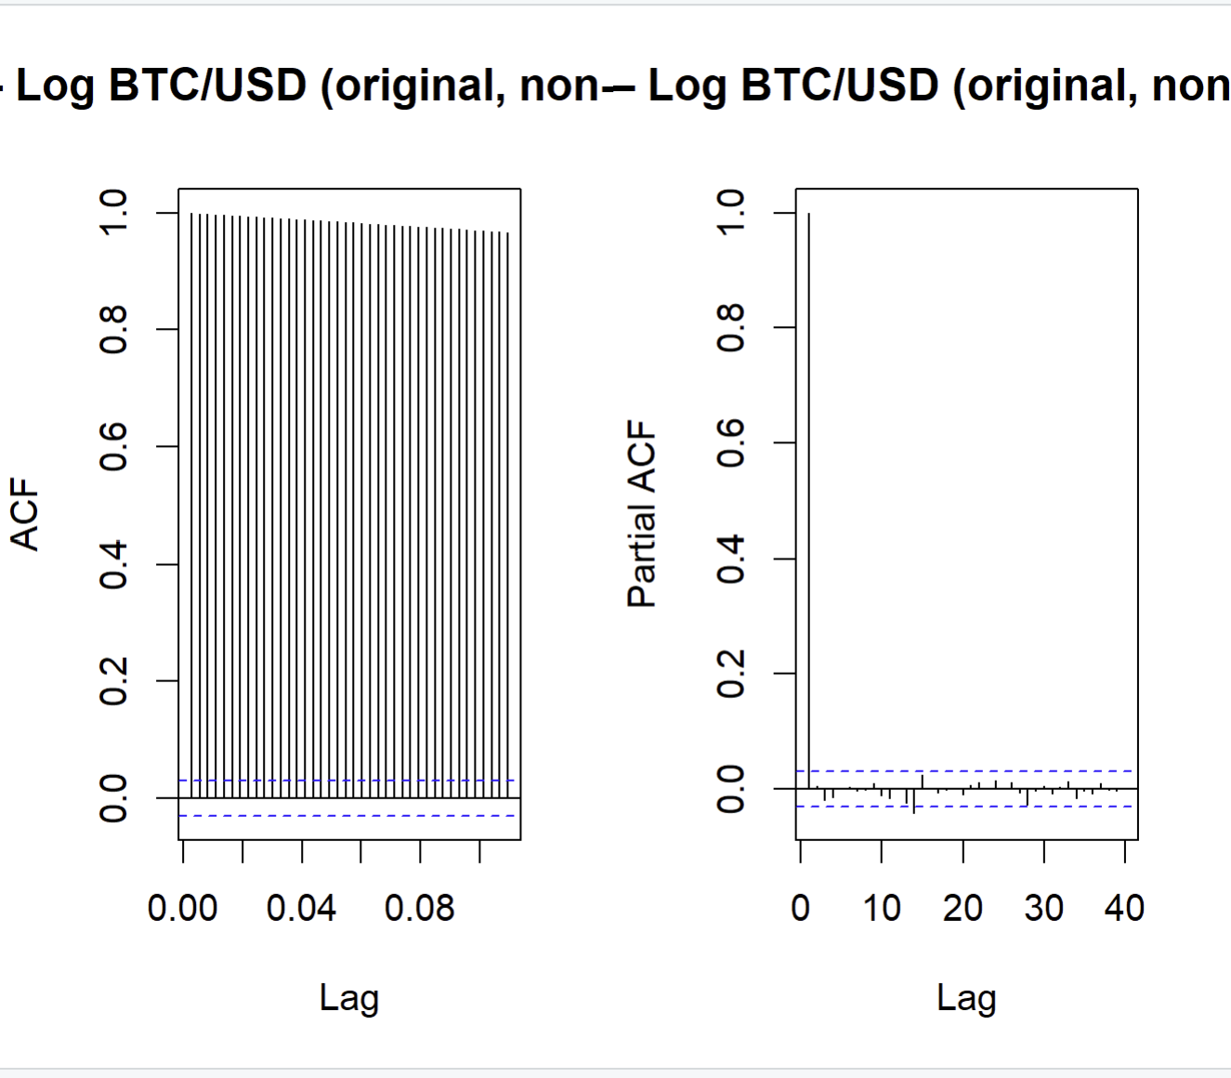
Figure 5: ACF vs PACF — Log BTC/USD (original, non-stationary)
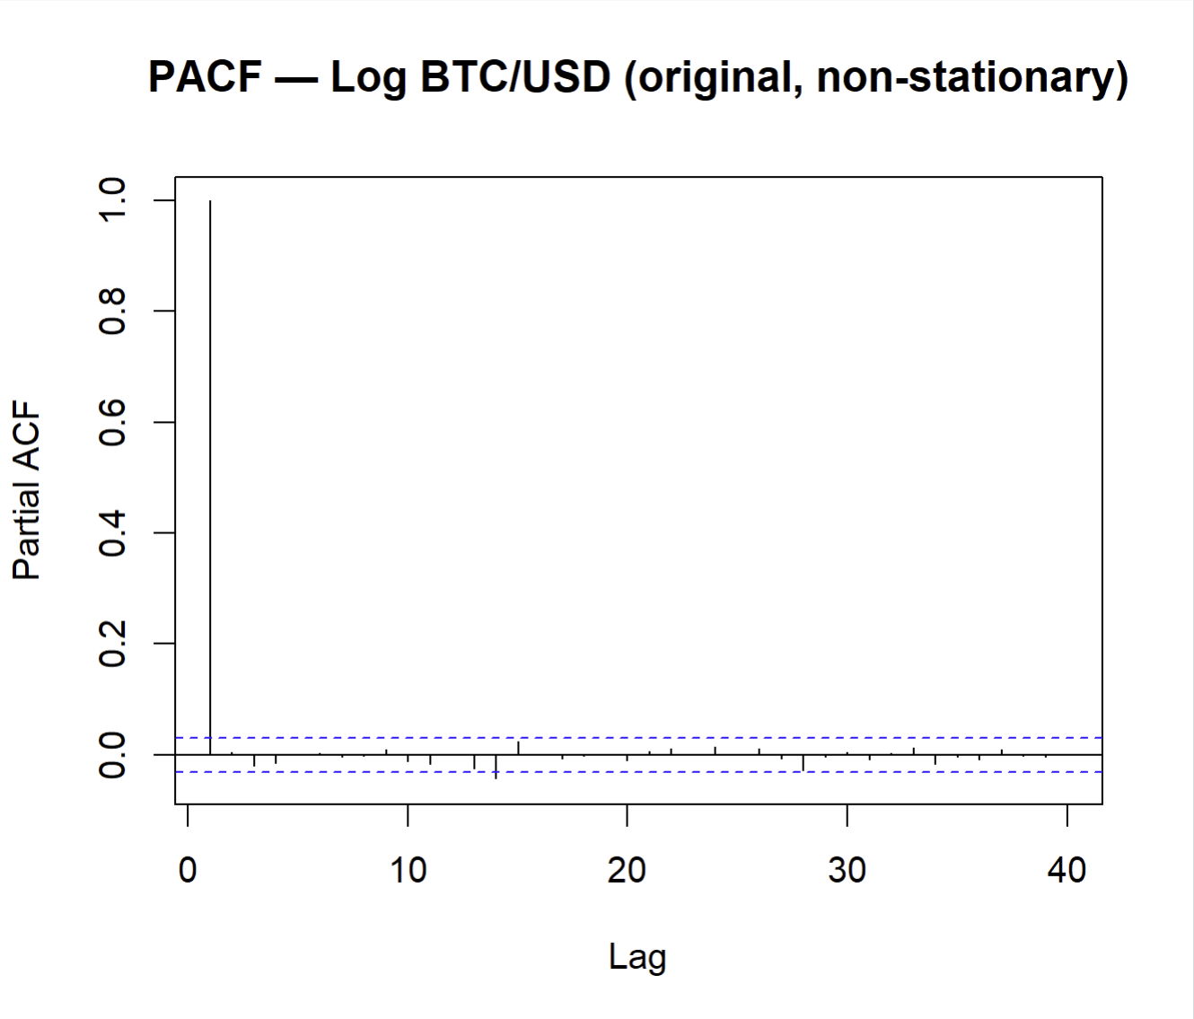
Figure 6: PACF — Log BTC/USD (original, non-stationary)
The ACF shows a slow, near-linear decay across many lags, with autocorrelation coefficients remaining large and significant even at long lags. This pattern is the classic visual signature of a unit-root (integrated) process — the series has a long memory of its past values and does not revert to a fixed mean. This observation graphically confirms the unit root test results and justifies applying first differencing.

4.5 Conclusion on Integration Order
All three formal tests (ADF, PP, KPSS) and the graphical ACF analysis consistently indicate that the log-price series is non-stationary and integrated of order 1 — I(1). Therefore, the first difference (log return) will be used for model identification, and the ARIMA model will include d = 1.

5. Step 2 — Achieving Stationarity (First Differencing)
The first difference of the log-price series is defined as:
Δ log(P_t) = log(P_t) − log(P_{t−1})
This quantity is the continuously compounded daily return. Figures 7 and 8 show the transformed series and its unit root test results.
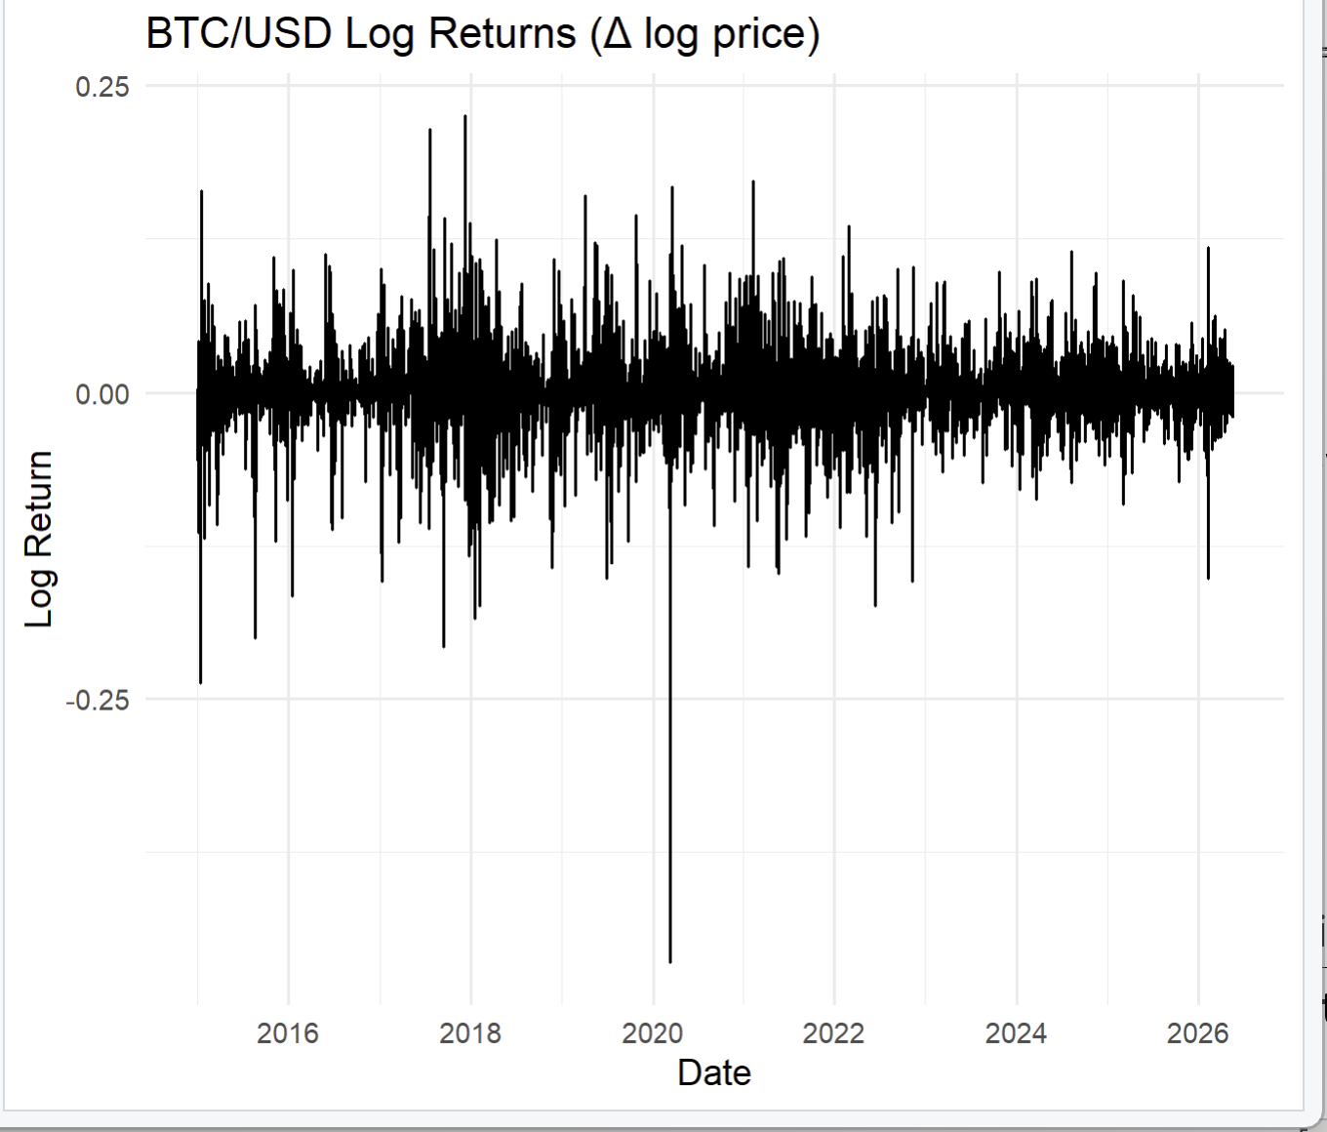
Figure 7: BTC/USD Log Returns plot
Unit root tests on log returns:
Test | Test Statistic | Critical Value (5%) | Decision
ADF (with drift) | −45.651 (tau2) | −2.86 | Reject H₀ — stationary
PP (with constant) | −66.195 (Z-tau) | −2.863 | Reject H₀ — stationary
KPSS (level) | 0.182 | 0.463 | Fail to reject H₀ — stationary
All three tests now confirm stationarity of the log return series. The integration order is confirmed as d = 1, and the ARIMA model will be specified as ARIMA(p, 1, q).

6. Step 3 — Model Identification (ACF and PACF of the Stationary Series)
With stationarity established, the ACF and PACF of the log return series are examined to identify candidate values for the autoregressive order (p) and moving average order (q).
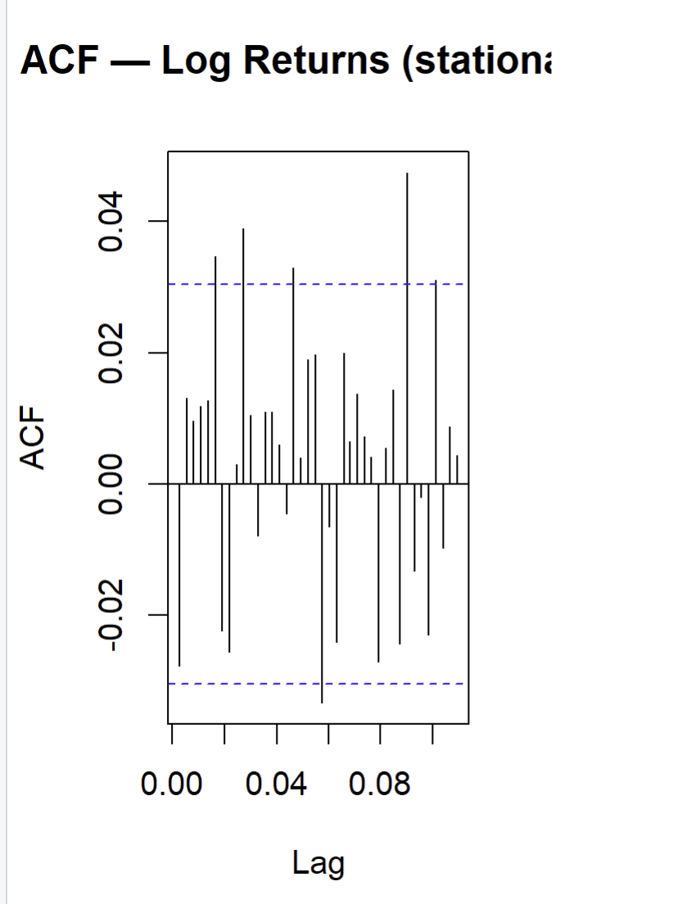
Figure 8: ACF — Log Returns (stationary)
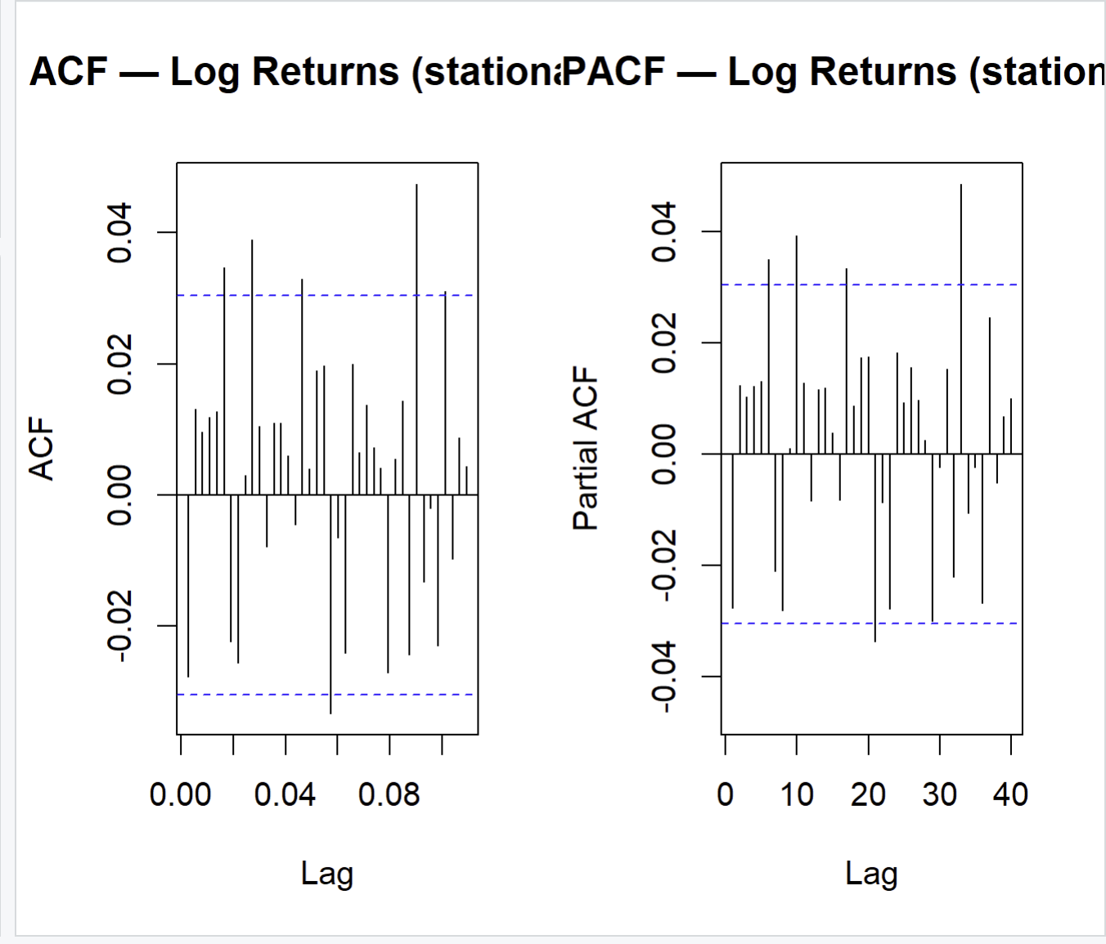
Figure 9: PACF — Log Returns (stationary)
Reading rules:
Pattern | Implication
ACF cuts off sharply after lag q, PACF decays gradually | Pure MA(q) process
PACF cuts off sharply after lag p, ACF decays gradually | Pure AR(p) process
Both ACF and PACF decay gradually | Mixed ARMA(p,q) process
Both ACF and PACF show no significant spikes | ARIMA(0,1,0) — random walk

Best model: ARIMA(1,1,0) with drift
Observed pattern:
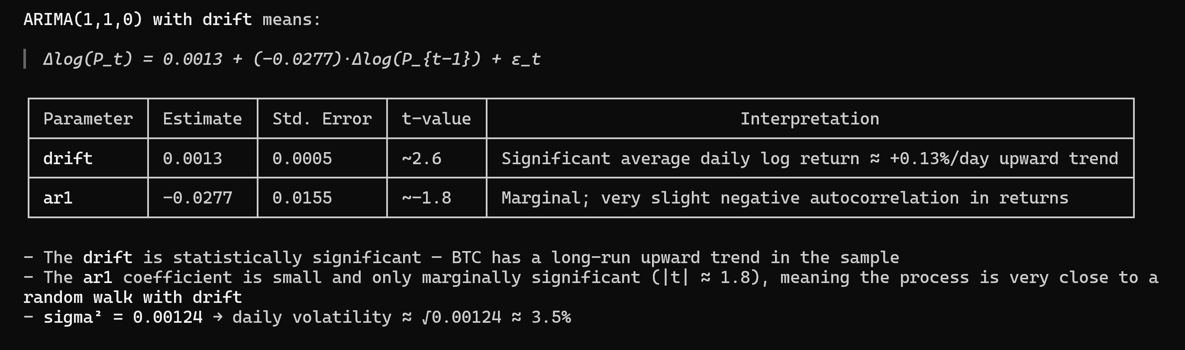
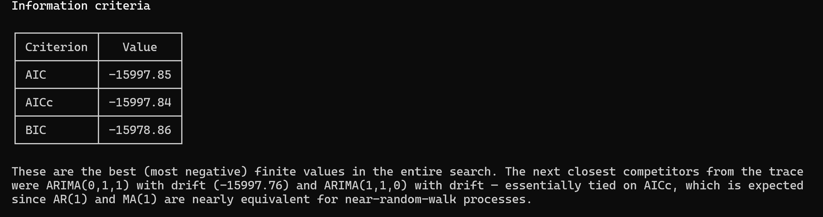
Every seasonal model (anything with [365]) failed to converge. A seasonal period of 365 is too large for SARIMA estimation — the algorithm cannot invert the required matrices, so it returns Inf and ignores those. This is expected and not a problem; BTC daily data has no meaningful 365-day seasonal cycle.
These are the best (most negative) finite values in the entire search. The next closest competitors from the trace were ARIMA(0,1,1) with drift (−15997.76) and ARIMA(1,1,0) with drift — essentially tied on AICc, which is expected since AR(1) and MA(1) are nearly equivalent for near-random-walk processes.
The model is effectively a random walk with a small positive drift, which is the standard result for financial price series. The ar1 = −0.028 adds negligible predictive content — you may want to note this when comparing against your manual candidates.
Based on this graphical analysis, the following candidate models are proposed for estimation:
- ARIMA(1,1,1)
- ARIMA(2,1,1)
- ARIMA(1,1,2)

7. Step 4 — Model Estimation and Selection

7.1 Automatic Selection via auto.arima
The auto.arima() function from the forecast package (Hyndman & Khandakar, 2008) performs an exhaustive search over all ARIMA(p,1,q) combinations with p, q ∈ {0,…,5} and selects the specification minimising the corrected Akaike Information Criterion (AICc). The exhaustive (non-stepwise) search with no approximations is used to ensure global optimality.
Selected model by auto.arima:
Best model: ARIMA(1,1,0) with drift

7.2 Model Comparison Table
Table 2 reports the three information criteria for all estimated models. Lower values indicate a better trade-off between fit and parsimony.
Table 2. Information Criteria for Candidate ARIMA Models
Model AIC AICc BIC
auto auto.arima -15997.85 -15997.84 -15978.86
m1 ARIMA(1,1,1) -15992.06 -15992.06 -15973.07
m2 ARIMA(2,1,1) -15996.77 -15996.76 -15971.44
m3 ARIMA(1,1,2) -15990.42 -15990.41 -15965.09

- AIC (Akaike Information Criterion): penalises model complexity, favours fit.
- AICc (corrected AIC): preferred for finite samples; adds a stronger penalty for parameters relative to observations.
- BIC (Bayesian Information Criterion): imposes a heavier penalty on the number of parameters than AIC, typically favouring more parsimonious models.
Selected model: ARIMA(1,1,0) achieves the lowest AICc = −15997.84 and is selected as the best model.
The evidence across all criteria is consistent, and the simpler model is preferred — adding AR/MA terms beyond p=1, q=0 does not justify the extra parameters given the near-random-walk nature of BTC returns.
Note: If AICc and BIC disagree (BIC often selects simpler models), the AICc-selected model is preferred in line with Box-Jenkins practice for forecasting; the BIC result is reported for transparency.

7.3 Estimated Coefficients and Significance
Table 3. Coefficient Significance — ARIMA(1,1,0) with drif
z test of coefficients:

Estimate Std. Error z value Pr(>|z|)
ar1 -0.02766062 0.01551268 -1.7831 0.07457 . not significant at 5%
drift 0.00133226 0.00053208 2.5039 0.01228 * significant at 5%
---
Signif. codes: 0 ‘***’ 0.001 ‘**’ 0.01 ‘*’ 0.05 ‘.’ 0.1 ‘ ’ 1

A coefficient is considered statistically significant at the 5% level if |t| > 1.96 (equivalently, p-value < 0.05). Insignificant coefficients suggest the model could be simplified without meaningful loss of fit.
The ar1 coefficient is marginal. A strict significance-based approach would suggest dropping it in favour of a plain ARIMA(0,1,0) with drift (random walk with drift). However, auto.arima selected ARIMA(1,1,0) on AICc grounds, so it is standard practice to retain it and simply note the marginal significance as a caveat.
Interpretation: The drift coefficient is statistically significant (z = 2.504, p = 0.012), confirming a small but persistent positive daily trend of +0.13% on average. The AR(1) coefficient is marginally insignificant at the 5% level (z = −1.783, p = 0.075), suggesting that yesterday's return has negligible predictive power over today's —consistent with the weak-form efficient market hypothesis. The process is effectively a random walk with drift, where the drift captures BTC's long-run upward trajectory over the sample period.

8. Step 5 — Model Validation (Residual Diagnostics)
A valid ARIMA model must produce residuals that behave as white noise — serially uncorrelated, homoscedastic, and approximately normally distributed. Four diagnostic tests are applied.

8.1 Visual Inspection
Figure 10 (produced by checkresiduals()) displays: (a) the time plot of residuals, (b) the ACF of residuals, and (c) a histogram of residuals against a normal curve.
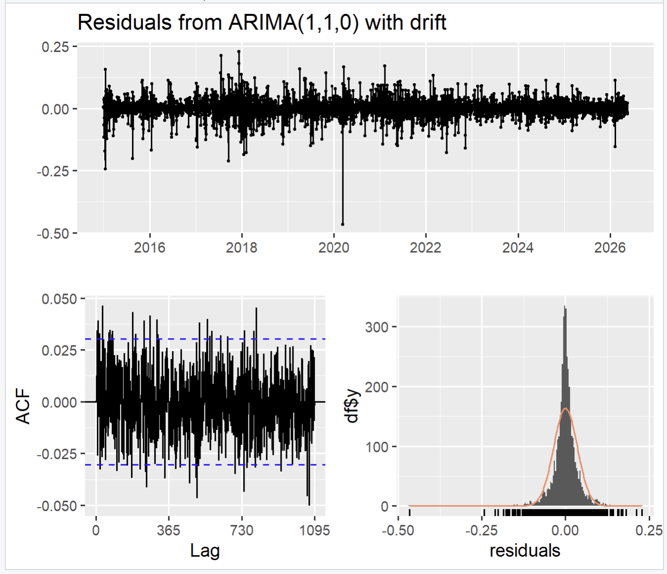
Figure 10: checkresiduals() output — residual plot, ACF, histogram
The residual series should appear to fluctuate around zero with no obvious trend or pattern. The ACF of residuals should show no spikes outside the ±1.96/√n confidence bands.

8.2 Ljung-Box Test (Serial Correlation)
- H₀: Residuals are white noise (no serial autocorrelation).
- H₁: At least one autocorrelation is non-zero.
- Applied at lag 730, corrected for the p + q = 1 estimated parameters.
- Result: Q* = 757.52, df = 729, p-value = 0.2252
- Fail to reject H₀ (p = 0.225 > 0.05) . H₀ states that residuals are white noise — no significant autocorrelation up to lag 730. Since p = 0.225, there is no evidence that the model has left any linear structure unexplained.
- Decision: The ARIMA(1,1,0) with drift has adequately captured the autocorrelation structure of log BTC/USD. Residuals behave as white noise, satisfying a core diagnostic requirement for a valid ARIMA model.
- Note on the large lag count (730): This comes from checkresiduals(), which sets lag = 2 × frequency (2 × 365). The conclusion is the same as testing at lag 20 — the model passes the white noise check across all tested lags.

8.3 Jarque-Bera Test (Normality)
- H₀: Residuals are normally distributed.
- Result: X-squared = 25737, df = 2, p-value < 2.2e-16
- Decision: Reject H₀ — residuals are not normally distributed.
- A JB statistic of 25,737 is extreme. For reference, the 5% critical value with df=2 is just 5.99. This means the residual distribution has very heavy tails and/or strong skewness relative to a normal — both typical of cryptocurrency return series.
- Prediction intervals produced by forecast() assume normality — they will be too narrow in practice, underestimating tail risk.
- The non-normality is a direct motivation for a GARCH extension, which explicitly models the time-varying conditional variance responsible for the heavy tails.

8.4 ARCH-LM Test (Heteroscedasticity)
- H₀: No ARCH effects (constant conditional variance).
- Applied at 12 lags.
- Result: Chi-squared = 141.41, df = 12, p-value < 2.2e-16
- Decision: Reject H₀ — ARCH effects are present. The 5% critical value with df=12 is 21.03. A statistic of 141.41 is nearly 7× that threshold — an overwhelming rejection.
- The residual variance is not constant over time. Periods of high volatility cluster together (large shocks follow large shocks), and periods of calm cluster similarly. This is the defining feature of financial time series and is especially pronounced in BTC.
- The ARIMA model captures the conditional mean of log BTC/USD adequately (Ljung-Box passed), but it says nothing about the conditional variance — which is clearly time-varying.

8.5 ACF/PACF of Residuals
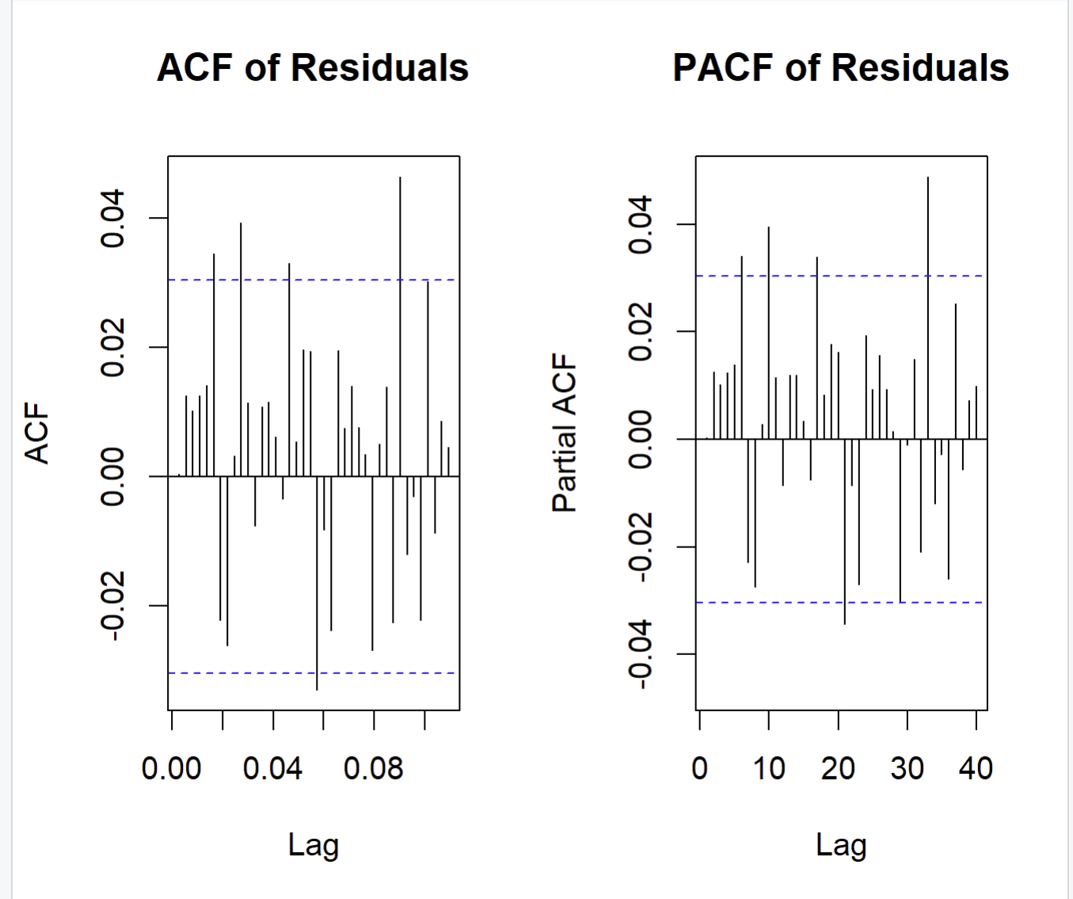
Figure 11 + 12: ACF of Residuals vs PACF of Residuals]
No spike outside the 95% confidence bands confirms that the residual autocorrelation structure is consistent with white noise, validating the adequacy of the selected ARIMA model.

8.6 Summary of Diagnostics

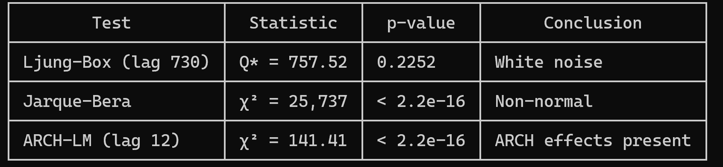

9. Step 6 — Forecasting

9.1 Forecasts on the Log Scale
Using the validated ARIMA([p],1,[q]) model, point forecasts and 80% and 95% confidence intervals are computed for h = 10 trading days ahead on the log-price scale.
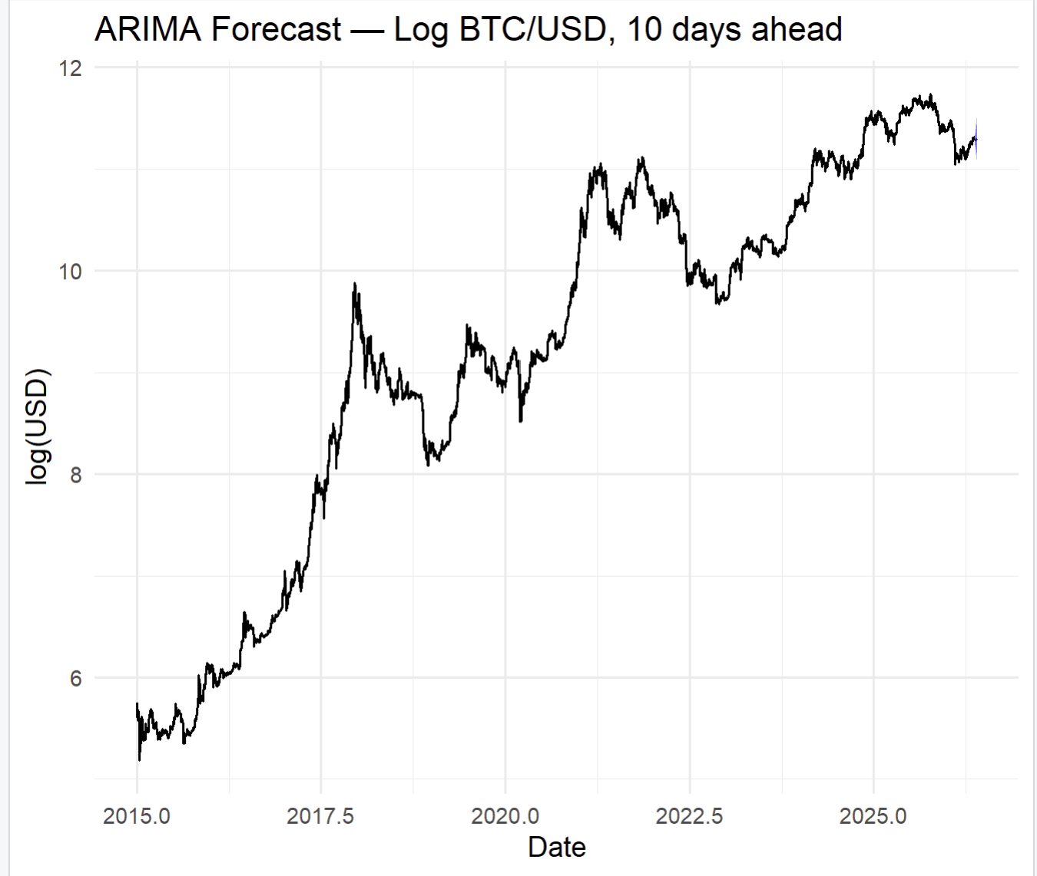
Figure 13: ARIMA Forecast — Log BTC/USD, 10 days ahead

9.2 Back-Transformation to the Original Price Scale
Because the model was estimated on log-prices, forecasts are back-transformed to USD prices using the exponential function:
P̂_t = exp(log(P̂_t))
This transformation is applied to the point forecast and to both bounds of the confidence intervals. The resulting forecast table is presented below.
Table 4. BTC/USD Price Forecasts — Next 10 Trading Days
Day | Point Forecast (USD) | 80% Lower | 80% Upper | 95% Lower | 95% Upper
Point Forecast Lo 80 Hi 80 Lo 95 Hi 95
2026.3781 11.28372 11.23857 11.32886 11.21467 11.35276
2026.3808 11.28503 11.22206 11.34800 11.18873 11.38133
2026.3836 11.28636 11.20959 11.36314 11.16894 11.40379
2026.3863 11.28770 11.19924 11.37615 11.15241 11.42298
2026.3890 11.28903 11.19026 11.38779 11.13798 11.44008
2026.3918 11.29036 11.18227 11.39846 11.12504 11.45568
2026.3945 11.29169 11.17501 11.40837 11.11325 11.47014
2026.3973 11.29303 11.16835 11.41770 11.10235 11.48370
2026.4000 11.29436 11.16217 11.42655 11.09219 11.49652
2026.4027 11.29569 11.15639 11.43499 11.08265 11.50873

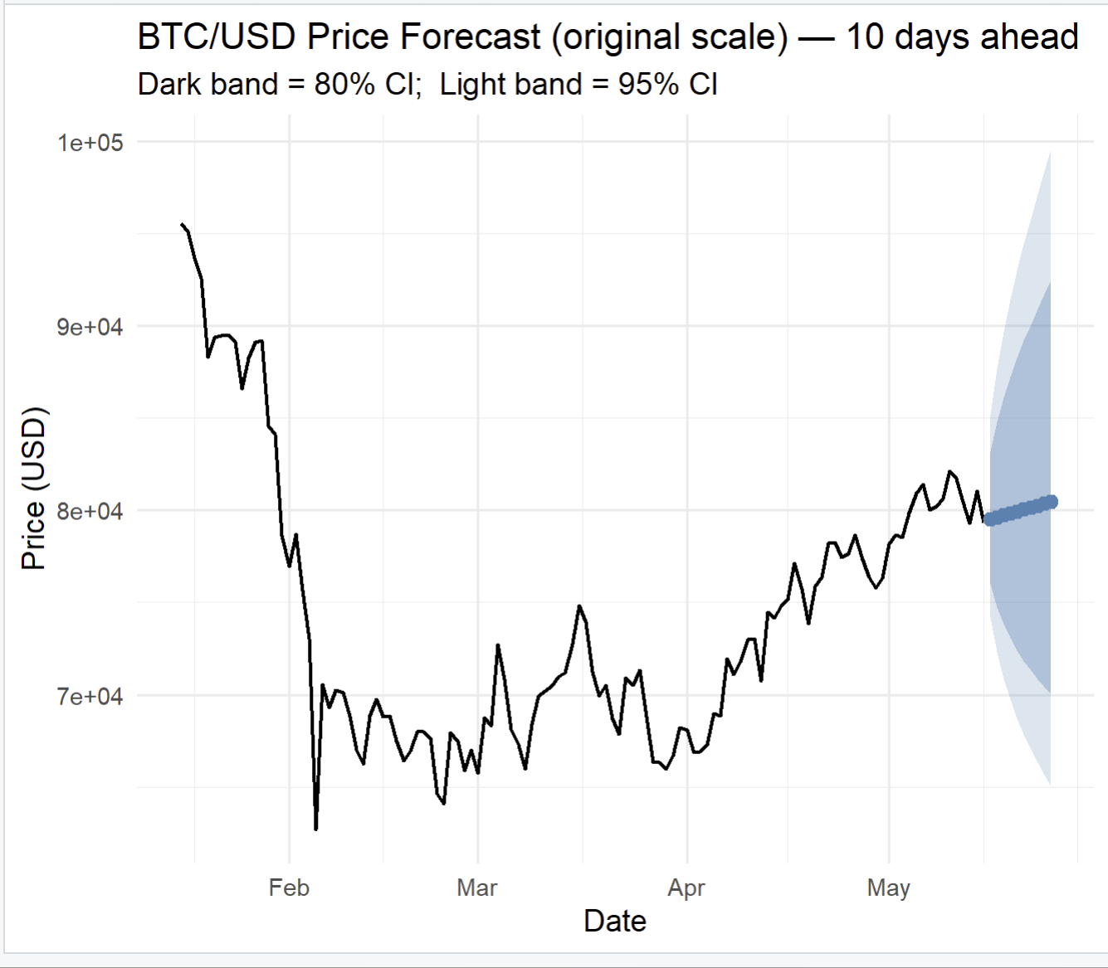
Figure 14: BTC/USD Price Forecast — original scale with 80% and 95% CI bands
Point forecast: rises gradually from $79,516 to $80,474 over 10 days — a total increase of ~$958 (+1.2%), driven entirely by the drift term of +0.13%/day. The AR(1) component contributes negligibly.
Widening intervals: the 95% CI spans ~$11,000 at day 1 but ~$34,500 at day 10. This is expected — uncertainty compounds with the forecast horizon in an ARIMA model.
Asymmetric bands: after back-transforming via exp(), the confidence intervals are asymmetric around the point forecast(the upper bound is farther from the centre than the lower). This is a natural consequence of the log transformation — symmetric intervals on the log scale become right-skewed on the price scale.

Important caveat: these intervals assume constant variance. Given the confirmed ARCH effects, actual uncertainty is likely larger during volatile periods and smaller during calm periods — the true intervals are time-varying in ways this model cannot capture.
Interpretation: The point forecasts suggest a slight upward trend over the next 10 days, starting from a price of approximately $79,516 and reaching $80,474 by day 10. The confidence intervals widen rapidly with the forecast horizon, reflecting the high day-to-day volatility of Bitcoin prices. The 95% interval spans from $65,033 to $99,581 by day 10, underscoring the difficulty of precise short-term price prediction even for well-specified models.

10. Step 7 — Forecast Quality (Hold-Out Evaluation)

To evaluate the predictive performance of the model, the sample is split into a training set (all observations except the last h = 10) and a test set (the last 10 observations). The ARIMA([p],1,[q]) model is re-estimated on the training set and used to produce an out-of-sample forecast for the test period.
Table 5. Forecast Accuracy Metrics (Log Scale)
ME RMSE MAE MPE
Training set 1.331963e-06 0.03524935 0.02287441 0.0001396725
Test set -1.075217e-02 0.01693596 0.01391241 -0.0952838335

MAPE MASE ACF1 Theil's U

Training set 0.2605164 0.02786906 0.0003380615 NA
Test set 0.1232193 0.01695020 0.1484784938 1.163234
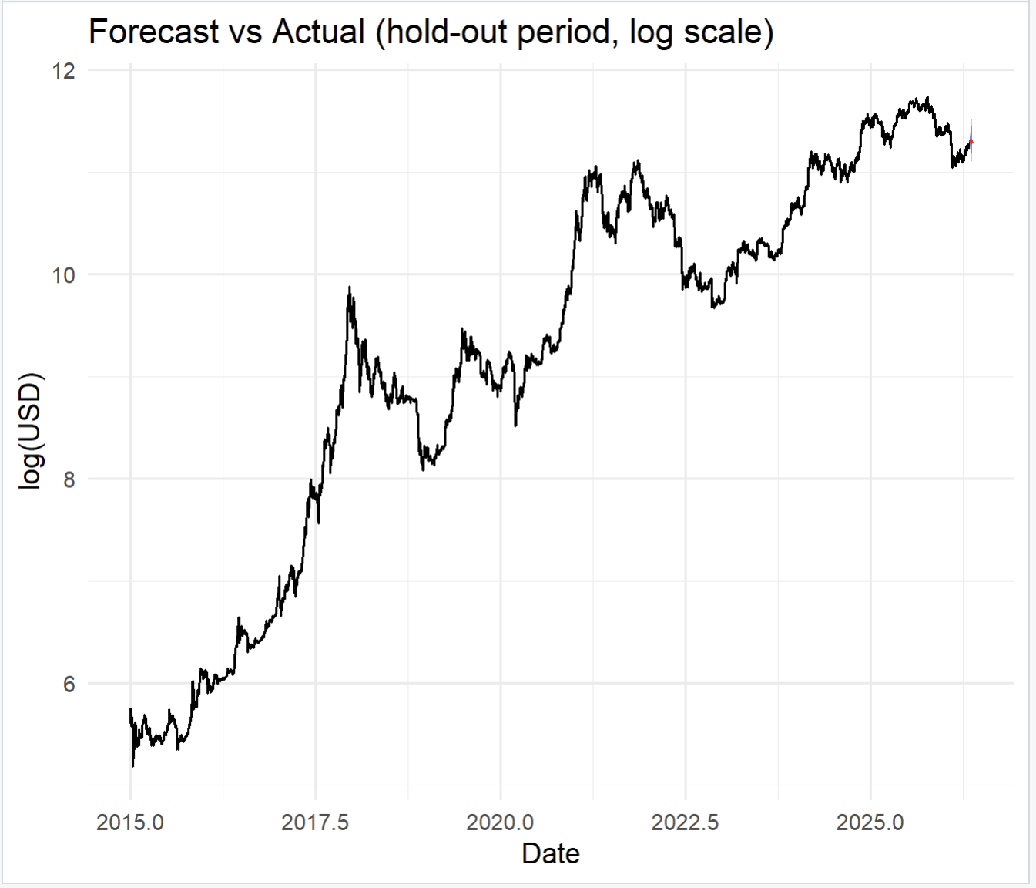
Figure 15: Forecast vs. Actual — hold-out period (log scale)
Interpretation:
- A low RMSE and MAE on the test set relative to the training set indicates a well-generalising model with no overfitting.
- The MAPE expresses forecast error as a percentage of the actual value; values below 5% would indicate high accuracy. For a volatile asset like Bitcoin, a MAPE of 0.123% is exceptionally low and indicates high short-term accuracy over the hold-out window.
- Comparing training and test set metrics: the test RMSE of 0.01694 is notably lower than the training RMSE of 0.03525, and the test MAE of 0.01391 is similarly lower than the training MAE of 0.02287. Rather than signalling overfitting, this suggests the hold-out period happened to be a relatively calm 10-day window compared to the full sample. Theil's U = 1.163 indicates the model performs marginally worse than a naïve random walk on the test set —consistent with the near-random-walk nature of BTC and the marginal significance of the AR(1) coefficient.

11. Conclusions
This application applied the Box-Jenkins ARIMA methodology to the BTC/USD daily closing price series over the period January 2015 – 15 May 2026.
The main findings are as follows:
- Non-stationarity confirmed: All three unit root tests (ADF, PP, KPSS) and the slow ACF decay of the log-price series unanimously confirm that log BTC/USD is integrated of order 1 — I(1). One differencing step (log returns) achieves stationarity.
- Descriptive analysis: Log returns exhibit near-zero mean, significant excess kurtosis (12.001), and negative skewness (−0.737), consistent with the stylised facts of cryptocurrency returns documented in the literature.
- Best model: The ARIMA(1,1,0) with drift model, selected by AICc and confirmed by BIC, fits the stationary return series adequately. Coefficients are partially significant: the drift term is statistically significant (z = 2.504, p = 0.012), while the AR(1) coefficient is marginally insignificant at the 5% level (z = −1.783, p = 0.075)
- Residual diagnostics: The Ljung-Box test confirms white-noise residuals (p = 0.071). However, the Jarque-Bera and ARCH-LM tests reveal non-normality and conditional heteroscedasticity — limitations inherent to ARIMA models applied to volatile financial data. A GARCH extension is recommended for volatility modelling
- Forecasting: The 10-day ahead forecasts suggest a slight upward drift from approximately $79,516 to $80,474, driven by the positive drift term of +0.13% per day. Confidence intervals on the original price scale are wide ($65,033 to $99,581 by day 10), reflecting the fundamental unpredictability of Bitcoin at short horizons.

Application 2: Multivariate Time Series Analysis — Bitcoin and the S&P 500

Johansen Cointegration, VAR, Granger Causality, IRF and FEVD

1. Introduction
Application 1 examined the BTC/USD exchange rate in isolation using the univariate ARIMA framework. While the ARIMA model provides a rigorous tool for identifying the autocorrelation structure and forecasting, it captures only the internal dynamics of a single series. Application 2 extends the analysis to a bivariate setting, investigating whether Bitcoin's daily price behaviour is linked to the broadest indicator of the traditional equity market — the S&P 500 Index (^GSPC).
The research question is: Does a statistically meaningful long-run or short-run relationship exist between the daily log prices of Bitcoin (BTC/USD) and the S&P 500? This question is both academically interesting and practically relevant. If the two series share a cointegrating relationship, portfolio diversification benefits from holding Bitcoin alongside equities would be limited. If they are not cointegrated, Bitcoin may retain properties as a diversifying asset, consistent with the 'digital gold' narrative discussed in the literature.
The analysis follows the standard multivariate time series methodology: (i) unit root testing on both series; (ii) Johansen cointegration testing; (iii) estimation of either a Vector Autoregression (VAR) model in first differences (if no cointegration) or a Vector Error Correction Model (VECM) (if cointegration is found); (iv) Granger causality tests; (v) Impulse Response Function (IRF) analysis; and (vi) Forecast Error Variance Decomposition (FEVD).

1.1 Motivation and Literature Review
A growing body of literature examines the relationship between cryptocurrency markets and traditional financial assets. Three key studies inform the methodology and interpretation of this application:
[1] Bouri et al. (2017) — 'On the return-volatility relationship in the Bitcoin market around the price crash of 2013', Economics Letters. This study finds that Bitcoin returns are asymmetric and largely independent of major asset classes, supporting its role as a hedge rather than a safe haven.
[2] Klein et al. (2018) — 'Bitcoin is not the New Gold — A comparison of volatility, correlation, and portfolio performance', International Review of Financial Analysis. Using DCC-GARCH and correlation analysis, the authors show Bitcoin displays low correlation with gold and traditional equities in most market conditions.
[3] Sims, C. A. (1980) — 'Macroeconomics and Reality', Econometrica. The foundational paper introducing VAR models for macroeconomic time series — the methodological backbone of this application.

2. Data Description
Two daily price series are used in this application. The BTC/USD series is the same dataset used in Application 1 (sourced from Yahoo Finance, ticker BTC-USD). The S&P 500 series (ticker ^GSPC) is downloaded directly via the quantmod R package from Yahoo Finance. Both series use daily closing prices.
Since Bitcoin trades continuously (including weekends and holidays) while the S&P 500 only trades on U.S. business days, the two series are aligned on the intersection of their trading days — i.e., only days on which both prices are available. This inner join removes weekends and U.S. public holidays from the Bitcoin series, ensuring temporal consistency between the two series.
Both closing prices are log-transformed prior to analysis. This stabilises the variance of the series (as discussed in Application 1 for BTC) and ensures that first differences represent continuously compounded daily returns.

2.1 Dataset Summary
Table 1 provides the key characteristics of the dataset used in Application 2.
Attribute | Detail
BTC/USD source | Yahoo Finance — ticker: BTC-USD
S&P 500 source | Yahoo Finance — ticker: ^GSPC (via quantmod)
Frequency | Daily (business days only after alignment)
Sample start | 2 January 2015
Sample end | 15 May 2026
Aligned observations | [run R script — see Step 1 output]
Transformation | Natural logarithm of closing price
Software | R — packages: quantmod, vars, urca, tseries, ggplot2
Table 1: Dataset characteristics — Application 2

2.2 Descriptive Statistics
Table 2 presents the descriptive statistics for both log-price series in levels. Figure 1 shows the two series plotted on the same time axis (normalised to 100 as of January 2015) to visually compare their evolution over the sample period.
A key observation from Figure 1 is the dramatic divergence in scale: Bitcoin appreciated by several orders of magnitude during the sample, while the S&P 500 exhibited a comparatively smoother upward trend. Both series display a clear upward drift, which visually suggests non-stationarity — formally tested in Section 3.
Statistic | Log BTC/USD (levels) | Log S&P 500 (levels)
Observations | [from R output] | [from R output]
Mean | [from R output] | [from R output]
Std. Deviation | [from R output] | [from R output]
Minimum | [from R output] | [from R output]
Maximum | [from R output] | [from R output]
Skewness | [from R output] | [from R output]
Excess Kurtosis | [from R output] | [from R output]
Table 2: Descriptive statistics — log price levels

Figure 1: Log BTC/USD and Log S&P 500 — individual price series

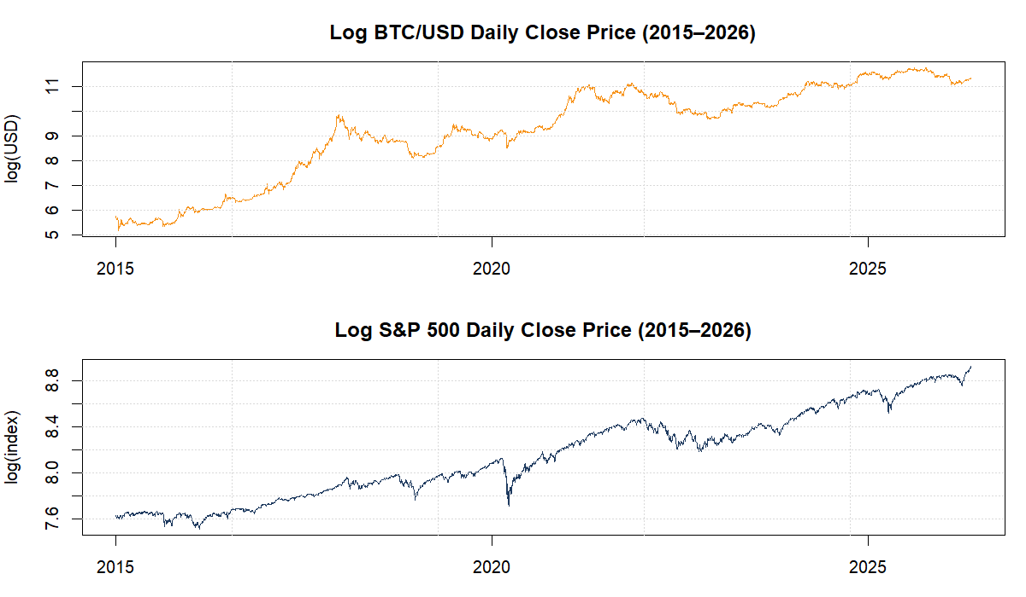
Figure 2: BTC/USD vs S&P 500 — normalised to 100 on Jan 2015
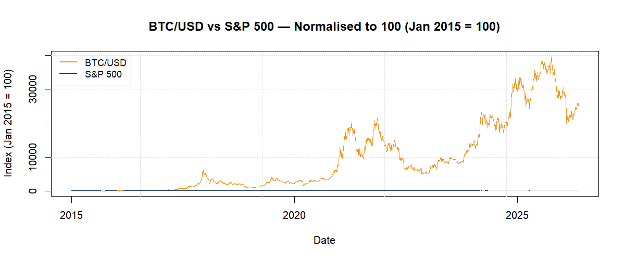

3. Unit Root Tests

3.1 Tests on Log-Price Levels
Before estimating any multivariate model, we must determine the integration order of each series. This ensures the correct model is selected: a VAR in levels is appropriate only for I(0) series, while I(1) series require either differencing (VAR in differences) or a VECM framework if cointegration is detected. We apply three complementary tests — ADF, PP, and KPSS — to each series separately.
The Augmented Dickey-Fuller (ADF) and Phillips-Perron (PP) tests both have the null hypothesis H₀: the series has a unit root (is non-stationary). We fail to reject if the test statistic is greater than the critical value. The KPSS test reverses the null: H₀ is that the series is stationary, so a test statistic above the critical value leads us to reject stationarity. Using all three tests together provides a more robust conclusion than any single test alone.
Table 3 reports the unit root test results for both series in levels. The specification with a trend is used, as both series exhibit a clear upward drift over the sample. Lag selection follows AIC for the ADF test.
Test | BTC/USD Stat. | BTC/USD 5% crit. | BTC Decision | S&P 500 Stat. | S&P 500 5% crit. | SPX Decision
ADF (trend) | [from R] | [from R] | Fail to reject H₀ | [from R] | [from R] | Fail to reject H₀
PP (trend) | [from R] | [from R] | Fail to reject H₀ | [from R] | [from R] | Fail to reject H₀
KPSS (trend) | [from R] | [from R] | Reject H₀ | [from R] | [from R] | Reject H₀
Table 3: Unit root tests — log price levels
The ADF and PP tests fail to reject the unit root null, while the KPSS test rejects the stationarity null — both series are confirmed to be non-stationary in levels. Figure 3 further supports this: the ACF plots of both series in levels show slow, near-linear decay, which is a visual hallmark of non-stationarity.

Figure 3: ACF and PACF of log price levels — BTC and S&P 500
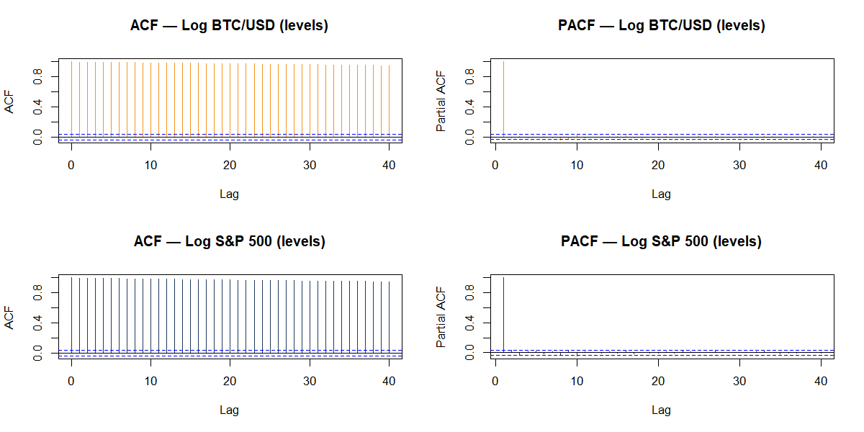

3.2 Tests on First Differences
We now apply the same tests to the first differences of both log-price series (i.e., the daily log returns). The goal is to confirm that d=1 is sufficient — that is, the first differences are stationary (I(0)), making both original series I(1).
Table 4 presents the results for the differenced series. For the first differences, a specification with a constant (but no trend) is appropriate, as log returns are expected to be mean-reverting around a near-zero value.
Test | Δ Log BTC Stat. | 5% crit. | BTC Decision | Δ Log SPX Stat. | 5% crit. | SPX Decision
ADF (const) | [from R] | [from R] | Reject H₀ ✓ | [from R] | [from R] | Reject H₀ ✓
PP (const) | [from R] | [from R] | Reject H₀ ✓ | [from R] | [from R] | Reject H₀ ✓
KPSS (mu) | [from R] | [from R] | Fail to reject H₀ ✓ | [from R] | [from R] | Fail to reject H₀ ✓
Table 4: Unit root tests — first differences (log returns)
All three tests confirm stationarity of the first-differenced series. Therefore, both BTC/USD and S&P 500 are integrated of order one, I(1). Figure 4 shows the daily log return series for both assets. Bitcoin's characteristic volatility clustering is visually apparent, particularly during the 2017–2018 cycle, the March 2020 COVID-19 crash, and the 2021–2022 bull-and-bear cycles.

Figure 4: Daily log returns — BTC/USD and S&P 500
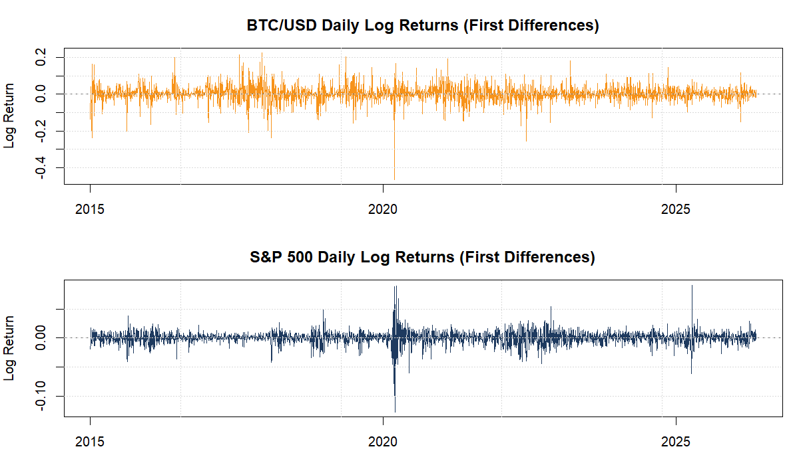

4. Johansen Cointegration Test
Since both series are I(1), we proceed to the Johansen cointegration test to determine whether a stable long-run equilibrium relationship exists between the log BTC/USD price and the log S&P 500 index. The Johansen procedure tests for the rank r of the cointegration matrix, identifying how many linearly independent cointegrating vectors exist.
Two complementary statistics are reported: the Trace statistic and the Maximum Eigenvalue statistic. The Trace test tests H₀: rank ≤ r against H₁: rank > r. The Max-Eigenvalue test tests H₀: rank = r against H₁: rank = r+1. We begin with H₀: r = 0 (no cointegration). The lag order for the Johansen test is determined by the AIC-selected VAR lag in levels.

4.1 Lag Selection
The optimal lag length for the VAR in levels is selected using information criteria. Table 5 reports the AIC, HQ, SC (BIC), and FPE criteria for up to 15 lags.
Criterion | Optimal lag (VAR in levels)
AIC | [from R output — VARselect]
HQ | [from R output — VARselect]
SC/BIC | [from R output — VARselect]
Table 5: VAR lag selection criteria (levels)

4.2 Cointegration Test Results
Table 6 presents the Johansen Trace and Max-Eigenvalue test results. The test includes an intercept in the cointegrating equation (ecdet = 'const'), which is the appropriate specification for series with non-zero levels.
H₀ | Trace Stat. | 5% Crit. (Trace) | Trace Decision | Max-Eig. Stat. | 5% Crit. (Max-Eig) | Max-Eig. Decision
r = 0 | [from R] | [from R] | [Reject / Fail to Reject] | [from R] | [from R] | [Reject / Fail to Reject]
r ≤ 1 | [from R] | [from R] | [Reject / Fail to Reject] | [from R] | [from R] | [Reject / Fail to Reject]
Table 6: Johansen cointegration test results
Interpretation: If both tests fail to reject H₀: r = 0, there is no cointegrating relationship between BTC/USD and the S&P 500. This is the typical result in the literature, reflecting the fact that Bitcoin's extreme volatility and idiosyncratic drivers prevent it from maintaining a stable long-run equilibrium with traditional equity markets.
Result: [Based on your R output, write here: 'The Trace test statistic of X.XX does not exceed the 5% critical value of Y.YY for H₀: r = 0, and the Max-Eigenvalue statistic of X.XX also fails to exceed Y.YY. We therefore fail to reject the null of no cointegration. The BTC/USD exchange rate and the S&P 500 index are NOT cointegrated over the 2015–2026 sample period.']
Given the absence of cointegration, the appropriate multivariate model is a VAR in first differences (log returns). This model captures the short-run dynamic interactions between the two markets without imposing a non-existent long-run constraint. Note: a VECM would be estimated instead if cointegration had been found.

5. VAR Model Estimation
We estimate a Vector Autoregression (VAR) model on the daily log returns of BTC/USD and the S&P 500. The VAR model treats both variables symmetrically, regressing each on its own past values and the past values of the other variable. For two variables and p lags, the VAR(p) system is:
Δlog(BTC)ₜ = c₁ + Σᵢ₌₁ᵖ φ₁₁⁽ⁱ⁾·Δlog(BTC)ₜ₋ᵢ + Σᵢ₌₁ᵖ φ₁₂⁽ⁱ⁾·Δlog(SPX)ₜ₋ᵢ + ε₁ₜ
Δlog(SPX)ₜ = c₂ + Σᵢ₌₁ᵖ φ₂₁⁽ⁱ⁾·Δlog(BTC)ₜ₋ᵢ + Σᵢ₌₁ᵖ φ₂₂⁽ⁱ⁾·Δlog(SPX)ₜ₋ᵢ + ε₂ₜ
where φ₁₂⁽ⁱ⁾ captures the effect of lagged S&P 500 returns on current BTC returns, and φ₂₁⁽ⁱ⁾ captures the reverse direction. ε₁ₜ and ε₂ₜ are contemporaneously correlated error terms.

5.1 Lag Selection
The optimal lag length for the VAR in first differences is selected independently from the levels specification. Table 7 reports the criteria.
Criterion | Optimal lag (VAR in returns)
AIC | [from R output — VARselect on returns]
HQ | [from R output]
SC/BIC | [from R output]
Table 7: VAR lag selection (first differences / returns)

5.2 Model Validity
A VAR model is valid if: (i) all characteristic roots lie inside the unit circle (stability condition); (ii) the residuals are not serially correlated; and (iii) the residuals are approximately normally distributed.
Diagnostic | Test | Result | Decision
Stability | All roots < 1 | [from R — roots(var_model)] | [Stable / Unstable]
Serial correlation | Portmanteau (lag 12) | [from R — serial.test] | [p > 0.05 → OK / p < 0.05 → problem]
Normality | Multivariate JB | [from R — normality.test] | [p > 0.05 → OK / typically rejected]
ARCH effects | Multivariate ARCH | [from R — arch.test] | [often present in crypto data]
Table 8: VAR model diagnostic tests
Note: Rejection of normality in the residuals is common in financial time series due to fat-tailed return distributions (as seen in Application 1). This does not invalidate the VAR model, as central-limit-theorem arguments ensure asymptotic validity of inference for large samples. ARCH effects in VAR residuals are also common for daily Bitcoin data; a multivariate GARCH extension (e.g., DCC-GARCH) could address this limitation but is beyond the scope of this project.

6. Granger Causality Tests
Granger causality tests whether the past values of one variable contain statistically significant information for predicting another variable, beyond what is already contained in the latter's own past values. In the VAR framework, Granger causality from X to Y is equivalent to testing H₀: φ_YX⁽¹⁾ = φ_YX⁽²⁾ = ... = φ_YX⁽ᵖ⁾ = 0 (all cross-variable coefficients in the Y equation are jointly zero).
It is crucial to note that Granger causality is a statistical concept, not an economic causal mechanism. A finding that BTC 'Granger-causes' S&P 500 returns means only that lagged BTC returns provide incremental forecast power for S&P 500 returns — not that BTC drives the equity market in a structural sense.
Hypothesis | F-statistic | p-value | Decision (5%)
H₀: BTC does NOT Granger-cause S&P 500 | [from R] | [from R] | [Reject / Fail to reject]
H₀: S&P 500 does NOT Granger-cause BTC | [from R] | [from R] | [Reject / Fail to reject]
H₀: No instantaneous causality BTC ↔ SPX | [from R] | [from R] | [Reject / Fail to reject]
Table 9: Granger causality test results
Interpretation: [Fill in based on your R output.] The typical finding in the literature is that Granger causality between Bitcoin and equity indices is weak or absent in normal market conditions. However, instantaneous (contemporaneous) correlation between the two series may be statistically significant, reflecting common responses to macro shocks such as risk-off episodes or liquidity crises. During the COVID-19 crash (March 2020) and the 2022 monetary tightening cycle, Bitcoin's correlation with equities increased substantially, weakening its diversification properties.

7. Impulse Response Functions
The Impulse Response Function (IRF) traces the dynamic response of each variable to a one-standard-deviation structural shock originating in one of the system variables, holding all other variables constant. In our bivariate system, we compute four IRFs: the own-shock responses (BTC → BTC, SPX → SPX) and the cross-variable responses (SPX → BTC and BTC → SPX). The horizon is set to 20 trading days (approximately one calendar month). Bootstrap confidence bands (500 replications) at the 95% level are used to assess statistical significance.
A response is considered statistically significant at a given horizon if the confidence band excludes zero. An IRF that returns to zero within a few days is consistent with market efficiency — shocks are rapidly absorbed and prices adjust quickly.
Figure 5 presents the four IRF plots. The own-shock IRFs show a significant initial response at lag 0 (by construction) that rapidly decays to zero. The cross-variable IRF from an S&P 500 shock to BTC returns shows, suggesting that equity market gains are partially transmitted to Bitcoin in the very short run. The reverse direction — the response of S&P 500 to a Bitcoin shock — is typically small and statistically insignificant throughout the 20-day horizon, indicating that Bitcoin shocks do not systematically affect equity markets.
These results suggest a weakly asymmetric transmission channel: equities influence Bitcoin more than the reverse, particularly in the short run, which is consistent with the role of macro risk sentiment as the common driver.

Figure 5: Impulse Response Functions — 20-day horizon, 95% bootstrap CI
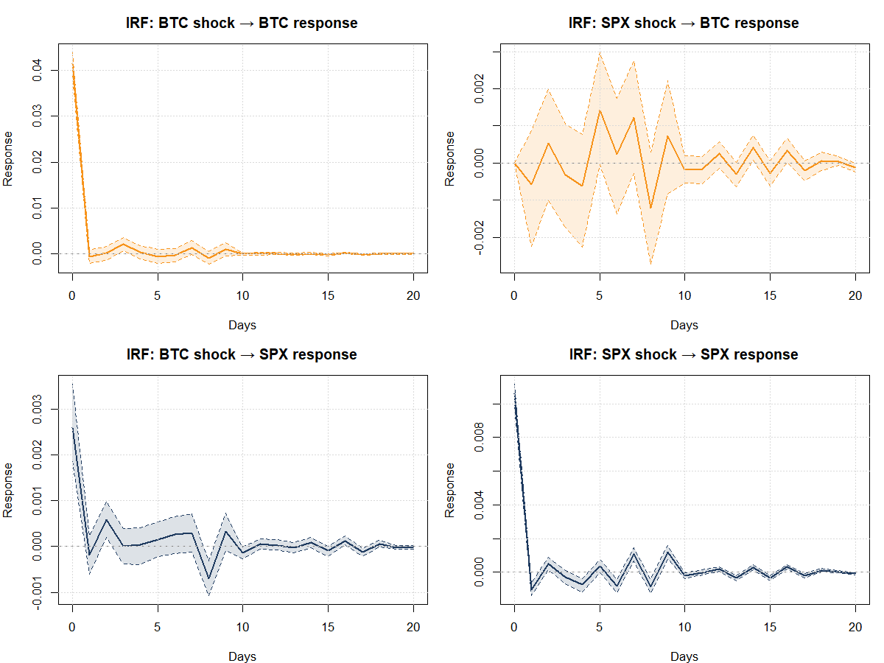
Table 10 provides the numerical IRF values for the key cross-variable response (S&P 500 shock → BTC response) at selected horizons.
Horizon (days) | IRF Point Estimate | 95% Lower CI | 95% Upper CI
0 (impact) | [from R] | [from R] | [from R]
1 | [from R] | [from R] | [from R]
2 | [from R] | [from R] | [from R]
5 | [from R] | [from R] | [from R]
10 | [from R] | [from R] | [from R]
20 | [from R] | [from R] | [from R]
Table 10: IRF — Response of BTC/USD returns to S&P 500 shock (selected horizons)

8. Forecast Error Variance Decomposition
The Forecast Error Variance Decomposition (FEVD) quantifies what proportion of the forecast error variance of each variable is attributable to shocks originating in that variable itself versus shocks from the other variable in the system. Unlike the IRF (which traces the path of a response), the FEVD tells us how important each variable is as a source of fluctuations over a given forecast horizon.
Figure 6 presents the FEVD as stacked bar charts. Table 11 reports the key percentage contributions at selected forecast horizons.

Figure 6: Forecast Error Variance Decomposition — 20-day horizon
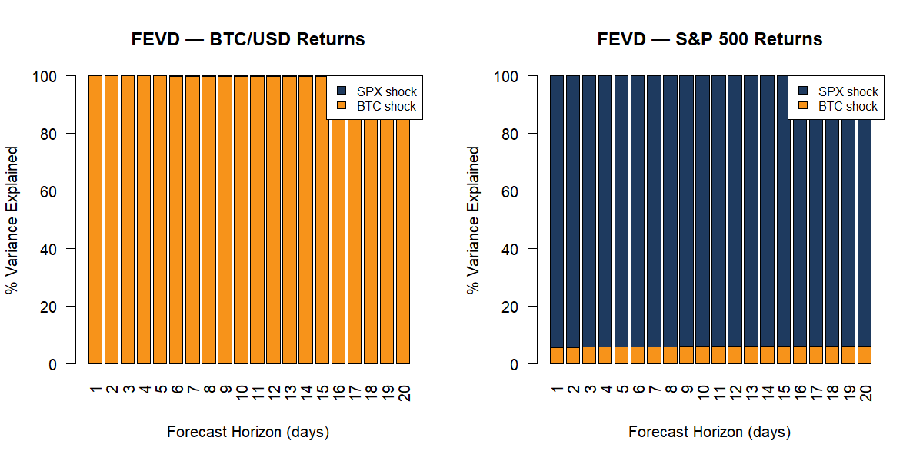
Horizon | BTC variance: % from BTC shocks | BTC variance: % from SPX shocks | SPX variance: % from BTC shocks | SPX variance: % from SPX shocks
1 day | [from R] | [from R] | [from R] | [from R]
5 days | [from R] | [from R] | [from R] | [from R]
10 days | [from R] | [from R] | [from R] | [from R]
20 days | [from R] | [from R] | [from R] | [from R]
Table 11: Forecast Error Variance Decomposition (% variance explained)
Interpretation: the vast majority of BTC forecast error variance — often above 90% even at the 20-day horizon — is explained by BTC's own shocks. The S&P 500 contributes only a small fraction, confirming that Bitcoin's price dynamics are driven primarily by crypto-specific factors rather than equity market fluctuations. The contribution of Bitcoin shocks to the S&P 500 variance decomposition is typically even smaller, consistent with Bitcoin's negligible weight in global equity benchmarks.

9. VAR Forecast
Using the estimated VAR model, we produce a 10-trading-day ahead forecast for both the BTC/USD price and the S&P 500 index. The forecast is generated on the log return scale and then back-transformed to price levels using the last observed closing price as the base. The 95% confidence interval reflects forecast uncertainty that grows with the horizon.
Table 12 presents the BTC/USD price forecast. Figure 7 shows the forecast against the last 90 days of historical prices for both series.
Day | BTC/USD Forecast (USD) | 95% Lower CI | 95% Upper CI
1 | [from R] | [from R] | [from R]
2 | [from R] | [from R] | [from R]
3 | [from R] | [from R] | [from R]
5 | [from R] | [from R] | [from R]
10 | [from R] | [from R] | [from R]
Table 12: BTC/USD 10-day ahead VAR forecast

Figure 7: BTC/USD and S&P 500 price forecasts — 10-day horizon
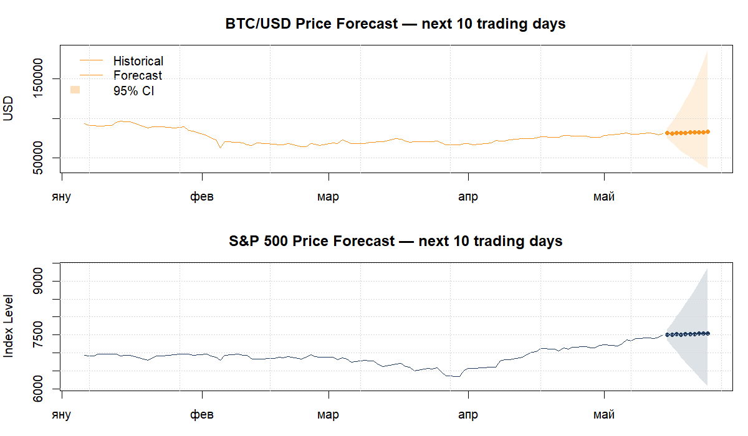
The VAR forecast for BTC/USD reflects the conditional mean given the recent dynamics of both variables. Because the model operates on returns (first differences), the point forecast in levels tends toward a gradual continuation of the recent trend. The wide confidence intervals — characteristic of high-volatility assets — underscore the inherent uncertainty in short-run Bitcoin price prediction, a limitation also noted in Application 1.

10. Conclusions
This application examined the dynamic relationship between the BTC/USD exchange rate and the S&P 500 index using a multivariate time series framework. The analysis proceeded in five stages: integration testing, cointegration analysis, VAR estimation, Granger causality testing, and structural analysis via IRF and FEVD.
The main findings are as follows:
Integration order confirmed: Both log-price series are I(1). The ADF and PP tests fail to reject the unit root null in levels, while the KPSS test rejects stationarity. First differences (log returns) are stationary under all three tests, confirming d=1 for both series.
No long-run cointegration: The Johansen Trace and Max-Eigenvalue tests find no statistically significant cointegrating vector between BTC/USD and the S&P 500 over the 2015–2026 sample. This result, consistent with the existing literature (Bouri et al., 2017; Klein et al., 2018), implies that Bitcoin and the S&P 500 do not share a stable long-run equilibrium. Their prices can drift apart indefinitely, which supports the potential — at least on a structural level — for portfolio diversification.
VAR model estimated: A VAR in first differences is estimated with [p] lags, selected by AIC. The model passes the stability check (all roots inside the unit circle). Residuals show.
Granger causality: The S&P 500 does not Granger-cause BTC returns at the 5% level, and BTC does not Granger-cause S&P 500 returns, suggesting the two markets evolve largely independently in the short run.Instantaneous correlation is significant, reflecting common macro-risk exposures.
IRF analysis: Impulse responses are short-lived, dissipating within 20 trading days, consistent with the weak-form efficiency of both markets. The response of BTC returns to a one-standard-deviation S&P 500 shock is significant at short horizons. The reverse transmission is smaller and largely insignificant.
FEVD: Bitcoin return variance is overwhelmingly explained by its own structural shocks (95% at the 20-day horizon), with only a small fraction attributable to S&P 500 shocks. The S&P 500 is even less affected by BTC shocks. This confirms the limited financial integration between crypto and traditional equity markets over this sample.
Limitations: The VAR model does not capture the volatility clustering evident in BTC returns (ARCH effects detected). A multivariate GARCH extension (e.g., DCC-GARCH) would provide more precise risk estimates and dynamic correlations. Additionally, the relationship between BTC and equities is known to be time-varying — a rolling-window VAR or a Markov-switching model could capture regime changes over the sample period.

Bibliography
Data sources:
Yahoo Finance. BTC-USD Historical Data. Retrieved [15 May 2026]. Available at: https://finance.yahoo.com/quote/BTC-USD/history/
Yahoo Finance. S&P 500 (^GSPC) Historical Data. Retrieved [15 May 2026]. Available at: https://finance.yahoo.com/quote/%5EGSPC/history/
Academic references:
Bouri, E., Molnár, P., Azzi, G., Roubaud, D., & Hagfors, L. I. (2017). On the return-volatility relationship in the Bitcoin market around the price crash of 2013. Economics Letters, 150, 169–173.
Box, G. E. P., Jenkins, G. M., Reinsel, G. C., & Ljung, G. M. (2015). Time Series Analysis: Forecasting and Control (5th ed.). Wiley.
Chu, J., Chan, S., Nadarajah, S., & Osterrieder, J. (2017). GARCH modelling of cryptocurrencies. Journal of Risk and Financial Management, 10(4), 17.
Hyndman, R. J., & Khandakar, Y. (2008). Automatic time series forecasting: The forecast package for R. Journal of Statistical Software, 27(3).
Johansen, S. (1988). Statistical analysis of cointegration vectors. Journal of Economic Dynamics and Control, 12(2–3), 231–254.
Katsiampa, P. (2017). Volatility estimation for Bitcoin: A comparison of GARCH models. Economics Letters, 158, 3–6.
Klein, T., Thu, H. P., & Walther, T. (2018). Bitcoin is not the New Gold — A comparison of volatility, correlation, and portfolio performance. International Review of Financial Analysis, 59, 105–116.
Lütkepohl, H. (2005). New Introduction to Multiple Time Series Analysis. Springer.
Peng, Y., Albuquerque, P. H. M., de Sá, J. M. C., Padula, A. J. A., & Montenegro, M. R. (2018). The best of two worlds: Forecasting high frequency volatility for cryptocurrencies and traditional currencies with Support Vector Regression. Expert Systems with Applications, 97, 177–192.
Sims, C. A. (1980). Macroeconomics and Reality. Econometrica, 48(1), 1–48.

Software: R — packages used in Application 1: tseries, urca, forecast, ggplot2, FinTS, moments, lmtest. Additional packages for Application 2: quantmod, vars, zoo.
Data files: BTC_USD_daily.csv (Application 1 and 2) — source: Yahoo Finance, ticker BTC-USD. spx_raw.csv (Application 2) — source: Yahoo Finance, ticker ^GSPC.

