Name, group:
CSIE Faculty
Economic Informatics, 3rd Year, E Series

Computer System Design Examination

I. Choose the correct answer (6 points, 0.33 each):
1. The <<boundary>> classes have the role of:
  - Mediating between boundary classes and entity classes;
  - Creating objects that must also exist after the system is turned off;
  - Identifying classes of the problem domain;
  - Ensuring communication with actors or other computer systems.
2. The principle of the gradual design of computer systems refers to:
- Staggered funds that can be allocated in time for the implementation of the information system;
- Staged involvement of the design forces that the project will engender;
- Establishing an order in which the subsystems / modules of the IT system will be approached, according to their priority;
- Separation of logical design from the physical design of computer systems.
3. Which of the following diagrams is not refined in the design stage:
- Class diagram;
- ERD diagram;
- State machine diagram;
- Sequence diagram;
4. The design of security and computer system controls can be carried out at the level of:
- Application, database, user interface;
- Database, user interface; cloud;
- Application; database; network;
- Company, application and database
5. Designing interfaces with other systems involves:
- Designing dialogue with system users;
- Design of graphic interface layouts;
- Designing the model of collaboration between processes from different systems;
- Designing how to connect and interact with other systems, whether internal or external;
6. The deployment diagram shows:
- Configuration of physical processing nodes during execution;
- Existing dependencies between various software components that compose an information system;
- Interactions that take place between various objects of a system, chronologically ordered;
- How a system is divided into logical groups and the links between them;
7. In a decision node of an activity diagram:
- enter several flows and come out one;
- enter more flows and come out more than one;
- output flows have mutually exclusive conditions;
- you can simulate the "DO-UNTIL" control structure from programming;
8. Shared aggregation has the following features:
- is a poor form of aggregation;
- is a powerful form of aggregation;
- is in the form of a full diamond;
- represents a parent / child relationship;
9. Which of the following is not a component of a computer system:
- Communications;
- Software;
- Users;
- Information system;
10. The life cycle of a computer system:
- is a template for ordering the activities of the computer system;
- it is included in the development cycle of the computer system;
- can be organized in 5 stages (identification of requirements, analysis, design, implementation, maintenance);
- ends with the decision to abandon the system and replace it with a new system.
Select the correct combination: a) 1+3+4, b) 1+2, c) 2+3+3, d) 3+4
11. Those languages for information modeling that have strict rules, and syntax and semantics are mathematically defined are called:
- Formal languages;
- Informal languages;
- Semi-formal languages;
- Programming languages;
12..A sequence diagram:
- highlights the order in time of messages exchanged between objects;
- models static aspects of the system;
- includes states, transitions and nodes;
- has the role of validating the class diagram;
13. Which of the following cannot be applied to DevOps methodology:
- Addresses the gap between Development-Testing and Operational;
- Automated release management;
- Addresses the gap between customer requirements and development - testing team;
- Intensifies reusability and automation;
14. In order to accelerate the analysis, design and implementation phases, in methodologies based on rapid development, it is recommended to use (0.4p):
A. CASE tools;
B. hierarchical databases;
C. code generators;
D. visual programming languages.
Select the correct option:
a. (A+B+C); b. (A+C+D); c. (B+C+D); d. (A+C)
15. What involves corrective maintentance?
- changes made to the system to reduce or eliminate the risk of system failure;
- making changes to the information system to enhance its functionality or to adapt it to a new environment;
- making changes within the system in order to repair and remove defects or errors in design, programming, or implementation;
- implementing new functional or non-functional system requirements;
16. What elements should be added/ defined in a design class diagram?
- stereotypes;
- controller classes;
- multiplicities;
- entity classes;
- navigability;
- member's complete signature;
- associations;
Select the correct combination:
a. (A+B+C+D) ; b.(A+B+D+G);c.(A+C+E+F); d.(A+B+E+F);
17.You are given the following sequence diagram. Which operations does class C have according to the diagram?
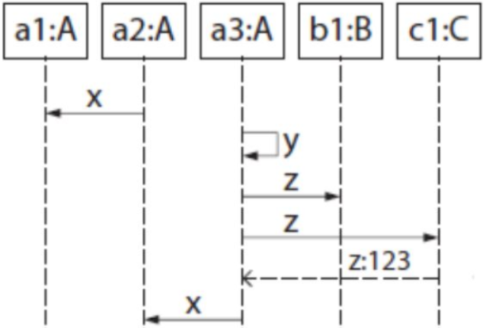

- x():String;
- y():int;
- z():void;
- z():int;
18. Which of the following is not a role according to the SCRUM methodology:
- product owner;
- development team;
- team leader;
- SCRUM master;

II. For your own project, offer a short description of a business process and draw a process diagram using BPMN notations: events, gateways, flows, lanes (1 point).

