Diagnostic Centre Client Coordination System

Analysis and Design Document

Student: Danila Lucia-Diana

**Group: 30433**

Revision History

|  |  |  |  |
| --- | --- | --- | --- |
| **Date** | **Version** | **Description** | **Author** |
| <30/mar/18> | <1.0> | <made the first version> | <Danila Lucia-Diana> |
|  |  |  |  |
|  |  |  |  |
|  |  |  |  |

Table of Contents

I. Project Specification 4

II. Elaboration – Iteration 1.1 4

1. Domain Model 4

2. Architectural Design 4

2.1 Conceptual Architecture 4

2.2 Package Design 5

2.3 Component and Deployment Diagrams 6

III. Elaboration – Iteration 1.2 6

1. Design Model 6

1.1 Dynamic Behavior 6

1.2 Class Design 6

2. Data Model 6

3. Unit Testing 6

IV. Elaboration – Iteration 2 7

1. Architectural Design Refinement 7

2. Design Model Refinement 7

V. Construction and Transition 7

1. System Testing 7

2. Future improvements 7

VI. Bibliography 7

# Project Specification

Diagnostic Centre Client Coordination System helps the diagnostic centres to maintain good relations with their clients. The clients may conduct various tests at the diagnostic center and the system must be capable of valuating patient bills and providing them in printable format.

# Elaboration – Iteration 1.1

# Domain Model

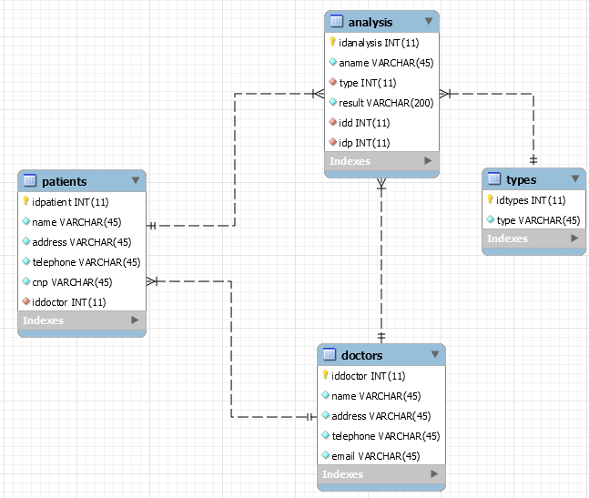

# Architectural Design

## Conceptual Architecture

For implementing this project, the architectural patterns I have chosen to implement are: a client server architecture with the following design patterns: table module pattern, and a dao pattern. The user interface will be implemented using an MVC architecture.

Client Server: Client/server architecture is a computing model in which the server hosts, delivers and manages most of the resources and services to be consumed by the client. This type of architecture has one or more client computers connected to a central server over a network or internet connection. This system shares computing resources.

Dao: access to data varies depending on the source of the data. Access to persistent storage, such as to a database, varies greatly depending on the type of storage (relational databases, object-oriented databases, flat files, and so forth) and the vendor implementation.

Table Module: A single instance that handles the business logic for all rows in a database table or view.

I choose them because the DCCCS will be client server system, dao and table module patterns will deal with the database needed to store the doctors, clients and their analysis (accessing these informations).

## Package Design

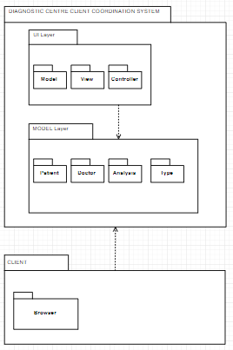

## Component and Deployment Diagrams

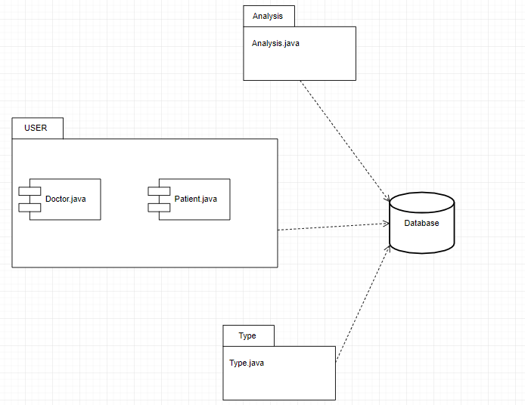

# Elaboration – Iteration 1.2

# Design Model

## Dynamic Behavior

*[Create the interaction diagrams (1 sequence, 1 communication diagrams) for 2 relevant scenarios]*

## Class Design

*[Create the UML class diagram; apply GoF patterns and motivate your choice]*

# Data Model

*[Create the data model for the system.]*

# Unit Testing

*[Present the used testing methods and the associated test case scenarios.]*

# Elaboration – Iteration 2

# Architectural Design Refinement

*[Refine the architectural design: conceptual architecture, package design (consider package design principles), component and deployment diagrams. Motivate the changes that have been made.]*

# Design Model Refinement

## *[Refine the UML class diagram by applying class design principles and GRASP; motivate your choices. Deliver the updated class diagrams.]*

# Construction and Transition

# System Testing

*[Describe how you applied integration testing and present the associated test case scenarios.]*

# Future improvements

*[Present future improvements for the system]*

# Bibliography