Assignment 3

Student: Danila Lucia-Diana

**Group: 30433**

Table of Contents

1. Requirements Analysis 3

1.1 Assignment Specification 3

1.2 Functional Requirements 3

1.3 Non-functional Requirements 3

2. Use-Case Model 4

3. System Architectural Design 4

4. UML Sequence Diagrams 7

5. Class Design 7

6. Data Model 10

7. System Testing 10

8. Bibliography 12

1. Requirements Analysis

# Assignment Specification

Use Java/C# API to design and implement a client-server application for a news agency. The application has three types of users: the readers, the writers and an administrator. The **readers** can view a list of articles, read an article and do not need to login in order the use the application. The **writers** need to authenticate in order to create, update or delete articles. The **admin** is the only one who can create writer accounts, but cannot create new admin accounts. So the admin accounts are preset by the application developer and cannot be altered.

# Functional Requirements

* an article has the following components: title, abstract, body and author, list of related articles
* writer must login to write articles
* any user can read articles
* only the admin can create writer accounts

# Non-functional Requirements

* The application must be client-server.
* Use the Observer design pattern for updating the list of articles in real time
* For sending data from the client to the server use JSON serialization.
* When writing an article, show a list that supports multi-select for choosing the related articles.

2. Use-Case Model

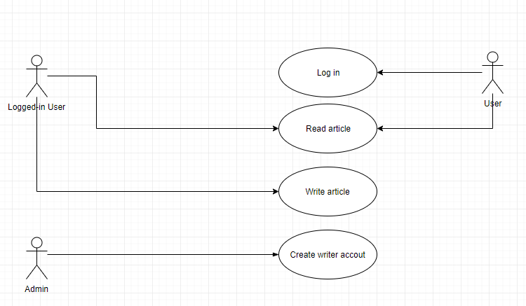

Use case: read article

Level: user-goal level

Primary actor: user (not logged in)

*Main success scenario: article is read*

*Extensions: the application runs succesfully*

3. System Architectural Design

**3.1 Architectural Pattern Description**

Client/server architecture is a computing model in which the server hosts, delivers and manages most of the resources and services to be consumed by the client. This type of architecture has one or more client computers connected to a central server over a network or internet connection. This system shares computing resources.

Client/server architecture is also known as a networking computing model or client/server network because all the requests and services are delivered over a network.

**3.2 Diagrams**

Package diagram:

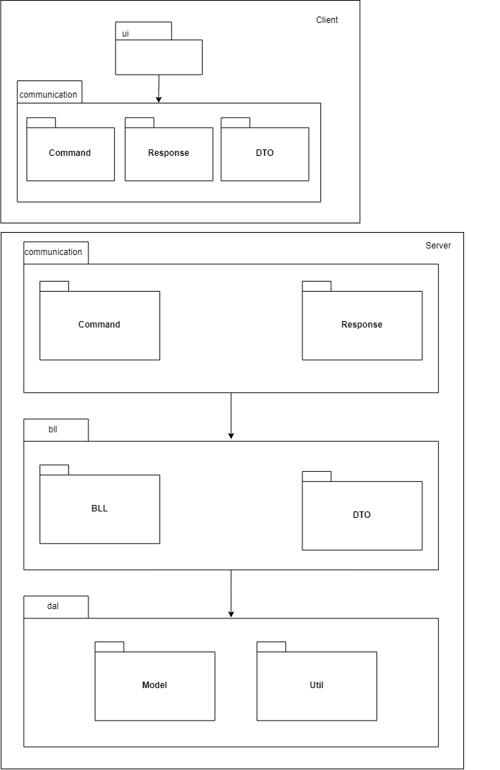

Component diagram:

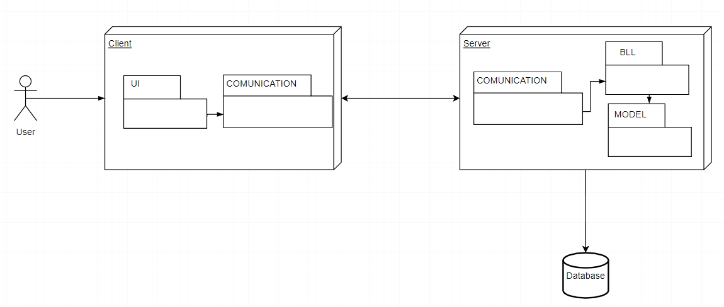

Deployment diagram:

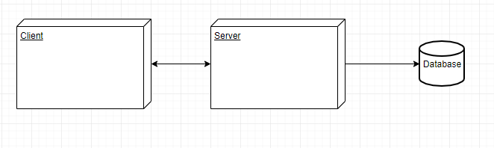

4. UML Sequence Diagrams

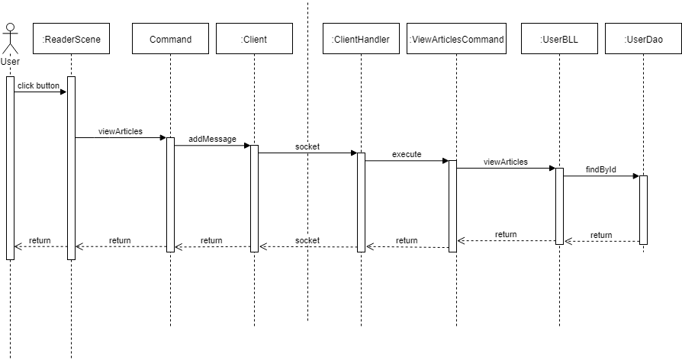

5. Class Design

**5.1 Design Patterns Description**

**Design Patterns Description**

The used design Patterns are Client-Server, DAO, and Table Module.

Dao: access to data varies depending on the source of the data. Access to persistent storage, such as to a database, varies greatly depending on the type of storage (relational databases, object-oriented databases, flat files, and so forth) and the vendor implementation.

Table Module: A single instance that handles the business logic for all rows in a database table or view.

Client/server architecture is a computing model in which the server hosts, delivers and manages most of the resources and services to be consumed by the client. This type of architecture has one or more client computers connected to a central server over a network or internet connection. This system shares computing resources.

Client/server architecture is also known as a networking computing model or client/server network because all the requests and services are delivered over a network.

**5.2 UML Class Diagram**

Server:

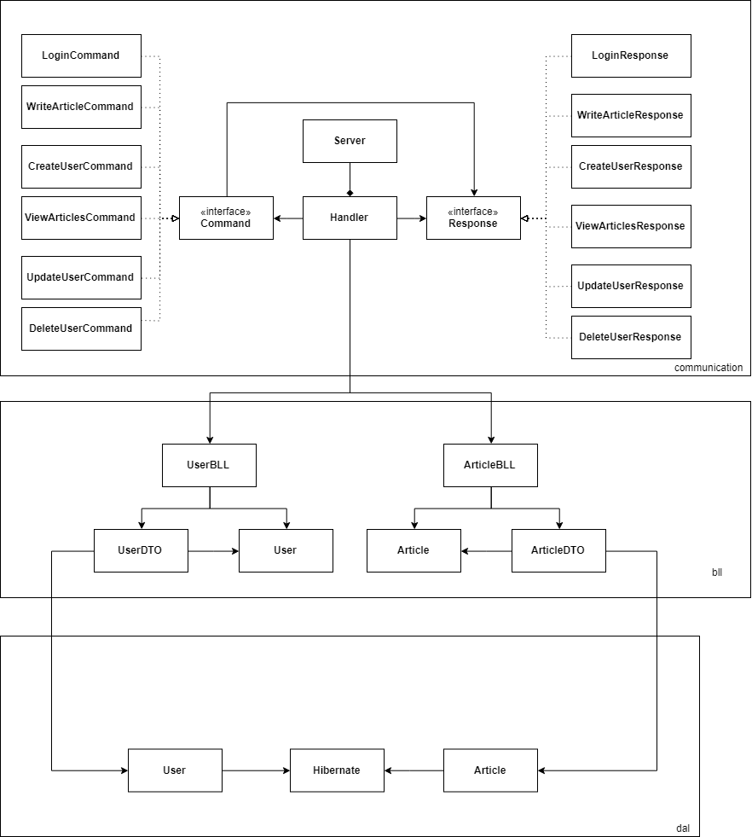

Client:

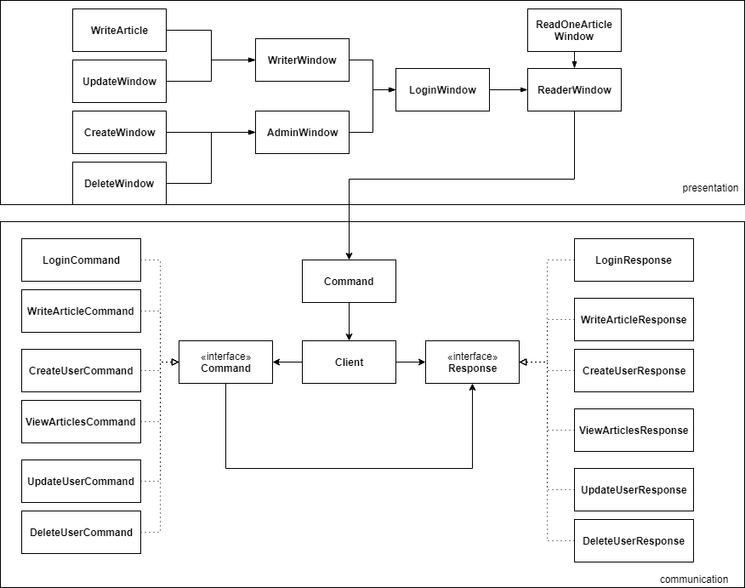

6. Data Model

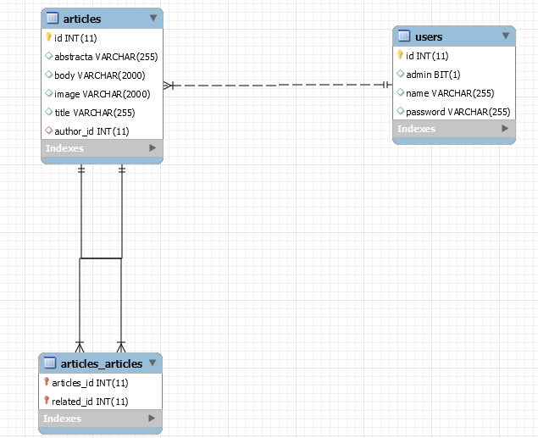

7. System Testing

The system was tested and the errors were solved with system.out.prinln().

Some print screens from using the application are:

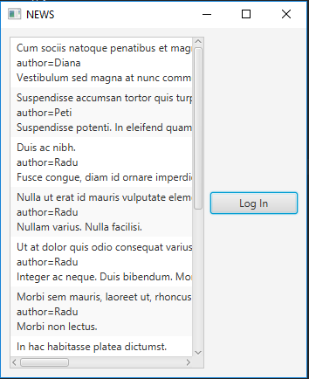 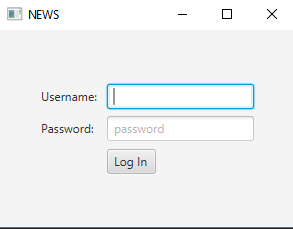

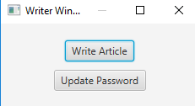

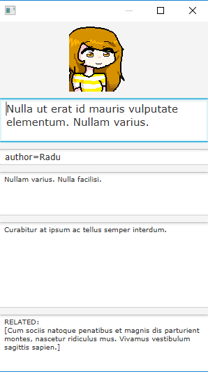 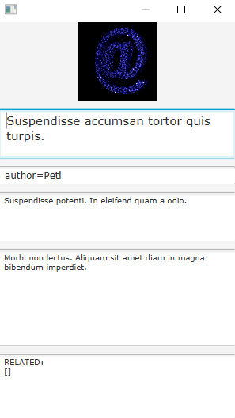 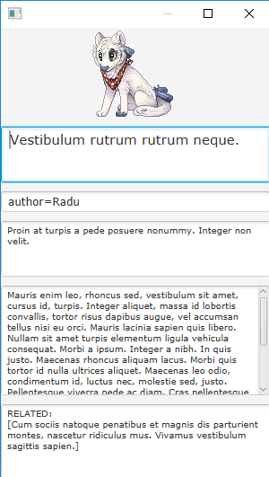

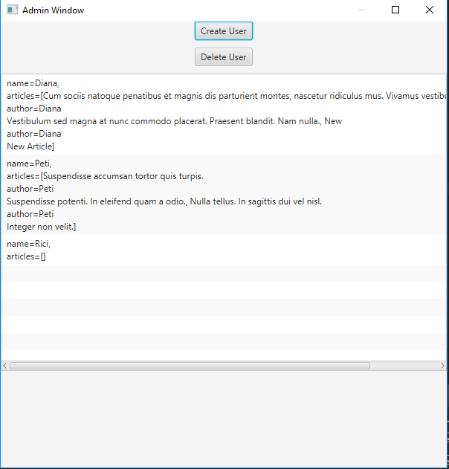

8. Bibliography

* <https://www.techopedia.com/definition/438/clientserver-architecture>
* <https://www.google.ro/search?rlz=1C1OKWM_enRO775RO775&tbm=isch&q=pictures+100x100+pixels&chips=q:pictures+100x100+pixels,online_chips:100x100+gif&sa=X&ved=0ahUKEwjUtMKW74DbAhUL16QKHVRVDSQQ4lYIJygB&biw=1920&bih=900&dpr=1#imgrc=r0MtwRMuExiDtM>:
* <https://stackoverflow.com/questions/37111582/simplest-way-to-add-an-image-in-javafx>
* <https://www.sqlservercentral.com/Forums/Topic625247-145-1.aspx>
* <http://cs.lmu.edu/~ray/notes/javanetexamples/>
* <https://docs.oracle.com/javase/tutorial/networking/sockets/clientServer.html>