# My Amazing NOAA Tech Memo

By

Me, Myself, and I

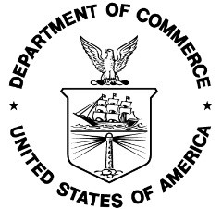

U.S. Department of Commerce

National Oceanic and Atmospheric Administration

National Marine Fisheries Service

Alaska Fisheries Science Center

7600 Sand Point Way N.E.

Seattle, WA 98115-6349

November 2020

# My Amazing NOAA Tech Memo

By

Me, Myself, and I

**NOAA Technical Memorandum NMFS-[F/SPO, OHC, OPR or OSF]-### November 2020**

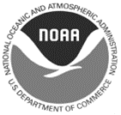

U.S. Department of Commerce

Wilbur L. Ross, Jr., Secretary

National Oceanic and Atmospheric Administration

Neil A. Jacobs, Ph.D., Acting NOAA Administrator

National Marine Fisheries Service

Chris Oliver, Assistant Administrator for Fisheries

**Recommended citation:**

Me, Myself, and I. 2021. My Amazing NOAA Tech Memo NOAA Tech. Memo. NMFS-[F/SPO, OHC, OPR or OSF]-###,

## p.

**Copies of this report may be obtained from:**

Alaska Fisheries Science Center

7600 Sand Point Way N.E.

Seattle, WA 98115-6349

Or online at:

<http://spo.nmfs.noaa.gov/tech-memos/>

[or alternate URL for OHC, OSF or OPR pages]

**This document is available to the public through:**

National Technical Information Service U.S.Department of Commerce 5285 Port Royal Road Springfield, VA 22161

www.ntis.gov