## Methods

Here is the report methodology! Here is some equation you’ll need to have in this report, of which produces the variable $X$.

Eq. 1

$$X=Y+Z$$

## Example Figure

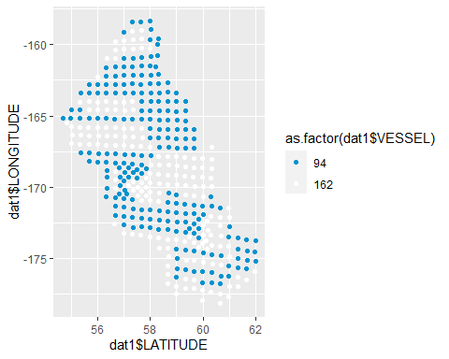

Figure 1. Here’s a plot[1]

## Example Table

### Table 1. Here’s a table[2]

|  |  |  |
| --- | --- | --- |
| Latitude | Longitude | Vessel ID Number |
| 58.3 | -168.5 | 162 |
| 58.3 | -168.5 | 162 |
| 58.3 | -168.5 | 162 |
| 58.3 | -168.5 | 162 |
| 58.3 | -168.5 | 162 |
| 58.3 | -168.5 | 162 |

1. A footnote for this figure!
2. Here is a Footnote for this table