**[Title]**

[authors]

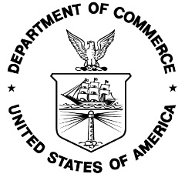

U.S. Department of Commerce

National Oceanic and Atmospheric Administration

National Marine Fisheries Service

NOAA Technical Memorandum NMFS-[F/SPO, OHC, OPR or OSF]-###

[Month] 2019

**[Title]**

[Authors]

**NOAA Technical Memorandum NMFS-[F/SPO, OHC, OPR or OSF]-###**

**[month] [year]**

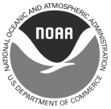

U.S. Department of Commerce

Wilbur L. Ross, Jr., Secretary

National Oceanic and Atmospheric Administration

Neil A. Jacobs, Ph.D., Acting NOAA Administrator

National Marine Fisheries Service

Chris Oliver, Assistant Administrator for Fisheries **Recommended citation:**

[Authors]. [Year]. [Title] NOAA Tech. Memo. NMFS-[F/SPO, OHC, OPR or OSF]-###, ## p.

**Copies of this report may be obtained from:**

[office name]

National Oceanic and Atmospheric Administration

1315 East-West Highway [bldg./room]

Silver Spring, MD 20910

[or alternate address]

**Or online at:**

<http://spo.nmfs.noaa.gov/tech-memos/>

[or alternate URL for OHC, OSF or OPR pages]

ii