This test is designed for a duration of 4 hours

------------------------------------------------------------------

Diana Lizeth Fernandez Nicolas

------------------------------------------------------------------

Activities:

1. Make a Docker container with Mysql



1. Load into mysql sakila db <https://downloads.mysql.com/docs/sakila-db.tar.gz>

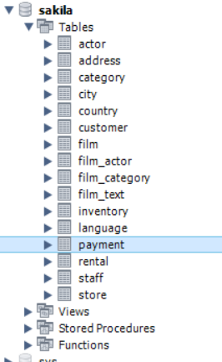

1. Inside sakila db modify 2 film records values



1. List of movies by actor

select film.title ,actor.first_name from film inner join film_actor inner join actor on film_actor.film_id=actor.actor_id on film_actor.film_id=film.film_id;

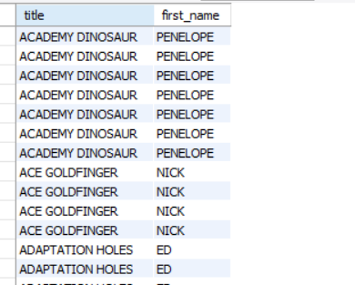

1. Count number of movies per actor

select actor.first_name ,actor.actor_id ,count(film_actor.film_id) AS total from film_actor INNER JOIN actor ON actor.actor_id= film_actor.actor_id group by actor_id;

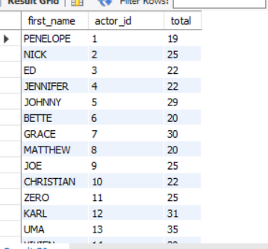

1. Count movie languages

select count(*) from language;

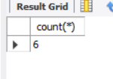

1. Calculate average cost for replacement of a film

select avg(replacement_cost) from film;

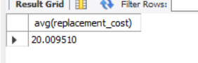

1. do a store procedure to update the film

delimiter //

create procedure UpdateFilm (titleF varchar(50),descriptionF varchar(50))

begin

Update film set description=descriptionF where title=titleF;

end //

call UpdateFilm('ACADEMY DINOSAUR','Beautiful and emotional movie');

