Data Wrangling and Analysis, Spring 2022, University of Helsinki Homewprk report
3/3/2022

Description on the study
In my study, I want to examine association of attitude to immigrant with people`s age, gender, satisfaction with life, interest in politics and trust in people. I want to observe differences between Finaland and Italy. For this purpose I wull use ESS data that I describe below.

General information on the data
Data was downloaded from: https://www.europeansocialsurvey.org/download.html?file=ESS9e03_1&y=2018.
Codebook fro the data can be found by the following link: chrome-extension://efaidnbmnnnibpcajpcglclefindmkaj/viewer.html?pdfurl=https%3A%2F%2Fwww.europeansocialsurvey.org%2Fdocs%2Fround9%2Fsurvey%2FESS9_appendix_a7_e03_1.pdf&clen=2111156.
The European Social Survey (ESS) is an academically-driven multi-country survey, which has been administered in over 35 countries to date. Its three aims are, firstly – to monitor and interpret changing public attitudes and values within Europe and to investigate how they interact with Europe’s changing institutions, secondly – to advance and consolidate improved methods of cross-national survey measurement in Europe and beyond, and thirdly – to develop a series of European social indicators, including attitudinal indicators. For the course we will use round 9 ESS.

Import and restrict data
# set working directory
setwd("C:/R scripts/DWA2022")
#import data
library(haven) # to open csv
data <- read_sav("C:/R scripts/DWA2022/ESS9e03_1.sav")
head(data)
## # A tibble: 6 x 572
## name essround edition proddate idno cntry nwspol netusoft netustm ppltrst
## <chr> <dbl> <chr> <chr> <dbl> <chr+lb> <dbl+> <dbl+lb> <dbl+l> <dbl+l>
## 1 ESS9~ 9 3.1 17.02.2~ 27 AT [Aus~ 60 5 [Ever~ 180 2 [2]
## 2 ESS9~ 9 3.1 17.02.2~ 137 AT [Aus~ 10 5 [Ever~ 20 7 [7]
## 3 ESS9~ 9 3.1 17.02.2~ 194 AT [Aus~ 60 4 [Most~ 180 5 [5]
## 4 ESS9~ 9 3.1 17.02.2~ 208 AT [Aus~ 45 5 [Ever~ 120 3 [3]
## 5 ESS9~ 9 3.1 17.02.2~ 220 AT [Aus~ 30 1 [Neve~ NA 5 [5]
## 6 ESS9~ 9 3.1 17.02.2~ 254 AT [Aus~ 45 2 [Only~ NA 8 [8]
## # ... with 562 more variables: pplfair <dbl+lbl>, pplhlp <dbl+lbl>,
## # polintr <dbl+lbl>, psppsgva <dbl+lbl>, actrolga <dbl+lbl>,
## # psppipla <dbl+lbl>, cptppola <dbl+lbl>, trstprl <dbl+lbl>,
## # trstlgl <dbl+lbl>, trstplc <dbl+lbl>, trstplt <dbl+lbl>, trstprt <dbl+lbl>,
## # trstep <dbl+lbl>, trstun <dbl+lbl>, vote <dbl+lbl>, prtvtcat <dbl+lbl>,
## # prtvtdbe <dbl+lbl>, prtvtdbg <dbl+lbl>, prtvtgch <dbl+lbl>,
## # prtvtbcy <dbl+lbl>, prtvtecz <dbl+lbl>, prtvede1 <dbl+lbl>, ...
dim(data) #everything is right
## [1] 49519 572
# create a sum var, wxluding missing values
library(tidyverse)
## -- Attaching packages --------------------------------------- tidyverse 1.3.1 --
## v ggplot2 3.3.5 v purrr 0.3.4
## v tibble 3.1.5 v dplyr 1.0.7
## v tidyr 1.1.4 v stringr 1.4.0
## v readr 2.1.0 v forcats 0.5.1
## -- Conflicts ------------------------------------------ tidyverse_conflicts() --
## x dplyr::filter() masks stats::filter()
## x dplyr::lag() masks stats::lag()
library(dplyr)
#create mean var
data$img_avg <- rowMeans(select(data, imwbcnt, imbgeco, imueclt), na.rm = TRUE)
head(data$img_avg)
## [1] 3.666667 4.666667 5.666667 5.000000 4.333333 6.000000
# select Finnish and Italian data
cntry_target <- c("EE", "LT", "LV")
data7 <- data %>% filter(cntry %in% cntry_target) %>%
select(., cntry, agea, gndr, img_avg, polintr, stflife)
data7 <- data7[complete.cases(data7[ ,c("cntry", "agea", "gndr", "img_avg", "polintr", "stflife")]), ]
summary(data7)
## cntry agea gndr img_avg
## Length:4574 Min. :15.00 Min. :1.000 Min. : 0.000
## Class :character 1st Qu.:39.00 1st Qu.:1.000 1st Qu.: 3.667
## Mode :character Median :56.00 Median :2.000 Median : 5.000
## Mean :53.77 Mean :1.633 Mean : 5.019
## 3rd Qu.:68.00 3rd Qu.:2.000 3rd Qu.: 6.333
## Max. :90.00 Max. :2.000 Max. :10.000
## polintr stflife
## Min. :1.000 Min. : 0.000
## 1st Qu.:2.000 1st Qu.: 5.000
## Median :3.000 Median : 7.000
## Mean :2.763 Mean : 6.629
## 3rd Qu.:3.000 3rd Qu.: 8.000
## Max. :4.000 Max. :10.000
head(data7)
## # A tibble: 6 x 6
## cntry agea gndr img_avg polintr stflife
## <chr+lbl> <dbl+lbl> <dbl+lbl> <dbl> <dbl+lbl> <dbl+lbl>
## 1 EE [Estonia] 37 2 [Female] 2.67 3 [Hardly interested] 10 [Extre~
## 2 EE [Estonia] 72 1 [Male] 5 1 [Very interested] 9 [9]
## 3 EE [Estonia] 57 1 [Male] 3 1 [Very interested] 5 [5]
## 4 EE [Estonia] 56 2 [Female] 4 4 [Not at all interested] 5 [5]
## 5 EE [Estonia] 53 2 [Female] 6.67 4 [Not at all interested] 4 [4]
## 6 EE [Estonia] 35 1 [Male] 6.67 2 [Quite interested] 5 [5]
dim(data7) #looks right!
## [1] 4574 6
hist(data7$img_avg)
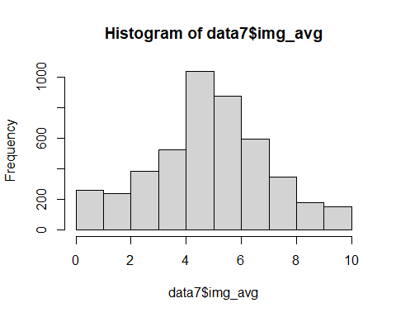
summary(data7)
## cntry agea gndr img_avg
## Length:4574 Min. :15.00 Min. :1.000 Min. : 0.000
## Class :character 1st Qu.:39.00 1st Qu.:1.000 1st Qu.: 3.667
## Mode :character Median :56.00 Median :2.000 Median : 5.000
## Mean :53.77 Mean :1.633 Mean : 5.019
## 3rd Qu.:68.00 3rd Qu.:2.000 3rd Qu.: 6.333
## Max. :90.00 Max. :2.000 Max. :10.000
## polintr stflife
## Min. :1.000 Min. : 0.000
## 1st Qu.:2.000 1st Qu.: 5.000
## Median :3.000 Median : 7.000
## Mean :2.763 Mean : 6.629
## 3rd Qu.:3.000 3rd Qu.: 8.000
## Max. :4.000 Max. :10.000
library(summarytools)
##
## Attaching package: 'summarytools'
## The following object is masked from 'package:tibble':
##
## view
with(data7,
stby(data=data7$img_avg,
INDICES=data7$cntry,
FUN=descr,
stats=c("mean","sd","min","med","max","skewness")))
## Descriptive Statistics
## img_avg by cntry
## Data Frame: data7
## N: 1897
##
## EE LT LV
## -------------- ------- ------- -------
## Mean 4.81 5.06 5.39
## Std.Dev 2.04 2.19 2.33
## Min 0.00 0.00 0.00
## Median 5.00 5.00 5.33
## Max 10.00 10.00 10.00
## Skewness -0.25 -0.12 -0.22
# histograms by groups for img_avg
ggplot(data7, aes(x = img_avg)) +
geom_histogram() + facet_grid(cntry ~ .)
## `stat_bin()` using `bins = 30`. Pick better value with `binwidth`.
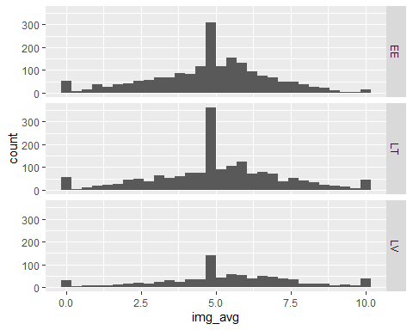 Visually I can see that the histogram has a tail that goes to left. I will test if the data normally distributed.
#testing for normal distribution
library(ggpubr)
ggqqplot(data7$img_avg)
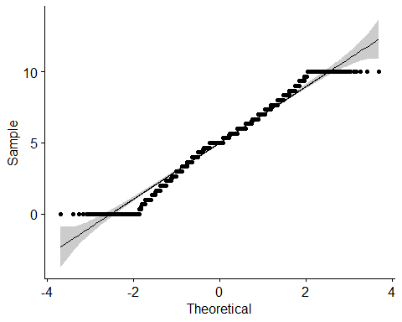 Dots are not following like entirely, going out of confidence intervals on both ends.
#testing for normal distribution
library(dplyr)
library(rstatix)
##
## Attaching package: 'rstatix'
## The following object is masked from 'package:stats':
##
## filter
data7 %>% group_by(cntry) %>% shapiro_test(img_avg)
## # A tibble: 3 x 4
## cntry variable statistic p
## <chr+lbl> <chr> <dbl> <dbl>
## 1 EE [Estonia] img_avg 0.985 3.30e-13
## 2 LT [Lithuania] img_avg 0.983 7.66e-14
## 3 LV [Latvia] img_avg 0.981 1.63e- 9
# Statistical test of normality
# H0: variable is normally distributed, H1: variable is not normally distributed
shapiro.test(data7$img_avg)
##
## Shapiro-Wilk normality test
##
## data: data7$img_avg
## W = 0.98488, p-value < 2.2e-16
ks.test(x = data7$img_avg, y = pnorm)
## Warning in ks.test(x = data7$img_avg, y = pnorm): ties should not be present for
## the Kolmogorov-Smirnov test
##
## One-sample Kolmogorov-Smirnov test
##
## data: data7$img_avg
## D = 0.89242, p-value < 2.2e-16
## alternative hypothesis: two-sided
As the p-value is smaller than 0.05, I reject the normality hypothesis. Therefore, I need to use the nonparametric version, the kruskal.test function: https://rc2e.com/linearregressionandanova#recipe-id231.
# H0: The mean is the same for all groups
# H1: At least the mean of one group is different
kruskal.test(data7$img_avg ~ data7$cntry)
##
## Kruskal-Wallis rank sum test
##
## data: data7$img_avg by data7$cntry
## Kruskal-Wallis chi-squared = 43.226, df = 2, p-value = 4.107e-10
Conventionally, p = 0.346 indicates that there is no a significant difference between the medians of three age groups. I don`t need to perform multiple pairwise-comparison, but I will do it as I am interested
(alternative: p = 0.05 indicates that there is a significant difference between the medians of three age groups. But we don’t know which pairs of groups are different. Next we will perform multiple pairwise-comparison to determine if the mean difference between specific pairs of group are statistically significant: https://www.spcforexcel.com/knowledge/comparing-processes/bonferronis-method).
library(tidyverse)
library(ggpubr)
library(rstatix)
#H0: attitude to immigrants of young middel and old are equal
#H1: attitude to immigrants of young middel and old are different
pairwise.wilcox.test(data7$img_avg, data7$cntry, p.adjust.method = "bonferroni")
##
## Pairwise comparisons using Wilcoxon rank sum test with continuity correction
##
## data: data7$img_avg and data7$cntry
##
## EE LT
## LT 0.00415 -
## LV 1.8e-10 0.00031
##
## P value adjustment method: bonferroni
library(summarytools)
with(data7,
stby(data=data7$img_avg,
INDICES=data7$cntry,
FUN=descr,
stats=c("mean","sd","min","med","max","skewness")))
## Descriptive Statistics
## img_avg by cntry
## Data Frame: data7
## N: 1897
##
## EE LT LV
## -------------- ------- ------- -------
## Mean 4.81 5.06 5.39
## Std.Dev 2.04 2.19 2.33
## Min 0.00 0.00 0.00
## Median 5.00 5.00 5.33
## Max 10.00 10.00 10.00
## Skewness -0.25 -0.12 -0.22
#library(ggplot2)
#library(GGally)
#$gndr <- as.numeric(data7$gndr)
#p <- ggpairs(data7, mapping = aes(col = gndr, alpha = 0.3), lower = list(combo = wrap("facethist", bins = 20)))
#p
#data_cat <- select(data7, "gndr", "polintr")
#data_cont <- select(data7, "agea", "img_avg")
#gather(data_cat) %>% ggplot(aes(value, col = data7gndr)) + facet_wrap("key", scales = "free") + geom_bar()
#gather(data_cont) %>% ggplot(aes(value)) + facet_wrap("key", scales = "free") + geom_histogram()
#boxplot(data7$gndr)
#boxplot()
library(ggplot2)
library(dplyr)
library(purrr)
#data7$gndr <- as.character(data7$gndr)
#data7["gndr"][data7["gndr"] == "1"] <= "Male"
#["gndr"][data7["gndr"] == "2"] <= "Female"
#ggplot(data7, aes(polintr, ..value.., fill = factor(gndr))) + geom_bar(stat = "identity", position = position_dodge()) + ggtitle ("")
g1 <- ggplot(data = data7, aes(x = polintr, fill = factor(gndr))) + geom_bar()
g2 <- ggplot(data = data7, aes(x = agea, fill = factor(gndr))) + geom_histogram()
g3 <- ggplot(data = data7, aes(x = img_avg, fill = factor(gndr))) + geom_bar()
g4 <- ggplot(data = data7, aes(x = stflife, fill = factor(gndr))) + geom_bar()
g5 <- ggplot(data = data7, aes(x = gndr, fill = factor(gndr)))+ geom_bar()
library(cowplot)
##
## Attaching package: 'cowplot'
## The following object is masked from 'package:ggpubr':
##
## get_legend
plot_grid(
g1, g2, g3, g4,
labels = c('1', '2', '3', '4'),
align="hv"
)
## Don't know how to automatically pick scale for object of type haven_labelled/vctrs_vctr/double. Defaulting to continuous.
## Don't know how to automatically pick scale for object of type haven_labelled/vctrs_vctr/double. Defaulting to continuous.
## `stat_bin()` using `bins = 30`. Pick better value with `binwidth`.
## Don't know how to automatically pick scale for object of type haven_labelled/vctrs_vctr/double. Defaulting to continuous.
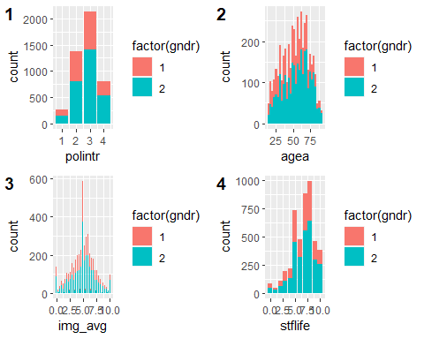
g5
## Don't know how to automatically pick scale for object of type haven_labelled/vctrs_vctr/double. Defaulting to continuous.
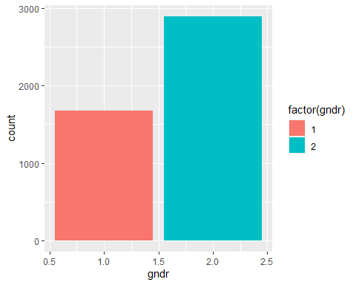
boxplot(select(data7, - cntry, -agea))
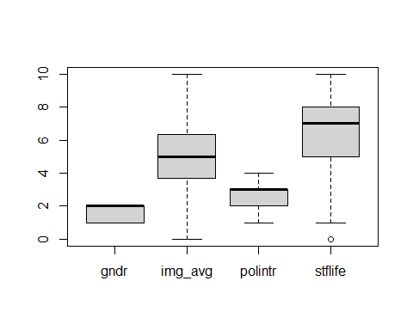
boxplot(data7$agea)
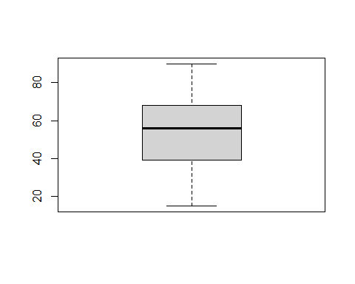
View(data7)
mean(data7$agea)
## [1] 53.7746
summary(data7)
## cntry agea gndr img_avg
## Length:4574 Min. :15.00 Min. :1.000 Min. : 0.000
## Class :character 1st Qu.:39.00 1st Qu.:1.000 1st Qu.: 3.667
## Mode :character Median :56.00 Median :2.000 Median : 5.000
## Mean :53.77 Mean :1.633 Mean : 5.019
## 3rd Qu.:68.00 3rd Qu.:2.000 3rd Qu.: 6.333
## Max. :90.00 Max. :2.000 Max. :10.000
## polintr stflife
## Min. :1.000 Min. : 0.000
## 1st Qu.:2.000 1st Qu.: 5.000
## Median :3.000 Median : 7.000
## Mean :2.763 Mean : 6.629
## 3rd Qu.:3.000 3rd Qu.: 8.000
## Max. :4.000 Max. :10.000
table(data7$polintr)
##
## 1 2 3 4
## 258 1376 2131 809
Multiple pairwise-comparison test indicates that there are no significnat differences between medians.
corrmatrix <- cor(select(data7, img_avg, agea, gndr, polintr, stflife), use="complete.obs")
corrmatrix
## img_avg agea gndr polintr stflife
## img_avg 1.00000000 -0.1255747 0.02604163 -0.12374598 0.18461860
## agea -0.12557467 1.0000000 0.13041350 -0.15286641 -0.19785523
## gndr 0.02604163 0.1304135 1.00000000 0.07002483 0.04780123
## polintr -0.12374598 -0.1528664 0.07002483 1.00000000 -0.07890345
## stflife 0.18461860 -0.1978552 0.04780123 -0.07890345 1.00000000
library(corrplot)
## corrplot 0.92 loaded
corrplot(corrmatrix)
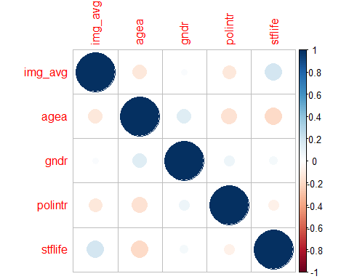
data7 <- data7 %>%
mutate(img_avg_cat = cut(img_avg, breaks = c(0,2,4,6,8, Inf), labels = c("Bad influence","3-4", "5-6", "7-8", "Good influence")))
data7 <- data7 %>%
mutate(stflife_cat = cut(stflife, breaks = c(0,2,4,6,8, Inf), labels = c("Extremely dissatisfied","3-4", "5-6", "7-8", "Extremely satisfied")))
t1 <- table(data7$img_avg_cat, data7$stflife_cat)
prop.table(t1) # sum of all values
##
## Extremely dissatisfied 3-4 5-6 7-8
## Bad influence 0.005730002 0.011230804 0.022232409 0.026358011
## 3-4 0.010084804 0.021544809 0.060738024 0.083887234
## 5-6 0.011001604 0.043548017 0.127893651 0.177859271
## 7-8 0.003896402 0.011460005 0.046069218 0.104973642
## Good influence 0.001833601 0.002979601 0.012606005 0.027274811
##
## Extremely satisfied
## Bad influence 0.012606005
## 3-4 0.028191611
## 5-6 0.071510429
## 7-8 0.046756819
## Good influence 0.027733211
prop.table(t1, 1) # sum of all values
##
## Extremely dissatisfied 3-4 5-6 7-8
## Bad influence 0.07331378 0.14369501 0.28445748 0.33724340
## 3-4 0.04932735 0.10538117 0.29708520 0.41031390
## 5-6 0.02547771 0.10084926 0.29617834 0.41188960
## 7-8 0.01827957 0.05376344 0.21612903 0.49247312
## Good influence 0.02531646 0.04113924 0.17405063 0.37658228
##
## Extremely satisfied
## Bad influence 0.16129032
## 3-4 0.13789238
## 5-6 0.16560510
## 7-8 0.21935484
## Good influence 0.38291139
library(gplots)
##
## Attaching package: 'gplots'
## The following object is masked from 'package:stats':
##
## lowess
balloonplot(t(t1), main ="effect of immigrants and satisfaction with life",
label = T, show.margins = TRUE)
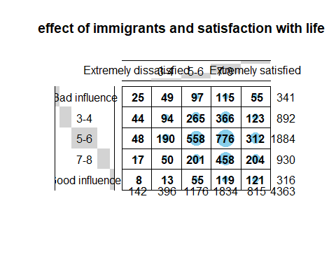
mosaicplot(t1, shade = TRUE, las=2,
main = "happiness and satisfaction")
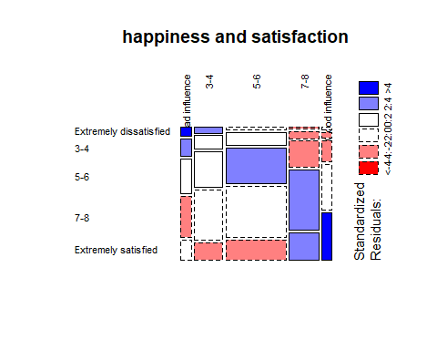
library(janitor)
##
## Attaching package: 'janitor'
## The following object is masked from 'package:rstatix':
##
## make_clean_names
## The following objects are masked from 'package:stats':
##
## chisq.test, fisher.test
data7 %>% tabyl(img_avg, stflife, show_na=F) %>% chisq.test()
## Warning in stats::chisq.test(., ...): Chi-squared approximation may be incorrect
##
## Pearson's Chi-squared test
##
## data: .
## X-squared = 701.63, df = 400, p-value < 2.2e-16
#print the results of x*2 test
results_chi1 <- chisq.test(data7$img_avg_cat, data7$stflife_cat)
results_chi1$observed
## data7$stflife_cat
## data7$img_avg_cat Extremely dissatisfied 3-4 5-6 7-8 Extremely satisfied
## Bad influence 25 49 97 115 55
## 3-4 44 94 265 366 123
## 5-6 48 190 558 776 312
## 7-8 17 50 201 458 204
## Good influence 8 13 55 119 121
results_chi1$expected #estimated
## data7$stflife_cat
## data7$img_avg_cat Extremely dissatisfied 3-4 5-6 7-8
## Bad influence 11.09833 30.95026 91.91290 143.3404
## 3-4 29.03140 80.96081 240.42906 374.9548
## 5-6 61.31744 170.99794 507.81206 791.9450
## 7-8 30.26816 84.40981 250.67156 390.9283
## Good influence 10.28467 28.68118 85.17442 132.8315
## data7$stflife_cat
## data7$img_avg_cat Extremely satisfied
## Bad influence 63.69814
## 3-4 166.62388
## 5-6 351.92757
## 7-8 173.72221
## Good influence 59.02819
results_chi1$residuals # The difference between observed and expected values
## data7$stflife_cat
## data7$img_avg_cat Extremely dissatisfied 3-4 5-6 7-8
## Bad influence 4.1729033 3.2444321 0.5306177 -2.3671248
## 3-4 2.7780955 1.4491499 1.5846314 -0.4624542
## 5-6 -1.7007043 1.4531328 2.2271420 -0.5666003
## 7-8 -2.4116695 -3.7452931 -3.1372941 3.3922749
## Good influence -0.7124062 -2.9280621 -3.2695227 -1.2001067
## data7$stflife_cat
## data7$img_avg_cat Extremely satisfied
## Bad influence -1.0898411
## 3-4 -3.3795252
## 5-6 -2.1283658
## 7-8 2.2971878
## Good influence 8.0661154
img_avg_males <- data7 %>% filter(gndr == 1) %>% select(img_avg)
img_avg_females <- data7 %>% filter(gndr == 2) %>% select(img_avg)
img_avg_males <- as.numeric(unlist(img_avg_males))
img_avg_females <- as.numeric(unlist(img_avg_females))
# test first the equality of variances
var.test(img_avg ~ gndr, data = data7)
##
## F test to compare two variances
##
## data: img_avg by gndr
## F = 0.99928, num df = 1679, denom df = 2893, p-value = 0.9899
## alternative hypothesis: true ratio of variances is not equal to 1
## 95 percent confidence interval:
## 0.918243 1.088534
## sample estimates:
## ratio of variances
## 0.9992829
# Computation of an unpaired two-samples t-test:
t.test(img_avg_males, img_avg_females, var.equal = TRUE)
##
## Two Sample t-test
##
## data: img_avg_males and img_avg_females
## t = -1.7614, df = 4572, p-value = 0.07823
## alternative hypothesis: true difference in means is not equal to 0
## 95 percent confidence interval:
## -0.24735208 0.01322783
## sample estimates:
## mean of x mean of y
## 4.944444 5.061507
#Mann-Whitney - test
wilcox.test(data7$img_avg ~ data7$gndr)
##
## Wilcoxon rank sum test with continuity correction
##
## data: data7$img_avg by data7$gndr
## W = 2347287, p-value = 0.05154
## alternative hypothesis: true location shift is not equal to 0
s1<- data7 %>%
ggplot(., aes(x = img_avg, y = stflife)) +
geom_point(position = "jitter") +
geom_smooth(method = lm)
s2<-data7 %>%
ggplot(., aes(x = img_avg, y = polintr)) +
geom_point(position = "jitter") +
geom_smooth(method = lm)
s3<- data7 %>%
ggplot(., aes(x = img_avg, y = agea)) +
geom_point(position = "jitter") +
geom_smooth(method = lm)
s4<- data7 %>%
ggplot(., aes(x = img_avg, y = gndr)) +
geom_point(position = "jitter") +
geom_smooth(method = lm)
library(cowplot)
plot_grid(
s1, s2, s3, s4,
labels = c('1', '2', '3', '4'),
align="hv"
)
## Don't know how to automatically pick scale for object of type haven_labelled/vctrs_vctr/double. Defaulting to continuous.
## `geom_smooth()` using formula 'y ~ x'
## Don't know how to automatically pick scale for object of type haven_labelled/vctrs_vctr/double. Defaulting to continuous.
## `geom_smooth()` using formula 'y ~ x'
## Don't know how to automatically pick scale for object of type haven_labelled/vctrs_vctr/double. Defaulting to continuous.
## `geom_smooth()` using formula 'y ~ x'
## Don't know how to automatically pick scale for object of type haven_labelled/vctrs_vctr/double. Defaulting to continuous.
## `geom_smooth()` using formula 'y ~ x'
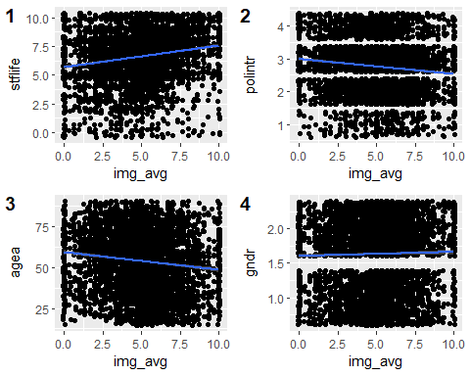
# A simple regression model
lm1 <- lm(img_avg ~ stflife + polintr + agea +gndr, data = data7)
summary(lm1)
##
## Call:
## lm(formula = img_avg ~ stflife + polintr + agea + gndr, data = data7)
##
## Residuals:
## Min 1Q Median 3Q Max
## -5.9764 -1.2399 0.0785 1.2833 6.2428
##
## Coefficients:
## Estimate Std. Error t value Pr(>|t|)
## (Intercept) 5.503170 0.213255 25.806 < 2e-16 ***
## stflife 0.144319 0.014444 9.992 < 2e-16 ***
## polintr -0.360778 0.039539 -9.125 < 2e-16 ***
## agea -0.014318 0.001757 -8.152 4.59e-16 ***
## gndr 0.199376 0.065543 3.042 0.00236 **
## ---
## Signif. codes: 0 '***' 0.001 '**' 0.01 '*' 0.05 '.' 0.1 ' ' 1
##
## Residual standard error: 2.102 on 4569 degrees of freedom
## Multiple R-squared: 0.06039, Adjusted R-squared: 0.05957
## F-statistic: 73.41 on 4 and 4569 DF, p-value: < 2.2e-16
lm2 <- lm(img_avg ~ stflife + polintr + agea, data = data7)
summary(lm2)
##
## Call:
## lm(formula = img_avg ~ stflife + polintr + agea, data = data7)
##
## Residuals:
## Min 1Q Median 3Q Max
## -6.0234 -1.2484 0.1039 1.2928 6.3303
##
## Coefficients:
## Estimate Std. Error t value Pr(>|t|)
## (Intercept) 5.724170 0.200679 28.524 < 2e-16 ***
## stflife 0.148142 0.014402 10.286 < 2e-16 ***
## polintr -0.348596 0.039371 -8.854 < 2e-16 ***
## agea -0.013472 0.001736 -7.761 1.03e-14 ***
## ---
## Signif. codes: 0 '***' 0.001 '**' 0.01 '*' 0.05 '.' 0.1 ' ' 1
##
## Residual standard error: 2.104 on 4570 degrees of freedom
## Multiple R-squared: 0.05849, Adjusted R-squared: 0.05787
## F-statistic: 94.63 on 3 and 4570 DF, p-value: < 2.2e-16
lm3 <- lm(img_avg ~ stflife + polintr +gndr, data = data7)
summary(lm3)
##
## Call:
## lm(formula = img_avg ~ stflife + polintr + gndr, data = data7)
##
## Residuals:
## Min 1Q Median 3Q Max
## -5.751 -1.264 0.110 1.289 6.443
##
## Coefficients:
## Estimate Std. Error t value Pr(>|t|)
## (Intercept) 4.53194 0.17813 25.442 < 2e-16 ***
## stflife 0.17062 0.01418 12.033 < 2e-16 ***
## polintr -0.30102 0.03913 -7.693 1.75e-14 ***
## gndr 0.11473 0.06518 1.760 0.0784 .
## ---
## Signif. codes: 0 '***' 0.001 '**' 0.01 '*' 0.05 '.' 0.1 ' ' 1
##
## Residual standard error: 2.117 on 4570 degrees of freedom
## Multiple R-squared: 0.04673, Adjusted R-squared: 0.0461
## F-statistic: 74.67 on 3 and 4570 DF, p-value: < 2.2e-16
lm4 <- lm(img_avg ~ stflife + polintr, data = data7)
summary(lm4)
##
## Call:
## lm(formula = img_avg ~ stflife + polintr, data = data7)
##
## Residuals:
## Min 1Q Median 3Q Max
## -5.8240 -1.3082 0.1385 1.3211 6.4874
##
## Coefficients:
## Estimate Std. Error t value Pr(>|t|)
## (Intercept) 4.69628 0.15174 30.950 < 2e-16 ***
## stflife 0.17196 0.01416 12.142 < 2e-16 ***
## polintr -0.29592 0.03903 -7.581 4.12e-14 ***
## ---
## Signif. codes: 0 '***' 0.001 '**' 0.01 '*' 0.05 '.' 0.1 ' ' 1
##
## Residual standard error: 2.117 on 4571 degrees of freedom
## Multiple R-squared: 0.04608, Adjusted R-squared: 0.04566
## F-statistic: 110.4 on 2 and 4571 DF, p-value: < 2.2e-16
AIC(lm1)
## [1] 19782.02
BIC(lm1)
## [1] 19820.59
AIC(lm2)
## [1] 19789.27
BIC(lm2)
## [1] 19821.41
AIC(lm3)
## [1] 19846.06
BIC(lm3)
## [1] 19878.2
AIC(lm4)
## [1] 19847.16
BIC(lm4)
## [1] 19872.88
data7
## # A tibble: 4,574 x 8
## cntry agea gndr img_avg polintr stflife img_avg_cat stflife_cat
## <chr+lbl> <dbl+> <dbl+lb> <dbl> <dbl+l> <dbl+lb> <fct> <fct>
## 1 EE [Estonia] 37 2 [Fema~ 2.67 3 [Har~ 10 [Ext~ 3-4 Extremely ~
## 2 EE [Estonia] 72 1 [Male] 5 1 [Ver~ 9 [9] 5-6 Extremely ~
## 3 EE [Estonia] 57 1 [Male] 3 1 [Ver~ 5 [5] 3-4 5-6
## 4 EE [Estonia] 56 2 [Fema~ 4 4 [Not~ 5 [5] 3-4 5-6
## 5 EE [Estonia] 53 2 [Fema~ 6.67 4 [Not~ 4 [4] 7-8 3-4
## 6 EE [Estonia] 35 1 [Male] 6.67 2 [Qui~ 5 [5] 7-8 5-6
## 7 EE [Estonia] 75 2 [Fema~ 8.33 2 [Qui~ 5 [5] Good influ~ 5-6
## 8 EE [Estonia] 72 2 [Fema~ 6 3 [Har~ 7 [7] 5-6 7-8
## 9 EE [Estonia] 28 1 [Male] 5.67 2 [Qui~ 5 [5] 5-6 5-6
## 10 EE [Estonia] 28 2 [Fema~ 3.33 3 [Har~ 6 [6] 3-4 5-6
## # ... with 4,564 more rows
# Scatter plot with some jittering & regression line.
ggplot(data7, aes(x = stflife, y = img_avg)) +
geom_point(position = "jitter") +
geom_smooth(method = lm)
## Don't know how to automatically pick scale for object of type haven_labelled/vctrs_vctr/double. Defaulting to continuous.
## `geom_smooth()` using formula 'y ~ x'
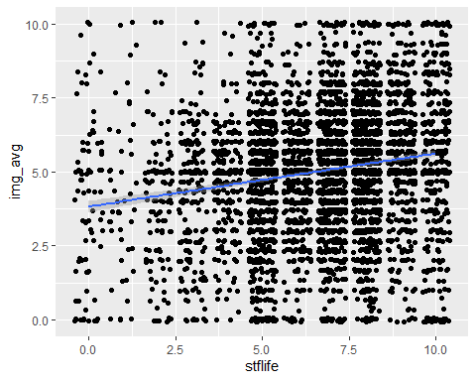
# Diagnostic plots:
layout(matrix(c(1,2,3,4),2,2))
plot(lm1)
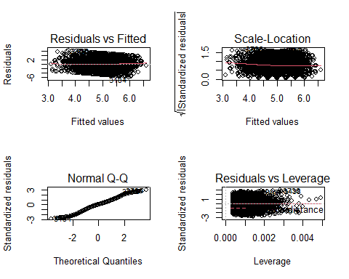
# diagnostic plots
layout(matrix(c(1,2,3,4),2,2)) # optional 4 graphs/page
plot(lm4)
