SRM INSTITUTE OF SCIENCE AND TECHNOLOGY
TIRUCHIRAPPALLI CAMPUS

Ph. D ENTRANCE EXAMINATION QUESTION PAPER – NOVEMBER 2025
DEPARTMENT OF CHEMISTRY
ANSWERE ALL THE QUESTIONS
1 | 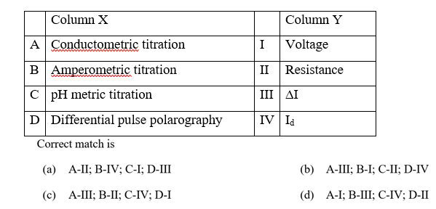 | A
2 | Which of the following acid derivatives are most stable?  - Acid chlorides (b) Esters (c) Amides (d) Anhydrides | C
3 | Which analytical technique is based on the principle of measuring the absorbance of radiation by a sample?  (a) Spectroscopy (b) Chromatography (c) Electrophoresis (d) Titration | A
4 | In the Hofmann bromamide degradation reaction, the number of moles of NaOH and Br₂ used per mole of amine produced are :  (a) One mole of NaOH and one mole of Br₂  (b) Four moles of NaOH and two moles of Br₂  (c) Two moles of NaOH and two moles of Br₂  (d) Four moles of NaOH and one mole of Br₂ | D
5 | Which one of the following statements about water is FALSE ?  (a) Water is oxidized to oxygen during photosynthesis  (b) Water can act both as an acid and as a base.  (c) There is extensive intramolecular hydrogen bonding in the condensed phase.  (d) Ice formed by heavy water sinks in normal water. | C
6 | Ionization energy of hydrogen atom in ground state is 13.6 eV. The energy released 9in eV) for third member of Balmer series is  - 13.056  - 2.856  - 0.967  - 0.306 | B
7 | In the Given cyclic voltammogram, the nature of the redox process is ______  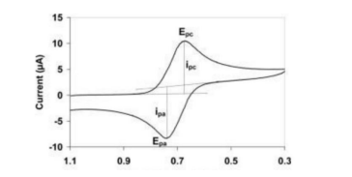  - The process is irreversible  - The process is reversible  - Analyte is adsorbed on the electrode surface  - Instrumental fault | B
8 | ________ containing food supplies Nitrogen in our body  - Vitamin – A  - Proteins  - Carbohydrates  - Fats | B
9 | The CORRECT expression that corresponds to reversible and adiabatic expansion of an ideal gas is  - ΔU = 0  - ΔH = 0  - ΔS = 0  - ΔG = 0 | C
10 | The reaction given below is an example of  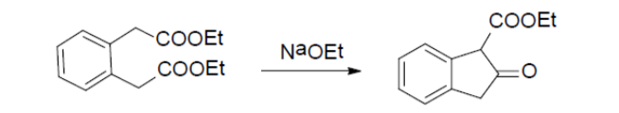  - Aldol condensation  - Knoevenagel Condensation  - Dieckmann condensation  - Acyloin condensation | C
11 | Jahn Teller distortion is observed in octahedral complexes with d-electron configuration of  A) d⁵-high spin B) d⁴-low spin C) d⁶-high spin D) d⁶-low spin | C
12 | On hydrolysis of aluminium carbide produces  - CH₄  - C₂H₆  - C₂H₄  - C₂H₂ | A
13 | 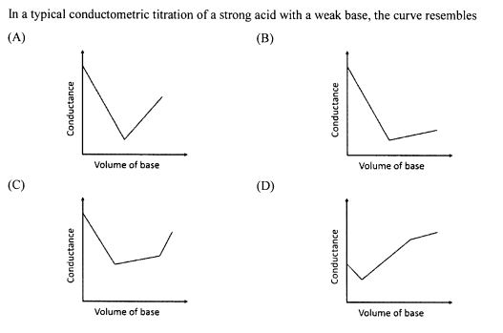 | B
14 | For adsorption of a gas on a solid surface, the plot that represents Freundlich isotherm is (x = mass of gas, m = mass of adsorbent, P = pressure)  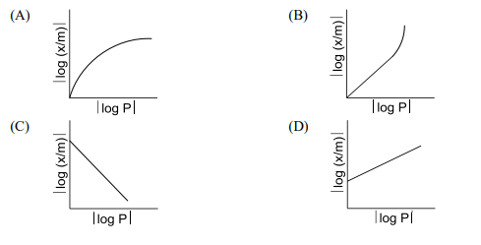 | D
15 | ________ containing food supplies Nitrogen in our body  - Vitamin – A  - Proteins  - Carbohydrates  - Fats | B
16 | The major product formed in the reaction of 2-methyl but-3-en-2-ol with HBr is  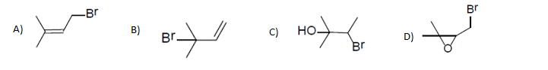 | A
17 | The monomer of biopolymer DNA is _________  - Nucleotide  - Amino acid  - Disaccharide  - Fatty acid | A
18 | Among the following compounds, the pair of enantiomers is  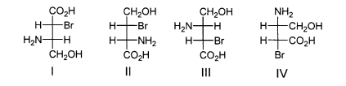  A) I and IV B) I and III C) II and III D)III and IV | B
19 | Boron cannot form which one of the following anions?  (a) BF₆³⁻  (b) BH₄⁻  (c) B(OH)₄⁻  (d) BO₂⁻ | A
20 | In IR spectrum, recorded neat, a compound shows a strong and broad band at 3300 cm-¹. The ban has become sharp and shifts to 3600 cm⁻¹ when the spectrum is recorded in CCl₄ at high dilution. This proves that the compound has  - OH group, which is involved in intramolecular H-bonding  - OH group, which is involved in intermolecular H-bonding  - A terminal alkyne group  - OH group, present in severely sterically hindered environment | B
21 | Oxidised form of enzyme catalase (Structure A); prepared by the reaction of [Fe(P)]+ (P = porphyrin) with H2O2, has green color because  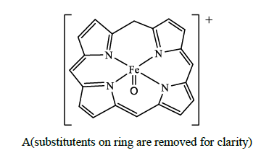  (A) Oxidation state of iron changed from Fe^{III} to Fe^{IV}.  (B) Porphyrin ring is oxidized by one electron  (C) π - π* transition appears in the visible region  (D) FeIV is coordinated with anionic tyrosinate ligand in axial position. | A
22 | According to MO theory, for the atomic species ‘C₂’  - Bond order is two and it is paramagnetic  - Bond order is two and it is diamagnetic  - Bond order is zero and it is paramagnetic  - Bond order is zero and it is diamagnetic | B
23 | The correct order of enthalpy of hydration for the transition metal ions is  - Cr²⁺ > Mn²⁺ > Co²⁺ > Ni²⁺  - Ni²⁺ > Co²⁺ > Mn²⁺ > Cr²⁺  - Ni²⁺ > Co²⁺ > Cr²⁺ > Mn²⁺  - Cr²⁺ > Mn²⁺ > Ni²⁺ > Co²⁺ | C
24 | The metal ion (M²⁺) in the following reaction is  - Mn²⁺  - Fe²⁺  - Cd²⁺  - Cu²⁺ | D
25 | Match the column 1 with column 2  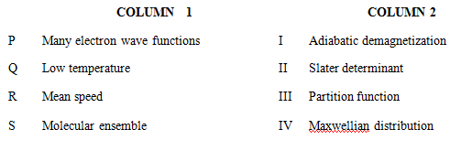  - P – I Q – III R – II S – IV  - P – II Q – IV R – III S – I  - P – II Q – I R – IV S – III  - P – I Q – II R – III S – IV | C
26 | Which of the following is not a ligand in the spectrochemical series?  - F⁻  - CN⁻  - C₂H₅OH  - CO | C
27 | Among the following metal carbonyl species, the one with the highest metal-carbon back bonding is  - [Ti(CO)₆]²⁻  - [V(CO)₆]⁻  - Cr(CO)₆  - [Mn(CO)₆]⁺ | A
28 | The Sequence of the three steps involved in the following conversion is  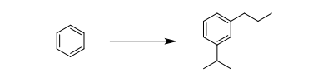  - (i) Friedel-Crafts alkylation; (ii) Reduction; (iii) Friedel-Crafts acylation  - (i) Friedel-Crafts acylation; (ii) Friedel-Crafts alkylation; (iii) Reduction  - (i) Friedel-Crafts acylation; (ii) Reduction; (iii) Friedel-Crafts alkylation  - (i) Friedel-Crafts alkylation; (ii) Friedel-Crafts acylation; (iii) Reduction | B
29 | Predict the starting material for the following reaction  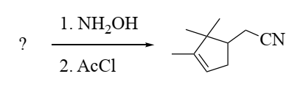  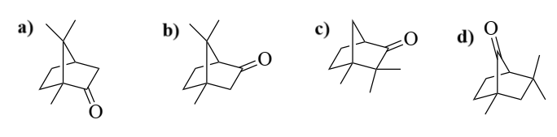 | A
30 |  | B

***********************

