 | FACULTY OF ENGINEERING AND TECHNOLOGY  DEPARTMENT OF MATHEMATICS
Ph.D.Entrance Examination – May 2026
MCQ Type Question Paper
Name | :_______________________________ | Department | : Physics
Application No. | :_______________________________ | Date | :
 |  | Duration | : 2 hrs
 |  | Maximum Marks | :
Instructions to candidates:
- All questions are Multiple Choice Questions (MCQs).
- Each question has four options, of which only one is correct.
- Each correct answer carries one mark.
- There is no negative marking for incorrect answers.
- The use of calculators, mobile phones, smartwatches, or any reference material is strictly prohibited during the examination.
- Use only a black or blue ballpoint pen to mark your answers in the OMR sheet.
- Perform rough work only in the space provided in the question paper booklet.
- Ensure that all required details (such as Name, Registration Number, etc.) are filled in correctly on the OMR sheet before starting the exam.

- Hamiltonian represents the __________
- Kinetic energy of a system
- Potential Energy of a system
- Total energy of a system
- Difference betweem K.E and P.E of a system
- Stokes theorem relates to _____________
  - any two integrals
  - line integral and surface integral
  - line integral and volume integral
  - volume integral and surface integral

- The coherence length in a superconductors is ______
  - proportional to the square of the average speed of electrons at the Fermion surface
  - Proportional to the transition temperature
  - Inversely proportional to the transition temperature
  - Inversely proportional to the average speed of electrons at the Fermion surface

- The four matrices α_{x}, α_{y}, α_{z} and β in Dirac's free particle equation,
  - must be hermitian
  - need not be hermitian
  - must be Quadratic
  - must be unitary

- The study of interaction of the nuclear quadrupole moment with the electric field gradient is
  - NMR
  - UV- spectroscopy
  - Infrared spectroscopy
  - Mass spectroscopy

- Maxwell's equation relates electric field intensity with
  - Volume density of charge
  - magnetic induction
  - current density
  - electric displacement vector

- Gibb's function is given by the equation

  - G = U+TS
  - G=U-TS
  - G=U-TS+PV
  - G=U+TS+PV

- According to Born-Oppenheimer approximation
  - electronic, vibrational and rotational energies of a molecule are independent of each other
  - vibrational and rotational energies are independent of each other but not electronic
  - electronic and rotational energies are independent of each other but not vibrational energy
  - electronic, vibrational and rotational energies of a molecules are depencent on each other

- In finding the roots of the polynomial using the iterative Newton-Raphson method, the initial guess is taken to be x = 2. In the next iteration its value is nearest to
(a) 1.671 (b) 1.656 (c) 1.559 (d) 1.551

- Which of the following matrices is an element of the group SU(2)?
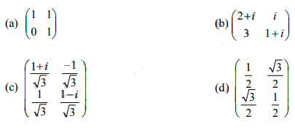

Answer: (c)

- The state of population inversion is also known as
    - Equilibrium state
    - Positive temperature state
    - Negative temperature state
    - None of the above

- Binding energy of cooper pair is of the order of
    - 10⁻¹⁰ eV
    - 10⁻⁴eV
    - 10⁻⁶eV
    - 10⁻⁸eV

13. In the Kronig-Penny model, if there exists no potential barrier, then
(a) There exists a periodic dependence of E and K
(b) There is no forbidden energy region
(c) E is not a continuous function of K
(d) All values of E are not allowed

14. The two operators && and || are
(a) Arithmetic operators (b) Equality operators (c) Logical operators (d) Relational operators

15. The initial tools used to help launch the nanoscience revolution were ___________
a) Binoculars
b) Microscope
c) Scanning probe instruments
d) Interferometer

16. In the chemical vapour deposition the films formed are formed by decomposition of what kind of substances?
a) Gaseous molecules
b) Solid molecules
c) Conducting polymers
d) Liquid molecules
17. Cu Kα radiation of wavelength 1.5418 A˚, is generated by which of the following transition?
a) 2s→4s
b) 2p→1s
c) 1s→2p
d) 3s→1s
- The longest wavelength that can be analysed by a NaCl crystal of interpalanar spacing 0.281 nm between its principal planes, in the first order is:
- 0.654 nm (b) 0.564 nm (c) 0.969 nm (d) 0.282 nm
- Chemical vapour deposition apparatus comprises of several basic components. Which of the following is not one of them?
a) Gas delivery system
b) RHEED Gun
c) Vacuum system
d) Exhaust system
- Interaction between biomolecules and nanoparticles is largely governed by:
(a) Van der Waals forces
(b) Quantum tunneling
(c) Covalent bonding
(d) Electrostatic and hydrophobic interactions
Answer: D
- The finer resolution in lithography can be obtained by using
- Blue light (b) UV light (c) Red light (d) X-rays
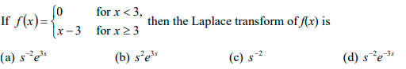

Answer: (d)
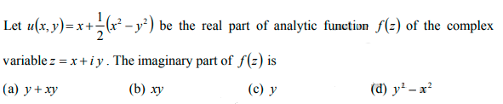

Answer: (a)

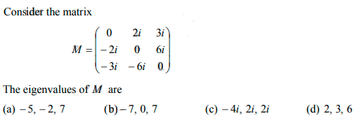

Answer: (b)

- A flip-flop is also called
  - monostable multivibrator
  - bistable multivibrator
  - astable multivibrator
  - Comparator

