 | FACULTY OF ENGINEERING AND TECHNOLOGY  DEPARTMENT OF CHEMISTRY
Ph.D Entrance Examination – January 2026
B
MCQ Type Question Paper
Name | :_______________________________ | Department | : Chemistry
Application No. | :_______________________________ | Date | : 10/11/2025
 |  | Duration | : 2hrs
 |  | Maximum Marks | : 501=50

Instructions to candidates:
- All questions are Multiple Choice Questions (MCQs).
- Each question has four options, of which only one is correct.
- Each correct answer carries one mark.
- There is no negative marking for incorrect answers.
- The use of calculators, mobile phones, smartwatches, or any reference material is strictly prohibited during the examination.
- Use only a black or blue ballpoint pen to mark your answers in the OMR sheet.
- Perform rough work only in the space provided in the question paper booklet.
- Ensure that all required details (such as Name, Registration Number, etc.) are filled in correctly on the OMR sheet before starting the exam.
- The main characteristic of scientific research is
A. Empirical
B. Theoretical
C. Experimental
D. All of the above

- Authenticity of a research finding is its
A. Originality
B. Validity
C. Objectivity
D. All of the above

- Which technique is generally followed when the population is finite?
A. Area Sampling Technique
B. Purposive Sampling Technique
C. Systematic Sampling Technique
D. None of the above

- Research problem is selected from the stand point of
A. Researcher’s interest
B. Financial support
C. Social relevance
D. Availability of relevant literature

- The research is always
A. verifying the old knowledge
B. exploring new knowledge
C. filling the gap between knowledge
D. all of these

- Research is
A. Searching again and again
B. Finding a solution to any problem
C. Working in a scientific way to search for the truth of any problem
D. None of the above

- A common test in research demands much priority on
A. Reliability
B. Use ability
C. Objectivity
D. All of the above

- Which of the following is the first step in starting the research process?
A. Searching sources of information to locate the problem.
B. Survey of related literature
C. Identification of the problem
D. Searching for solutions to the problem

- Which correlation coefficient best explains the relationship between creativity and intelligence?
A.1.00
B. 0.6
C. 0.5
D. 0.3

- Manipulation is always a part of
A. Historical research
B. Fundamental research
C. Descriptive research
D. Experimental research

- Generalized conclusion on the basis of a sample is technically known as
A. Data analysis and interpretation
B. Parameter inference
C. Statistical inference
D. All of the above

- The experimental study is based on
A. The manipulation of variables
B. Conceptual parameters
C. Replication of research
D. Survey of literature

- Which one is called non-probability sampling?
A. Cluster sampling
B. Quota sampling
C. Systematic sampling
D. Stratified random sampling

- Formulation of hypothesis may NOT be required in
A. Survey method
B. Historical studies
C. Experimental studies
D. Normative studies

15. A researcher is interested in studying the prospects of a particular political party in an urban area. So, what tool should he prefer for the study?
A. Rating Scale
B. Interview
C. Questionnaire
D. Schedule
16. How to judge the depth of any research?
A. By research title
B. By research duration
C. By research objectives
D. By total expenditure on research
17. Which of the following is not the method of Research?
A. Survey
B. Historical
C. Observation
D. Philosophical
18. What does a good thesis involve?
a. Reducing punctuation as well as grammatical errors to minimalist
b. Correct reference citations
c. Consistency in the way of thesis writing
d. Well defined abstract
Select the answers from the codes given below:
A. b), c) and d)
B. a), b), c) and d)
C. a), b) and c)
D. a), b) and d)

19. On what basis did Jean Piaget give his theory of cognitive development of humans?
A. Evaluation Research
B. Fundamental Research
C. Applied Research
D. Action Research

20. “Sampling Cases” can be defined as
A. Sampling using a sampling frame
B. Identifying people who are suitable for research
C. Literally the researcher’s brief case
D. A sampling of people, newspapers, television programs etc

21. Which one among the following variables cannot be expressed in quantitative terms?
A. Numerical Aptitude
B. Marital Status
C. Socio-economic Status
D. Professional Attitude

22. On what basis can one formulate the assumptions?
A. The cultural background of the country
B. Universities
C. Some specific characteristics of castes
D. All of the above

23. The process not needed in experimental research is
A. Controlling
B. Observation
C. Reference collection
D. Manipulation and replication

24. Which one among the following is the most comprehensive source of population data?
A. Census
B. National Sample Surveys
C. Demographic Health Surveys
D. National Family Health Survey

25. How can we enhance the research objective?
A. By making it more valid
B. By making it more reliable
C. By making it more impartial
D. All of the above
26. The decreasing order of nucleophilicity for the following anions is
CH₃CO₂⁻, CH₃O⁻, C₆H₅O⁻, NO₃⁻
A. CH₃CO₂⁻ > CH₃O⁻ > C₆H₅O⁻ > NO₃⁻
B. CH₃O⁻ > NO₃⁻ > C₆H₅O⁻ > CH₃CO₂⁻
C. CH₃O⁻ > C₆H₅O⁻ > CH₃CO₂⁻ > NO₃⁻
D. C₆H₅O⁻ > CH₃O⁻ > NO₃⁻ > CH₃CO₂⁻

27. Consider the statements about the following structures (X) & (Y).
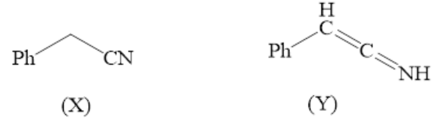
(i) X and Y are resonance structures
(ii) X and Y are tautomers
(iii) Y is more basic than X
(iv) X is more basic than Y
Correct statement(s) are
A. (i) and (iii)
B. (iii)
C. (ii) and (iv)
D. (ii) and (iii)

28. The highest occupied molecular orbital in N₂ and O₂⁺ respectively are (take x as
internuclear axis)
A. σ_{2px}, π*_{2p}
B. π_{2py}, π_{2pz}
C. σ*_{2px}, σ_{2px}
D. π*_{2py}, π*_{2pz}

29. According to wade's rule, the correct structural types of the complexes [Co(n⁵C₅H₅)B₄H₈]
and [Mn(n²-B₃H₈)(CO)₄]

A. Closo and Nido
B. Nido and Arachno
C. Closo and Arachno
D. Nido and Nido
30. The number of valance electrons provided by [Ru(CO)₃] towards cluster bonding is
A. 1
B. 14
C. 6
D. 2
31. Which of the following dipositive lanthanide ion is most stable?
A. Ce²⁺
B. Eu²⁺
C. Gd²⁺
D. Ho²⁺

32. What are the total number of fine EPR lines expected from high spin Cr (II) complexes?
(for Cr, I = 3/2)
A. 6
B. 0
C. 4
D. 2

33. Number of chiral centers present in the following molecule are
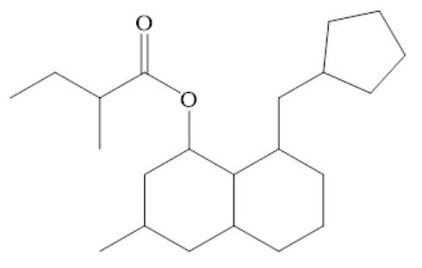
A. 4
B. 5
C. 6
D. 7

34. Which of the following is correct about the following compound?
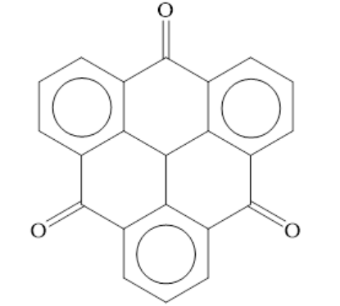
A. It possesses a centre of symmetry
B. It possesses a C₄ axis of symmetry
C. It possesses a plane of symmetry
D. Compound is chiral

35. The sensitivity of 600 MHz NMR spectrometer is more than that of a 60 MHz
spectrometer because
A. Population of spin states is directly proportional to the applied magnetic field.
B. Population of spin states is inversely proportional to the applied magnetic field.
C. According to the Boltzmann distribution law, the excess population in the lower
spin state increases with increasing applied magnetic field.
D. The spectral scan width is more for a 600 MHz spectrum compared to a 60 MHz
spectrum.

36. Which of the following compounds is expected to show a sharp singlet for one of its
protons at δ > 8 ppm in ¹H NMR spectrum, given that this signal remains unaffected on
shaking the solution thoroughly with D₂O?
A. CH₃CO₂H
B. CH₃CONHC₆H₅
C. n-C₆H₁₃C≡CH
D. n-C₆H₁₃CHO

37. Sucrose is converted to a mixture of glucose and fructose in a pseudo first order process
under alkaline conditions. The reaction has a half-life of 28.4 min. The time required for
the reduction of a 8.0 mM sample of sucrose to 1.0 mM is
A. 56.8 min
B. 170.4 min
C. 85.2 min
D. 227.2 min

38. Which of the following species posses both C₃ and C₂ axis?
A. SO₃
B. NH₃
C. PCl₃
D. [H₃O]⁺

39. Cyclooctatetraene is not aromatic because of
A. It does not have essential π electrons.
B. It does not have delocalization of π electrons.
C. It does not have a planer conformation.
D. It does not follow (4n) π Huckel's rule.

40. The number of triangular faces in square antiprism, icosahedron and tricapped triagonal
prism (capped on square faces) respectively are
A. 8, 20, 14
B. 8, 20, 12
C. 10, 12, 14
D. 10, 12, 12

41. The order of polarity of NH₃, NF₃ and BF₃ is
A. NH₃ < NF₃ < BF₃
B. BF₃ < NF₃ < NH₃
C. BF₃ < NH₃ < NF₃
D. NF₃ < BF₃ < NH₃
42. The amino acid which is not optically active is
A. Lactic acid
B. Serine
C. Alanine
D. Glycine

43. Which of the following hormones is excreted from adrenal cortex?
A. Cortisone
B. Estrogen
C. Progesterone
D. Testosterone

44. Trivalent lanthanide ion having isotopic magnetic susceptibility is
A. Eu³⁺
B. Gd³⁺
C. Yb³⁺
D. Lu³⁺

45. In the Lindemann mechanism of unimolecular reactions, the observed order at low
concentration is
A. 0.5
B. 1
C. 1.5
D. 2

46. The value log_{e} (K_{sp}) for Fe(OH)₃ at 298 K is
A. -38.2
B. +87.6
C. -96.0
D. -87.6

47. Which of the following statements is not correct about the given compound?
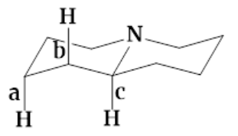
A. The stretching frequency of bond b is greater than bond c
B. The stretching frequency of bond c is greater than bond a
C. The bond length of a is smaller than bond c
D. The bond length of b is smaller than bond c

48. Among the bromide I-III given below, the order of their reactivity in the SN¹ reaction is
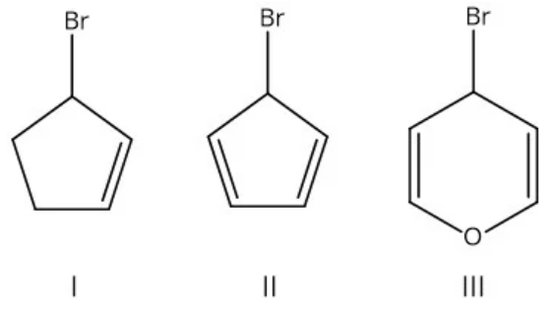
A. III>II>I
B. II>III>I
C. III>I>II
D. II>I>III
49. Which of the following absorptions are shown by 1,3-butadiene in its UV absorption
spectrum recorded in n-hexane (ε_{max} is the molar absorptivity)?
A. λ_{max} 217 nm (ε_{max} = 21000)
B. λ_{max} 214 nm (ε_{max} = 210)
C. λ_{max} 253 nm (ε_{max} = 50000)
D. λ_{max} 250 nm (ε_{max} = 500)

50. Compound that exhibits sharp bands at 3300 cm⁻¹ and 2150 cm⁻¹ in the IR spectrum is
A. 1-butyne
B. 2-butyne
C. butyronitrile
D. butylamine

