 | FACULTY OF ENGINEERING AND TECHNOLOGY  DEPARTMENT OF CHEMISTRY
A
Name | :___________________________ | Department | : ________________________
Application No. | :___________________________ | Date | : 16/05/2026
 |  | Duration | : 2 hrs
 |  | Maximum Marks | : 50$×$1=50

Instructions to Candidates
- This question paper consists of Multiple Choice Questions (MCQs) only.
- Each question has four options (a, b, c, and d), out of which only one option is correct.
- Each correct answer carries one mark. There is no negative marking for incorrect answers.
- Candidates must mark their answers only on the OMR sheet provided.
- The use of calculators, mobile phones, smartwatches, or any electronic devices is strictly prohibited inside the examination hall.
- Reference materials, notes, books, or any printed resources are not permitted during the examination.
- Use only a black or blue ballpoint pen to mark the answers on the OMR sheet.
- Rough work should be done only in the space provided in the question paper booklet.
- Before starting the examination, ensure that all required details (Name, Application Number, etc.) are correctly filled in on the OMR sheet.
- Do not fold, damage, or mark the OMR sheet unnecessarily, as it will be scanned for evaluation.

Research Methodology
(25$×$1=25)
- The question starts here
- Option A
- Option B
- Option C
- Option D
- The question starts here
- Option A
- Option B
- Option C
- Option D
- The question starts here
- Option A
- Option B
- Option C
- Option D

- The question starts here
- Option A
- Option B
- Option C
- Option D

Chemistry Questions
(25$×$1=25)
26 | Predict the starting material for the following reaction  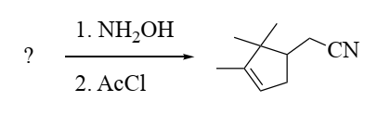  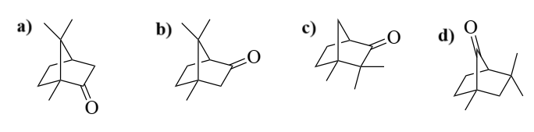
27 | Among the following compounds which is the best Brønsted acid?  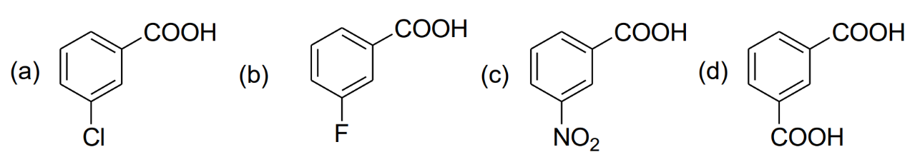
28 | For an unambiguous single step synthesis of the following target molecule (TM), the best bond disconnection in its retrosynthetic analysis is  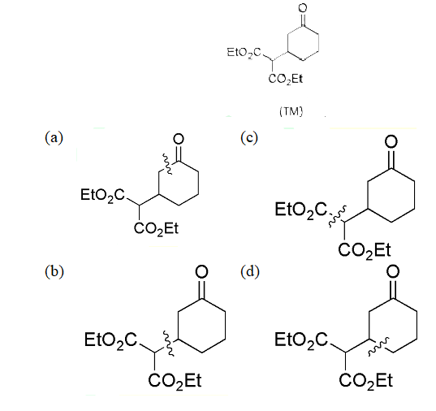
29 | Which of the following compounds does not give a tertiary alcohol upon reaction with methyl magnesium bromide?  - 4,4-Dimethylcyclohexanone  - 4-Heptanone  - Ethyl benzoate  - 3-Methylpentanal
30 | The reaction given below is an example of  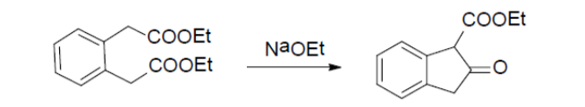  - Aldol condensation  - Knoevenagel Condensation  - Dieckmann condensation  - Acyloin condensation
31 | Jahn Teller distortion is observed in octahedral complexes with d-electron configuration of  - d⁵-high spin  - d⁴-low spin  - d⁶-high spin  - d⁶-low spin
32 | O₂¯ is  (a) having a shorter O – O bond length than that in O₂  (b) IR active  (c) unable to abstract proton from weak acids  (d) a strong oxidising agent than O₂
33 | Consider the following statements:  (A) the highest oxidation state of Group 8 elements is more readily shown in their oxides than in fluorides  (B) Fe can exist in – 2 formal oxidation state also  (C) Mn, Tc and Re easily form M(II) compounds  The correct statements is / are:  - A and B  - A and C  - B and C  - C only
34 | The correct statement about hexagonal boron nitride is  (a) It is a good electrical conductor  (b) It has same layer stacking as that of graphite  (c) It is reactive towards fluorine  (d) It has lower thermal stability in air compare to that of graphite
35 | Select optically active complex molecule from the following  - Pt(NH₃)₂Cl₂  - Ni(CO)₂(PPh₃)₂  - trans-Co(en)₂Cl₂  - cis-Co(en)₂Cl₂
36 | In neutron analysis the radiation commonly detected is  - α – rays  - β – rays  - γ – rays  - X – rays
37 | Consider the following reaction:  Hg₂⁺ _{(aq)} + X – _{(aq)} === [HgX]⁺_{(aq)}  The solubility constants for [HgX]⁺_{(aq)} for X = F, Cl and Br follow the order  - F<Cl<Br  - Br<Cl<F  - Cl < Br < F  - Br<F<Cl
38 | Chose the correct statements for oxyhaemoglobin and cytochrome P450 (resting state) from the following:  - Both contain dianion of protoporphyrin – IX  - They have same fifth ligand to metal centre from the protein backbone  - They contain single active site  - They contain metal ion in +3 oxidation state  Answer is  - A,B and C  - A,C and D  - A,B and D  - B and C only
39 | What is the ground state term symbol for a d⁵ high-spin ion?  - ³P  - ⁴F  - ⁵D  - ⁶S
40 | In a reaction ‘X’ moles of the reactant A decomposes to give 1 mole each of C and D. It has been found that the fraction of A decomposed at equilibrium is independent of initial concentration of A. The value of ‘X’ is  - 1  - 2  - 4  - 3
41 | Among the following, select the complex that exhibits the largest molar absorptivity in the visible region of the electronic absorption spectrum is:  - [Ti(H₂O)₆]³⁺  - [NiCl₄]²⁻  - [CrO₄]²⁻  - [Mn(H₂O)₆]²⁺
42 | The correct option for the metal ion present in the active site of myoglobin, hemocyanin and vitamin B12, respectively,  (a) Iron, Iron and Zinc  (b) Molybdenum, iron and copper  (c) Iron, copper and cobalt  (d) Molybdenum, copper and cobalt
43 | Find the radius of an atom in FCC unit cell having edge length 393 pm.  - 196.51 pm  - 170.22 pm  - 138.93 pm  - 150.93 pm
44 | Identify the Gibbs phase rule for metallurgical system  - F = C – 1 – P  - F = C + 1 – P  - P + F = C – 2  - P + F = C + 2
45 | The conversion of excited singlet state (S₁) of a molecule to triplet state (T₁) is known as  - Fluorescence  - Phosphoresence  - Intersystem crossing  - Internal conversion
46 | The purpose of adding Buffer solution is.  - To make the solution basic  - To make the solution acidic  - To maintain solution’s pH  - To change the concentration
47 | What is the primary advantage of High-Performance Liquid Chromatography (HPLC) over Gas Chromatography (GC)?  (a) Higher sensitivity  (b) Faster analysis time  (c) Ability to analyze non-volatile compounds  (d) Lower cost
48 | The forbidden transition in UV Visible is.  - π →π*  - n→π*  - n→σ*  - σ→σ*
49 | Assertion (A): Calcium salt solution does not show any change even after adding an excess of ammonia solution to it.  Reason (R): The low concentration of hydroxide ion in ammonium hydroxide solution which are unable to precipitate the hydroxide ions of calcium  - Both A and R are true and R is the correct explanation of A.  - Both A and R are true but R is not the correct explanation of A.  - A is true but R is false.  - A is false but R is true.
50 | Which versatile laboratory technique used to separate, identify, and purify individual components within complex mixtures ?  - Spectroscopy  - Chromatography  - Electrophoresis  - Titration

Answer Key
A
Question No. | Correct Option | Question No. | Correct Option
1 | (Example:) A | 26 | A
2 |  | 27 | C
3 |  | 28 | C
4 |  | 29 | D
5 |  | 30 | C
6 |  | 31 | B
7 |  | 32 | D
8 |  | 33 | A
9 |  | 34 | A
10 |  | 35 | D
11 |  | 36 | C
12 |  | 37 | A
13 |  | 38 | B
14 |  | 39 | D
15 |  | 40 | B
16 |  | 41 | C
17 |  | 42 | C
18 |  | 43 | C
19 |  | 44 | B
20 |  | 45 | C
21 |  | 46 | C
22 |  | 47 | C
23 |  | 48 | A
24 |  | 49 | A
25 |  | 50 | B

Note to Question Paper Setters
- Format Requirements
  - Font: Times New Roman
  - Font Size: 12
- Equations
  - All equations must be created using MathType or the Microsoft Equation Editor.
  - Images of equations should not be inserted.
- Figures and Images
  - Any figures or images included must be clear, high-resolution, and suitable for printed format.
- Answer Indication
  - The correct answer should be clearly bolded in the submitted question paper template.
- Examination Rules
  - The use of calculators or reference materials is not permitted during the examination.
- Question Set Preparation
  - Questions must not be repeated across Set A and Set B.
  - Questions with similar meaning or concept duplication should be avoided across the sets to ensure a diverse assessment of candidates' knowledge and critical thinking skills.
- Standard of Questions
  - The questions should be appropriate for a PhD entrance examination and cover both:
    - Research Methodology
    - Subject-specific advanced concepts
- The answer keys must be provided in the template.
- The name of the institution and the department must be clearly mentioned at the top of the template.

