 | FACULTY OF ENGINEERING AND TECHNOLOGY  DEPARTMENT OF CHEMISTRY
Ph.D Entrance Examination – January 2026
A
MCQ Type Question Paper
Name | :_______________________________ | Department | : Chemistry
Application No. | :_______________________________ | Date | : 10/11/2025
 |  | Duration | : 2hrs
 |  | Maximum Marks | : 501=50

Instructions to candidates:
- All questions are Multiple Choice Questions (MCQs).
- Each question has four options, of which only one is correct.
- Each correct answer carries one mark.
- There is no negative marking for incorrect answers.
- The use of calculators, mobile phones, smartwatches, or any reference material is strictly prohibited during the examination.
- Use only a black or blue ballpoint pen to mark your answers in the OMR sheet.
- Perform rough work only in the space provided in the question paper booklet.
- Ensure that all required details (such as Name, Registration Number, etc.) are filled in correctly on the OMR sheet before starting the exam.

- Which of the following statement is correct?
A. Reliability ensures the validity
B.Validity ensures reliability
C. Reliability and validity are independent of each other
D. Reliability does not depend on objectivity

- The first step of research is
A. Selecting a problem
B. Searching a problem
C. Finding a problem
D. Identifying a problem

- Which of the following statements is correct?
A. Objectives of research are stated in first chapter of the thesis
B. Researcher must possess analytical ability
C. Variability is the source of problem
D. All the above
- Research can be conducted by a person who
A. holds a postgraduate degree
B. has studied research methodology
C. possesses thinking and reasoning ability
D. is a hard worker
- Research can be classified as
A. Basic, Applied and Action Research
B. Philosophical, Historical, Survey and Experimental Research
C. Quantitative and Qualitative Research
D. All the above
- To test null hypothesis, a researcher uses
A. t test
B. ANOVA
C. X²
D. factorial analysis
- Bibliography given in a research report
A. shows vast knowledge of the researcher
B. helps those interested in further research
C. has no relevance to research
D. all the above
- A research problem is feasible only when
A. it has utility and relevance
B. it is researchable
C. it is new and adds something to knowledge
D. all the above
- The study in which the investigators attempt to trace an effect is known as
A. Survey Research
B. Summative Research
C. Historical Research
D. ‘Ex-post Facto’ Research
- Fundamental research reflects the ability to
A. Synthesize new ideals
B. Expound new principles
C. Evaluate the existing material concerning research
D. Study the existing literature regarding various topics
- The research which is exploring new facts through the study of the past is called
A. Philosophical research
B. Historical research
C. Mythological research
D. Content analysis

- A null hypothesis is
A. when there is no difference between the variables
B. the same as research hypothesis
C. subjective in nature
D. when there is difference between the variables
- We use Factorial Analysis
A. To know the relationship between two variables
B. To test the Hypothesis
C. To know the difference between two variables
D. To know the difference among the many variables

- Which of the following is classified in the category of the developmental research?
A. Philosophical research
B. Action research
C. Descriptive research
D. All the above

- Action-research is
A. An applied research
B. A research carried out to solve immediate problems
C. A longitudinal research
D. All the above

- The basis on which assumptions are formulated?
A. Cultural background of the country
B. Universities
C. Specific characteristics of the castes
D. All of these

- How can the objectivity of the research be enhanced?
A. Through its impartiality
B. Through its reliability
C. Through its validity
D. All of these

- A research problem is not feasible only when
A. it is researchable
B. it is new and adds something to the knowledge
C. it consists of independent and dependent variables
D. it has utility and relevance

- The process not needed in experimental research is
A. Observation
B. Manipulation and replication
C. Controlling
D. Reference collection

- When a research problem is related to heterogeneous population, the most suitable sampling method is
A. Cluster Sampling
B. Stratified Sampling
C. Convenient Sampling
D. Lottery Method

- Field-work-based research is classified as
A. Empirical
B. Historical
C. Experimental
D. Biographical

- Which of the following sampling method is appropriate to study the prevalence of AIDS amongst male and female in India in 1976, 1986, 1996 and 2006?
A. Cluster sampling
B. Systematic sampling
C. Quota sampling
D. Stratified random sampling

- The research that applies the laws at the time of field study to draw more and more clear ideas about the problem is
A. Applied research
B. Action research
C. Experimental research
D. None of these

- What is the major attribute of Correlation Analysis?
A. Association among variables
B. Difference among variables
C. Regression among variables
D. Variations among variables

- What do you understand by the term Anusandhan?
A. Goal-oriented
B. Following an aim
C. Attaining an aim
D. Praying to achieve an aim
26. The correct order of the bond dissociation energies for the indicated C-H bond in the
following compounds is
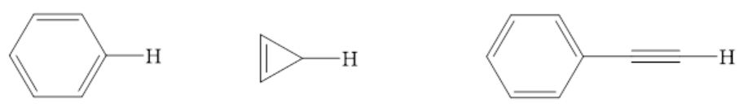
- (ii) (iii)
A. iii > ii > i
B. I > ii > iii
C. I > iii > ii
D. iii > I > ii

27. In allene, hybridization of the central and terminal carbons respectively are
A. sp² and sp²
B. sp² and sp³
C. sp and sp²
D. sp and sp³

28. According to Bent's rule, for p-block elements the correct combination of geometry
around the central atom and the position of more electronegative substituent is
A. trigonal bipyramidal and axial
B. trigonal bipyramidal and equatorial
C. square pyramidal and axial
D. square pyramidal and equatorial

29. The cluster having Arachno type structure is
A. [Os₅(CO)₁₆]
B. [Os₃(CO)₁₂]
C. [Ir₄(CO)₁₂]
D. [Rh₆(CO)₁₆]

30. The number of skeletal electrons present in the compounds C₂B₃H₅, C₂B₄H₆ and
B₅H₉ respectively are
A. 10, 12 and 12
B. 12, 14 and 14
C. 10, 12 and 14
D. 12, 14 and 12

31. The separation of trivalent lanthanide ions, Lu³⁺, Yb³⁺, Dy³⁺, Eu³⁺, can be effectively
done by a cation exchange resin using ammonia o-hydroxy isobutyrate as the event the
order in which the ions will be separated is

A. Lu³⁺, Yb³⁺, Dy³⁺, Eu³⁺
B. Eu³⁺, Dy³⁺, Yb³⁺, Lu³⁺
C. Dy³⁺, Yb³⁺, Eu³⁺, Lu³⁺
D. Yb³⁺, Dy³⁺, Lu³⁺, Eu³⁺

32. Which of the following molecules are ESR active?
A. KMnO₄
B. [Fe(CO)₆]²⁺
C. K₄[Fe(CN)₆]
D. K₃[Fe(CN)₆]

33. How are the following compounds related?
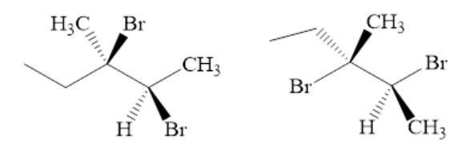
A. Diastereomers
B. Enantiomers
C. Meso compounds
D. Identical

34. Following compounds are different in respect of
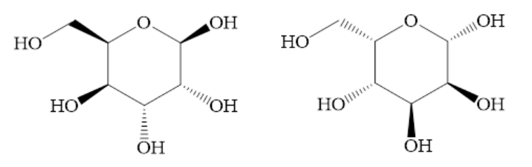
A. their chemical and physical properties
B. nothing
C. the direction in which they tend to rotate the plane polarized light
D. their interactions with molecules

35. ¹H NMR spectrum of a mixture of benzene and acetonitrile shows two singlets of equal
integration. The molar ratio of benzene: acetonitrile is
A. 1:1
B. 2:1
C. 1:2
D. 6:1

36. In the photochemical reaction formation of the compound [X] can be inferred by the
disappearance of the ¹H NMR signal at ¹H NMR spectrum of the starting material: δ 9.7
(1H, s), 7.8 (1H, d, J=8 Hz), 7.1-6.8 (2H, m), 3.9 (3H, s), 2.5 (3H, s) ppm.
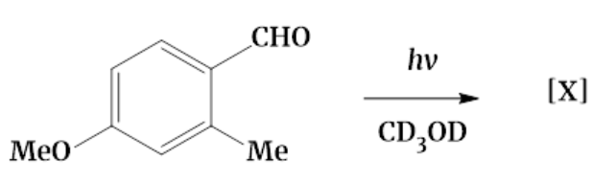
A. δ 9.7 ppm
B. δ 7.8 ppm
C. δ 3.9 ppm
D. δ 2.5 ppm

37. In kinetic study of a chemical reaction, slopes are drawn at different times in the plot of
concentration of reactants versus time. The magnitude of slopes with increase of time
A. remains unchanged
B. increases
C. decreases
D. increases and decreases periodically

38. Conversion of boron trifluoride to tetrafluoroborate ion accompanies
A. Increase in symmetry and bond elongation
B. Increase in symmetry and bond contraction
C. Decrease in symmetry and bond contraction
D. Decrease in symmetry and bond elongation

39. Azulene possesses a dipole moment because of
A. Aromaticity
B. Anti Aromaticity
C. Planarity
D. Diradical character

40. The correct shape of [TeF₅]⁻ ion on the bases of VSEPR theory is
A. Trigonal bipyramidal
B. Square pyramidal
C. Pentagonal planer
D. See-Saw
41. The pair of compounds having same hybridization for the central atom is
A. XeF₄ and [SiF₆]²⁻
B. [NiCl₄]²⁻ and [PtCl₄]²⁻
C. Ni(CO)₄ and XeO₂F₂
D. [Co(NH₃)₆]³⁺ and [Co(H₂O)₆]³⁺
42. Which one of the following harmones conatains iodine?
A. Adrenaline
B. Testosterone
C. Thyroxine
D. Insulin

43. Which one of the following does not match correctly with each other?
A. Silk – polyamide
B. Lipase – exzyme
C. Butter – fat
D. Oxytocin - enzyme

44. The 'g' values for Ce³⁺ (4f¹) and Pr³⁺ (4f²) respectively are
A. 3/7 and 2/5
B. 5/7 and 4/5
C. 6/7 and 3/5
D. 6/7 and 4/5

45. The rate constant of a unimolecular reaction was 2.66x10⁻³ s⁻¹ and 2.2x10⁻¹ s⁻¹ at T=120 K
and 360 K respectively. The rate constant (in s⁻¹ units) at 240 K would be
A. 2.4 x 10⁻²
B. 2.4 x 10⁻¹
C. 4.8 x 10⁻²
D. 1.8 x 10⁻³

46. For the determination of solubility product K_{sp} of Fe(OH)₃, the appropriate cell
representation and its EMF are, respectively.
A. Fe | Fe(OH)₃(s) | OH⁻(aq) Fe³⁺(aq) | Fe, -0.750 V
B. Fe | Fe³⁺(aq) OH⁻(aq) | Fe(OH)₃(s) | Fe, -0.750 V
C. Fe | Fe(OH)₃(s) | OH⁻(aq) Fe³⁺(aq) | Fe, +0.750 V
D. Fe | Fe³⁺(aq) OH⁻(aq) | Fe(OH)₃(s) | Fe, -0.822 V

47. The correct statement about the following compound is:
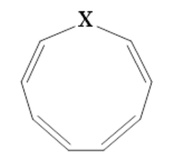
A. If X = NH, aromatic; if X = O, non-aromatic
B. If X = O, aromatic; if X = NH, non-aromatic
C. If X = NH, aromatic; if X = O, aromatic
D. If X = O, anti-aromatic; if X = NH, aromatic

48. The frontier orbital interactions involved in the formation of carbocation intermediate in
the reaction of isobutylene with HCl are
A. π of olefin and σ* of HCl
B. π of olefin and σ of HCl
C. π* of olefin and σ* of HCl
D. π* of olefin and σ of HCl
49. In the UV-Vis spectrum of an α,β-unsaturated carbonyl compound, with increasing
solvent polarity,
A. n-π* transitions undergo hypsochromic shift, π-π* undergo bathochromic shift
B. n-π* transitions undergo bathochromic shift, π-π* undergo hypsochromic shift
C. both n-π* and π-π* transitions undergo bathochromic shift
D. both n-π* and π-π* transitions undergo hypsochromic shift

50. In the IR spectrum, carbonyl absorption band for the following compound appears at
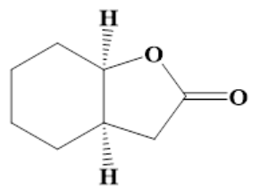
A. 1810 cm⁻¹
B. 1770 cm⁻¹
C. 1730 cm⁻¹
D. 1690 cm⁻¹

