Ph.D Entrance Examination May 2026-Physics –SET B

- In terms of arbitrary constants, A and B, the general solution to the differential equation 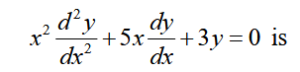
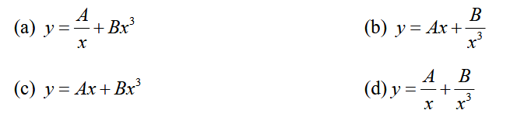
Answer: D

- The Polynomial f(x) = 1 + 5x + 3x² is written as the linear combination of the Legendre polynomials
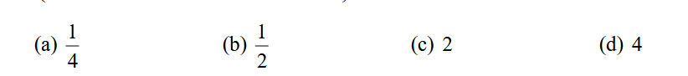
Answer: C

- The Newton-Raphson method is to be used to determine the reciprocal of the number x = 4. If we start with the initial guess 0.20 then after the first iteration the reciprocal is
(a) 0.23 (b) 0.24 (c) 0.25 (d) 0.26
Answer: B

- The generating function for Legendre Polynomial is
- (1-2xy+y²) ^{-1/2}
- (1+2xy+y²) ^{-1/2}
- (1-2xy+y²) ^{1/2}
- (1+2xy+y²) ^{1/2}
Answer: A

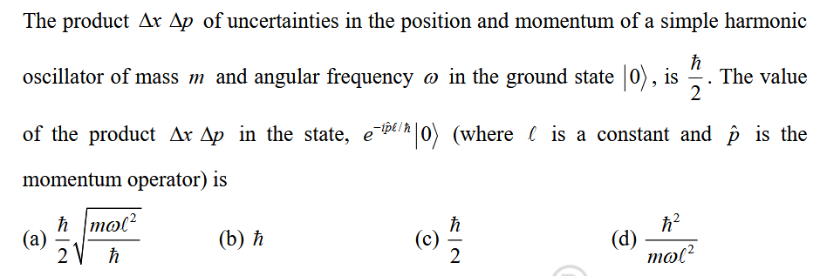

Answer: C

- A particle moves in a circular orbit under a force field given by
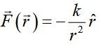,
Were k is a positive constant. If the force changes suddenly to
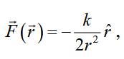
The shape of the new orbit would be,
- Parabolic (b) Circular (c) elliptical (d) hyperbolic

Answer: A

- The Schrodinger wave function for a stationary state of an atom in spherical polar
Coordinates (r, θ, Φ) is ψ $=Af \left(r\right)sin θCos θe^{iΦ}$ where A is the normalization constant. The eigen value of
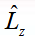for this state is
- ħ (b) -ħ (c) -3ħ (d) 2ħ
Answer: A

- In terms of a complete set of orthonormal basis kets |n⟩.:
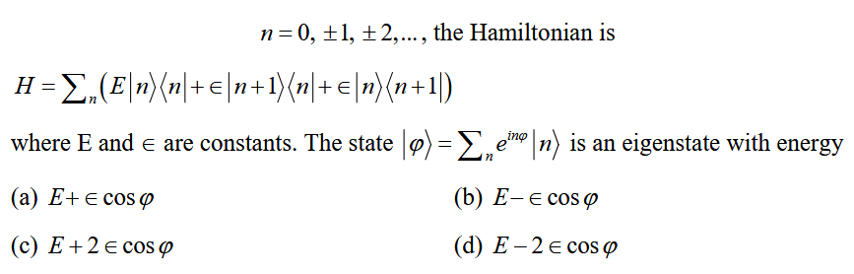
Answer: C

- An electromagnetic wave is incident from vacuum normally on a planer surface of a non-
magnetic medium. If the amplitude of the electric field of the incident wave is E₀ and that of the transmitted wave is 2 E₀/3, then neglecting any loss, the refractive index of the medium is

- 2.0 (b) 3.0 (c) 2.7 (d) 1.7

Answer: A

- A charged particle moves uniformly on the xy -plane along a circle of radius a centered at
the origin. A detector is put at a distance d on the x -axis to detect the electromagnetic wave radiated by the particle along the x -direction. If d>>a, the wave received by the detector is
(a) Unpolarized
(b) Circularly polarized with the plane of polarization being the yz -plane
(c) Linearly polarized along the y -direction
(d) Linearly polarized along the z -direction

Answer: C

- ESR is used to study:
(a) Atomic nuclei with spin
(b) Unpaired electron systems
(c) Vibrational transitions
(d) Neutron scattering

Answer: B

- Which of the following is a selection rule for electric dipole transitions?
(a) ΔJ=0
(b) Δl=±2
(c) ΔJ=±1
(d) Δm=2

Answer: C

- In a solid, a Raman line observed at 300 cm⁻¹ has intensity of Stokes line four times that
of the anti-Stokes line. The temperature of the sample is
- 311K to 312K (b) 320K to 350K (c) 400K to 412K (d) 200K to 210K
Answer: A

- In FT-IR spectroscopy, the main advantage over conventional IR is:
(a) Cheaper instrumentation
(b) Higher scan time
(c) Better signal-to-noise ratio and resolution
(d) No use of lasers

Answer: C

- SHG is a nonlinear optical process where:
(a) Photon energy is halved
(b) Photon frequency is doubled
(c) Photon is scattered
(d) Laser beam is attenuated
Answer: B

- Q-switching in lasers is used to:
(a) Increase output wavelength
(b) Convert continuous wave to noise
(c) Generate short, intense pulses
(d) Improve thermal stability
Answer: C

- The magnetic field at a point due to an elemental conductor carrying current at a distance R from the element is given by
(a) Ampere’s law
- Faraday’s law
- Coulomb’s Law
- Biot-Savart’s law

Answer: D

- Modes in a laser cavity determine:
(a) Wavelength precision
(b) Output power
(c) Coherence and directionality
(d) Pumping efficiency

Answer: C

- At low temperatures, lattice specific heat follows which law?
A) Stefan-Boltzmann Law
B) Einstein Law
C) Debye T³ law
D) Planck's Law
Answer: C

- A Schottky defect in an ionic crystal involves:
A) A missing cation
B) A missing anion
C) A pair of cation and anion vacancies
D) An extra atom in the lattice
Answer: C

- In a common emitter base connection, I_{E} = 1mA, I_{C} = 0.95 mA, Calculate the value of I_{B}
- 0.05
- 0.51
- 0.55
- 0.03

Answer: A

- According to Fermi-Dirac Statistics, at the Fermi energy, the occupation index is
- unity
- zero
- half
- one
Answer: C
- What kind of operation occurs in a J – K flip flop when both inputs J and K are equal to 1?
(a) Preset operation
(b) Reset operation
(c) Clear operation
(d) Toggle operation
Answer: D

- The two operators && and || are
- Arithmetic operators
- Equality operators
- Logical operators
- Relational operators
Answer: (C)

- As particle size decreases in nanomaterials, the surface-to-volume ratio:
(a) Increases
(b) Decreases
(c) Remains the same
(d) Becomes negligible
Answer: A

