SRM INSTITUTE OF SCIENCE AND TECHNOLOGY
TIRUCHIRAPPALLI CAMPUS

Ph. D ENTRANCE EXAMINATION QUESTION PAPER – NOVEMBER 2025
DEPARTMENT OF CHEMISTRY
ANSWERE ALL THE QUESTIONS
1 | The product is/are-  (a)  (b)  (c) Both (a) and (b)  (d) None is correct | A
2 | Which of the following would be least reactive towards electrophilic aromatic substitution?  (a) Nitrobenzene (b) Ethyl benzene (c) Benzene (d) Phenol | A
3 | Pyrolysis of acyl azides to isocyanates is called  (a) Losson rearrangement (b) Curtius rearrangement  (c) Schmit rearrangement (d) Hoffman rearrangement | B
4 | Which of the following compounds does not give a tertiary alcohol upon reaction with methyl magnesium bromide?  (a) 4,4-dimethylcyclohexanone (b) 4-heptanone  (c) Ethyl benzoate (d) 3-methylpentanal | D
5 | Which of the following acid derivatives are most stable?  - Acid chlorides (b) Esters (c) Amides (d) Anhydrides | C
6 | The correct match of 13C NMR chemical shift values (δ ppm) for pyridine is  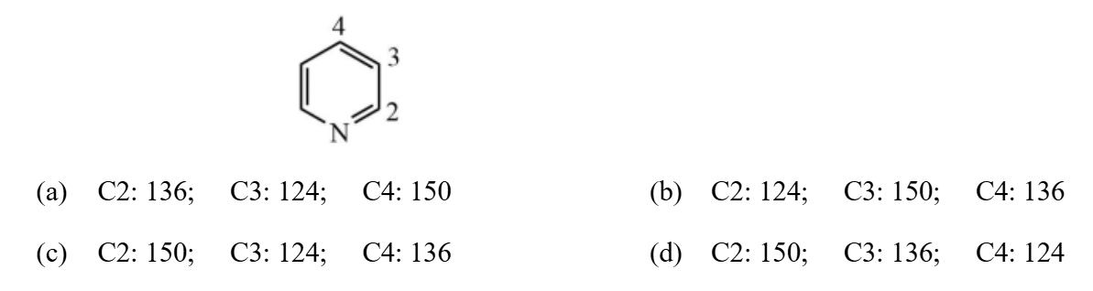 | C
7 | Among the following compounds which is the best Brønsted acid?  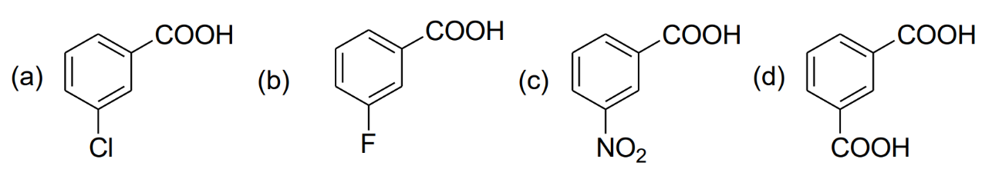 | C
8 | For an unambiguous single step synthesis of the following target molecule (TM), the best bond disconnection in its retrosynthetic analysis is  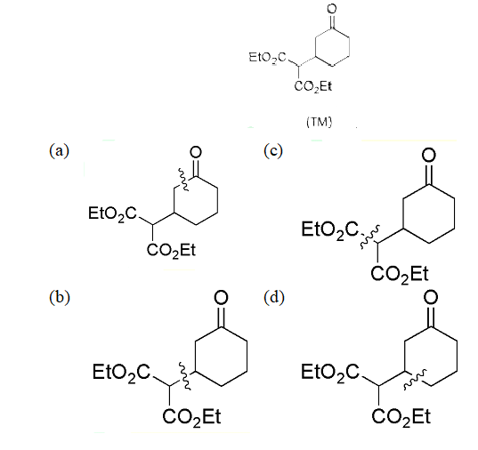 | C
9 | The reaction given below is an example of  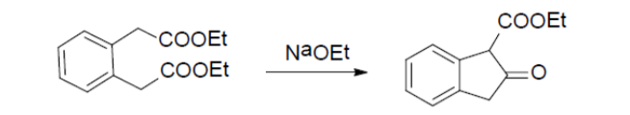  - Aldol condensation  - Knoevenagel Condensation  - Dieckmann condensation  - Acyloin condensation | C
10 | Consider the following statements:  (A) the highest oxidation state of Group 8 elements is more readily shown in their oxides than in fluorides  (B) Fe can exist in – 2 formal oxidation state also  (C) Mn, Tc and Re easily form M(II) compounds  The correct statements is / are:  (a) A and B (b) A and C (c) B and C (d) C only | A
11 | The coordination number of Gd in GdCl₃. 6H₂O is  (a) 3 (b) 6 (c) 8 (d) 9 | C
12 | O₂¯ is  (a) having a shorter O – O bond length than that in O₂  (b) IR active  (c) unable to abstract proton from weak acids  (d) a strong oxidising agent than O₂ | D
13 | Which of the following is the known name for the reaction given below?  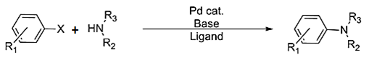  (a) Buchwald-Hartwig Reaction  (b) Chan-Lam coupling  (c) Ullmann reaction  (d) Gabriel phthalimide synthesis | A
14 | The Sequence of the three steps involved in the following conversion is  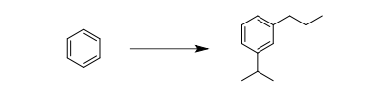  - (i) Friedel-Crafts alkylation; (ii) Reduction; (iii) Friedel-Crafts acylation  - (i) Friedel-Crafts acylation; (ii) Friedel-Crafts alkylation; (iii) Reduction  - (i) Friedel-Crafts acylation; (ii) Reduction; (iii) Friedel-Crafts alkylation  - (i) Friedel-Crafts alkylation; (ii) Friedel-Crafts acylation; (iii) Reduction | B
15 | The compound that will show a base peak at m/z 120 in its EI mass spectrum is  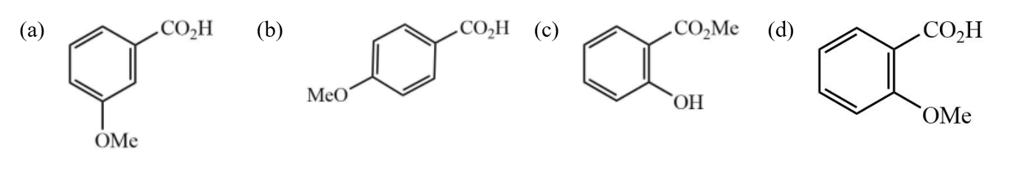 | C
16 | Which of the following complexes exhibits Jahn-Teller distortion?  A. [Ti(H₂O)₆]³⁺  B. [Fe(CN)₆]³⁻  C. [Co(NH₃)₆]³⁺  D. [Mn(H₂O)₆]²⁺ | A
17 | Chose the correct statements for oxyhaemoglobin and cytochrome P450 (resting state) from the following:  - Both contain dianion of protoporphyrin – IX  - They have same fifth ligand to metal centre from the protein backbone  - They contain single active site  - They contain metal ion in +3 oxidation state  Answer is  (a) A,B and C (b) A,C and D (c) A,B and D (d) B and C only | B
18 | In which method we explore the interaction between electromagnetic radiation and  analyte atoms or molecules or the emission of radiation by analytes?  - Gravimetric method  - Volumetric method  - Electroanalytical method  - Spectroscopic method | D
19 | The decay modes of ¹⁴C and ¹⁴O are  - β – decay  - positron emission  - β-decay and positron emission, respectively  - positron emission and β-decay, respectively | C
20 | Consider the following reaction:  Hg₂⁺ _{(aq)} + X – _{(aq)} === [HgX]⁺_{(aq)}  The solubility constants for [HgX]⁺_{(aq)} for X = F, Cl and Br follow the order  (a) F<Cl<Br (b) Br<Cl<F (c) Cl < Br < F (d) Br<F<Cl | A
21 | Calculate the potential of hydrogen electrode in contact with a solution whose pH is 10?  a) –0.0591 V b) +0.0591 V c) –0.591 V d) +0.591 V | C
22 | What is the ground state term symbol for a d⁵ high-spin ion?  a) ³P b) ⁴F c) ⁵D d) ⁶S | D
23 | In the pure rotational microwave spectrum of XY molecule, the adjacent lines are separated by 4 cm⁻¹. If the molecules irradiated by a radiation of 30,000 cm⁻¹, the first stokes line (in cm⁻¹) appears at  (a) 29988 (b) 30012 (c) 30004 (d) 2996 | A
24 | The correct option for the metal ion present in the active site of myoglobin, hemocyanin and vitamin B12, respectively,  (a) iron, iron and zinc  (b) molybdenum, iron and copper  (c) iron, copper and cobalt  (d) molybdenum, copper and cobalt | C
25 | In a reaction ‘X’ moles of the reactant A decomposes to give 1 mole each of C and D. It has been found that the fraction of A decomposed at equilibrium is independent of initial concentration of A. The value of ‘X’ is  (a) 1 (b) 2 (c)4 (d) 3 | B
26 | Find the radius of an atom in FCC unit cell having edge length 393 pm.  (a) 196.51pm (b) 170.22 pm (c) 138.93 pm (d) 150.93pm | C
27 | The de Broglie wavelength of an electron moving with a speed of 5.0 × 10⁶ m/s is closest to:  - 1.46 nm  - 0.146 nm  - 0.0146 nm  - 1.46 μm | B
28 | 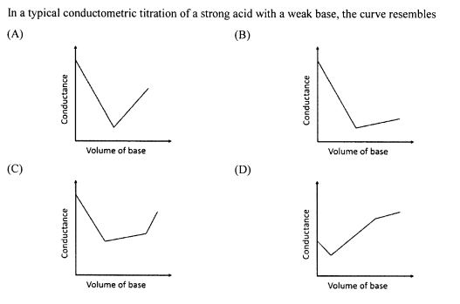 | B
29 | The frequency of O – H stretch occurs at ~3600 cm⁻¹. The O – D stretch frequency (in cm⁻¹) would be close to  (a) 3000 (b) 2600 (c) 1800 (d) 900 | B
30 | In IR spectrum, recorded neat, a compound shows a strong and broad band at 3300cm⁻¹. The band has become sharp and shifts to 3600 cm⁻¹ when the spectrum is recorded in CCl₄ at high dilution. This proves that the compound has  - OH group, which is involved in intramolecular H – bonding  - OH group, which is involved in intermolecular H – bonding  - A terminal alkyne group  - OH group, present in severely sterically hindered environment | B
31 | What is the primary advantage of High-Performance Liquid Chromatography (HPLC) over Gas Chromatography (GC)?  (a) Higher sensitivity  (b) Faster analysis time  (c) Ability to analyze non-volatile compounds  (d) Lower cost | C
32 | What can we measure with the help of Gouy balance?  - Composition of the sample  - Temperature phase change of the sample  - Magnetic susceptibility of the sample  - Stability of the sample | C
33 | Match the following:  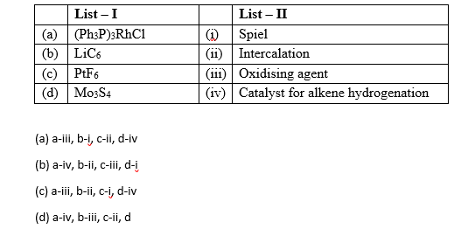 | B
34 | Which one of the following pairs of electronic configurations of low spin transition metal ions (3d) in an octahedral field undergoes a strong John Teller Distortion?  (a) d¹ , d⁹ (b) d⁷ , d⁹ (c) d⁶ , d² (d) d⁴ , d³ | B
35 | C₆H₆ molecule has point group  (a) D_{4h} (b) D_{2d} (c) D_{6h} (d) D_{3d} | C
36 | What is the primary function of a salt bridge in an electrochemical cell?  (a) To facilitate electron transfer  (b) To maintain electrical neutrality  (c) To increase the reaction rate  (d) To reduce the cell potential | B
37 | Which analytical technique is based on the principle of measuring the absorbance of radiation by a sample?  (a) Spectroscopy (b) Chromatography (c) Electrophoresis (d) Titration | A
38 | In which of the following colloids are the dispersing medium a liquid?  (a) Mist (b) Foam (c) Jelly (d) Shaving Cream | D
39 | The amino acids required for creatine formation  (a) Glycine (b) Arginine (c) Methionine (d) All of these | D
40 | A patient is suffering from untreated insulin dependent diabetes. Which one of the following metabolic actions is occurring in this patient?  (a) Glucose is used by skeletal muscle for fuel  (b) Ketone bodies are released by the liver into the blood  (c) Glucose is used by the liver for fuel  (d) Fatty acids are transported from the liver to the adipose tissue | B

************************

