DOCUMENTATION

ASSIGNMENT

ASSIGNMENT_1

STUDENT NAME: Vaida Diana-Laura
GROUP: 30423

CONTENTS

1. Assignment Objective 3
2. Problem Analysis, Modeling, Scenarios, Use Cases 3
3. Design 3
4. Implementation 3
5. Results 3
6. Conclusions 3
7. Bibliography 3

Assignment Objective

The main objective of this assignment is to implement a program for a polynomial calculator. The sub-objectives are represented by the operations the calculator does on the polynomials, which include 6 different modes of calculation:
-Addition
-Subtraction
-Multiplication
-Division
-Integrative
-Derivative

Problem Analysis, Modeling, Scenarios, Use Cases
In mathematics, a polynomial is an expression consisting of indeterminates (also called variables) and coefficients, that involves only the operations of addition, subtraction, multiplication, and positive-integer powers of variables.
Polynomials appear in many areas of mathematics and science. For example, they are used to form polynomial equations, which encode a wide range of problems, from elementary word problems to complicated scientific problems.
They are used to define polynomial functions, which appear in settings ranging from basic chemistry and physics to economics and social science; they are used in calculus and numerical analysis to approximate other functions. In advanced mathematics, polynomials are used to construct polynomial rings and algebraic varieties, which are central concepts in algebra and algebraic geometry.

Use case diagram

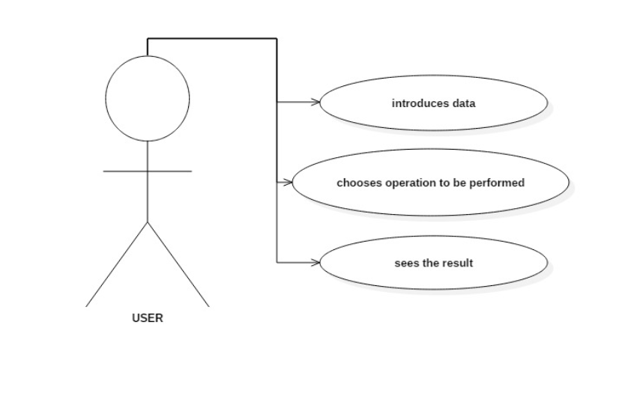

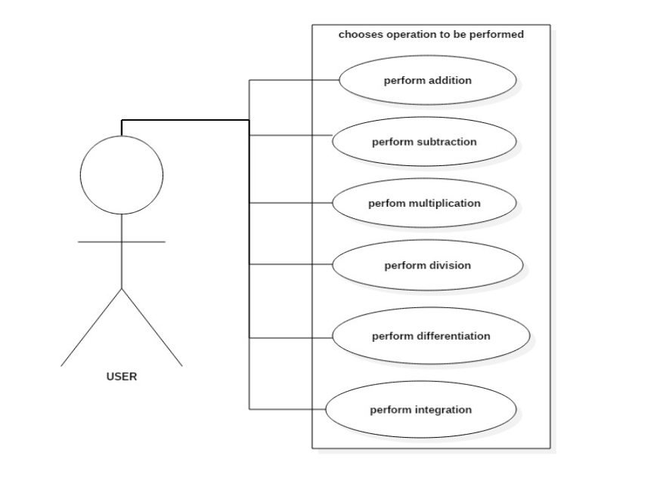

Design
The following class diagram is the one I used for the project.
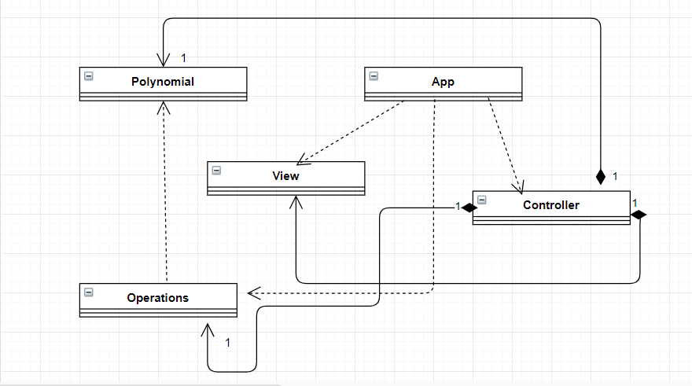
Most of the data structures I used were primitive types, especially integers and doubles. A more complex one would be the hash map. I used a hash map to store the terms of the polynomials. Each polynomial will be described by a hash map that has 2 pair values – the exponential which is an integer and the coefficient which is a double for every term.

Java packages help in organizing multiple modules and group together related classes and interfaces.
My classes are structured in a MVC architecture.
These classes are: Controller, View, Polynomial, Operations and App.
MVC is an architectural pattern consisting of three parts: Model, View, Controller.
Model: Handles data logic.
View: It displays the information from the model to the user.
Controller: It controls the data flow into a model object and updates the view whenever data changes.

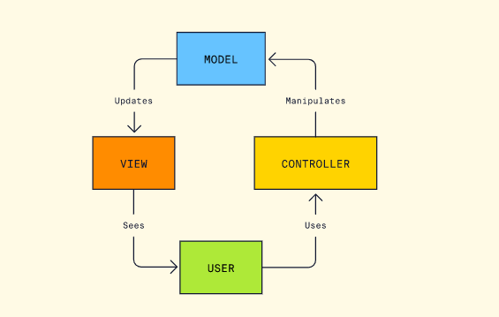

Implementation

Polynomial class
Fields: private Map<Integer, Double> map=new HashMap<>();
Methods:
public Map<Integer, Double> getMap() – getter for the map
public void setMap(Map<Integer, Double> map) – setter for the map
public void StringtoPol(String string) - this method allows me to convert from a string input to a polynomial
The input will be read like ax^n+bx^n-1+…+cx^0. My method works only if I put in the string a number for every coefficient, including 1 and one for every exponential, including 0.
In this method I used the pattern – matcher method, I search for numbers in a string I receive as input, then I store all the numbers I find from the string in a vector and increment a counter. Then after I stored every number I had in the polynomial, I know the coefficient and exponential were stored one right after another. I put them in a map in their respective places and decrement the counter of the vector. Then I empty the vector in case the user wants to calculate something else on a new polynomial, because the vector will still contain the old values inserted before.

public Polynomial empty(Polynomial polynomial) – I use this method to solve a specific problem. After addition or subtraction I encounter something – if I add two polynomials which both have the same coefficient and exponent for an x, the new polynomial result will have a term that has a coefficient 0. That is a problem. So I used this function to store all my elements from a map in another map without the values that have a coefficient of 0.

public Polynomial copy(Polynomial polynomial) – This method copies every single value from a polynomial’s map into another polynomial’s map. I used this function mainly for division where I need the original polynomial and a copy of it I can manipulate how I want.

public double value(Polynomial polynomial) – This function is also a method I used for division only. I used it to find the coefficient of the polynomial that belongs to the biggest exponent in the polynomial.

Operations class
Fields: this class has no fields, but I consider it the most important class of the whole assignment and the heart of the program. I used it as a ‘helper’ class. Like the name suggests, this is where I implemented all my operations.
Methods:
public Polynomial add(Polynomial polynomial, Polynomial polynomial2) – This method performs the addition of the polynomials. It receives two polynomials and returns a polynomial in which the result is stored. It traverses the first polynomial’s map and stores the values it has in the result, then it traverses the second polynomial. It checks if the polynomial result already has a coefficient that belongs to that exponent, if it doesn’t, it simply puts it into the result map, if it already does it adds it to the value already stored in the map at that respective exponent.

public Polynomial subtraction(Polynomial polynomial, Polynomial polynomial2) – This method performs the subtraction of the polynomials. It receives two polynomials and returns a polynomial in which the result is stored. It traverses the first polynomial’s map and stores the values it has in the result, then it traverses the second polynomial. It checks if the polynomial result already has a coefficient that belongs to that exponent, if it doesn’t, it simply puts it into the result map with a negative sign in front, if it already does it subtracts it to the value already stored in the map at that respective exponent.

public Polynomial derivative(Polynomial polynomial) – This method calculates the derivative of a polynomial. It returns the polynomial result stored. It goes through every element from the polynomial’s map. The derivative does the following algorithm, the coefficient is calculated by multiplying the exponent with the coefficient and every exponent is subtracted by one. If after the operations the exponent is at least one the result is stored in the new polynomial.

public Polynomial multiplication(Polynomial polynomial, Polynomial polynomial2) – This method calculates the multiplication of the polynomials. It returns their multiplication in a result polynomial. It uses 2 foreach, the first to go through the first polynomial and the second one, nested inside the first one. For every ‘pair’ of terms the exponent of the new term is the sum of the exponents pair, and the coefficient is the multiplication of their coefficients. Then it puts the new term in the result’s map accordingly. If the result polynomial is null at that exponent, it puts the coefficient in the map, if it isn’t, it adds it to the already existing value stored there.

public Polynomial integrative(Polynomial polynomial) – This method calculates the integration of a polynomial. It returns the polynomial result stored. It goes through every element from the polynomial’s map. The coefficient is calculated like this: the coefficient is divided by the exponent added by 1, and the new exponent is the old one added by 1. If after the operations the exponent is at least one the result is stored in the new polynomial.

public Polynomial[] division(Polynomial polynomial, Polynomial polynomial2) – This method calculates the division of the polynomials. It returns two values – the remainder and the quotient, so I used a polynomial vector to return them. It was by far the most complex operation to implement. It uses 5 polynomials to do this – the dividend, the divisor, the remainder, the quotient, the temp. At first the dividend is copied into the remainder. Then my function checks everytime so the dividend biggest exponent is bigger or at least equal to the quotient exponent(so the division can still be performed), the dividend map is not empty and the remainder to have an exponent that is bigger than 0. In the quotient I stored as exponent the difference between the exponent of the dividend and divisor, the coefficient will be equal to the division of the coefficients that belong to the biggest exponent of the dividend and divisor. Then I clean the remainder and the temp maps because I need to use empty ones for the next operations. The quotient’s map isn’t emptied – it needs to store all the values. The temp polynomial does the exact the remainder does – expect it stores the coefficient with a negative sign. In the remainder I will store the multiplication of the temp and the divisor then add this result to the dividend. Then in the result vector I copy the remainder and the quotient.

Every single method uses at the end the ‘empty’ method from the Polynomial class. I use this so I won’t have any problems when I print the output, I won’t have missing exponents with the coefficient 0, I also won’t have problems when I perform the add and the multiplication in the division method.
Controller class – this class “connects” everything together
Fields:
private View view;
private Polynomial polynomial;
private Operations operations;
Methods: it doesn’t have methods
The controller controls what happens everytime the user presses a specific button from the graphical user interface. Every commands does a different type of operation but they have something in common- after the result is stored in a polynomial, I go through the polynomial result maps and I convert it into a string I can put show on the box “Text Area”.

View class
Fields: The fields include buttons, text areas, labels, text fields to make it as user friendly as possible.
This class is used for the user graphical interface.
Methods: Again, a lot of methods for the fields, especially for the buttons. But the most important method is
Public View() – this is where the interface comes to life

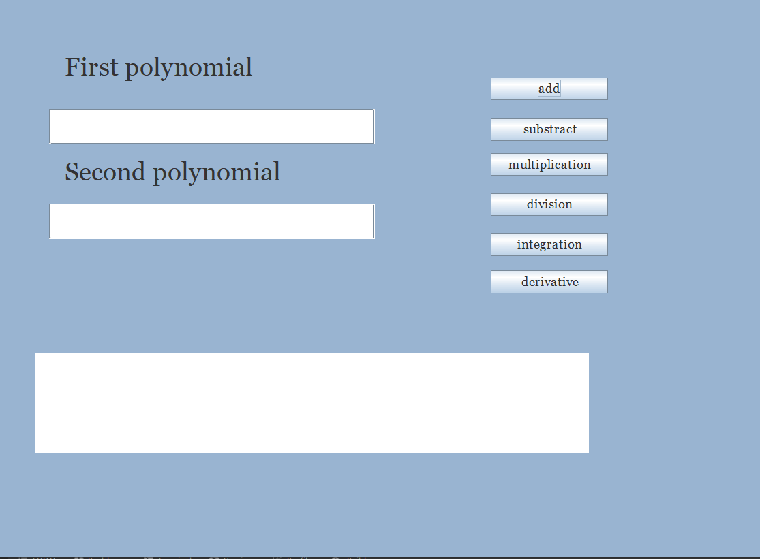

This is how the user graphical interface looks like. In the first text field we insert the first polynomial, and in the second the other one. The input must be inserted like this, ax^n+bx^n-1+…+cx^0, otherwise the program won’t work. There are also 6 buttons available – one for every operation the calculator does. At last, the text area is there to shown the result after one button is pressed.

App
- this class starts the program, it has only one class: main

Results
These are the results with Junit.
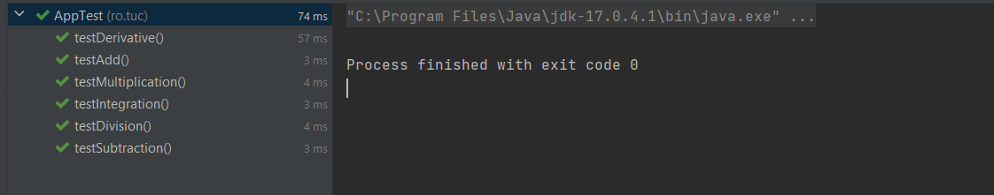

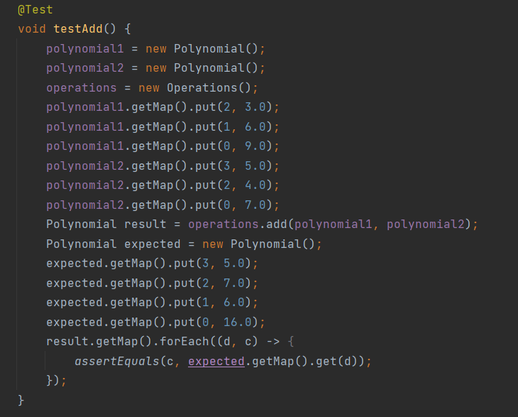

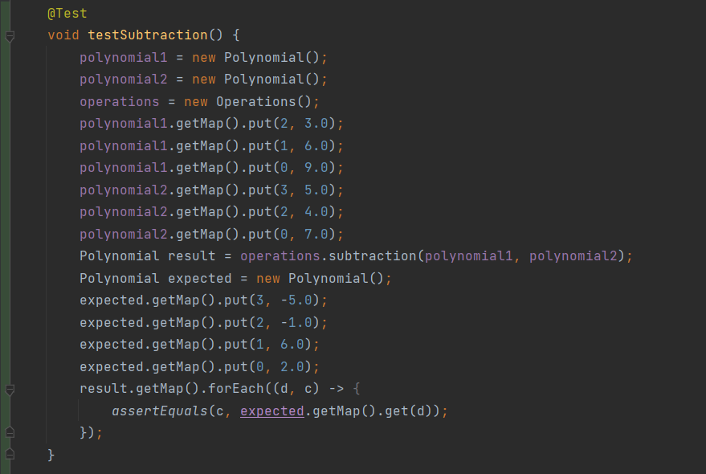

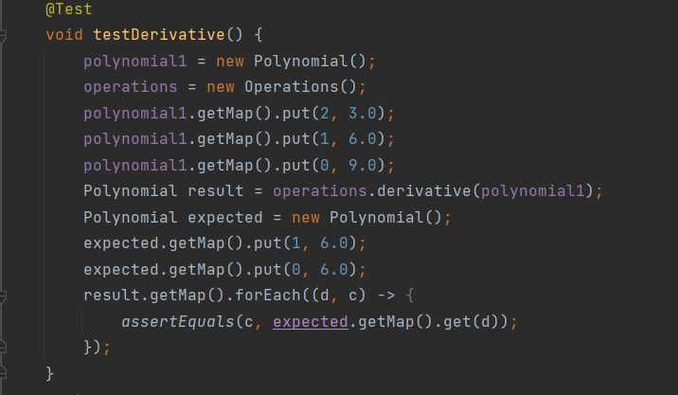
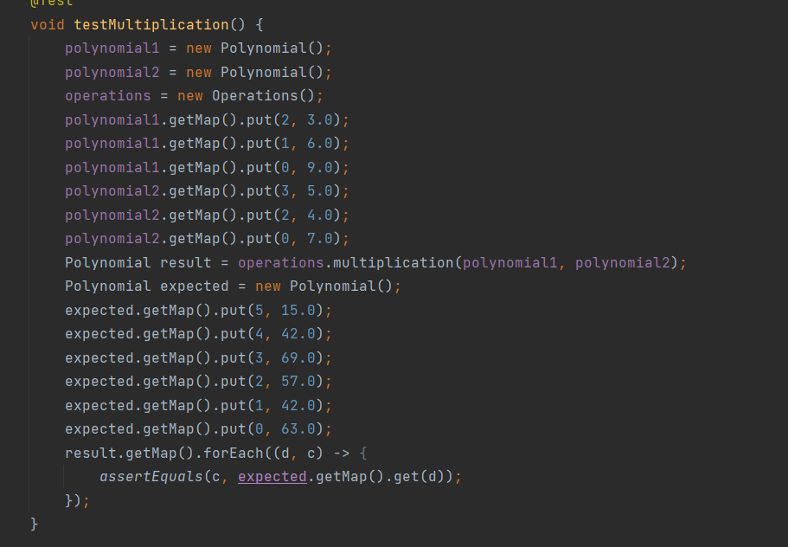

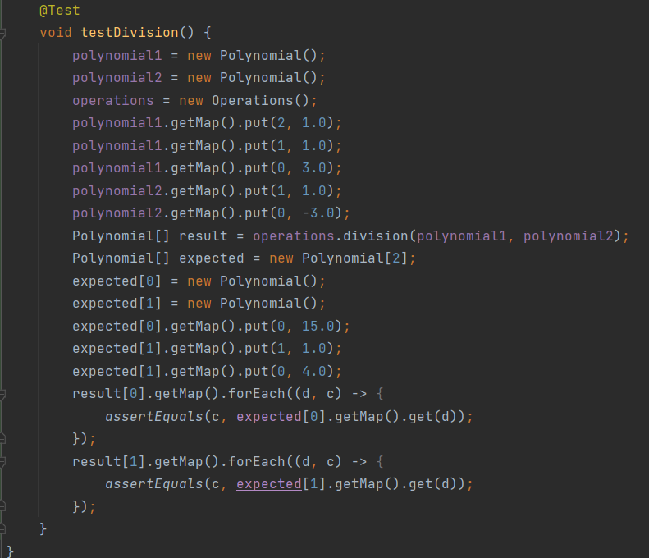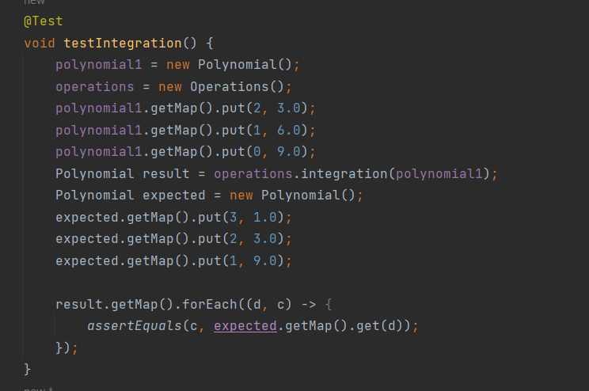

Conclusions
I think I learned more about how to manipulate maps and writing code in Java in general. I know it could have been better but thinking about how to implement the polynomial division really put my mind to work.

Bibliography

https://stackoverflow.com/
Programming Techniques – lectures of prof. Pop Cristina
https://ro.wikipedia.org/

