DOCUMENTATION

ASSIGNMENT

ASSIGNMENT_2

STUDENT NAME: Vaida Diana-Laura
GROUP: 30423

CONTENTS

1. Assignment Objective 3
2. Problem Analysis, Modeling, Scenarios, Use Cases 3
3. Design 3
4. Implementation 3
5. Results 3
6. Conclusions 3
7. Bibliography 3

Assignment Objective

Design and implement a simulation application aiming to analyse queuing based systems for determining and minimizing clients’ waiting time.
Queues are commonly seen both in real world and in the models. The main objective of a queue is to provide a place for a client wait before receiving a service.
The management of queue based systems is interested in minimizing the time amount its client are waiting in queues.
One way to minimize the waiting time is to add more servers, i.e. more queues in the system (each queue is considered as having an associated processor) but this approach increases the costs of the supplier. When a new server is added the waiting clients will be evenly distributed to all current available queues.
The application should simulate a series of clients arriving for service, entering queues, waiting, being served and finally leaving the queue. It tracks the time the clients spend waiting in queues and outputs the average waiting time.
Input data:
- Minimum and maximum interval of arriving time between clients;
- Minimum and maximum service time;
- Number of queues;
- Simulation interval;
-Number of clients
Minimal output:
- Average of waiting time, service time and empty queue time for 1, 2 and 3 queues for the simulation interval and for a specified interval;
- Log of events and main system data;
- Queue evolution;
- Peak hour for the simulation interval;
2) Problem analysis, scenarios, use cases
General overview
This application should simulate customers waiting to receive a service (e.g. supermarket, bank, etc.) just like in the real world, they have to wait in queues, each queue processing clients simultaneously. The idea is to analyse how many clients can be served in a certain simulation interval, by entering parameters in an intuitive, user- friendly, application graphical interface.
Use cases
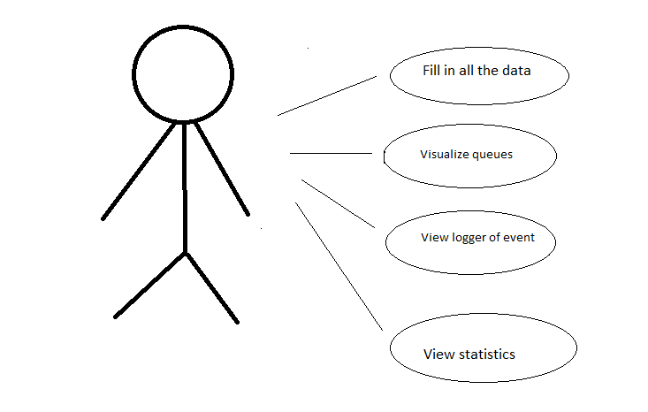
- Input and Output
The customers are generated randomly, each having its own service time and arrival time, the number of clients depends on the input values.

The user can set:
- The maximum number of queues available to process customers.
- Minimum and maximum arrival interval: the delay between customers arriving to receive a service (in seconds)
- Minimum and maximum service time: the number of seconds needed for a client to be processed
- Simulation interval: finishing time of the simulation.
The user can read
- The “peak hour”, when the most clients were served
- The total number of clients served in the simulation
- How every client enters and exists the queue

3)Design
The following class diagram is the one I used for the project.

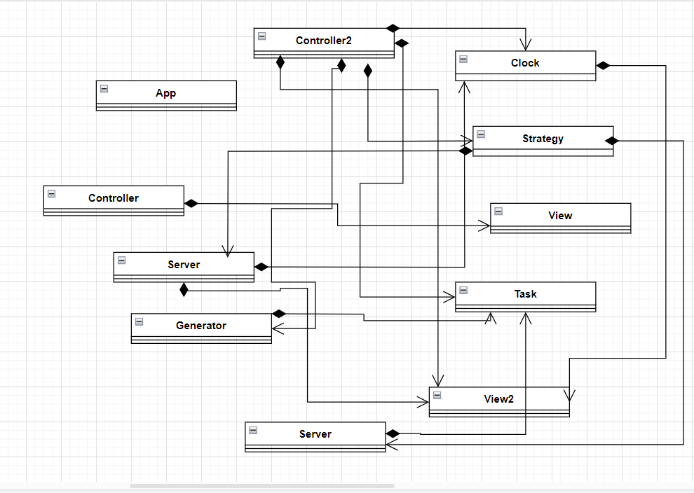

Data structures – I used blocking queues, atomic integers, atomic booleans to assure thread safety. I also used array lists, mainly in the Controllers.
Java packages help in organizing multiple modules and group together related classes and interfaces.
In object-oriented programming development, model-view-controller (MVC) is the name of a methodology or design pattern for successfully and efficiently relating the user interface to underlying data models. The MVC pattern is widely used in program development with programming languages such as Java, Smalltalk, C, and C++.
The MVC pattern has been heralded by many developers as a useful pattern for the reuse of object code and a pattern that allows them to significantly reduce the time it takes to develop applications with user interfaces.
My classes are structured in a MVC architecture.
These classes are: Controller, View, Controller2, View2, Clock, Generator, Server, Strategy, Task and App.
MVC is an architectural pattern consisting of three parts: Model, View, Controller
Model: Handles data logic.
View: It displays the information from the model to the user.
Controller: It controls the data flow into a model object and updates the view whenever data changes.
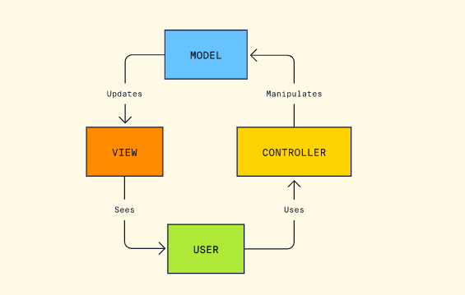

4)Implementation
App class - this class starts the program, it has only one class: main
Clock class
Fields:
private Thread clockThread, private int timer, private boolean isRunning, private View2 view2;
Methods:
public void startClock()- this method starts my clock, initializes the time with 0,gives the isRunning the true value for the run method,and starts the clockThread
public void stopClock()- this method stops my clock,it gives the isRunning boolean the false value
public getTime()-returns the current time,important method
public void run() – the method that is going to be overridden,if the isRunning value is true it means the simulation hasn’t stopped,the timer will increase and the value of the timer will be shown to the user in real time,the thread will be put to sleep for 1000 millis

Generator class -
Fields:
private Task task;
private int serviceMin;
private int serviceMax;
private int arrivalMax;
private int arrivalMin;
private static int counter=0;
private static final ThreadLocalRandom random2 = ThreadLocalRandom.current();
private static final ThreadLocalRandom random = ThreadLocalRandom.current();
Methods:
public Task generatortime() – use this function to generate a random arrival and service time for a client, using the ThreadLocalRandom variables for thread safety, I also use the static counter to give every client a ID in ascending order from the previous one

Strategy class -
I adopted a strategy based on the queue length, that means I place every new client to the shortest queue available at the moment
Fields:
private ArrayList<Server> myQueues;
private int nbQueues;
Methods:
public int getShortestQueue() - I go through all the queues with a for and I pick the one with the smallest size and then return it

Server class -
This is the class I used for each queue.
Fields:
private BlockingQueue <Task> tasks;
private int queueIndex;
private AtomicBoolean isRunning=new AtomicBoolean(false);
private AtomicInteger total=new AtomicInteger(0);
Methods:
public void start()- this sets the isRunning variable to true and starts the queue thread
public void stop()- sets the isRunning variable to false
public void addClient(Task task) –adds a client to a my queue(server)
public void removeClient (Task task) – removes a client from my queue(server)
public void run()- a class to be overridden. Checks if the timer is still on and if the queue isn’t empty and removes the first client from the queue, it also uses thread sleep

Task class -
Class used for each client
Fields:
private int arrivalTime;
private int serviceTime;
private int clientID;
Methods: Only getter and settes for the fields

View class -
This class contains a button to start the simulation, labels and text fields for the user to give parameters

View2 class –
This class contains a button called Start to start the actual simulation, a text area to display the current timer, and another one to show the generated clients and the process in real life(what client joined what queue and which one left a queue), and also text areas for other statistics, like the peak hour, average service and waiting time.

Controller class –
This class controls the first view. It receives the input for the simulation and gives it to the Controller2 class

Controller2 class –
private Generator generator;
private Strategy strategy;
private Clock clock;
private Thread controllerThread;
private ArrayList<Server> myQueues;
private ArrayList<Task> myClients;
private int nbClients;
This class controls the second view. For my project this class is very important. It controls almost everything, for better or worse. After the class initializes itself it goes in the start() method
Methods:
public void start() – this function makes a jump to the initialize() method, sets the clock and the controllerThread
public void initialize() – this functions adds a Listener and checks if the start function was pressed, it add creates the number of queues that was inserted by the user, starts the clock and the thread

public int getMaxOfClients() – this method returns the max number of clients
public ArrayList<Task> sort(ArrayList<Task> myClients) – this method sorts the arrival time for clients using bubble sort, because at first when I generate the clients their arrival time is random, but logically their arrival time should be in ascending order, just like in real life
public void run() – this method does a lot
At first it checks if the simulation has just started(if the clock is currently 0), I use an index to know which client I am currently adding and I check to see if it smaller than the total number of clients. I generate for each client an id, arrival time and service time. Then I sort the clients using the method I mentioned above. Now the clients are sorted, I display them and I make the index equal to 0 again.
This method checks if the current time is smaller than the simulation total duration, it puts the thread to sleep for a second, it goes through every client and checks if their arrival time is equal to the current time, if it is, it gives to a variable the number for the smallest queue available using the strategy I adopted. I then proceed to add the client to that specific queue, I also use the index to know how many clients managed to enter a queue during the simulation duration.
To calculate the peak moment, the busiest moment of the simulation, I use the function which calculates the maximum number of clients I have in the queue and I store that number plus that specific second. For the service time I add the service time of every client that entered a queue and divide it by them.

5)The results
These are the results displayed by graphical user interface. The logs show the evolution of the queues and the output area show statistics such as the total number of clients served.
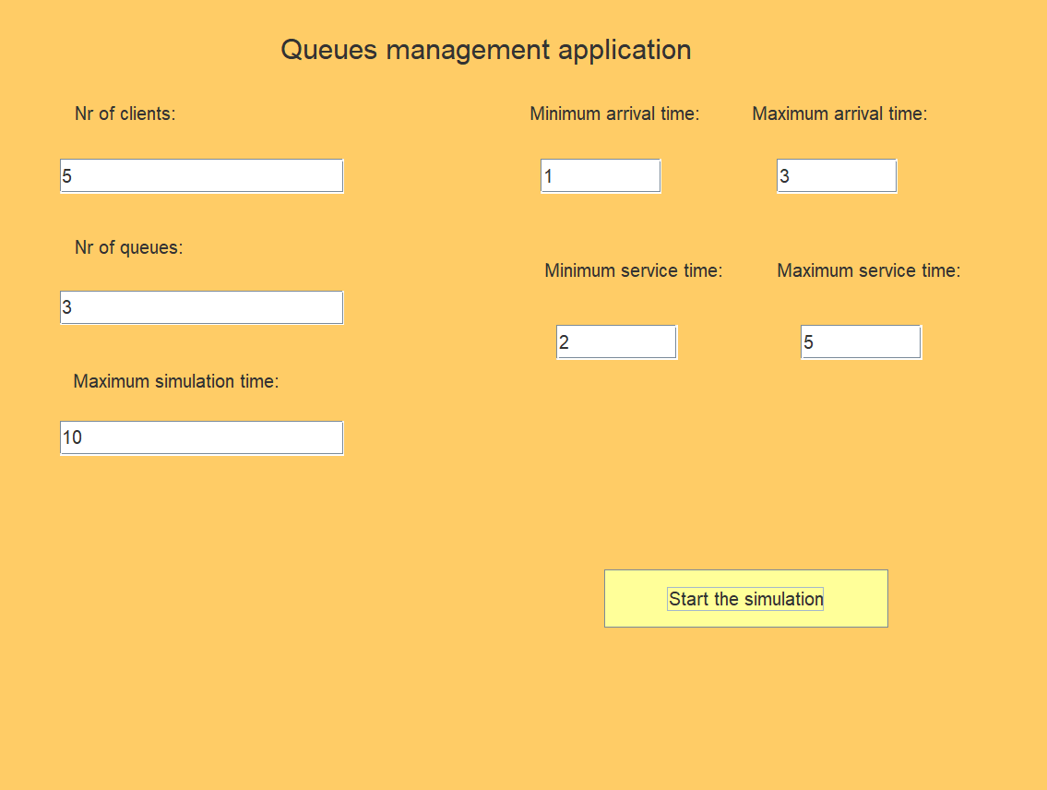

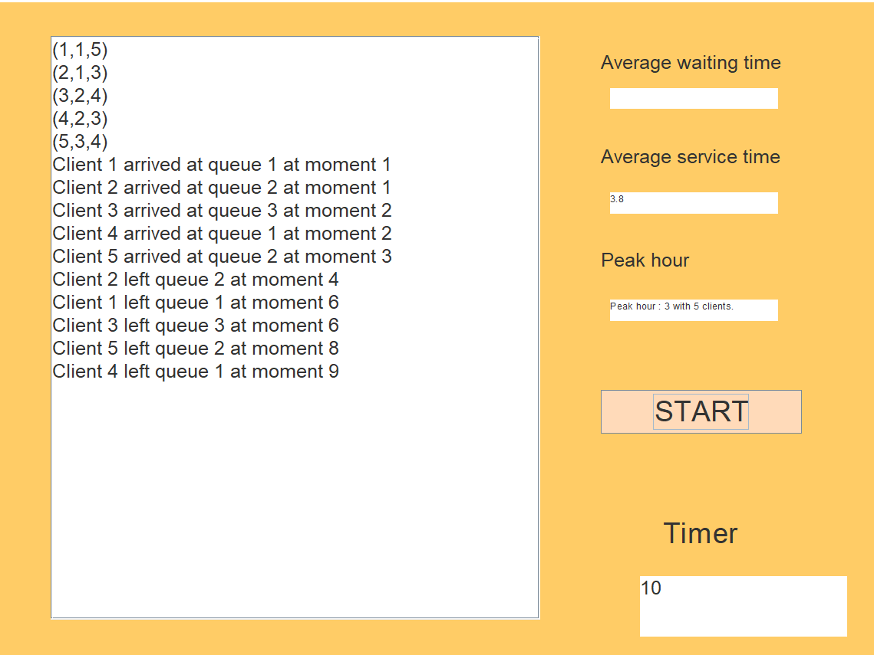

6)Conclusions
It is really hard to implement simulations that work in real life time.
7)Bibliography
https://stackoverflow.com/
Programming Techniques – lectures of prof. Pop Cristina
https://ro.wikipedia.org/

