XOR GATE

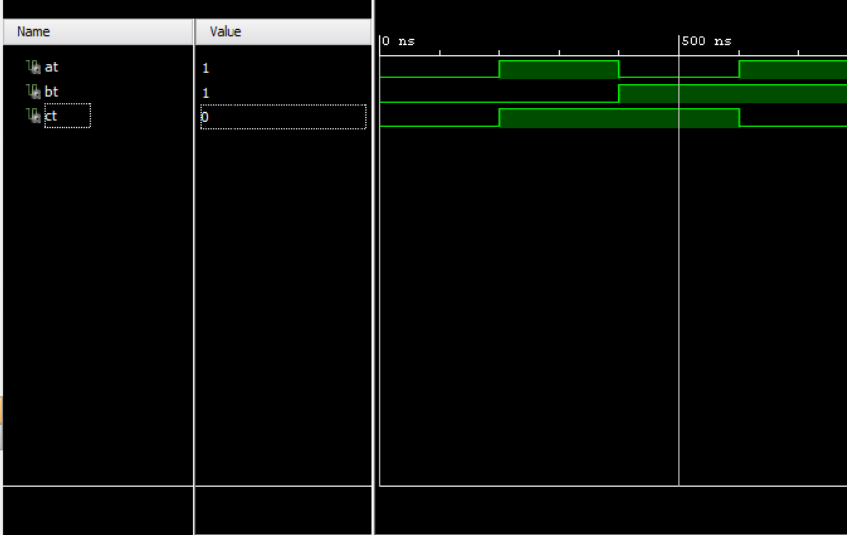

D FLIP FLOP



REGISTER

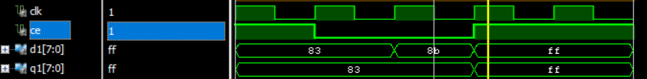

SHIFT REGISTER

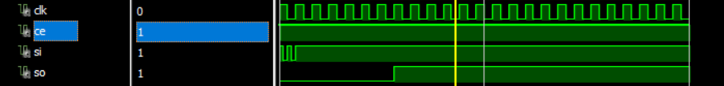

MUX

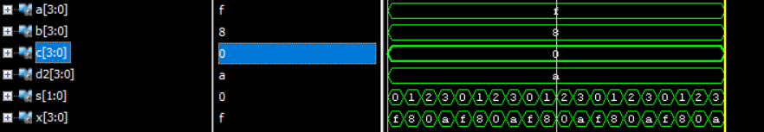

COUNTER



DECODER



DMUX

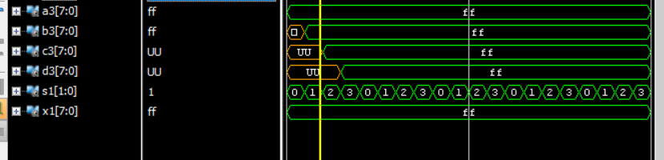

BCD to 7 SEG

