Carry lookahead adder

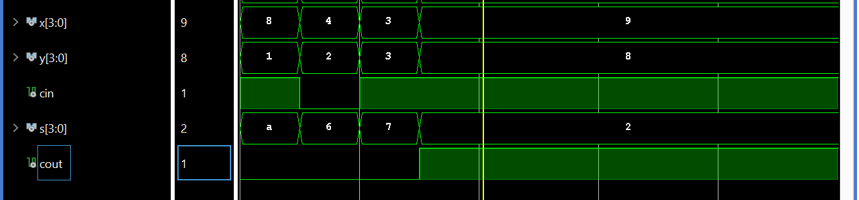

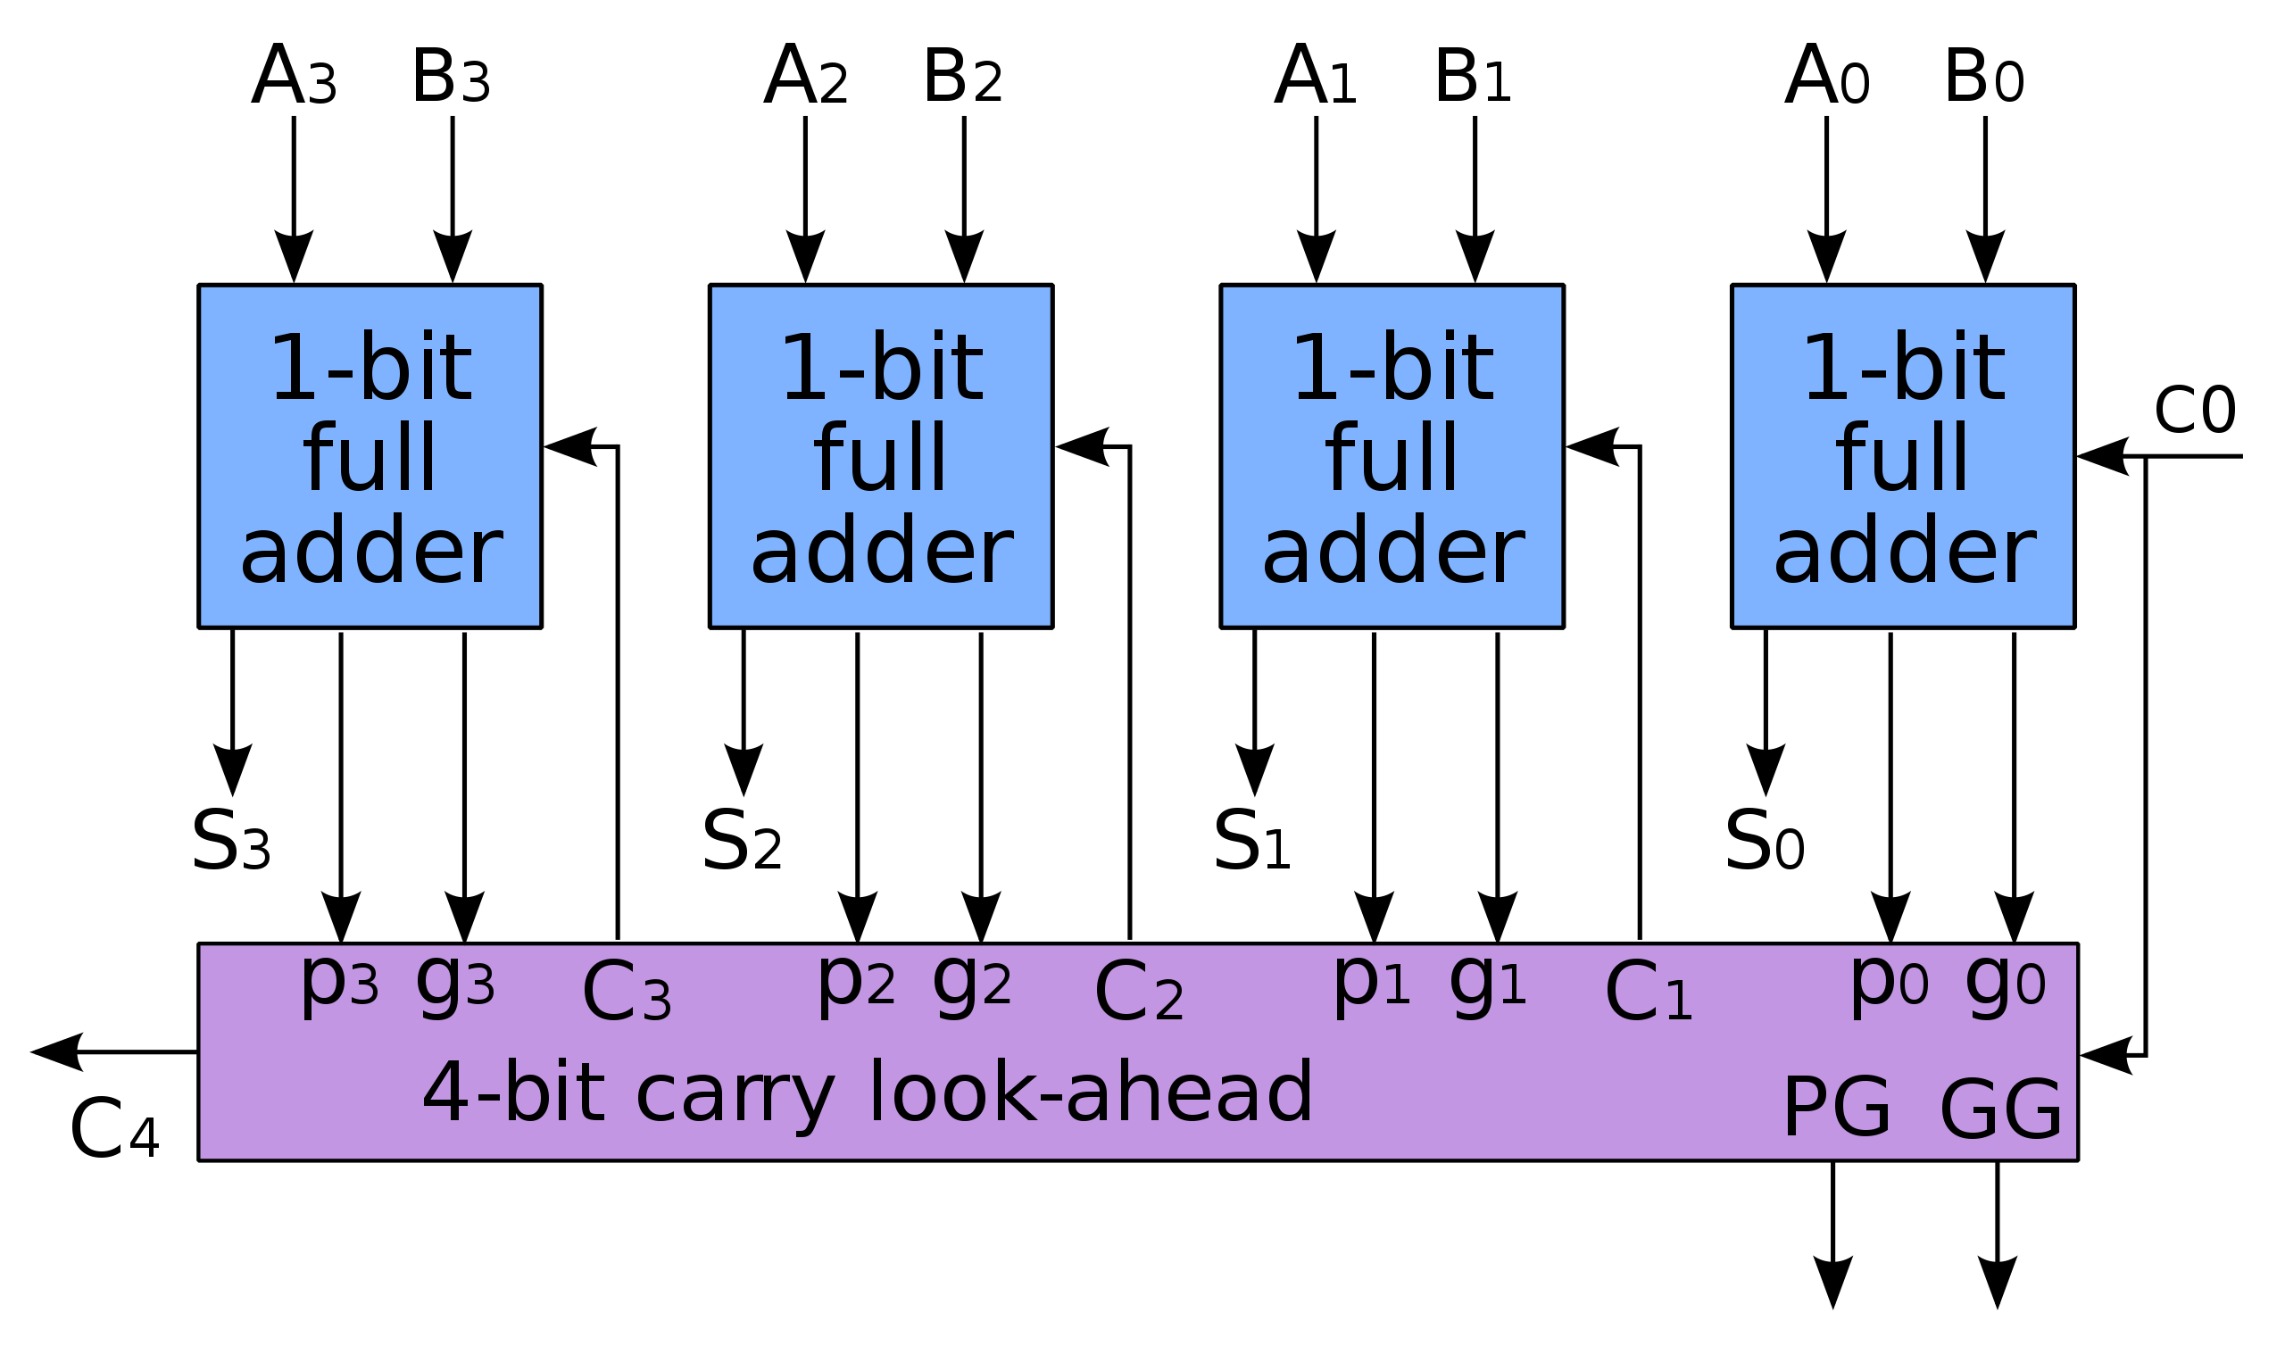

Wallace tree

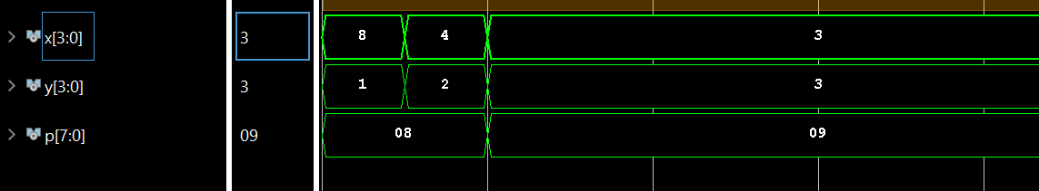

For the Wallace tree I used the following diagram

