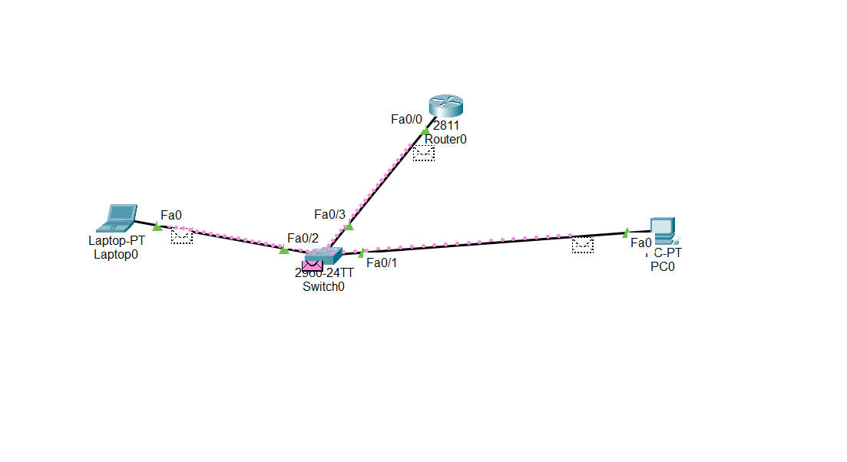

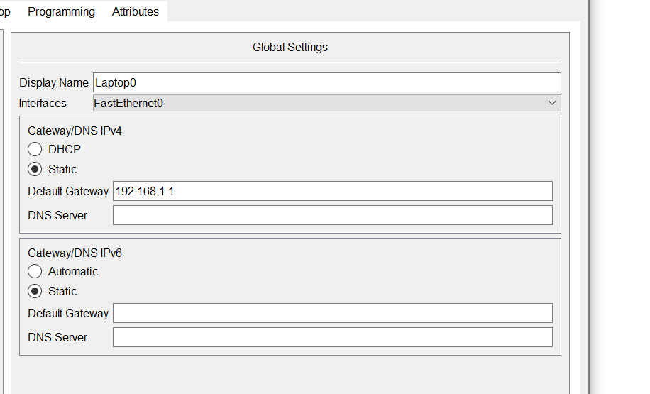

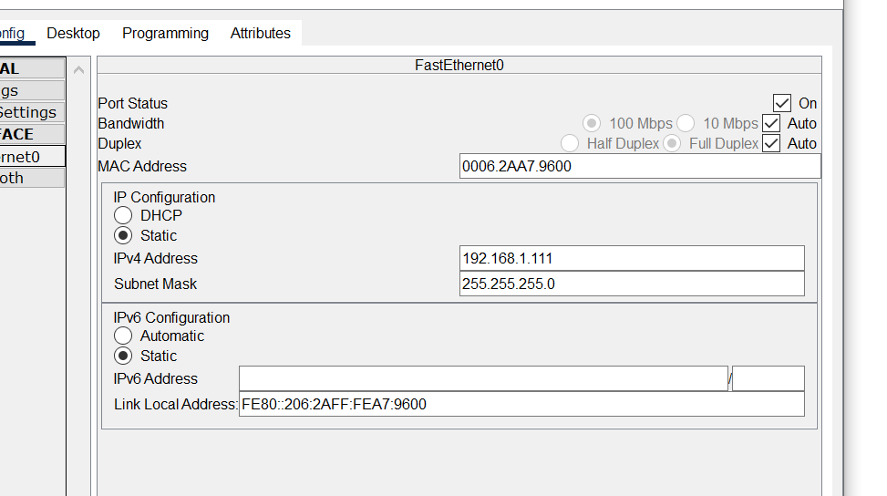

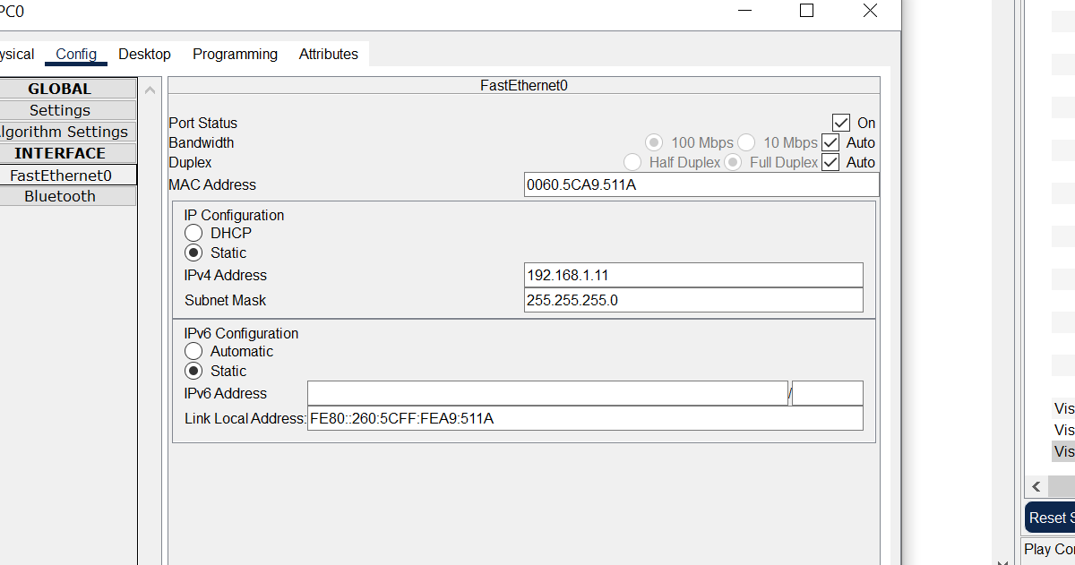

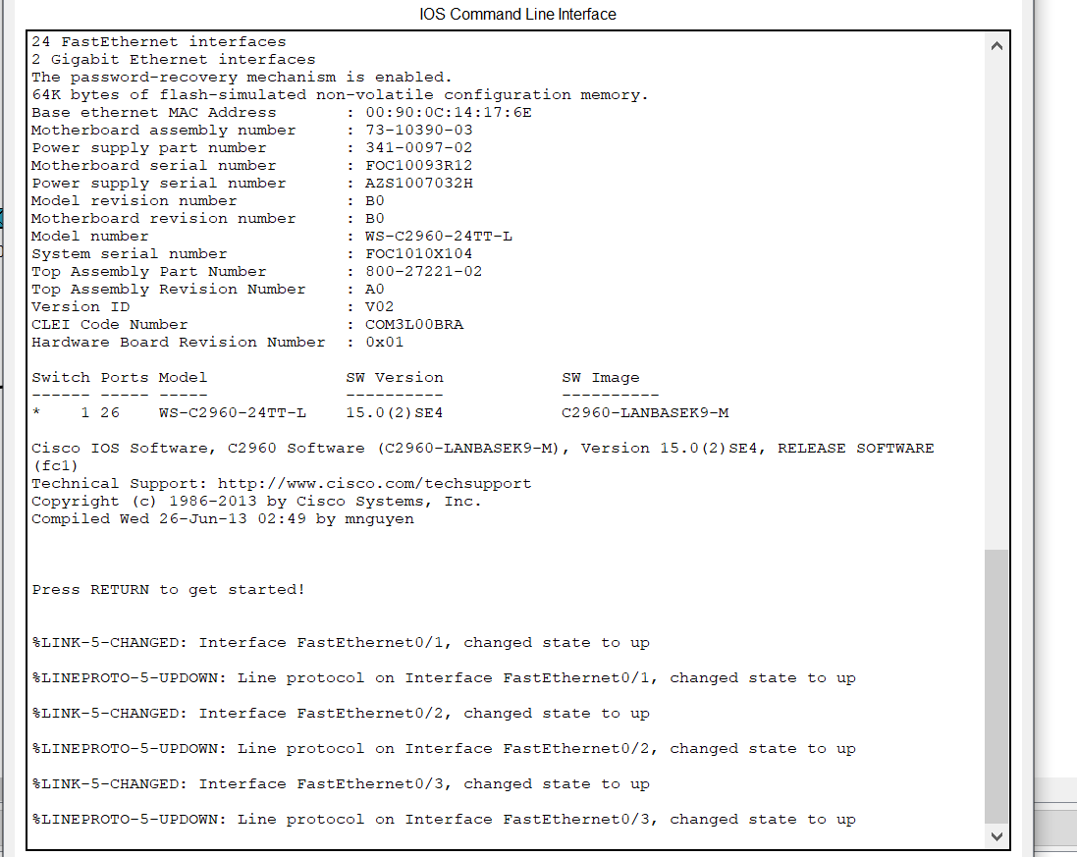

|  |  |  |  |  |
| --- | --- | --- | --- | --- |
| IPv4  Address/Prefix | Network Address | Broadcast Address | Total Number  of Host Bits | Total Number  of Hosts |
| 172.16.104.99/27 | 172.16.104.96 | 172.16.104.127 | 5 | 30 |
| 198.133.219.250/24 | 198.133.219.0 | 198.133.219.255 | 8 | 254 |
| 10.1.113.75/19 | 10.1.96.0 | 10.1.127.255 | 13 | 8190 |