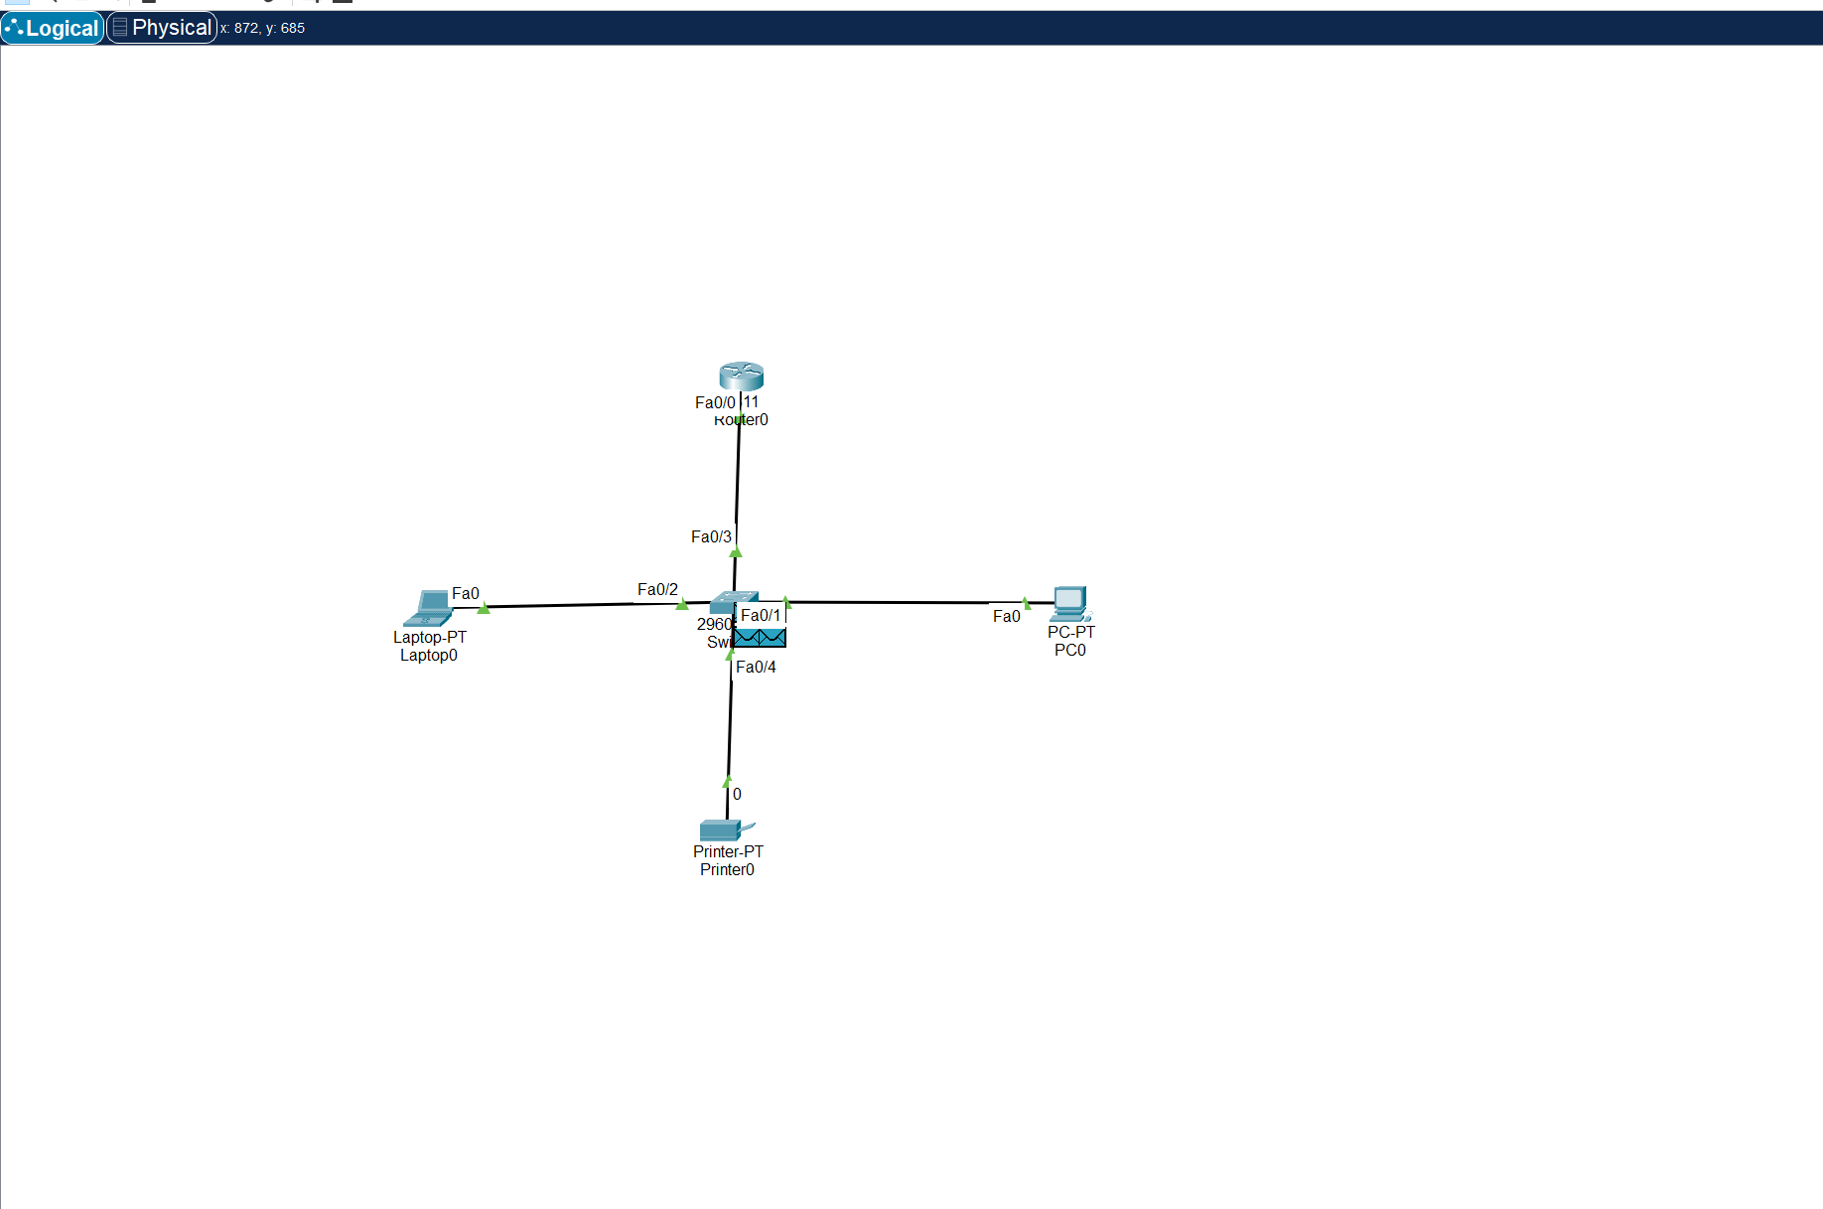

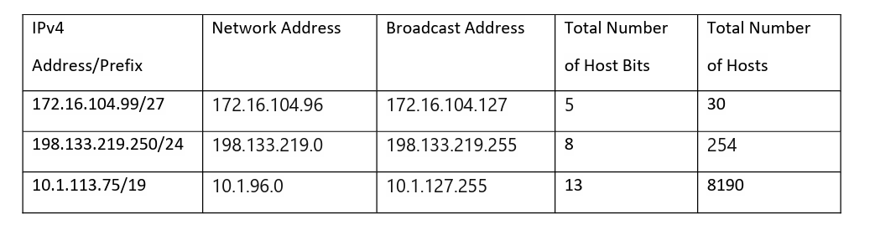

**Having the following information, compute subnets with the following constrains: A number of 62 subnets Host IP Address: 172.16.0.0 Original Subnet Mask 255.255.0.0**

A number of 62 subnets -> 6 bits

Host IP Address: 172.16.0.0

Original Subnet Mask 255.255.0.0

new SM : 255.255.252.0 10bits for host => 1022 hosts/subnet

Ip subnets: 172.16.0.0

network bits subnet host

10101100 00010000 111111 0000000000 Network address SN1

10101100 00010000 000000 1111111111 Broadcast address SN1

**Having the following information, compute subnets with the following constrains: A maximum number of 29 hosts/subnet Host IP Address: 192.168.200.0 Original Subnet Mask 255.255.255.0**

A maximum number of 29 hosts/subnet -> 5 bits for host, 3bits for subnet

new SM: 255.255.255.224

Ip subnets: 192.168.200.0

network bits subnet host

11000000 10101000 11001000 00000000 Network address SN1

11000000 10101000 11001000 00011111 Broadcast address SN1

**Having the following information, compute subnets with the following constrains: A number of 250 subnets Host IP Address: 10.0.0.0 Original Subnet Mask 255.0.0.0**

**A number of 250 subnets -> 8 bits (256 subnets)**

new SM: 255.255.0.0

16 bits for host => 65.534 hosts/subnet

Ip subnets: 10.0.0.0

network bits subnet host

00001010 00000000 00000000 00000000 Network address SN1

00001010 00000000 11111111 11111111 Broadcast address SN1