1. Dayeon Lee(A20393991)
2. Seyeon Lee(A20389155)
3. Soji Kim(A20394056)

a) UML

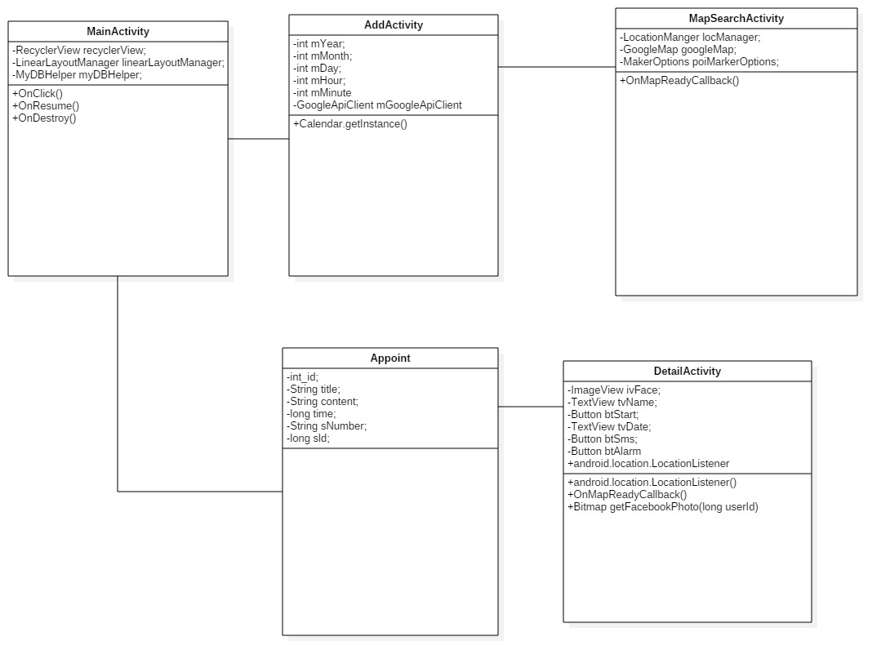

b)snapshots

-Main screen

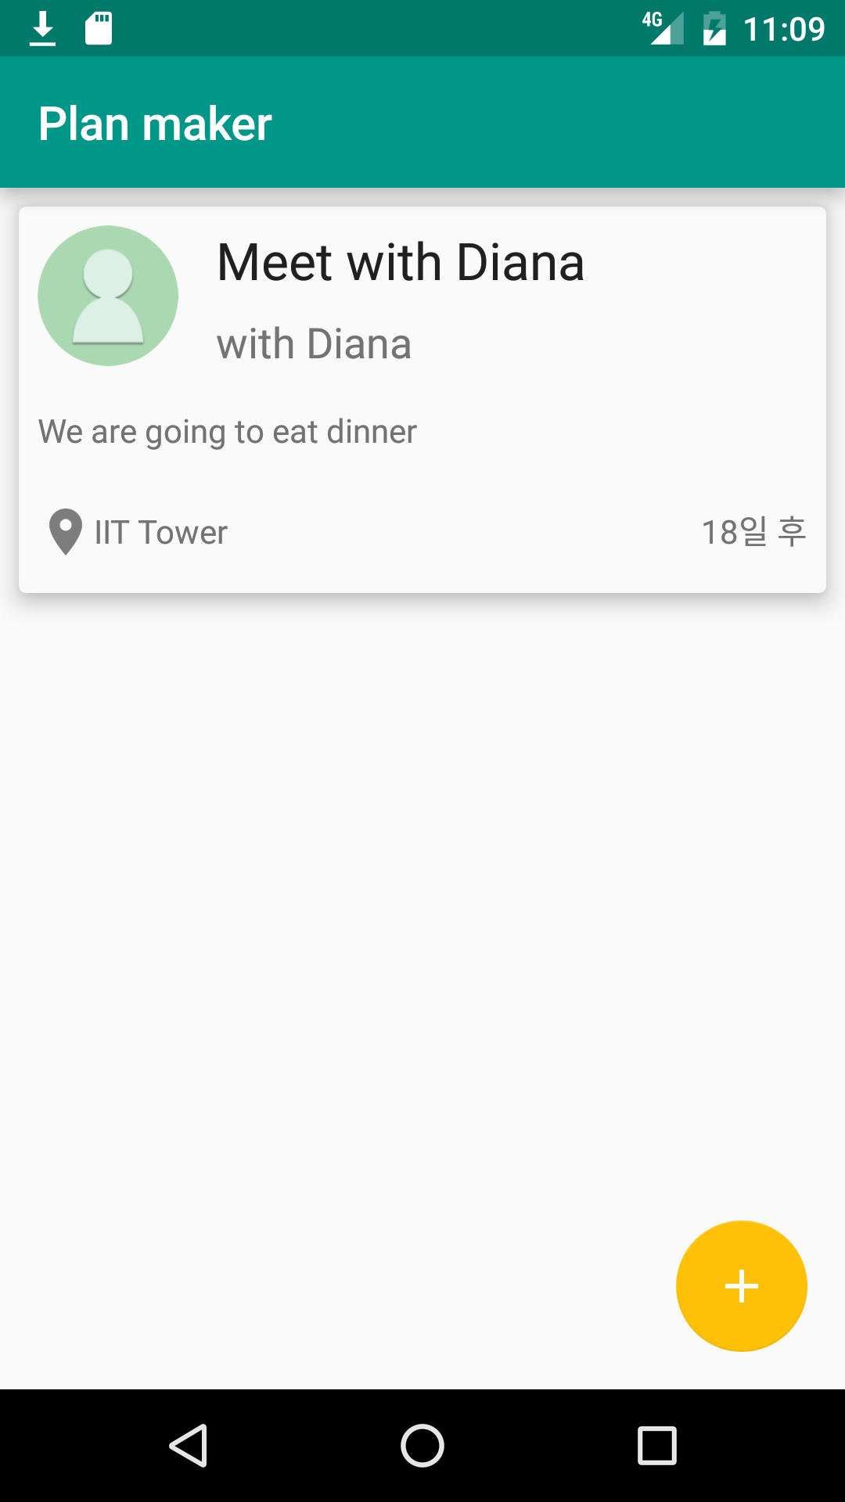

-Adding schedule screen

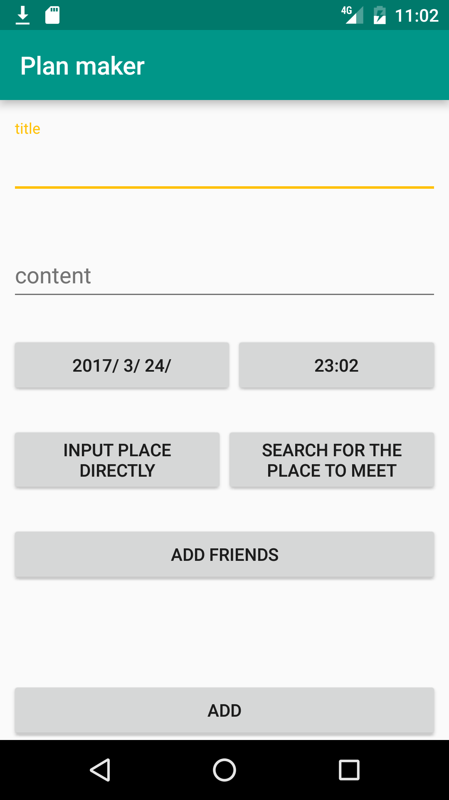

-Date selection

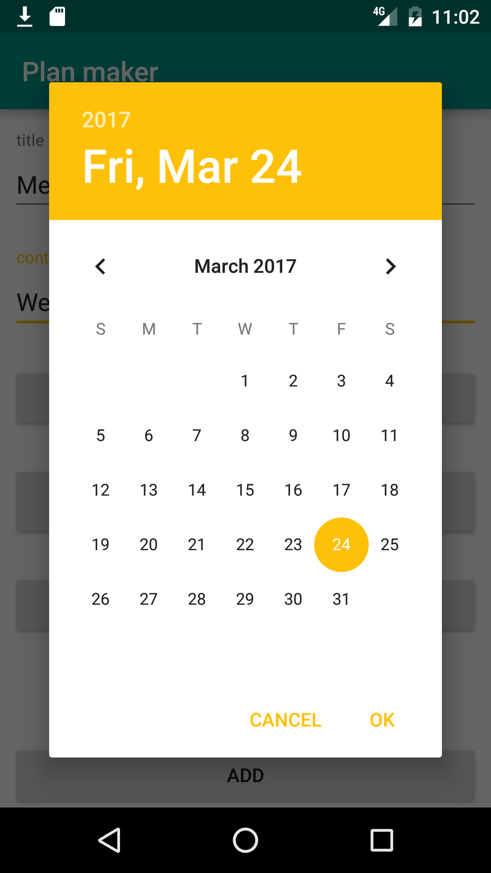

-place selection

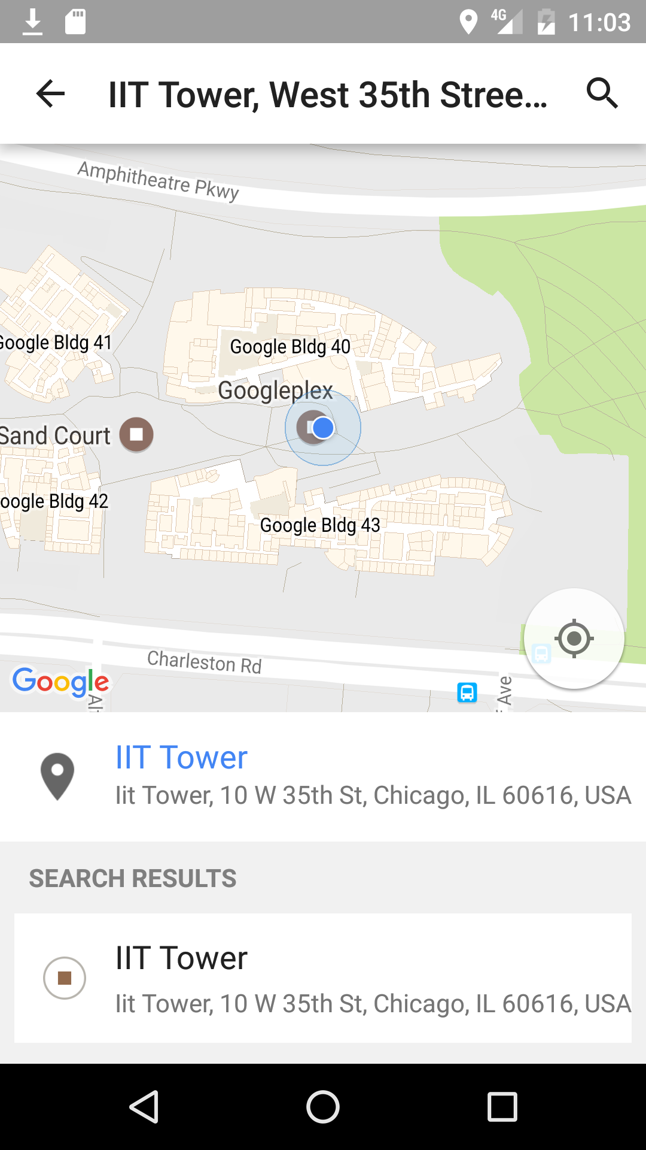

-schedule detail screen

