Міністерство освіти і науки України

Національний технічний університет України «Київський політехнічний інститут імені Ігоря Сікорського"

Факультет інформатики та обчислювальної техніки Кафедра інформатики та програмної інженерії

Звіт

з лабораторної роботи № 5 з дисципліни

«Основи програмування – 2. Метидології програмування»

«Наслідування та поліморфізм» Варіант 29

Виконав студент ІП-13 Романюк Діана Олексіївна

(шифр, прізвище, ім'я, по батькові)

Перевірив Вєчерковська Анастасія Сергіївна

( прізвище, ім'я, по батькові)

Київ 2022

# Лабораторна робота 5

**Мета** – вивчити механізми створення класів та об’єктів.

# Варіант 29 Постановка задачі:

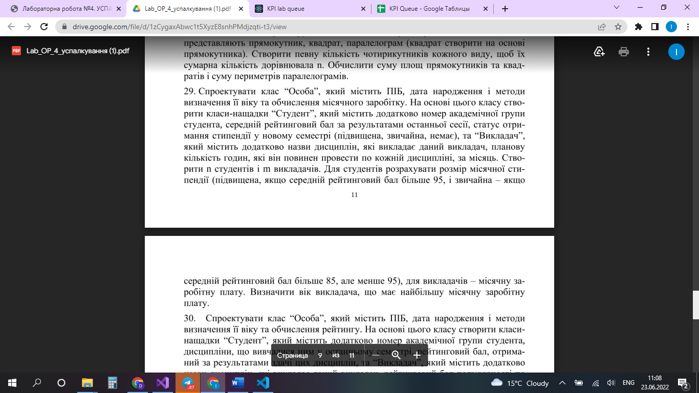



**Код програми на С++:**

# Header.h

#include <iostream>

#include <string>

#include <vector>

#include <Windows.h>

using namespace std;

class Person {

private:

string name;

string date_of_birth;

public:

Person(string line);

string getName();

string count_age();

virtual double monthly_income(double);

};

class Student : public Person {

private:

int group_id;

double average_grade;

char status;

public:

Student(string line1 = "none none none 01:01:1970", string line2 = "00 0.0");

double monthly_income(double) override;

};

class Teacher : public Person {

private:

string subject;

int hours;

public:

int getHours();

double monthly_income(double) override;

Teacher(string line1 = "none none none 01:01:1970", string line2 = "none 0");

};

# std::vector<string> split(string, char sep = ' ');

# Lab5.cpp

#include "Header.h"

int main() {

vector <Student> base_of_students;

vector <Teacher> base_of_teachers;

int n, m;

string str1, str2;

cout << "Enter amount of students: "; cin >> n;

cin.ignore();

for (int i = 0; i < n; i++) {

cout << "[Surname Name Patronymic DD::MM:YYYY]\n";

getline(cin, str1);

cout << "[id grades]\n";

getline(cin, str2);

base_of_students.push_back(Student(str1, str2));

}

cout << "Enter amount of teachers: "; cin >> m;

cin.ignore();

for (int i = 0; i < m; i++) {

cout << "[Surname Name Patronymic DD::MM:YYYY]\n";

getline(cin, str1);

cout << "[subject hours]\n";

getline(cin, str2);

base_of_teachers.push_back(Teacher(str1, str2));

}

double grants; cout << "Enter the grants amount: ";

cin >> grants;

cout << "Students:" << endl;

for (auto& s : base_of_students) {

cout << s.getName() << ": " << s.monthly_income(grants) << " UAH" << endl;

}

double salary; cout << "Enter the teachers' salary per hour: ";

cin >> salary;

cout << "Teachers:" << endl;

Teacher richest;

if (base_of_teachers.size() > 0) {

richest = base_of_teachers[0];

}

for (int i = 0; i < m; i++) {

cout << base_of_teachers[i].getName() << ": " << base_of_teachers[i].monthly_income(salary) << " UAH" << endl;

if (base_of_teachers[i].monthly_income(salary) > richest.monthly_income(salary)) richest = base_of_teachers[i];

}

cout << "The teacher with the biggest salary : " << richest.getName() << "\nHis age: " << richest.count_age();

return 0;

}

# Header.cpp

#include "Header.h"

Person::Person(string line) {

name = split(line)[0] + ' ' + split(line)[1] + ' ' + split(line)[2];

date_of_birth = split(line)[3];

}

string Person::getName() {

return name;

}

double Person::monthly_income(double hours) {

return (150 * hours);

}

string Person::count_age() {

SYSTEMTIME current_date;

GetLocalTime(&current_date);

int birth_year = stoi(split(date_of_birth, ':')[2]);

int birth_month = stoi(split(date_of_birth, ':')[1]);

int birth_day = stoi(split(date_of_birth, ':')[0]);

int d_day, d_month, d_year;

d_year = current_date.wYear - birth_year;

if (current_date.wMonth < birth_month) { d_month = current_date.wMonth + 12 - birth_month; }

else { d_month = current_date.wMonth - birth_month; }

if (current_date.wDay < birth_day) { d_day = current_date.wDay + 30 - birth_day; }

else { d_day = current_date.wDay - birth_day; }

if (current_date.wMonth < birth_month || current_date.wMonth == birth_month && current_date.wDay < birth_day) {

d_year--;

}

string age = "";

age += to_string(d_year) + "year(s)" + to_string(d_month) + "month(s)" + to_string(d_day) + "day(s)\n";

return age;

}

Student::Student(string line1, string line2) : Person(line1) {

group_id = stoi(split(line2)[0]);

average_grade = stod(split(line2)[1]);

}

double Student::monthly_income(double grants)

{

if (average_grade >= 95) {

status = 'h';

return grants * 1.4;

}

if (average_grade >= 85) {

status = 'd';

return grants;

}

status = 'n';

return 0;

}

Teacher::Teacher(string line1, string line2) : Person(line1) {

subject = split(line2)[0];

hours = stoi(split(line2)[1]);

}

int Teacher::getHours() {

return hours;

}

double Teacher::monthly_income(double payment)

{

return (payment * this->getHours());

}

vector<string> split(string line, char sep) {

vector<string> words;

string temp_word = "";

line += sep;

for (int i = 0; i < line.length(); i++) {

if (line[i] == sep) {

if (temp_word.length() > 0) {

words.push_back(temp_word);

}

temp_word = "";

}

else {

temp_word += line[i];

}

}

return words;

# }

# Код програми на Python

# Lab5.py

from foo import *

base_of_students = list()

base_of_teachers = list()

n = int(input('Enter amount of students: '))

for i in range(n):

    line1 = input('[Surname Name Patronymic DD::MM:YYYY]\n')

    line2 = input('[id grades]\n')

    base_of_students.append(Student(line1, line2))

m = int(input('Enter amount of teachers: '))

for i in range(m):

    line1 = input('[Surname Name Patronymic DD::MM:YYYY]\n')

    line2 = input('[subject hours]\n')

    base_of_teachers.append(Teacher(line1, line2))

grants = float(input('Enter the grants amount: '))

print('STUDENTS:')

for i in range(n):

    print(f'student {base_of_students[i].get_name()} {base_of_students[i].monthly_income(grants)} UAH')

if m > 0:

    payment = float(input('Enter the payment per hour: '))

    richest = base_of_teachers[0]

for i in range(m):

    print(f'teacher {base_of_teachers[i].get_name()} {base_of_teachers[i].monthly_income(payment)} UAH')

    if base_of_teachers[i].monthly_income(payment) > richest.monthly_income(payment):

        richest = base_of_teachers[i]

print(f'Richest teacher: {richest.get_name()}')

print(f'His age: {richest.get_age()}')

# foo.py

from datetime import date

from abc import ABC, abstractmethod

class Person(ABC):

    def __init__(self, line: str):

        self.__name__ = line.split()[0] + ' ' + line.split()[1] + ' ' + line.split()[2]

        self.__date_of_birth = line.split()[3]

    def get_name(self):

        return self.__name__

    def get_age(self) -> str:

        today = date.today()

        b_day = int(self.__date_of_birth.split(':')[0])

        b_month = int(self.__date_of_birth.split(':')[1])

        b_year = int(self.__date_of_birth.split(':')[2])

        d_year = today.year - b_year

        if today.month < b_month:

            d_month = today.month + 12 - b_month

        else:

            d_month = today.month - b_month

        if today.day < b_day:

            d_day = today.day + 30 - b_day

        else:

            d_day = today.day - b_day

        if today.month < b_month or today.month == b_month and today.day < b_day:

            d_year -= 1

        age = f'{str(d_year)} year(s) {str(d_month)} month(s) {str(d_day)} day(s)'

        return age

    @abstractmethod

    def monthly_income(self, hours: float) -> float:

        return 150 * hours

class Student(Person):

    def __init__(self, line1, line2):

        super().__init__(line1)

        self.group_id = int(line2.split()[0])

        self.__average_grade = float(line2.split()[1])

        self.__status = 'n'

    def monthly_income(self, grants: float) -> float:

        if self.__average_grade >= 95:

            self.__status = 'h'

            return grants*1.4

        elif self.__average_grade >= 85:

            self.__status = 'd'

            return grants

        else:

            return 0

class Teacher(Person):

    def __init__(self, line1, line2):

        super().__init__(line1)

        self.__subject = line2.split()[0]

        self.hours = float(line2.split()[1])

    def monthly_income(self, salary: float) -> float:

        return salary*self.hours

# 

**Висновки:** під час лабораторної роботи ми вивчили механізми створення класів та об’єктів.