DAY8 SESSION ASSIGNMENTS

1. When to use (Rapid Application Development) RAD model
When not to use (Rapid Application Development) RAD model

Ans:
When to use (Rapid Application Development) RAD model:

• RAD should be used only when a system can be modularized to be delivered in incremental manner.
• It should be used if there is high availability of designers for modeling
• It should be used only if the budget permits use of automated code generating tools
• RAD SDLC model should be chosen only if domain experts are available with relevant business knowledge.
• Should be used where the requirements change during the course of the project and working prototypes are to be presented to customer in small iterations of 2-3 months.
• Suitable for systems that are component based and scalable.
• Used when user involvement is possible throughout the life cycle.
• increased reusability of components is critical and important.

When not to use (Rapid Application Development) RAD model:

• Changing requirements cannot be accommodated
• Quick initial reviews doesn’t needed
• Customer doesn’t need just a feedback but requires a perfect and completed project within a limited time
• Technically strong team and highly skilled developers/designers cannot be provided
• System that cannot be modularized cannot be built using RAD
• Projects are cheaper then RAD model fails because cost of modelling and automated code generation is very high.
• RAD model is not apllicable when the user involvement cannot be provided during the life cycle.

2. Define an ER diagram of a software Organization with all the relationship model that was discussed in the classroom

Ans:

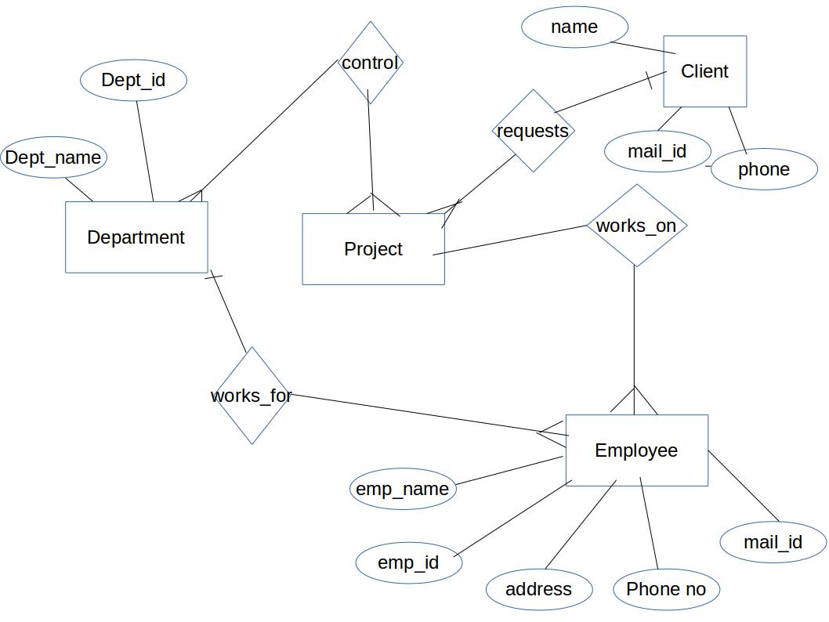

3. Describe the Entity Relationships for the following diagram

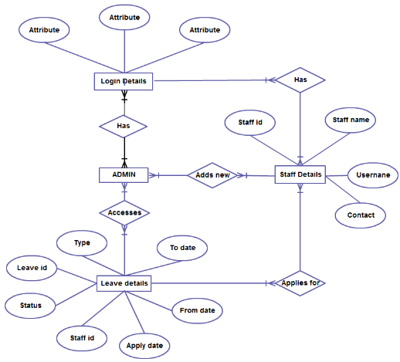

Ans:
An entity relationship model, also called an entity-relationship (ER) diagram, is a graphical representation of entities and their relationships to each other, typically used in computing in regard to the organization of data within databases or information systems.

ER diagram may contain entities,attributes,relationships .
Entities, are represented by rectangles. An entity is an object or concept about which you want to store information.
Actions, are represented by diamond shapes, show how two entities share information in the database .

Attributes, are represented by ovals. A key attribute is the unique, distinguishing characteristic of the entity.
Entities in the above diagram are:
-Admin
-Login details
--Staff details
-Leave details

Each of these entities will have many attributes.As per the above diagram:

Entity | Attributes
Login Details | Attribute,Attribute,Attribute
Admin | No attributes mentioned
Staff details | Staff id,staff name,username,contact
Leave details | leave id, status,staff id, apply date,from date,to date, type

Different type of relationships:

Has: one or more admin has one or more login details(many to many relation).
One or more staff has one or more login details(many to many relation).

Applies For: one or more staff applies for one or more leave(many to many relation).

Leave Details:one or more admin accesses one or more leave details(many to many relation).

