15 October 2024

Programming 2B POE Part 2

Dianca Jade Naidu

ST10261874

Contents

Github Link 2

Video Link 2

Screenshot of Feedback from Lecturer: 2

Github Commits 3

Unit Tests 4

References 5

# Github Link: <https://github.com/VCWVL/prog6212-part-2-ST10261874.git>

# Video Link: <https://youtu.be/tbUBfMzkMhA>

# Screenshot of Feedback from Lecturer:

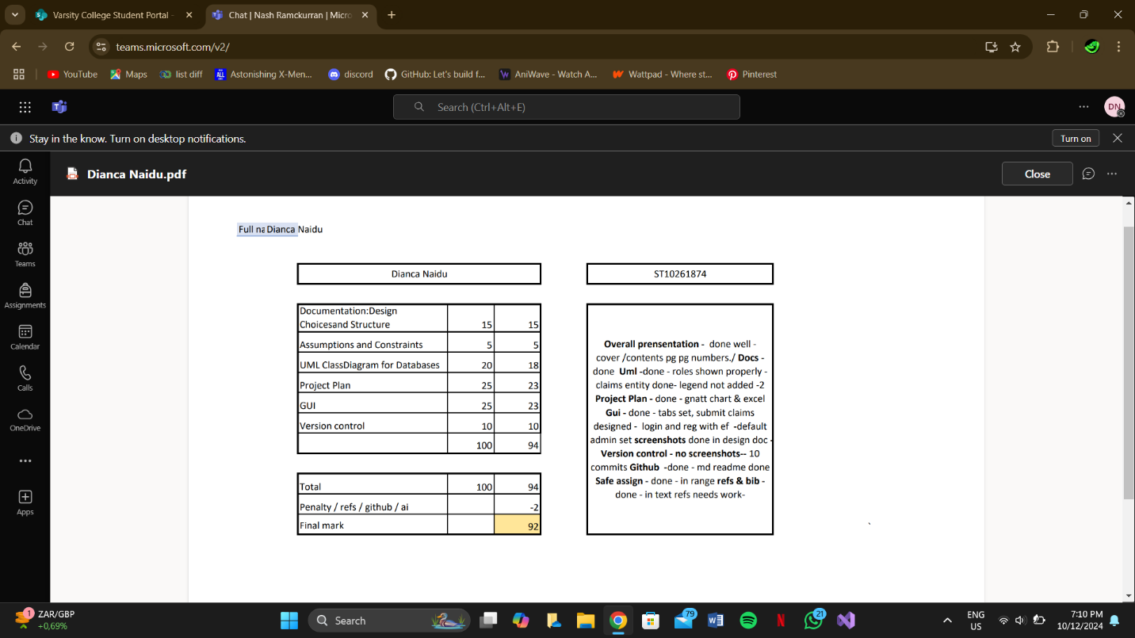

CHANGELOG

No changes were needed to be made for the MVC app based on feedback.

# Github Commits

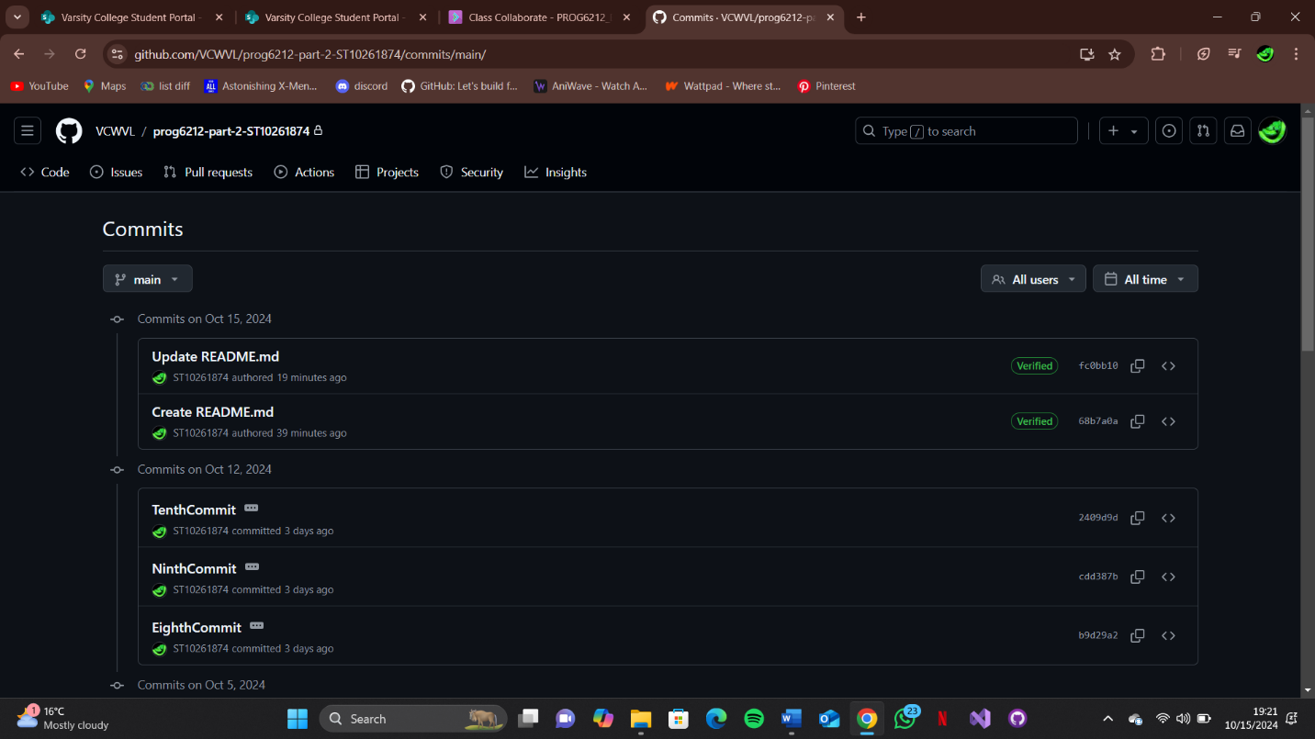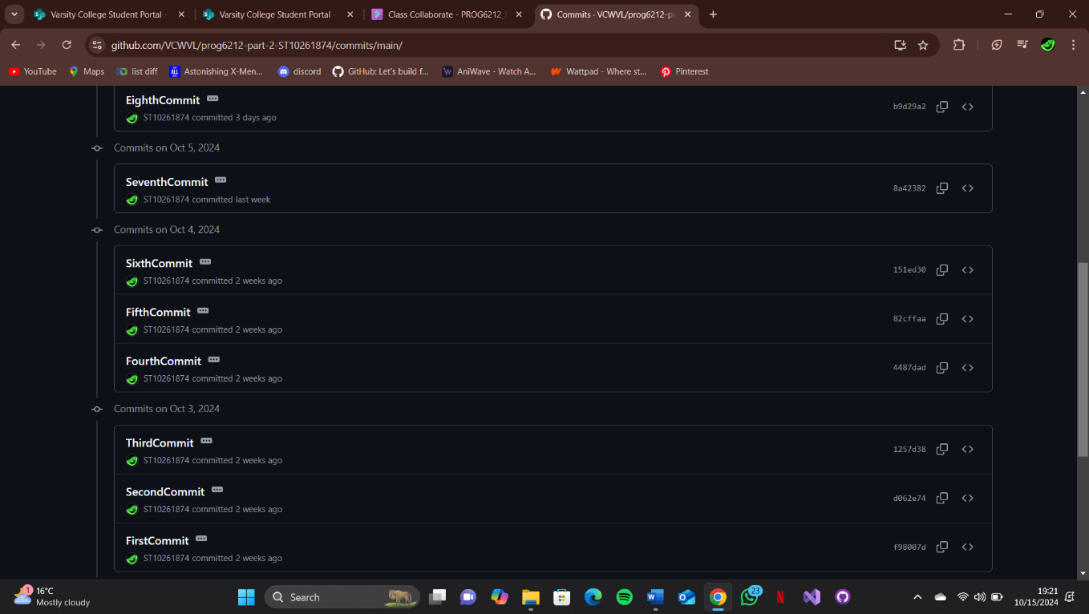

# Unit Tests

Screenshot of Unit Tests being successful:

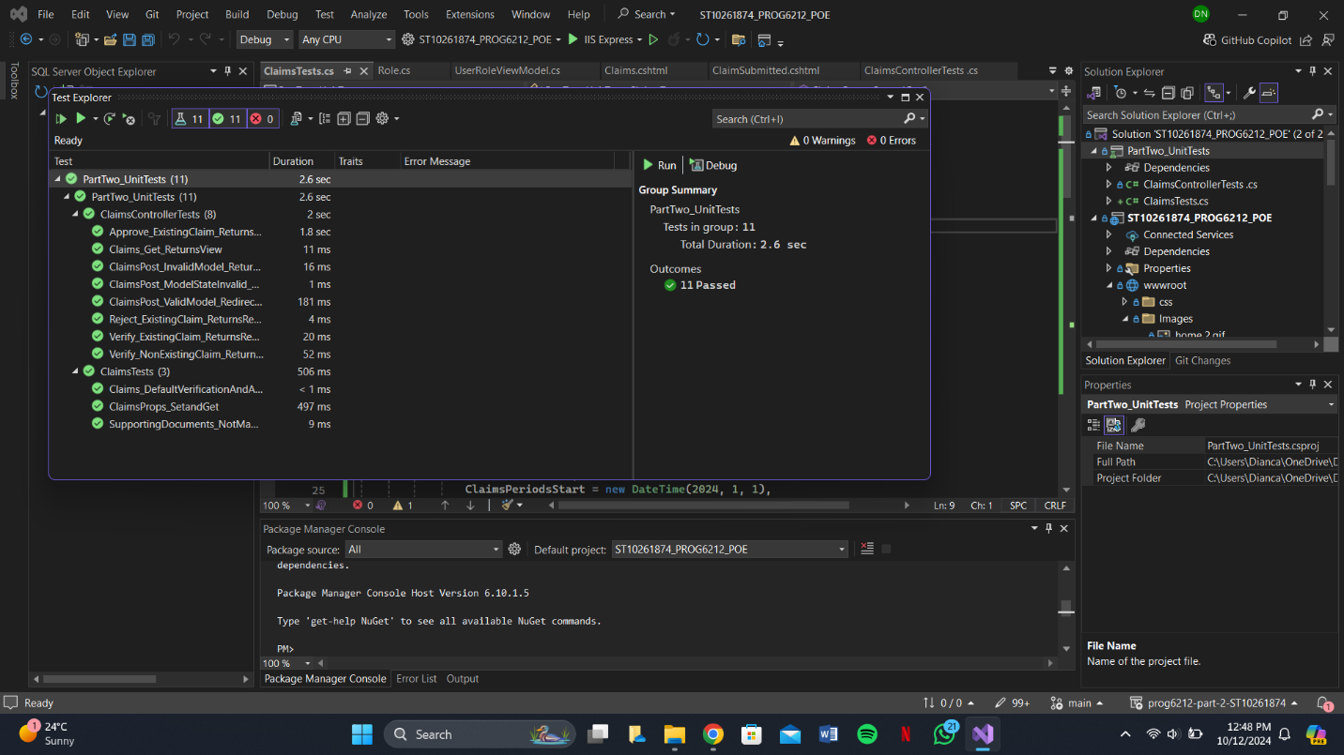

# References

https://chatgpt.com/