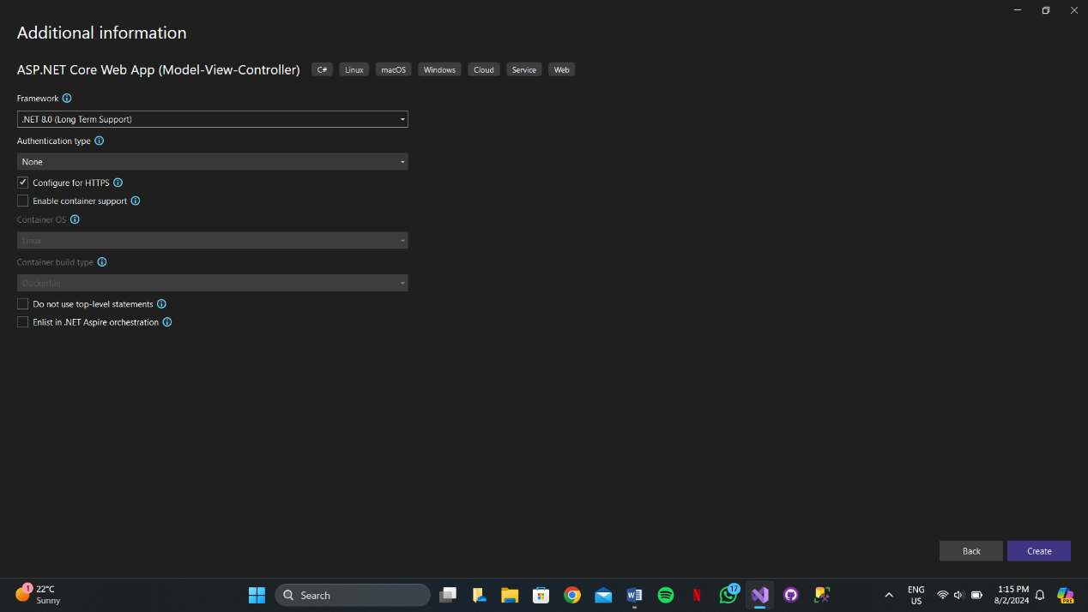

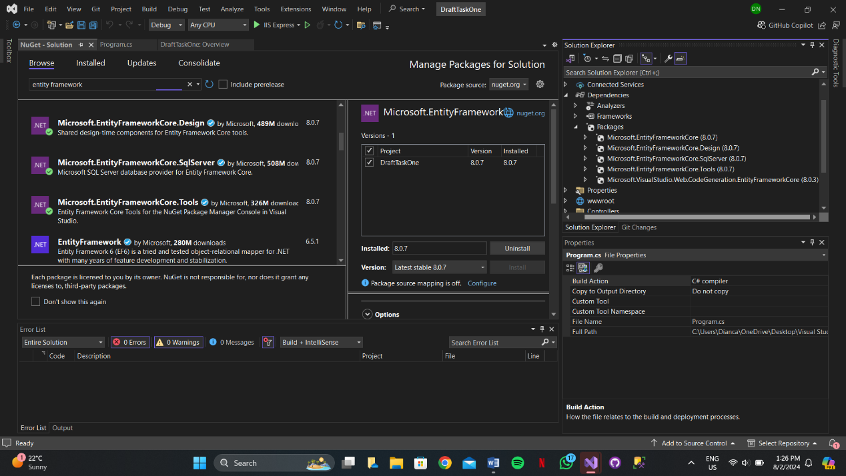

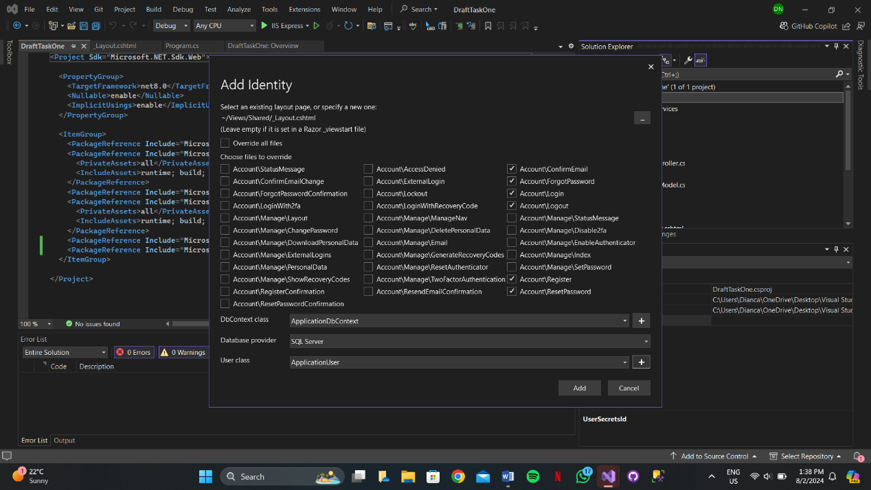

Go to ssms (localdb)\MSSQLLocalDb

Then go to nugget

add-migration FirstMig

update-database

then go to SSMS and find your project there