# Table of contents

# List of graphics

# List of tables

# iris outputs

## Plot

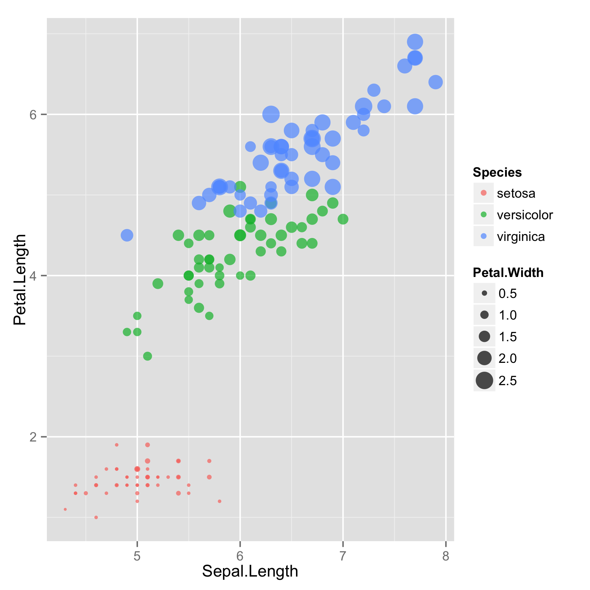

1. iris plot

## Table

|  |  |  |  |  |
| --- | --- | --- | --- | --- |
| **Sepal.Length** | **Sepal.Width** | **Petal.Length** | **Petal.Width** | **Species** |
| 5.1 | 3.5 | 1.4 | 0.2 | setosa |
| 4.9 | 3.0 | 1.4 | 0.2 | setosa |
| 4.7 | 3.2 | 1.3 | 0.2 | setosa |
| 4.6 | 3.1 | 1.5 | 0.2 | setosa |
| 5.0 | 3.6 | 1.4 | 0.2 | setosa |
| 5.4 | 3.9 | 1.7 | 0.4 | setosa |

1. iris table

# mtcars outputs

## Plot

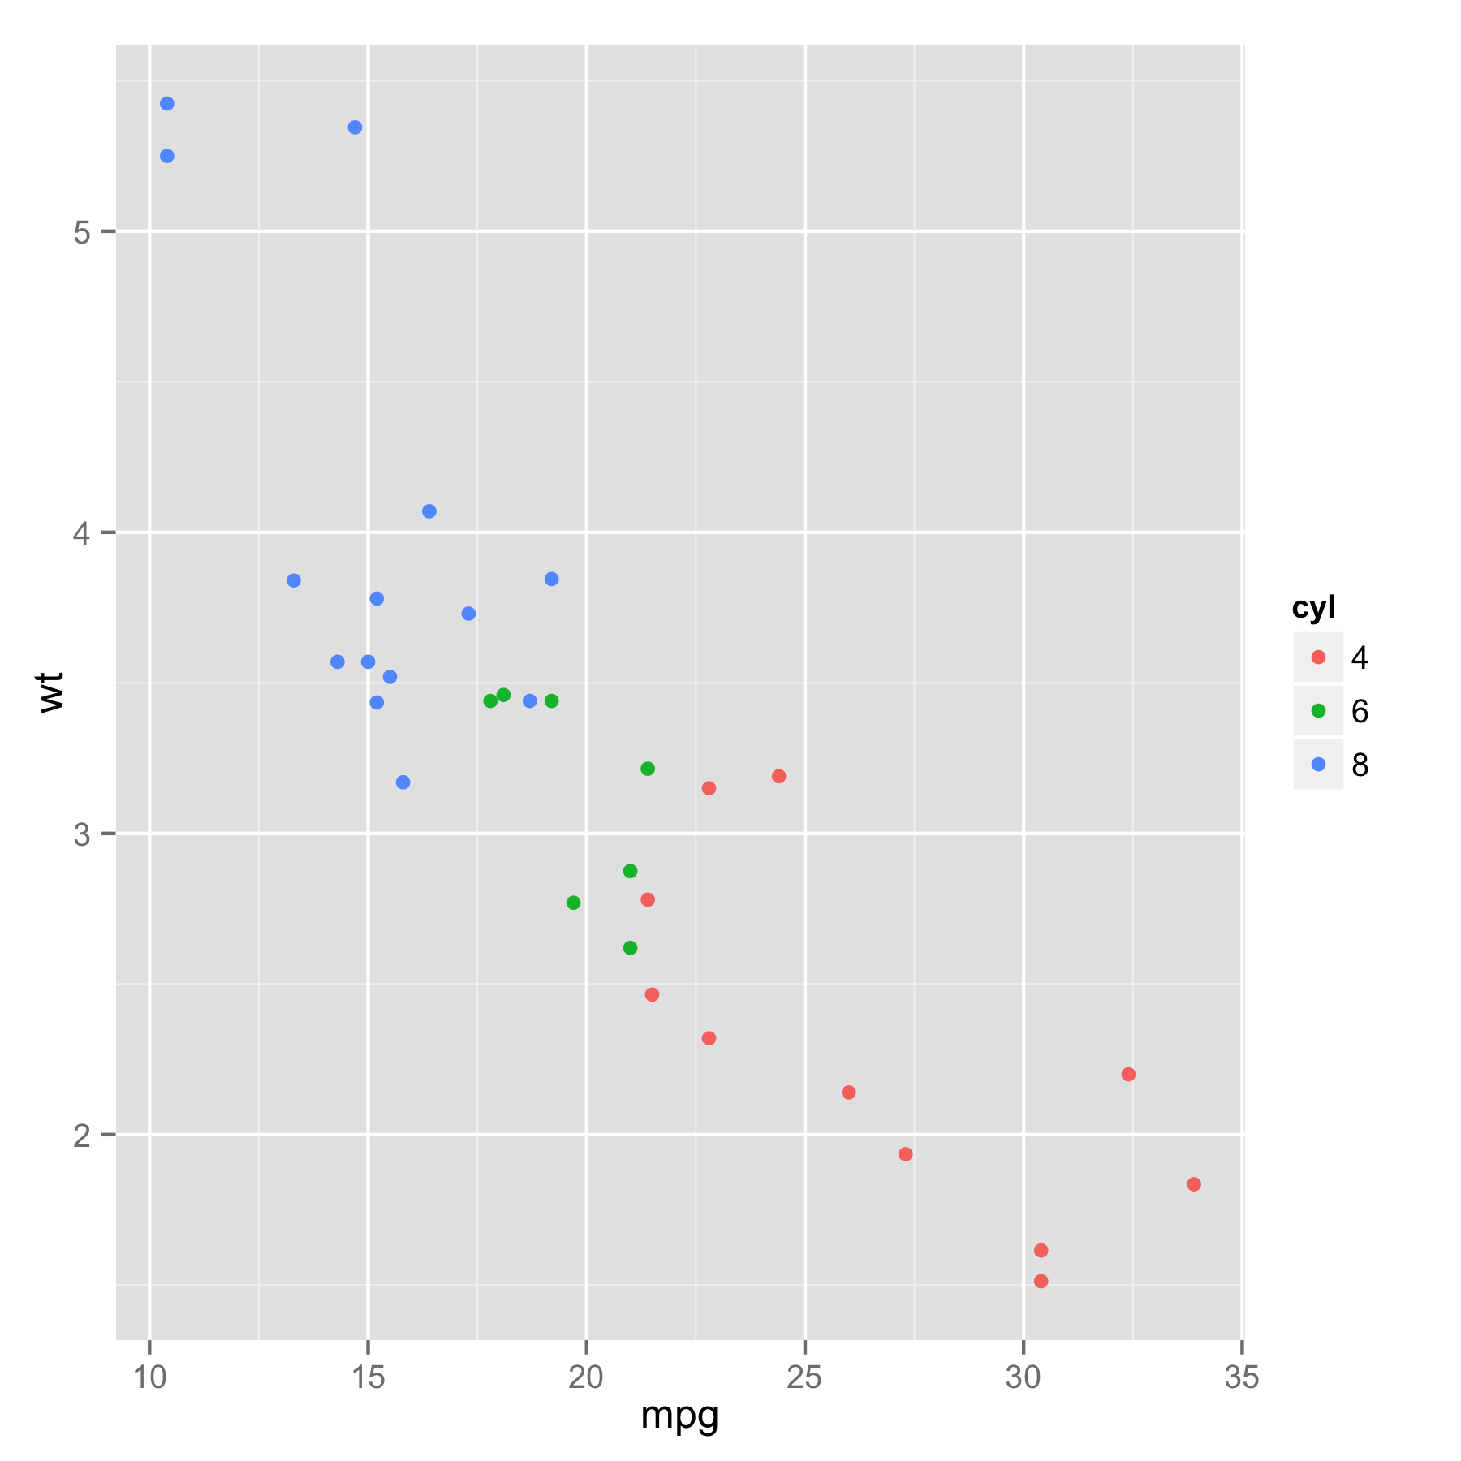

1. mtcars plot

## Table

|  |  |  |  |  |  |
| --- | --- | --- | --- | --- | --- |
| **mpg** | **cyl** | **disp** | **hp** | **drat** | **wt** |
| 21.0 | 6 | 160 | 110 | 3.90 | 2.620 |
| 21.0 | 6 | 160 | 110 | 3.90 | 2.875 |
| 22.8 | 4 | 108 | 93 | 3.85 | 2.320 |
| 21.4 | 6 | 258 | 110 | 3.08 | 3.215 |
| 18.7 | 8 | 360 | 175 | 3.15 | 3.440 |
| 18.1 | 6 | 225 | 105 | 2.76 | 3.460 |

1. mtcars table