My report

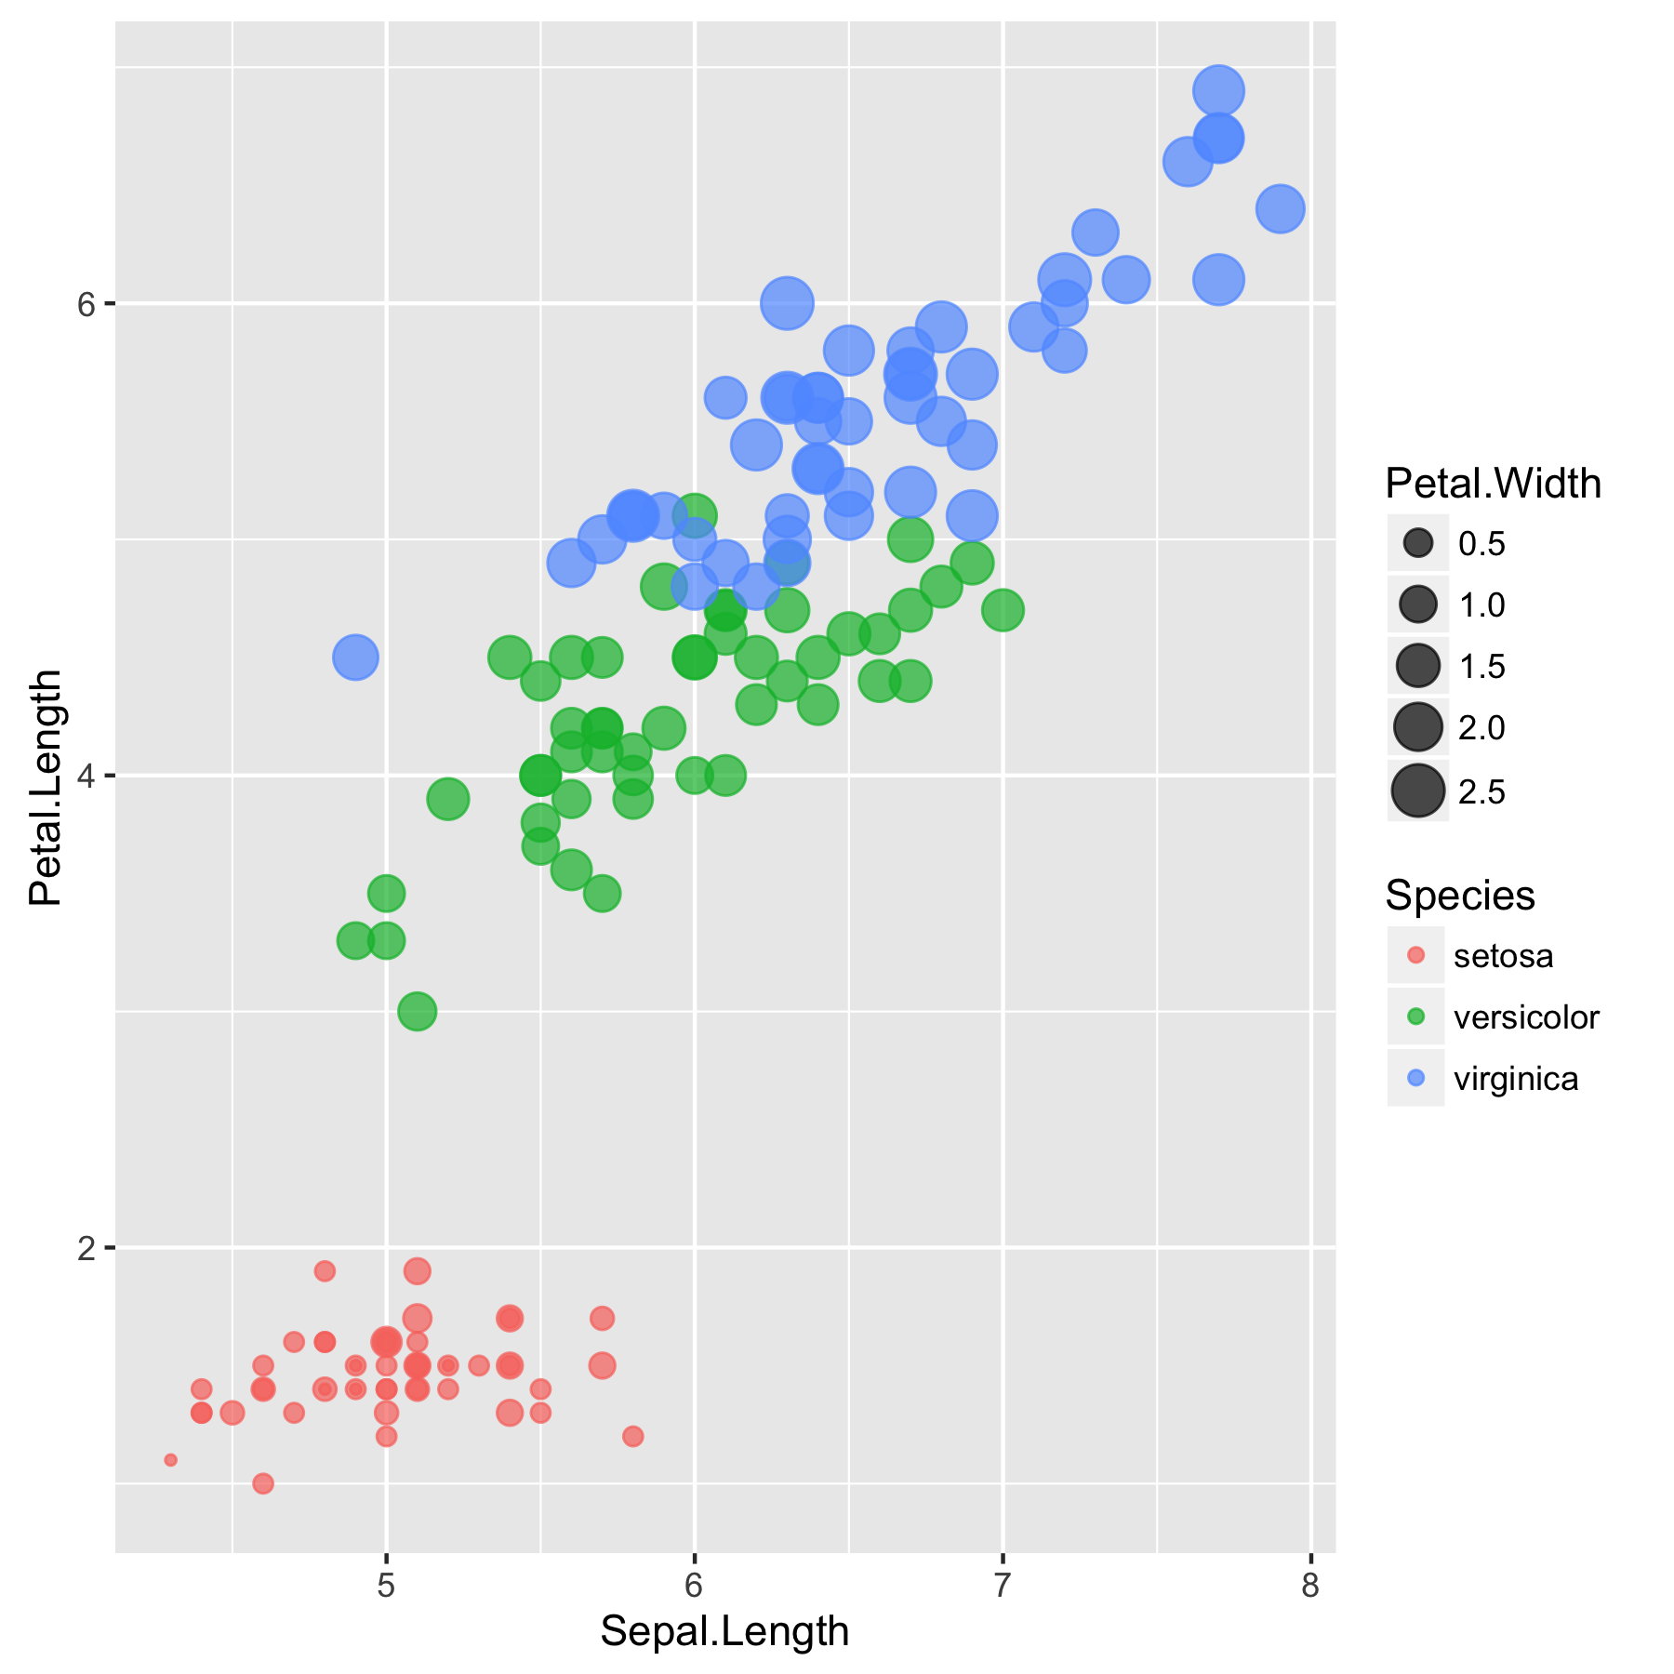

Illud tamen clausos vehementer angebat quod captis navigiis, quae frumenta vehebant per flumen, Isauri quidem alimentorum copiis adfluebant, ipsi vero solitarum rerum cibos iam consumendo inediae propinquantis aerumnas exitialis horrebant.

Illud tamen clausos vehementer angebat quod captis navigiis, quae frumenta vehebant per flumen, Isauri quidem alimentorum copiis adfluebant, ipsi vero solitarum rerum cibos iam consumendo inediae propinquantis aerumnas exitialis horrebant.

Below a table

|  | **mpg** | **cyl** | **disp** | **hp** | **drat** | **wt** | **qsec** | **vs** | **am** | **gear** | **carb** |
| --- | --- | --- | --- | --- | --- | --- | --- | --- | --- | --- | --- |
| Mazda RX4 | 21.0 | 6 | 160.0 | 110 | 3.90 | 2.620 | 16.46 | 0 | 1 | 4 | 4 |
| Mazda RX4 Wag | 21.0 | 6 | 160.0 | 110 | 3.90 | 2.875 | 17.02 | 0 | 1 | 4 | 4 |
| Datsun 710 | 22.8 | 4 | 108.0 | 93 | 3.85 | 2.320 | 18.61 | 1 | 1 | 4 | 1 |
| Hornet 4 Drive | 21.4 | 6 | 258.0 | 110 | 3.08 | 3.215 | 19.44 | 1 | 0 | 3 | 1 |
| Hornet Sportabout | 18.7 | 8 | 360.0 | 175 | 3.15 | 3.440 | 17.02 | 0 | 0 | 3 | 2 |
| Valiant | 18.1 | 6 | 225.0 | 105 | 2.76 | 3.460 | 20.22 | 1 | 0 | 3 | 1 |
| Duster 360 | 14.3 | 8 | 360.0 | 245 | 3.21 | 3.570 | 15.84 | 0 | 0 | 3 | 4 |
| Merc 240D | 24.4 | 4 | 146.7 | 62 | 3.69 | 3.190 | 20.00 | 1 | 0 | 4 | 2 |
| Merc 230 | 22.8 | 4 | 140.8 | 95 | 3.92 | 3.150 | 22.90 | 1 | 0 | 4 | 2 |
| Merc 280 | 19.2 | 6 | 167.6 | 123 | 3.92 | 3.440 | 18.30 | 1 | 0 | 4 | 4 |

Illud tamen clausos vehementer angebat quod captis navigiis, quae frumenta vehebant per flumen, Isauri quidem alimentorum copiis adfluebant, ipsi vero solitarum rerum cibos iam consumendo inediae propinquantis aerumnas exitialis horrebant.