 | DIRECTION DE LA PREVISION ET DU RESEAU D'OBSERVATION METEOROLOGIQUE  SERVICE DE LA PREVISION ET DE L'ASSISTANCE METEOROLOGIQUE  MARINE FORECAST FOR SEME | 

From Saturday, 16th May 2026 at 07:00 pm to Tuesday, 19th May 2026 at 07:00 pm (local time)

Warning: Significant wave heights are expected to be relatively stable, reaching a peak of 1.7 meters around Tuesday, 19th May at 7:00 PM (local time). Wind speeds are also expected to reach 15 knots with gusts up to 20 knots from SSW.
Met Situation:
[ Met situation — enter text here ]
Weather:
[ Weather description — enter text here ]
Table 1: Weather and Ocean parameters
 |  | Weather parameters |  |  |  |  |  |  |  |  |  |  | Ocean parameters
 |  | Wind at 10m |  |  | Wind at 100m |  | MSLP (hPa) | Vis. (km) | T (°C) | Weather condition | Rain (%) | SST (°C) | Swell 1 |  |  | Swell 2 |  |  | S.W (m) | Currents |  | Confidence
Date & Time | Time | Dir. | Spd  (kts) | Gust  (kts) | Dir. | Spd  (kts) | MSLP  (hPa) | Vis.  (km) | T  (°C) | Weather  cond. | Rain  (%) | SST  (°C) | Dir. | Per.  (s) | Ht.  (m) | Dir. | Per.  (s) | Ht.  (m) | S.W  (m) | Dir. | Spd.  (kts) | Conf.
Sat. 16 May | 19:00 | SW | 13 | 17 | SW | 14 | 1010 | 7 | 29 | — Select — | 10 | 30 | S | 8 | 1.1 | SW | 15 | 0.4 | 1.6 | ESE | 1.0
 | 22:00 | WSW | 11 | 15 | WSW | 12 | 1012 | 7 | 29 | — Select — | 20 | 30 | S | 8 | 1.1 | SW | 14 | 0.4 | 1.6 | ESE | 0.0
Sun. 17 May | 01:00 | SW | 11 | 15 | SW | 12 | 1012 | 7 | 29 | — Select — | 20 | 30 | S | 9 | 0.9 | SW | 14 | 0.5 | 1.6 | ESE | 0.0
 | 04:00 | WSW | 10 | 13 | WSW | 10 | 1010 | 9 | 28 | — Select — | 100 | 30 | S | 8 | 1.1 | SW | 13 | 0.5 | 1.6 | SE | 0.0
 | 07:00 | SW | 5 | 10 | SW | 5 | 1012 | 9 | 26 | — Select — | 100 | 30 | S | 7 | 1.1 | SW | 12 | 0.5 | 1.6 | SE | 0.0
 | 10:00 | SW | 8 | 11 | SW | 8 | 1014 | 8 | 27 | — Select — | 60 | 30 | S | 8 | 1.0 | SW | 12 | 0.6 | 1.6 | SE | 0.0
 | 13:00 | WSW | 9 | 13 | WSW | 10 | 1012 | 9 | 28 | — Select — | 10 | 30 | SSW | 8 | 1.1 | SW | 9 | 0.6 | 1.5 | ESE | 0.0
 | 16:00 | WSW | 12 | 16 | WSW | 13 | 1010 | 9 | 28 | — Select — | 10 | 30 | SSW | 8 | 1.0 | SW | 10 | 0.6 | 1.5 | ESE | 0.0
 | 19:00 | WSW | 12 | 16 | WSW | 13 | 1010 | 9 | 29 | — Select — | 10 | 30 | S | 7 | 0.8 | SSW | 12 | 0.8 | 1.5 | ESE | 0.0
 | 22:00 | WSW | 13 | 19 | WSW | 14 | 1013 | 8 | 29 | — Select — | 20 | 30 | SSW | 10 | 0.8 | S | 10 | 0.8 | 1.6 | E | 0.0
Mon. 18 May | 01:00 | WSW | 13 | 17 | WSW | 14 | 1012 | 10 | 29 | — Select — | 20 | 30 | SSW | 10 | 0.8 | S | 10 | 0.7 | 1.5 | ESE | 1.0
 | 04:00 | W | 13 | 18 | W | 14 | 1011 | 10 | 28 | — Select — | 50 | 30 | SSW | 10 | 0.9 | SSW | 8 | 0.7 | 1.5 | ESE | 1.0
 | 07:00 | WNW | 5 | 8 | WNW | 5 | 1012 | 8 | 26 | — Select — | 100 | 30 | SSW | 10 | 1.0 | SW | 6 | 0.6 | 1.5 | ESE | 1.0
 | 10:00 | SW | 11 | 15 | SW | 12 | 1013 | 8 | 27 | — Select — | 90 | 30 | SSW | 10 | 0.8 | S | 11 | 0.6 | 1.5 | E | 1.0
 | 13:00 | WSW | 12 | 15 | WSW | 13 | 1012 | 8 | 28 | — Select — | 10 | 30 | SSW | 10 | 0.8 | S | 10 | 0.7 | 1.5 | E | 1.0
 | 16:00 | SSW | 15 | 20 | SSW | 15 | 1010 | 9 | 27 | — Select — | 100 | 30 | SSW | 10 | 0.8 | S | 12 | 0.6 | 1.6 | E | 1.0
 | 19:00 | SSW | 14 | 18 | SSW | 15 | 1011 | 8 | 27 | — Select — | 100 | 30 | SSW | 11 | 0.8 | S | 14 | 0.4 | 1.6 | E | 1.0
 | 22:00 | WSW | 12 | 16 | WSW | 13 | 1013 | 8 | 28 | — Select — | 100 | 30 | SW | 11 | 0.8 | S | 14 | 0.4 | 1.6 | E | 1.0
Tue. 19 May | 01:00 | WSW | 11 | 17 | WSW | 12 | 1013 | 8 | 27 | — Select — | 100 | 30 | SW | 11 | 0.8 | S | 15 | 0.3 | 1.7 | E | 1.0
 | 04:00 | W | 10 | 15 | W | 10 | 1011 | 8 | 27 | — Select — | 100 | 29 | SW | 11 | 0.7 | S | 15 | 0.3 | 1.7 | E | 1.0
 | 07:00 | N | 4 | 11 | N | 4 | 1012 | 10 | 25 | — Select — | 100 | 29 | SW | 11 | 0.8 | S | 14 | 0.4 | 1.7 | E | 1.0
 | 10:00 | SE | 10 | 16 | SE | 10 | 1014 | 10 | 25 | — Select — | 100 | 29 | SW | 11 | 0.8 | S | 14 | 0.4 | 1.7 | E | 1.0
 | 13:00 | SE | 12 | 18 | SE | 12 | 1013 | 10 | 25 | — Select — | 100 | 29 | SW | 11 | 0.8 | S | 14 | 0.4 | 1.7 | E | 1.0
 | 16:00 | S | 11 | 17 | SSW | 12 | 1010 | 8 | 26 | — Select — | 100 | 30 | SW | 11 | 0.8 | S | 13 | 0.5 | 1.7 | ENE | 1.0
 | 19:00 | SSW | 10 | 15 | SSW | 10 | 1011 | 9 | 27 | — Select — | 100 | 30 | SW | 11 | 0.8 | S | 13 | 0.5 | 1.7 | ENE | 1.0
🟨 Weather condition: select from dropdown | 🟩 Confidence: enter manually | Dir=Direction | Spd=Speed(kts) | Per=Period(s) | Ht=Height(m) | S.W=Significant Wave Height

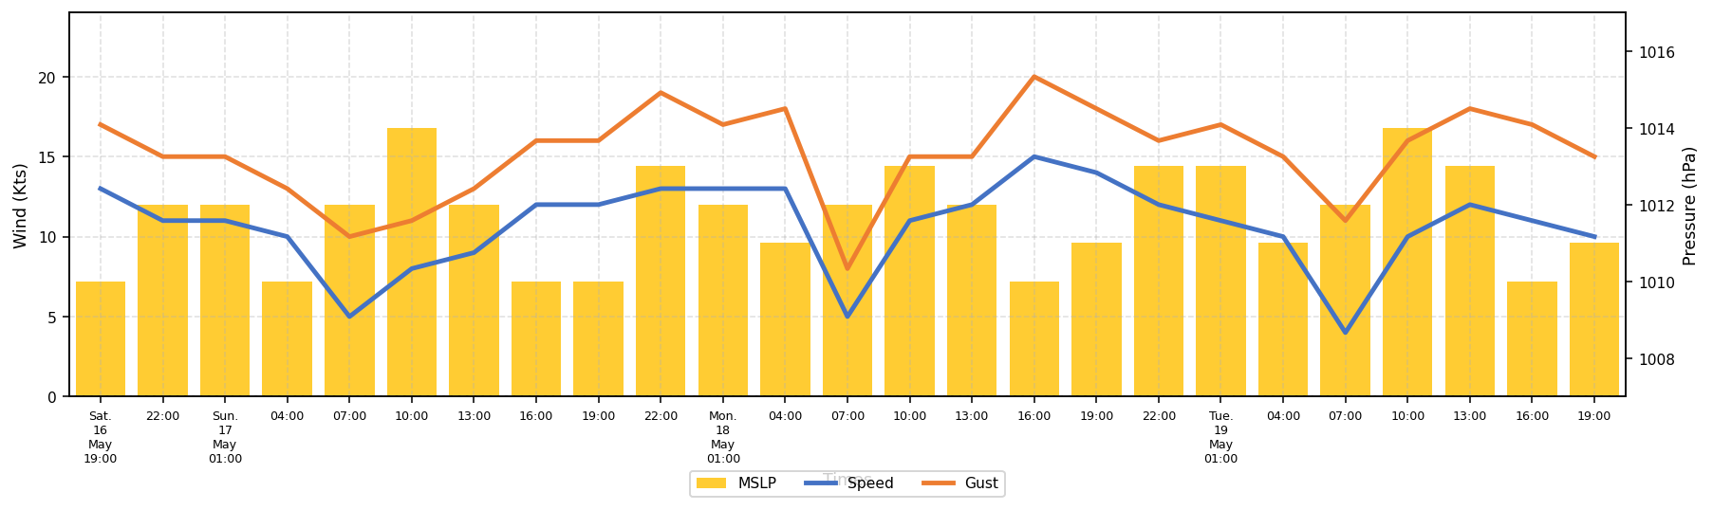
Figure 1: Trends of winds and Mean Sea Level Pressure from 16th to 19th May 2026
❖ Table 2: Tides predictions for SEME
Dates | HIGH TIDES |  |  |  | LOW TIDES
Dates | Time | Height | Time | Height | Time | Height | Time | Height

[ Insert ENSgram image here — copy/paste from ECMWF website ]
Figure 2: Wave ensemblegram issued by ECMWF from 16th to 19th May 2026
❖ Significant wave heights are forecast to...
[ Commentary on ENSgram — enter text here ]

[ Image 1 ] | [ Image 2 ]
[ Image 3 ] | [ Image 4 ]
Figure 3: Probability forecast for Sunday, 17th May 2026 at 01:00 pm local time.

