 | DIRECTION DE LA PREVISION ET DU RESEAU D'OBSERVATION METEOROLOGIQUE  SERVICE DE LA PREVISION ET DE L'ASSISTANCE METEOROLOGIQUE  MARINE FORECAST FOR SEME | 

From Sunday, 17th May 2026 at 07:00 pm to Wednesday, 20th May 2026 at 07:00 pm (local time)

Warning: None. Significant wave heights are expected to be relatively stable, peaking at 1.7 m around Wednesday, 20th May at 1:00 AM (local time). Mariners are advised to exercise caution.
Met Situation:
[ Met situation — enter text here ]
Weather:
[ Weather description — enter text here ]
Table 1: Weather and Ocean parameters
 |  | Weather parameters |  |  |  |  |  |  |  |  |  |  | Ocean parameters
 |  | Wind at 10m |  |  | Wind at 100m |  | MSLP (hPa) | Vis. (km) | T (°C) | Weather condition | Rain (%) | SST (°C) | Swell 1 |  |  | Swell 2 |  |  | S.W (m) | Currents |  | Confidence
Date & Time | Time | Dir. | Spd  (kts) | Gust  (kts) | Dir. | Spd  (kts) | MSLP  (hPa) | Vis.  (km) | T  (°C) | Weather  cond. | Rain  (%) | SST  (°C) | Dir. | Per.  (s) | Ht.  (m) | Dir. | Per.  (s) | Ht.  (m) | S.W  (m) | Dir. | Spd.  (kts) | Conf.
Sun. 17 May | 19:00 | WSW | 13 | 16 | WSW | 14 | 1010 | 7 | 29 | — Select — | 10 | 30 | SSW | 9 | 0.9 | SSW | 12 | 0.5 | 1.6 | ESE | 0.0 | — Select —
 | 22:00 | SW | 17 | 22 | SW | 18 | 1014 | 8 | 28 | — Select — | 40 | 30 | SSW | 10 | 0.7 | SSW | 12 | 0.5 | 1.6 | E | 0.0
Mon. 18 May | 01:00 | W | 9 | 15 | WSW | 10 | 1014 | 8 | 28 | — Select — | 100 | 30 | S | 8 | 0.8 | SW | 12 | 0.7 | 1.6 | ESE | 1.0 | — Select —
 | 04:00 | W | 11 | 14 | W | 11 | 1011 | 9 | 27 | — Select — | 90 | 30 | S | 8 | 0.8 | SW | 12 | 0.7 | 1.6 | ESE | 1.0
 | 07:00 | WSW | 10 | 16 | WSW | 10 | 1012 | 8 | 27 | — Select — | 60 | 30 | S | 9 | 0.8 | SW | 11 | 0.7 | 1.6 | ESE | 1.0
 | 10:00 | WSW | 11 | 15 | WSW | 12 | 1014 | 8 | 28 | — Select — | 30 | 30 | SSW | 10 | 0.8 | S | 10 | 0.8 | 1.6 | E | 1.0
 | 13:00 | SSW | 14 | 18 | SSW | 15 | 1014 | 10 | 26 | — Select — | 100 | 30 | SSW | 10 | 0.8 | S | 10 | 0.8 | 1.6 | E | 1.0
 | 16:00 | SW | 12 | 17 | SW | 13 | 1011 | 8 | 28 | — Select — | 100 | 30 | SSW | 10 | 0.8 | S | 10 | 0.8 | 1.6 | E | 1.0
 | 19:00 | WSW | 12 | 17 | SW | 13 | 1011 | 8 | 27 | — Select — | 100 | 30 | SW | 10 | 0.8 | S | 9 | 0.8 | 1.6 | E | 1.0
 | 22:00 | SW | 12 | 17 | SW | 13 | 1013 | 7 | 28 | — Select — | 90 | 30 | SW | 11 | 0.8 | S | 10 | 0.6 | 1.6 | E | 1.0
Tue. 19 May | 01:00 | WSW | 7 | 13 | WSW | 7 | 1013 | 8 | 27 | — Select — | 100 | 30 | SW | 11 | 0.8 | S | 14 | 0.4 | 1.6 | E | 1.0 | — Select —
 | 04:00 | NW | 2 | 7 | NW | 3 | 1012 | 9 | 26 | — Select — | 100 | 29 | SW | 11 | 0.8 | SW | 15 | 0.3 | 1.6 | E | 1.0
 | 07:00 | WSW | 3 | 6 | WSW | 3 | 1013 | 9 | 26 | — Select — | 100 | 29 | SW | 11 | 0.8 | S | 15 | 0.3 | 1.6 | E | 1.0
 | 10:00 | S | 8 | 11 | S | 8 | 1015 | 9 | 26 | — Select — | 100 | 29 | SW | 11 | 0.8 | S | 15 | 0.3 | 1.6 | E | 1.0
 | 13:00 | S | 7 | 11 | SSW | 8 | 1013 | 8 | 26 | — Select — | 100 | 29 | SW | 11 | 0.8 | S | 14 | 0.4 | 1.6 | E | 1.0
 | 16:00 | SSW | 8 | 13 | SSW | 9 | 1011 | 8 | 27 | — Select — | 80 | 30 | SW | 11 | 0.8 | S | 14 | 0.4 | 1.6 | ENE | 1.0
 | 19:00 | SW | 9 | 13 | SW | 10 | 1011 | 7 | 28 | — Select — | 20 | 30 | SW | 11 | 0.8 | S | 13 | 0.4 | 1.7 | ENE | 1.0
 | 22:00 | SW | 8 | 12 | SW | 9 | 1013 | 6 | 28 | — Select — | 40 | 29 | SW | 11 | 0.8 | S | 13 | 0.4 | 1.7 | E | 1.0
Wed. 20 May | 01:00 | SW | 11 | 15 | SW | 12 | 1013 | 7 | 28 | — Select — | 30 | 29 | SW | 11 | 0.8 | S | 13 | 0.5 | 1.7 | E | 1.0 | — Select —
 | 04:00 | WSW | 10 | 14 | WSW | 10 | 1011 | 7 | 27 | — Select — | 90 | 29 | SW | 11 | 0.8 | S | 12 | 0.5 | 1.7 | E | 1.0
 | 07:00 | WSW | 8 | 12 | WSW | 8 | 1012 | 7 | 27 | — Select — | 100 | 29 | SW | 11 | 0.8 | S | 12 | 0.5 | 1.7 | E | 1.0
 | 10:00 | SW | 8 | 13 | SW | 8 | 1014 | 8 | 28 | — Select — | 30 | 30 | SW | 11 | 0.8 | S | 12 | 0.5 | 1.6 | E | 1.0
 | 13:00 | SW | 12 | 16 | SW | 13 | 1013 | 8 | 27 | — Select — | 40 | 30 | SW | 11 | 0.8 | S | 12 | 0.6 | 1.6 | E | 1.0
🟨 Weather condition: select from dropdown | 🟩 Confidence: enter manually | Dir=Direction | Spd=Speed(kts) | Per=Period(s) | Ht=Height(m) | S.W=Significant Wave Height

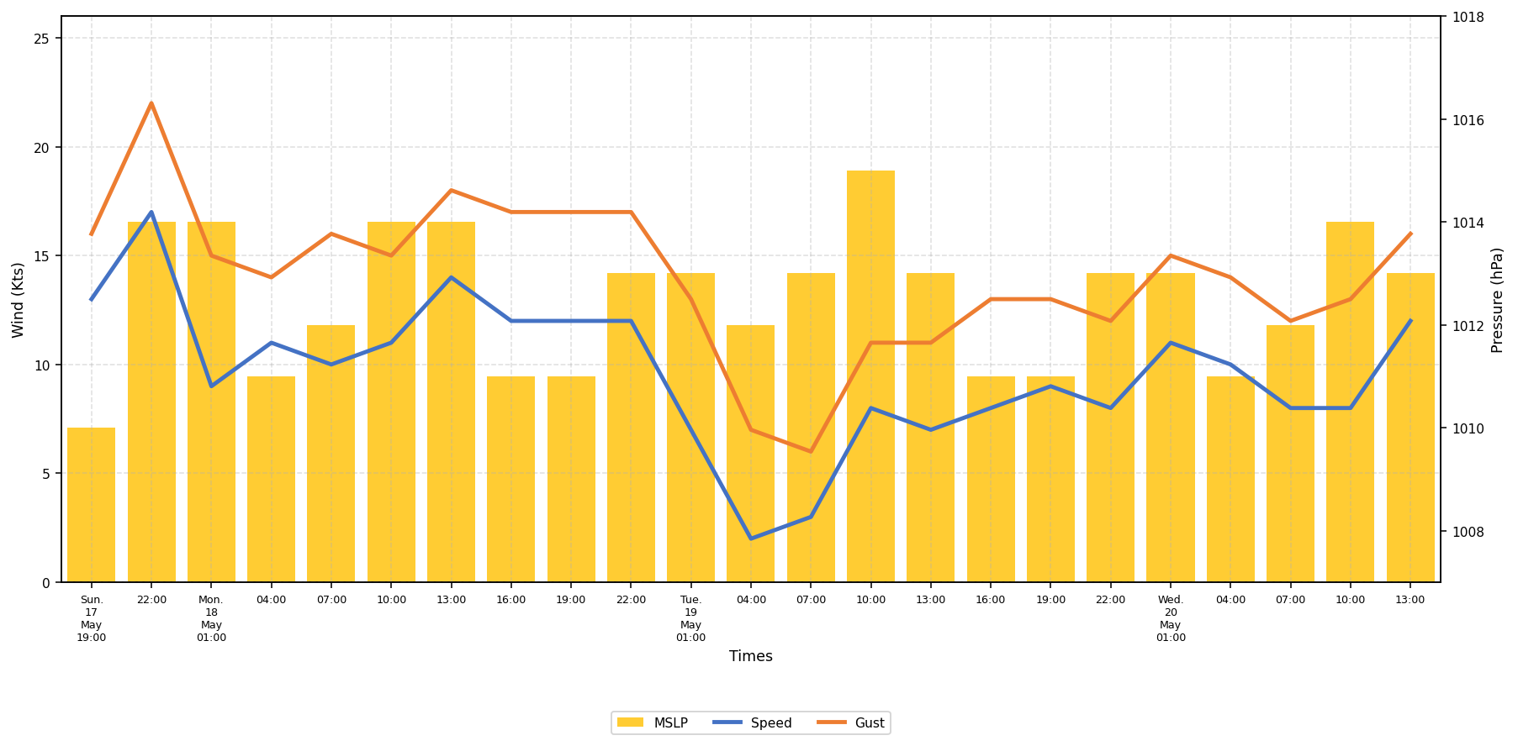
Figure 1: Trends of winds and Mean Sea Level Pressure from 17th to 20th May 2026
❖ Table 2: Tides predictions for SEME
Dates | HIGH TIDES |  |  |  | LOW TIDES
Dates | Time | Height | Time | Height | Time | Height | Time | Height
Sun. 17 May | — | — | — | — | 11:23 PM | 0.0 m | — | —
Mon. 18 May | 5:52 AM | 1.6 m | 5:48 PM | 1.8 m | 11:31 AM | 0.4 m | — | —
Tue. 19 May | 6:46 AM | 1.6 m | 6:39 PM | 1.7 m | 12:10 AM | 0.1 m | 12:22 PM | 0.5 m
Wed. 20 May | 7:44 AM | 1.5 m | 7:33 PM | 1.5 m | 12:59 AM | 0.1 m | 1:17 PM | 0.6 m

[ Insert ENSgram image here — copy/paste from ECMWF website ]
Figure 2: Wave ensemblegram issued by ECMWF from 17th to 20th May 2026
❖ Significant wave heights are forecast to...
[ Commentary on ENSgram — enter text here ]

[ Image 1 ] | [ Image 2 ]
[ Image 3 ] | [ Image 4 ]
Figure 3: Probability forecast for Monday, 18th May 2026 at 01:00 pm local time.

