OPTIMAL NEEDLE CHANNEL PLANNING FOR patient-tailored brachytherapy applicators for cervical cancer

Background

Cervical cancer is the fourth most common cancer among women, accounting for approximately 640,000 newly diagnosed cases and 342,000 deaths in 2020. **Brachytherapy** is a technique where radioactive sources are placed in close proximity to or within the tumour by guiding them through an intracavitary implant in the vaginal or uterine cavity, or through interstitial needles into tumour tissue by using a device called an **applicator** (Figure 1). Due to the steep radioactive dose gradient, brachytherapy enables delivering a high dose to the tumour volume with minimal dose in healthy organs. However, in conventional applicators (Figure 1a) radioactive source placement may be suboptimal in challenging tumours.

**The** **ARCHITECT applicator** (Figure 1b) is a concept 3D-printed patient-tailored applicator with optimised brachytherapy source channels, based on pre-brachytherapy magnetic resonance imaging (MRI) scans of patients. The outer shape of this applicator is derived from the vaginal anatomy. The internal source channels must obey to curvature constraints of the needles, be of minimal number, and facilitate optimal placement of sources (Figure 1c).

Goals

Brachytherapy optimisation for the ARCHITECT project includes facets of: (a) coverage planning / dwell position optimisation, (b) motion planning / trajectory optimisation, and (c) treatment planning / dwell time optimisation. In this project you will integrate these by:

1. Developing **sampling-based motion planning under differential constraints** as to generate feasible or (near) optimal needle source channels in applicator free space;
2. Integrating **needle source channel selection methods** with current treatment planning systems;
3. Comparing dosimetric outcome parameters for personalised and standard applicator designs.

INTERACTION

Supervision of this project will mainly take place at the TU Delft, but will be in close collaboration with researchers at the Erasmus MC. Input from other project partners can be arranged if desired.

REQUIREMENTS

Knowledge of and previous experience with sampling-based motion planning methods, such as RRT or RRT*, is required.

Supervision

* **Robin Straathof, MSc. - BME, TU Delft / Radiotherapy, Erasmus MC:** [r.straathof-1@tudelft.nl](mailto:r.straathof-1@tudelft.nl)
* **Dr. Javier Alonso Mora** - CoR, TU Delft: [J.AlonsoMora@tudelft.nl](mailto:J.AlonsoMora@tudelft.nl)
* **Dr.ir. Nick van de Berg** - BME, TU Delft / Gynaecological Oncology, Erasmus MC: [n.j.vandeberg@tudelft.nl](mailto:n.j.vandeberg@tudelft.nl)

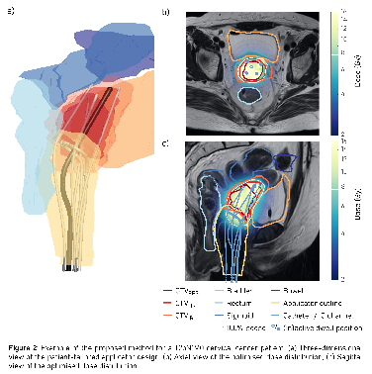

(c) Results from coverage and dwell time optimisation

(a) Utrecht IC/IS CT/MR Applicator (Elekta, Stockholm, Sweden).

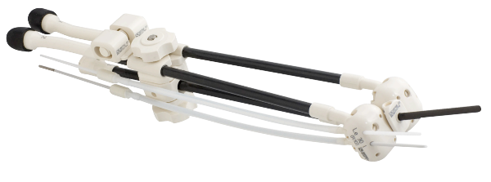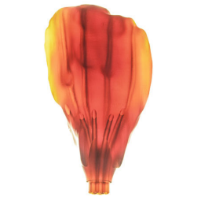

(b) Customised 3D printed prototype IC/IS ARCHITECT applicator.

Stockholm, Sweden).

**Figure 1**: State-of-the-art brachytherapy applicator design and optimisation