Overview
After going through the project notes, I extended the robustness experiments that had already been started, but with a stronger quantitative evaluation. From what I understood, most of the work so far explored how the model behaves under different image perturbations (e.g., blur, noise, brightness, contrast, and occlusion) by visually inspecting predictions on a few examples. I kept the same overall objective of evaluating robustness, but instead of relying mainly on qualitative observations, I focused on measuring the effect of each perturbation quantitatively and making the analysis reproducible. Unlike the original Neuromatch notebook, which evaluates a single trained model, I extended the evaluation to quantify robustness across multiple independent training runs, allowing both training variability and perturbation-specific effects to be characterized simultaneously. Throughout this work, I use the term robustness to refer to the ability of the trained model to maintain localization accuracy when evaluated under image perturbations relative to its corresponding baseline performance.
I developed everything in Google Colab. If we have (or create) a shared GitHub repository, I can upload the final notebook, generated figures, and report so everyone can reproduce the experiments and continue extending the evaluation framework
1. I kept the original Neuromatch model unchanged
The first decision I made was not to modify the original Neuromatch U-Net. The U-Net architecture, loss function, optimizer, number of epochs, and per-run optimization settings were kept consistent with the original Neuromatch notebook. The experimental pipeline was extended to include multiple seeded training runs and a systematic robustness evaluation.
2. I replaced the single training run with multiple independent runs
The original notebook trains one model and evaluates its performance. Instead, I trained five independent U-Net models using different random seeds (11, 22, 33, 44, and 55).
I did this because training neural networks is stochastic. Even when using the same architecture and hyperparameters, different random initializations can produce slightly different models. Evaluating only one model may therefore lead to conclusions that depend on a particular random initialization. Training multiple independent models allows me to estimate the natural variability of the training process and determine whether the observed robustness trends are reproducible.
Five independent runs were selected as a compromise between computational cost and the need to estimate training variability. Although five runs do not fully characterize the distribution of possible trained models, they provide a substantially more reliable estimate of training variability than a single run.
3. I kept the validation set fixed
Each evaluation was performed on the same fixed validation subset containing all 17 annotated anatomical landmarks. The same validation images were used across all independent runs and perturbation conditions to ensure fair comparisons. This ensured that every perturbation was evaluated under identical validation conditions across all runs.
This was important because I wanted differences in performance to reflect either training variability or the applied perturbations, rather than differences in the evaluation data. Using the same validation set makes the comparisons fair across all runs.
4. I applied perturbations only during evaluation
One important point is that I did not use perturbation-based data augmentation during training. All models were trained using the original Neuromatch training pipeline.
After training, I evaluated each model on the original validation images (baseline) and then evaluated the same model on the same validation images after applying several common image perturbations: Mild Gaussian Blur used kernel size 5 and σ = 1.0, whereas Strong Gaussian Blur used kernel size 9 and σ = 2.0. Gaussian Noise was applied with σ = 0.10, Brightness with a factor of 1.30, Contrast with a factor of 1.40, Central Occlusion masked a centered rectangular region covering 40% of the image height and 40% of the image width. Perturbed pixel values were clipped to the valid image range.
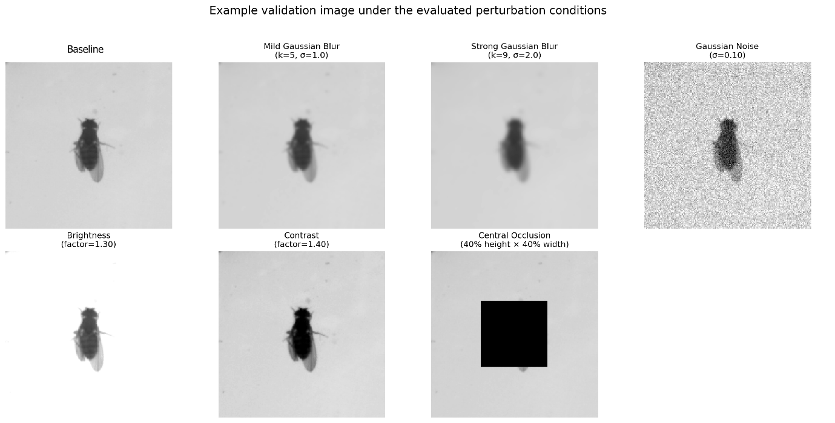
Representative validation image showing the baseline (original image) and the six perturbation conditions used during evaluation. The same perturbation parameters were applied deterministically to every independently trained model.
Because the landmark coordinates remained unchanged, differences relative to the corresponding baseline were interpreted as the model’s response to the applied image perturbation under this evaluation protocol.
My objective was therefore to measure the robustness of the original U-Net rather than improve it through data augmentation.
5. I compared every perturbation with its own baseline
Rather than comparing different models directly, each perturbed condition was compared with the corresponding baseline from the same training run.
All perturbations were applied deterministically so that every independently trained model was evaluated under identical perturbed validation images.
This paired comparison is important because different runs produced models with slightly different baseline accuracies. Comparing each perturbation with the baseline from the same run controls for differences in baseline model performance and provides a more direct estimate of the perturbation-associated change.
6. I extended the quantitative evaluation
The original notebook reports only a limited set of performance metrics. I expanded the evaluation by computing:
- mean localization error,
- median localization error,
- standard deviation,
- PCK@5 and PCK@10(Percentage of Correct Keypoints within 5 and 10 pixels of the ground-truth landmark, respectively)
- paired changes relative to baseline,
- landmark-specific localization errors,
- and summary statistics across the five independent runs.
Using multiple metrics provides a more complete description of model performance than relying on a single error value.
7. I analyzed robustness at the landmark level
Instead of evaluating only the overall localization error, I also analyzed each anatomical landmark separately.
This makes it possible to identify which landmarks are consistently more difficult to localize under baseline conditions and which landmarks are most sensitive to each image perturbation.
8. I added exploratory statistical analyses
To complement the descriptive statistics, I also included exploratory paired statistical comparisons across the five independent runs.
Because only five paired observations were available, the statistical tests had limited resolution and power. The one-sided Wilcoxon p-values primarily reflect the consistency of the direction of the paired differences rather than the magnitude of the observed effects. Perturbations that increased error in all five runs produced identical Wilcoxon p-values, whereas Brightness and Contrast, which increased error in four of the five runs, produced different values. In addition, the reported p-values were exploratory and were not adjusted for multiple comparisons.
The multi-run evaluation produced the following main findings:
- Across the five independently trained models, the baseline mean localization error was 2.82 ± 1.96 pixels, while the baseline PCK@5 (the percentage of landmarks localized within 5 pixels of the ground-truth position) was 87.3 ± 14.9%.
- Mild Gaussian Blur, Strong Gaussian Blur, Gaussian Noise, and Central Occlusion increased localization error relative to their corresponding baselines in all five independent training runs. Brightness and Contrast increased error in four of the five runs.
- Central Occlusion produced the largest average paired increase in localization error (+47.16 ± 6.91 pixels), followed by Gaussian Noise (+31.97 ± 32.58 pixels) and Strong Gaussian Blur (+7.07 ± 1.07 pixels).
- Contrast (+0.11 ± 0.15 pixels), Mild Gaussian Blur (+0.95 ± 0.54 pixels), and Brightness (+0.97 ± 0.92 pixels) produced the smallest average changes in localization error.
- Across the five runs, leg_fr_tip had the highest mean baseline localization error (6.98 pixels), whereas the abdomen landmark showed the lowest (0.77 pixels).
- Throughout this work, I considered a perturbation to be consistently harmful only if it increased localization error in all five independent training runs. Brightness and Contrast did not meet that criterion because each reduced error slightly in one run. When the magnitude or direction of an effect varied across runs, I explicitly reported that variability rather than making a general claim.
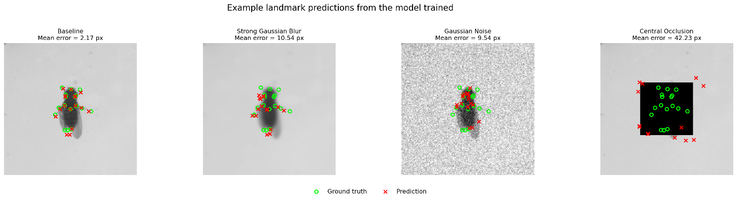
Examples are shown for one representative independently trained model (seed 11). Green circles denote ground-truth landmarks and red crosses denote model predictions. Mean localization errors are reported for each condition. These examples qualitatively illustrate how more severe perturbations are associated with larger localization errors.
Baseline Performance Across Independent Training Runs
Table 1. Run-level quantitative results.
Run | Seed | Condition | Mean error (px) | Median error (px) | PCK@5 (%) | PCK@10 (%)
1 | 11 | Baseline | 3.536 | 1.481 | 81.766 | 89.898
1 | 11 | Mild Gaussian Blur | 4.713 | 2.147 | 73.704 | 84.547
1 | 11 | Strong Gaussian Blur | 10.984 | 8.096 | 37.097 | 57.454
1 | 11 | Gaussian Noise | 15.790 | 7.222 | 40.618 | 58.055
1 | 11 | Brightness | 4.035 | 1.584 | 79.321 | 91.840
1 | 11 | Contrast | 3.512 | 1.437 | 84.239 | 91.868
1 | 11 | Central Occlusion | 42.852 | 41.484 | 0.056 | 0.182
2 | 22 | Baseline | 5.958 | 1.920 | 63.406 | 75.115
2 | 22 | Mild Gaussian Blur | 6.182 | 2.451 | 61.059 | 75.255
2 | 22 | Strong Gaussian Blur | 13.696 | 9.959 | 33.799 | 50.175
2 | 22 | Gaussian Noise | 43.704 | 17.628 | 22.062 | 32.108
2 | 22 | Brightness | 5.533 | 1.773 | 66.662 | 76.792
2 | 22 | Contrast | 5.995 | 1.950 | 64.245 | 75.213
2 | 22 | Central Occlusion | 56.315 | 47.634 | 0.000 | 0.070
3 | 33 | Baseline | 1.729 | 1.155 | 97.052 | 98.407
3 | 33 | Mild Gaussian Blur | 3.196 | 1.558 | 83.121 | 95.431
3 | 33 | Strong Gaussian Blur | 7.553 | 3.178 | 60.822 | 73.494
3 | 33 | Gaussian Noise | 13.291 | 2.737 | 58.879 | 64.720
3 | 33 | Brightness | 3.522 | 1.722 | 75.227 | 94.327
3 | 33 | Contrast | 1.825 | 1.131 | 97.024 | 98.170
3 | 33 | Central Occlusion | 49.636 | 44.512 | 0.000 | 0.084
4 | 44 | Baseline | 1.509 | 0.957 | 97.136 | 98.477
4 | 44 | Mild Gaussian Blur | 2.853 | 1.348 | 85.385 | 93.894
4 | 44 | Strong Gaussian Blur | 7.585 | 4.842 | 51.223 | 69.512
4 | 44 | Gaussian Noise | 88.185 | 103.348 | 7.866 | 13.232
4 | 44 | Brightness | 2.845 | 1.396 | 82.046 | 96.772
4 | 44 | Contrast | 1.593 | 1.019 | 96.479 | 98.170
4 | 44 | Central Occlusion | 43.177 | 34.116 | 0.098 | 0.503
5 | 55 | Baseline | 1.379 | 0.860 | 97.136 | 98.631
5 | 55 | Mild Gaussian Blur | 1.938 | 1.070 | 93.894 | 97.164
5 | 55 | Strong Gaussian Blur | 9.654 | 4.856 | 50.678 | 69.387
5 | 55 | Gaussian Noise | 12.997 | 4.296 | 51.921 | 62.135
5 | 55 | Brightness | 3.003 | 1.229 | 87.732 | 93.447
5 | 55 | Contrast | 1.754 | 1.016 | 95.822 | 97.611
5 | 55 | Central Occlusion | 57.944 | 57.852 | 0.182 | 0.265

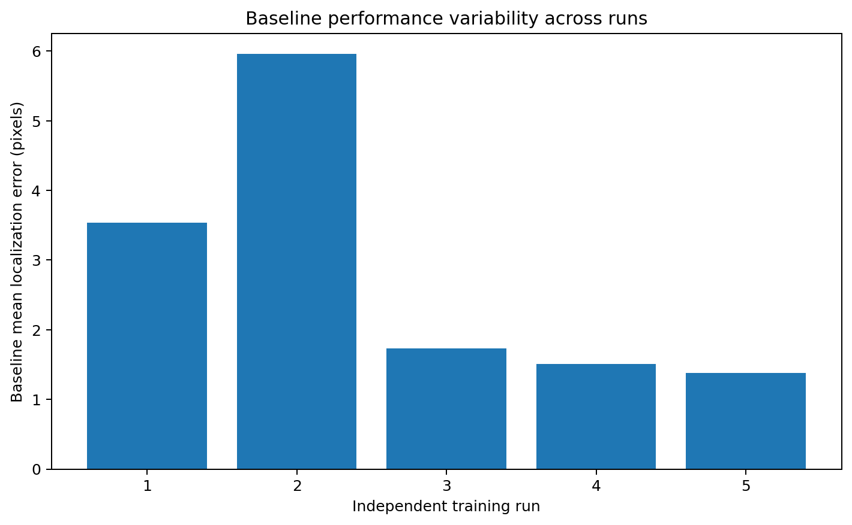
Figure 1. Baseline mean localization error for each independent run.
Table 1 summarizes the performance obtained by each independently trained U-Net model. Although all models were trained using the same architecture, hyperparameters, and validation set, noticeable differences in baseline localization error were observed across runs. Baseline mean error ranged from approximately 1.38 to 5.96 pixels, indicating that random initialization and training stochasticity influenced final model performance. Nevertheless, every run produced a model that successfully localized landmarks, although accuracy varied across runs. Figure 1 illustrates this between-run variability. Evaluating five independent runs provides a broader estimate of training variability than a single execution, although these runs do not fully characterize all possible outcomes of the training procedure.
Overall Robustness to Image Perturbations
Table 2. Summary across independent training runs.
Condition | Mean error across runs (px) | SD across runs (px) | Mean PCK@5 across runs (%) | SD PCK@5 across runs | Mean paired change vs baseline (px) | SD paired change (px) | Runs with increased error (%)
Baseline | 2.822 | 1.958 | 87.299 | 14.917 | 0.000 | 0.000
Mild Gaussian Blur | 3.777 | 1.676 | 79.433 | 12.536 | 0.954 | 0.537 | 100.000
Strong Gaussian Blur | 9.895 | 2.574 | 46.723 | 11.117 | 7.072 | 1.070 | 100.000
Gaussian Noise | 34.793 | 32.514 | 36.269 | 21.117 | 31.971 | 32.579 | 100.000
Brightness | 3.788 | 1.082 | 78.198 | 7.888 | 0.965 | 0.923 | 80.000
Contrast | 2.936 | 1.879 | 87.562 | 14.071 | 0.114 | 0.153 | 80.000
Central Occlusion | 49.985 | 7.085 | 0.067 | 0.076 | 47.163 | 6.909 | 100.000

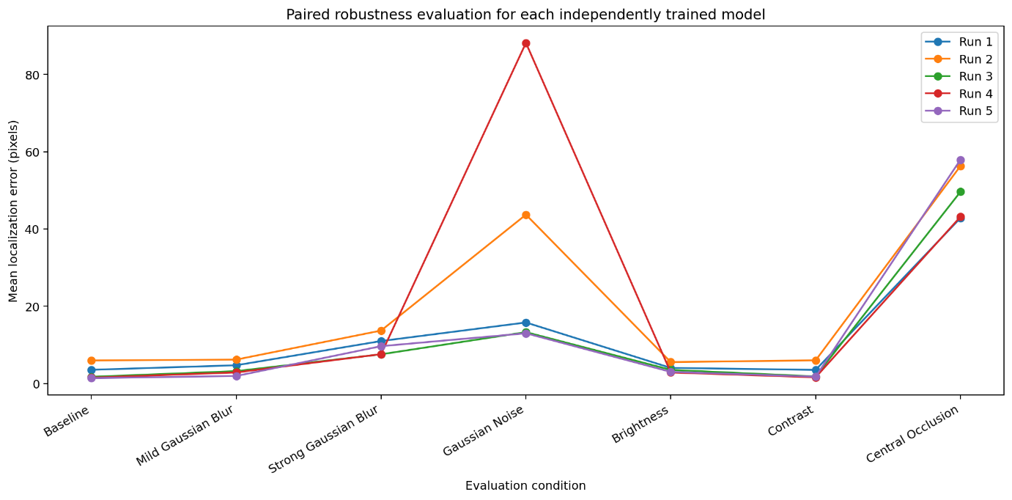
Figure 2. Paired performance of every independently trained model across evaluation conditions.
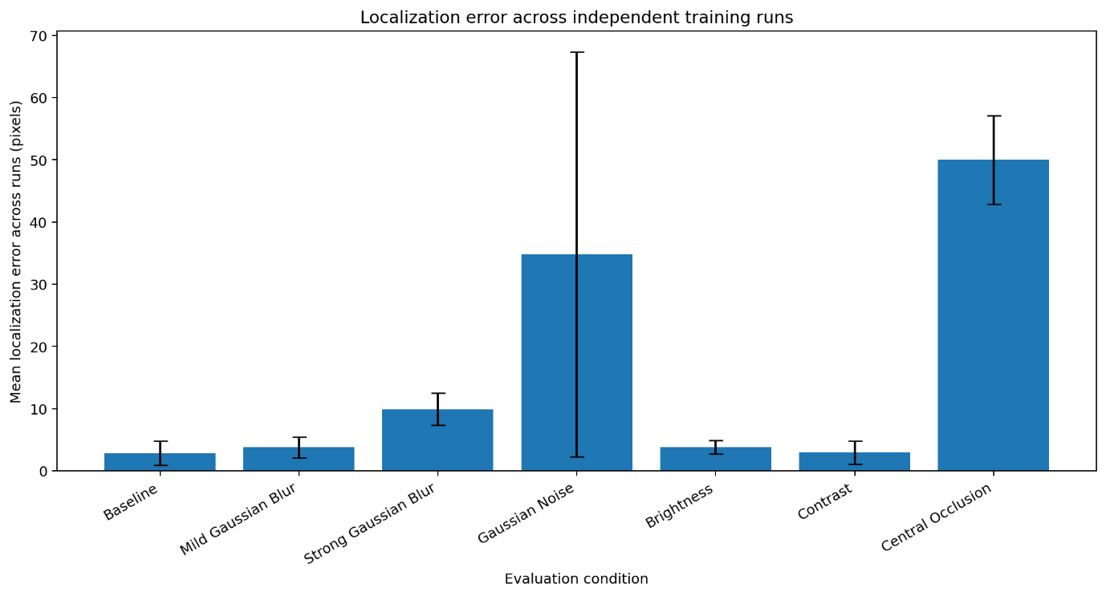
Figure 3. Mean localization error and standard deviation across runs.
Table 2 and Figures 2–3 summarize the effect of each image perturbation across the five independent training runs. Central Occlusion produced the largest mean increase in localization error, followed by Gaussian Noise and Strong Gaussian Blur. Mild Gaussian Blur produced a small but consistent degradation, whereas Brightness and Contrast had small average effects and each improved performance slightly in one run. The error bars in Figure 3 show that Gaussian Noise exhibited especially large variability across independently trained models. These results suggest that the evaluated U-Net models were less sensitive to moderate appearance changes than to perturbations that substantially altered or removed image information. Consequently, robustness estimates based on a single model could either underestimate or overestimate the robustness observed across independently trained models.
Paired Robustness Analysis
Table 3. Paired changes relative to baseline.
Run | Seed | Condition | Baseline mean error (px) | Perturbed mean error (px) | Absolute change (px) | Relative change (%)
1 | 11 | Mild Gaussian Blur | 3.536 | 4.713 | 1.177 | 33.290
1 | 11 | Strong Gaussian Blur | 3.536 | 10.984 | 7.449 | 210.659
1 | 11 | Gaussian Noise | 3.536 | 15.790 | 12.255 | 346.579
1 | 11 | Brightness | 3.536 | 4.035 | 0.499 | 14.102
1 | 11 | Contrast | 3.536 | 3.512 | -0.023 | -0.663
1 | 11 | Central Occlusion | 3.536 | 42.852 | 39.316 | 1111.917
2 | 22 | Mild Gaussian Blur | 5.958 | 6.182 | 0.224 | 3.768
2 | 22 | Strong Gaussian Blur | 5.958 | 13.696 | 7.738 | 129.892
2 | 22 | Gaussian Noise | 5.958 | 43.704 | 37.746 | 633.575
2 | 22 | Brightness | 5.958 | 5.533 | -0.425 | -7.133
2 | 22 | Contrast | 5.958 | 5.995 | 0.037 | 0.626
2 | 22 | Central Occlusion | 5.958 | 56.315 | 50.357 | 845.251
3 | 33 | Mild Gaussian Blur | 1.729 | 3.196 | 1.467 | 84.829
3 | 33 | Strong Gaussian Blur | 1.729 | 7.553 | 5.824 | 336.772
3 | 33 | Gaussian Noise | 1.729 | 13.291 | 11.562 | 668.554
3 | 33 | Brightness | 1.729 | 3.522 | 1.793 | 103.677
3 | 33 | Contrast | 1.729 | 1.825 | 0.096 | 5.523
3 | 33 | Central Occlusion | 1.729 | 49.636 | 47.907 | 2770.243
4 | 44 | Mild Gaussian Blur | 1.509 | 2.853 | 1.344 | 89.016
4 | 44 | Strong Gaussian Blur | 1.509 | 7.585 | 6.076 | 402.519
4 | 44 | Gaussian Noise | 1.509 | 88.185 | 86.676 | 5742.125
4 | 44 | Brightness | 1.509 | 2.845 | 1.336 | 88.478
4 | 44 | Contrast | 1.509 | 1.593 | 0.083 | 5.528
4 | 44 | Central Occlusion | 1.509 | 43.177 | 41.667 | 2760.395
5 | 55 | Mild Gaussian Blur | 1.379 | 1.938 | 0.560 | 40.590
5 | 55 | Strong Gaussian Blur | 1.379 | 9.654 | 8.275 | 600.158
5 | 55 | Gaussian Noise | 1.379 | 12.997 | 11.618 | 842.655
5 | 55 | Brightness | 1.379 | 3.003 | 1.624 | 117.818
5 | 55 | Contrast | 1.379 | 1.754 | 0.375 | 27.190
5 | 55 | Central Occlusion | 1.379 | 57.944 | 56.566 | 4102.593
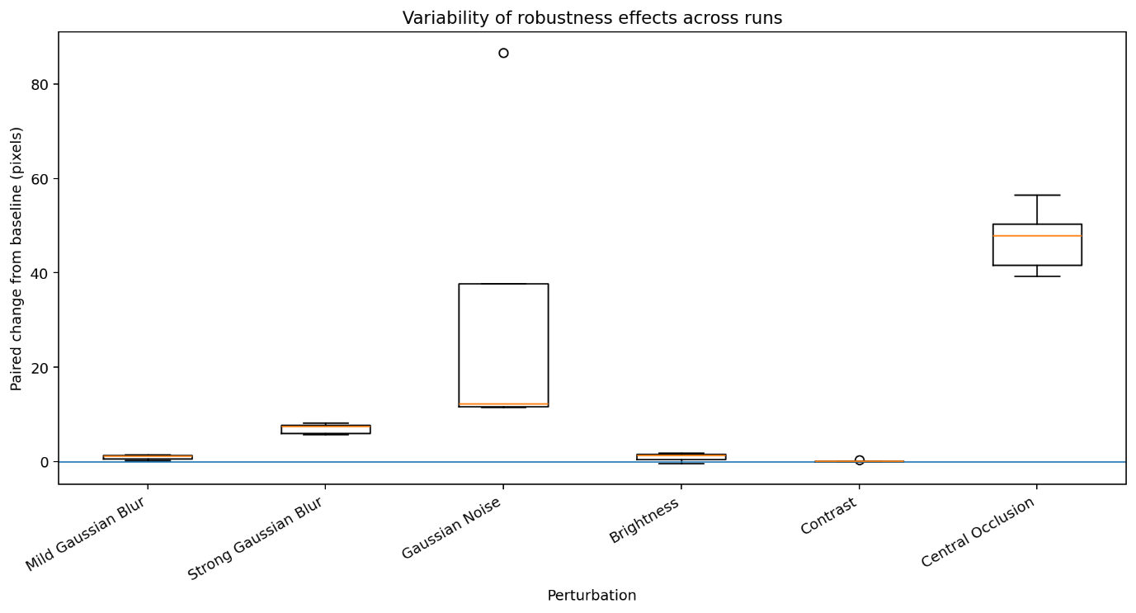
Figure 4. Distribution of paired changes relative to baseline across runs.
Comparing each perturbed condition with its corresponding baseline within the same training run helps isolate the effect of the perturbation from differences in baseline model quality. Mild Gaussian Blur, Strong Gaussian Blur, Gaussian Noise, and Central Occlusion increased localization error in all five runs. Brightness and Contrast increased error in four runs but produced small improvements in one run each. The magnitude of the increase varied substantially, especially for Gaussian Noise, whereas Central Occlusion produced consistently large degradation. Using paired comparisons reduced the influence of baseline differences between runs and allowed the perturbation-associated changes to be estimated more directly.
Landmark-Level Robustness
Table 4. Landmark-level robustness summary across runs.
Condition | Landmark | Mean error across runs (px) | SD across runs (px) | Mean paired change vs baseline (px) | SD paired change (px) | Runs with increased error (%)
Brightness | leg_mr_tip | 10.343 | 5.346 | 5.319 | 4.262 | 100.000
Brightness | leg_br_tip | 8.627 | 1.567 | 3.187 | 2.757 | 80.000
Brightness | leg_ml_tip | 8.036 | 3.248 | 3.163 | 2.253 | 100.000
Brightness | leg_bl_tip | 9.289 | 1.828 | 3.001 | 2.904 | 80.000
Brightness | leg_fl_tip | 7.127 | 4.316 | 1.083 | 2.422 | 60.000
Brightness | leg_fr_tip | 7.371 | 4.088 | 0.395 | 4.086 | 60.000
Brightness | leg_mr_c | 1.527 | 0.222 | 0.289 | 0.143 | 100.000
Brightness | abdomen | 1.009 | 0.224 | 0.237 | 0.255 | 80.000
Brightness | leg_mr_in | 1.321 | 0.246 | 0.173 | 0.238 | 80.000
Brightness | leg_ml_c | 1.528 | 0.327 | 0.168 | 0.382 | 60.000
Brightness | head_bl | 1.535 | 0.725 | 0.084 | 0.427 | 60.000
Brightness | leg_ml_in | 1.062 | 0.150 | 0.070 | 0.127 | 60.000
Brightness | thorax_fr | 1.315 | 0.535 | 0.064 | 0.283 | 40.000
Brightness | thorax_bc | 0.990 | 0.221 | 0.015 | 0.043 | 40.000
Brightness | thorax_fl | 0.982 | 0.230 | 0.007 | 0.253 | 40.000
Brightness | head_br | 1.025 | 0.289 | -0.131 | 0.320 | 60.000
Brightness | head_fc | 1.299 | 0.936 | -0.714 | 1.595 | 40.000
Central Occlusion | leg_mr_c | 59.686 | 10.326 | 58.449 | 10.440 | 100.000
Central Occlusion | leg_mr_tip | 63.350 | 22.124 | 58.326 | 25.358 | 100.000
Central Occlusion | leg_br_tip | 62.936 | 22.520 | 57.496 | 24.378 | 100.000
Central Occlusion | head_bl | 58.907 | 32.615 | 57.457 | 32.818 | 100.000
Central Occlusion | head_fc | 58.013 | 41.596 | 55.999 | 39.470 | 100.000
Central Occlusion | thorax_bc | 51.886 | 11.586 | 50.911 | 11.660 | 100.000
Central Occlusion | abdomen | 51.612 | 23.967 | 50.840 | 23.992 | 100.000
Central Occlusion | leg_mr_in | 50.797 | 8.563 | 49.648 | 8.605 | 100.000
Central Occlusion | leg_ml_in | 45.484 | 10.144 | 44.492 | 10.137 | 100.000
Central Occlusion | thorax_fr | 44.441 | 6.877 | 43.189 | 6.596 | 100.000
Central Occlusion | leg_ml_c | 44.365 | 7.426 | 43.005 | 7.525 | 100.000
Central Occlusion | thorax_fl | 43.636 | 9.171 | 42.661 | 9.101 | 100.000
Central Occlusion | head_br | 43.626 | 9.977 | 42.470 | 9.558 | 100.000
Central Occlusion | leg_ml_tip | 44.738 | 17.283 | 39.865 | 13.747 | 100.000
Central Occlusion | leg_fl_tip | 44.238 | 18.360 | 38.194 | 13.672 | 100.000
Central Occlusion | leg_bl_tip | 42.659 | 19.446 | 36.372 | 22.404 | 100.000
Central Occlusion | leg_fr_tip | 39.366 | 10.664 | 32.390 | 10.923 | 100.000
Contrast | leg_mr_tip | 6.049 | 5.999 | 1.025 | 1.898 | 60.000
Contrast | leg_mr_in | 1.490 | 0.509 | 0.341 | 0.373 | 100.000
Contrast | thorax_fr | 1.518 | 0.701 | 0.266 | 0.551 | 80.000
Contrast | thorax_bc | 1.197 | 0.296 | 0.222 | 0.131 | 100.000
Contrast | leg_ml_in | 1.214 | 0.328 | 0.222 | 0.231 | 100.000
Contrast | leg_ml_tip | 5.082 | 4.705 | 0.209 | 0.600 | 60.000
Contrast | leg_mr_c | 1.383 | 0.242 | 0.145 | 0.230 | 80.000
Contrast | leg_bl_tip | 6.407 | 3.737 | 0.120 | 0.511 | 60.000
Contrast | abdomen | 0.889 | 0.126 | 0.117 | 0.118 | 80.000
Contrast | thorax_fl | 1.084 | 0.352 | 0.109 | 0.080 | 100.000
Contrast | leg_br_tip | 5.509 | 3.091 | 0.069 | 0.670 | 40.000
Contrast | leg_ml_c | 1.420 | 0.162 | 0.060 | 0.289 | 60.000
Contrast | head_br | 1.147 | 0.368 | -0.010 | 0.280 | 40.000
Contrast | leg_fl_tip | 6.002 | 6.110 | -0.042 | 1.361 | 60.000
Contrast | head_bl | 1.404 | 0.296 | -0.046 | 0.356 | 40.000
Contrast | head_fc | 1.863 | 2.236 | -0.151 | 0.284 | 60.000
Contrast | leg_fr_tip | 6.251 | 5.855 | -0.724 | 1.535 | 40.000
Gaussian Noise | leg_mr_tip | 48.760 | 25.554 | 43.736 | 25.840 | 100.000
Gaussian Noise | head_fc | 45.711 | 49.600 | 43.697 | 48.699 | 100.000
Gaussian Noise | leg_bl_tip | 49.598 | 35.202 | 43.311 | 37.051 | 100.000
Gaussian Noise | leg_br_tip | 46.695 | 48.758 | 41.255 | 50.608 | 100.000
Gaussian Noise | leg_ml_tip | 44.962 | 41.052 | 40.089 | 42.070 | 100.000
Gaussian Noise | abdomen | 40.559 | 55.464 | 39.787 | 55.457 | 100.000
Gaussian Noise | leg_fl_tip | 43.718 | 32.640 | 37.674 | 31.979 | 100.000
Gaussian Noise | head_br | 37.743 | 44.648 | 36.586 | 44.517 | 100.000
Gaussian Noise | leg_ml_c | 36.750 | 47.672 | 35.390 | 47.584 | 100.000
Gaussian Noise | leg_fr_tip | 40.247 | 33.208 | 33.271 | 33.441 | 100.000
Gaussian Noise | leg_mr_c | 34.470 | 54.006 | 33.232 | 53.970 | 100.000
Gaussian Noise | thorax_fr | 32.213 | 35.233 | 30.961 | 35.267 | 100.000
Gaussian Noise | thorax_bc | 24.964 | 43.744 | 23.988 | 43.774 | 100.000
Gaussian Noise | head_bl | 21.624 | 25.620 | 20.173 | 25.620 | 100.000
Gaussian Noise | leg_mr_in | 18.838 | 23.205 | 17.689 | 23.317 | 100.000
Gaussian Noise | thorax_fl | 12.585 | 19.732 | 11.609 | 19.451 | 100.000
Gaussian Noise | leg_ml_in | 12.053 | 13.913 | 11.061 | 13.880 | 100.000
Mild Gaussian Blur | leg_br_tip | 8.431 | 1.616 | 2.991 | 2.007 | 80.000
Mild Gaussian Blur | leg_bl_tip | 9.042 | 2.433 | 2.755 | 2.532 | 80.000
Mild Gaussian Blur | leg_ml_tip | 7.188 | 4.223 | 2.315 | 2.446 | 100.000
Mild Gaussian Blur | leg_mr_tip | 7.266 | 3.827 | 2.242 | 2.518 | 80.000
Mild Gaussian Blur | leg_fr_tip | 8.809 | 6.213 | 1.833 | 1.342 | 100.000
Mild Gaussian Blur | leg_fl_tip | 7.454 | 5.818 | 1.410 | 0.697 | 100.000
Mild Gaussian Blur | head_fc | 2.632 | 3.013 | 0.618 | 0.649 | 100.000
Mild Gaussian Blur | head_br | 1.549 | 0.959 | 0.393 | 0.508 | 80.000
Mild Gaussian Blur | leg_mr_c | 1.571 | 0.273 | 0.333 | 0.225 | 100.000
Mild Gaussian Blur | leg_mr_in | 1.466 | 0.628 | 0.317 | 0.503 | 80.000
Mild Gaussian Blur | thorax_fr | 1.552 | 0.935 | 0.300 | 0.652 | 60.000
Mild Gaussian Blur | leg_ml_c | 1.622 | 0.361 | 0.262 | 0.235 | 80.000
Mild Gaussian Blur | leg_ml_in | 1.177 | 0.194 | 0.185 | 0.134 | 100.000
Mild Gaussian Blur | thorax_fl | 1.123 | 0.443 | 0.148 | 0.162 | 80.000
Mild Gaussian Blur | thorax_bc | 1.048 | 0.168 | 0.073 | 0.175 | 80.000
Mild Gaussian Blur | abdomen | 0.806 | 0.066 | 0.034 | 0.091 | 80.000
Mild Gaussian Blur | head_bl | 1.466 | 0.336 | 0.015 | 0.527 | 20.000
Strong Gaussian Blur | leg_mr_tip | 17.209 | 4.407 | 12.185 | 8.963 | 80.000
Strong Gaussian Blur | head_fc | 13.548 | 17.277 | 11.535 | 16.941 | 100.000
Strong Gaussian Blur | leg_br_tip | 15.501 | 3.423 | 10.061 | 6.713 | 100.000
Strong Gaussian Blur | leg_ml_tip | 14.809 | 3.875 | 9.936 | 7.916 | 80.000
Strong Gaussian Blur | leg_bl_tip | 16.194 | 4.858 | 9.906 | 7.763 | 80.000
Strong Gaussian Blur | leg_fl_tip | 15.839 | 7.954 | 9.796 | 2.309 | 100.000
Strong Gaussian Blur | leg_fr_tip | 14.281 | 5.831 | 7.305 | 2.635 | 100.000
Strong Gaussian Blur | head_br | 7.903 | 6.826 | 6.746 | 6.322 | 100.000
Strong Gaussian Blur | thorax_fr | 7.770 | 6.264 | 6.519 | 6.006 | 80.000
Strong Gaussian Blur | leg_mr_in | 7.318 | 2.993 | 6.169 | 3.021 | 100.000
Strong Gaussian Blur | head_bl | 7.487 | 7.569 | 6.037 | 7.748 | 80.000
Strong Gaussian Blur | thorax_fl | 6.668 | 6.349 | 5.693 | 6.158 | 100.000
Strong Gaussian Blur | leg_ml_c | 6.938 | 5.206 | 5.578 | 5.173 | 100.000
Strong Gaussian Blur | leg_ml_in | 6.401 | 6.102 | 5.409 | 6.035 | 100.000
Strong Gaussian Blur | leg_mr_c | 6.108 | 1.578 | 4.870 | 1.650 | 100.000
Strong Gaussian Blur | thorax_bc | 3.339 | 1.460 | 2.364 | 1.510 | 100.000
Strong Gaussian Blur | abdomen | 0.894 | 0.196 | 0.122 | 0.237 | 60.000

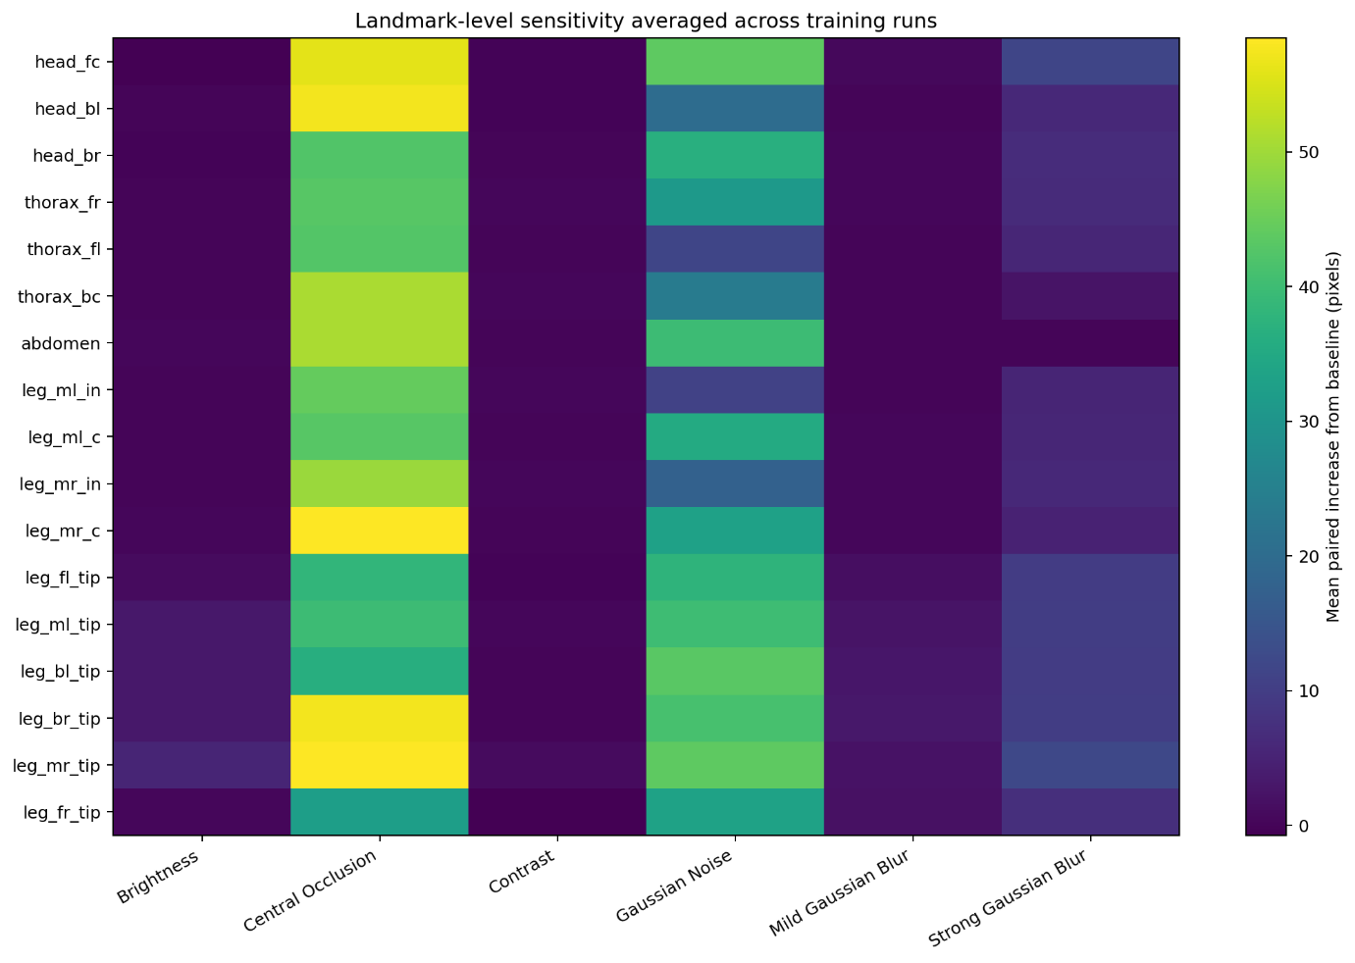
Figure 5. Mean paired increase in localization error for each landmark and perturbation.
The landmark-level analysis showed that sensitivity varied across both perturbations and anatomical landmarks. Distal leg tips were particularly affected by Brightness and Gaussian Blur, while Central Occlusion and Gaussian Noise produced widespread increases in localization error across many landmarks. The most vulnerable landmark therefore depended on the type of degradation rather than following a single anatomical pattern.
Statistical Consistency of the Robustness Effects
Table 5. Exploratory paired statistical tests.
Condition | Mean paired change (px) | SD paired change (px) | Paired t-test p-value | One-sided Wilcoxon p-value | Runs increased / total
Mild Gaussian Blur | 0.954 | 0.537 | 0.016 | 0.031 | 5/5
Strong Gaussian Blur | 7.072 | 1.070 | 0.000 | 0.031 | 5/5
Gaussian Noise | 31.971 | 32.579 | 0.093 | 0.031 | 5/5
Brightness | 0.965 | 0.923 | 0.079 | 0.062 | 4/5
Contrast | 0.114 | 0.153 | 0.173 | 0.062 | 4/5
Central Occlusion | 47.163 | 6.909 | 0.000 | 0.031 | 5/5

Using the paired t-test, Mild Gaussian Blur, Strong Gaussian Blur, and Central Occlusion produced p-values below 0.05. Gaussian Noise, Brightness, and Contrast did not reach that threshold in the paired t-test consistent with either large between-run variability or small effect magnitude. The one-sided Wilcoxon test returned p = 0.031 for Mild Gaussian Blur, Strong Gaussian Blur, Gaussian Noise, and Central Occlusion, which increased error in all five runs, and p = 0.062 for Brightness and Contrast, which increased error in four of five runs. Because only five paired observations were available, these tests should be interpreted as exploratory; effect magnitude, variability, and consistency across runs provide the stronger evidence.
Discussion
How robust is the Neuromatch U-Net pose estimation model to common image perturbations across multiple independent training runs?
The multi-run evaluation indicates that the Neuromatch U-Net is not equally robust to all image perturbations. Central Occlusion, Gaussian Noise, Strong Gaussian Blur, and Mild Gaussian Blur increased localization error in every run, although the magnitude of degradation differed substantially. Brightness and Contrast produced only small mean changes and each slightly improved performance in one run. Central Occlusion caused the largest mean increase in localization error, while Gaussian Noise showed the greatest between-run variability.
How accurately does the U-Net localize landmarks under the original imaging conditions?
Under the original imaging conditions, the U-Net achieved relatively low mean localization errors and high PCK@5 values across the independent training runs. The average baseline error was 2.82 ± 1.96 pixels and the average PCK@5 was 87.3 ± 14.9%. Baseline performance nevertheless varied from 1.38 to 5.96 pixels across runs, showing that training stochasticity affected final localization accuracy.
Is baseline performance stable across independently trained models?
Baseline performance was moderately consistent but not identical across the five independent training runs. Some models achieved substantially lower localization errors than others despite being trained with the same architecture, hyperparameters, validation data, and evaluation procedure. This indicates that conclusions based on a single run may depend on the particular random initialization.
Does the model maintain localization accuracy when image quality changes?
The results indicate that localization accuracy generally decreases when image quality is degraded, but the degree of performance loss depends strongly on the perturbation. Mild Gaussian Blur caused a small consistent reduction in accuracy. Brightness and Contrast had small average effects and were not harmful in every run. In contrast, Strong Gaussian Blur, Gaussian Noise, and especially Central Occlusion caused much larger degradations.
Which image perturbations produce the largest and most consistent degradation in localization performance?
Among all evaluated perturbations, Central Occlusion produced the largest average degradation in localization accuracy (+47.16 ± 6.91 pixels), followed by Gaussian Noise (+31.97 ± 32.58 pixels) and Strong Gaussian Blur (+7.07 ± 1.07 pixels). Mild Gaussian Blur caused a smaller but consistent increase (+0.95 ± 0.54 pixels). Contrast produced the smallest mean change (+0.11 ± 0.15 pixels), while Brightness also had a relatively small effect (+0.97 ± 0.92 pixels).
Are the robustness effects consistent across independently trained models?
The robustness effects were consistent in direction for Mild Gaussian Blur, Strong Gaussian Blur, Gaussian Noise, and Central Occlusion, which increased mean localization error in all five runs. Brightness and Contrast increased error in four runs but slightly reduced it in one run each. Effect magnitude varied substantially across models, particularly for Gaussian Noise, demonstrating why multiple independent training runs are important for robustness assessment.
Which anatomical landmarks are consistently the most difficult to localize?
The landmark-level analysis revealed that localization difficulty was not uniform across anatomical structures. Under baseline conditions, leg_fr_tip had the highest mean localization error across runs (6.98 pixels), while abdomen had the lowest (0.77 pixels). Several other distal leg-tip landmarks also had comparatively high baseline errors, indicating that fine distal structures were generally more difficult to localize than central body landmarks.
Are some landmarks consistently more sensitive to blur, noise, illumination changes, or occlusion?
Yes. The landmark-level robustness analysis demonstrates that sensitivity to image perturbations varies across anatomical landmarks and depends on perturbation type. Distal leg tips showed some of the largest increases under Brightness and Gaussian Blur, while Gaussian Noise and Central Occlusion produced large errors across a broader set of landmarks. Therefore, no single anatomical group was uniformly most robust or most vulnerable under every degradation.
Is better baseline performance associated with greater robustness?
I did not investigate this question directly. Although baseline performance and robustness were evaluated independently, no correlation analysis was performed to determine whether models with lower baseline localization error also exhibited greater robustness to image perturbations. Therefore, no conclusion can currently be drawn regarding this relationship.
Limitations and Future Work
Throughout this project, I evaluated robustness using a single dataset, one perturbation severity for each evaluated condition, and five independent training runs. Although this design provided a substantially more reliable assessment than a single training run, it does not fully characterize all possible sources of training variability or robustness.
In future work, I would like to extend this evaluation framework to investigate perturbation-based data augmentation during training, additional perturbation types (e.g., rotations, translations, or motion blur), multiple perturbation severity levels, and alternative pose estimation architectures. I would also like to evaluate the framework on additional datasets and real-world degraded images to determine whether the robustness patterns observed here generalize across different models and imaging conditions.

