Animal Pose Estimation
Multi-Run Robustness Study
5 independent training runs and 6 image perturbations

Executive Summary
- Across 5 independently trained models, baseline mean localization error was 2.82 ± 1.96 pixels, and baseline PCK@5 was 87.3 ± 14.9%.
- Mild Gaussian Blur produced a mean paired change of +0.95 ± 0.54 pixels and increased error in every run (5/5).
- Strong Gaussian Blur produced a mean paired change of +7.07 ± 1.07 pixels and increased error in every run (5/5).
- Gaussian Noise produced a mean paired change of +31.97 ± 32.58 pixels and increased error in every run (5/5).
- Brightness produced a mean paired change of +0.97 ± 0.92 pixels and increased error in most runs (4/5).
- Contrast produced a mean paired change of +0.11 ± 0.15 pixels and increased error in most runs (4/5).
- Central Occlusion produced a mean paired change of +47.16 ± 6.91 pixels and increased error in every run (5/5).
- The largest average degradation was observed for Central Occlusion (+47.16 pixels relative to baseline).
- Across runs, the highest baseline landmark error was observed for leg_fr_tip (6.98 px), while abdomen had the lowest (0.77 px).

1. Research Question
How robust is the Neuromatch U-Net animal pose estimation model to common image perturbations across multiple independent training runs?

2. Experimental Design
5 independently initialized U-Net models were trained using seeds [11, 22, 33, 44, 55]. A fixed validation split was used in every run. Each trained model was evaluated on the same validation examples under the baseline condition and all perturbation conditions. Changes were computed relative to the corresponding baseline from the same run.
The perturbations were Gaussian Blur, Gaussian Noise, increased Brightness, increased Contrast, and Central Occlusion. These appearance transformations preserve landmark coordinates.

3. Performance in Every Run
Table 1 reports the main performance metrics for every run and condition.
Table 1. Run-level quantitative results.
Run | Seed | Condition | Mean error (px) | Median error (px) | PCK@5 (%) | PCK@10 (%)
1 | 11 | Baseline | 3.536 | 1.481 | 81.766 | 89.898
1 | 11 | Mild Gaussian Blur | 4.713 | 2.147 | 73.704 | 84.547
1 | 11 | Strong Gaussian Blur | 10.984 | 8.096 | 37.097 | 57.454
1 | 11 | Gaussian Noise | 15.790 | 7.222 | 40.618 | 58.055
1 | 11 | Brightness | 4.035 | 1.584 | 79.321 | 91.840
1 | 11 | Contrast | 3.512 | 1.437 | 84.239 | 91.868
1 | 11 | Central Occlusion | 42.852 | 41.484 | 0.056 | 0.182
2 | 22 | Baseline | 5.958 | 1.920 | 63.406 | 75.115
2 | 22 | Mild Gaussian Blur | 6.182 | 2.451 | 61.059 | 75.255
2 | 22 | Strong Gaussian Blur | 13.696 | 9.959 | 33.799 | 50.175
2 | 22 | Gaussian Noise | 43.704 | 17.628 | 22.062 | 32.108
2 | 22 | Brightness | 5.533 | 1.773 | 66.662 | 76.792
2 | 22 | Contrast | 5.995 | 1.950 | 64.245 | 75.213
2 | 22 | Central Occlusion | 56.315 | 47.634 | 0.000 | 0.070
3 | 33 | Baseline | 1.729 | 1.155 | 97.052 | 98.407
3 | 33 | Mild Gaussian Blur | 3.196 | 1.558 | 83.121 | 95.431
3 | 33 | Strong Gaussian Blur | 7.553 | 3.178 | 60.822 | 73.494
3 | 33 | Gaussian Noise | 13.291 | 2.737 | 58.879 | 64.720
3 | 33 | Brightness | 3.522 | 1.722 | 75.227 | 94.327
3 | 33 | Contrast | 1.825 | 1.131 | 97.024 | 98.170
3 | 33 | Central Occlusion | 49.636 | 44.512 | 0.000 | 0.084
4 | 44 | Baseline | 1.509 | 0.957 | 97.136 | 98.477
4 | 44 | Mild Gaussian Blur | 2.853 | 1.348 | 85.385 | 93.894
4 | 44 | Strong Gaussian Blur | 7.585 | 4.842 | 51.223 | 69.512
4 | 44 | Gaussian Noise | 88.185 | 103.348 | 7.866 | 13.232
4 | 44 | Brightness | 2.845 | 1.396 | 82.046 | 96.772
4 | 44 | Contrast | 1.593 | 1.019 | 96.479 | 98.170
4 | 44 | Central Occlusion | 43.177 | 34.116 | 0.098 | 0.503
5 | 55 | Baseline | 1.379 | 0.860 | 97.136 | 98.631
5 | 55 | Mild Gaussian Blur | 1.938 | 1.070 | 93.894 | 97.164
5 | 55 | Strong Gaussian Blur | 9.654 | 4.856 | 50.678 | 69.387
5 | 55 | Gaussian Noise | 12.997 | 4.296 | 51.921 | 62.135
5 | 55 | Brightness | 3.003 | 1.229 | 87.732 | 93.447
5 | 55 | Contrast | 1.754 | 1.016 | 95.822 | 97.611
5 | 55 | Central Occlusion | 57.944 | 57.852 | 0.182 | 0.265

4. Summary Across Runs
Table 2 reports the mean and variability across independently trained models. The paired change compares each condition with the same model's baseline.
Table 2. Summary across independent training runs.
Condition | Mean error across runs (px) | SD across runs (px) | Mean PCK@5 across runs (%) | SD PCK@5 across runs | Mean paired change vs baseline (px) | SD paired change (px) | Runs with increased error (%)
Baseline | 2.822 | 1.958 | 87.299 | 14.917 | 0.000 | 0.000
Mild Gaussian Blur | 3.777 | 1.676 | 79.433 | 12.536 | 0.954 | 0.537 | 100.000
Strong Gaussian Blur | 9.895 | 2.574 | 46.723 | 11.117 | 7.072 | 1.070 | 100.000
Gaussian Noise | 34.793 | 32.514 | 36.269 | 21.117 | 31.971 | 32.579 | 100.000
Brightness | 3.788 | 1.082 | 78.198 | 7.888 | 0.965 | 0.923 | 80.000
Contrast | 2.936 | 1.879 | 87.562 | 14.071 | 0.114 | 0.153 | 80.000
Central Occlusion | 49.985 | 7.085 | 0.067 | 0.076 | 47.163 | 6.909 | 100.000
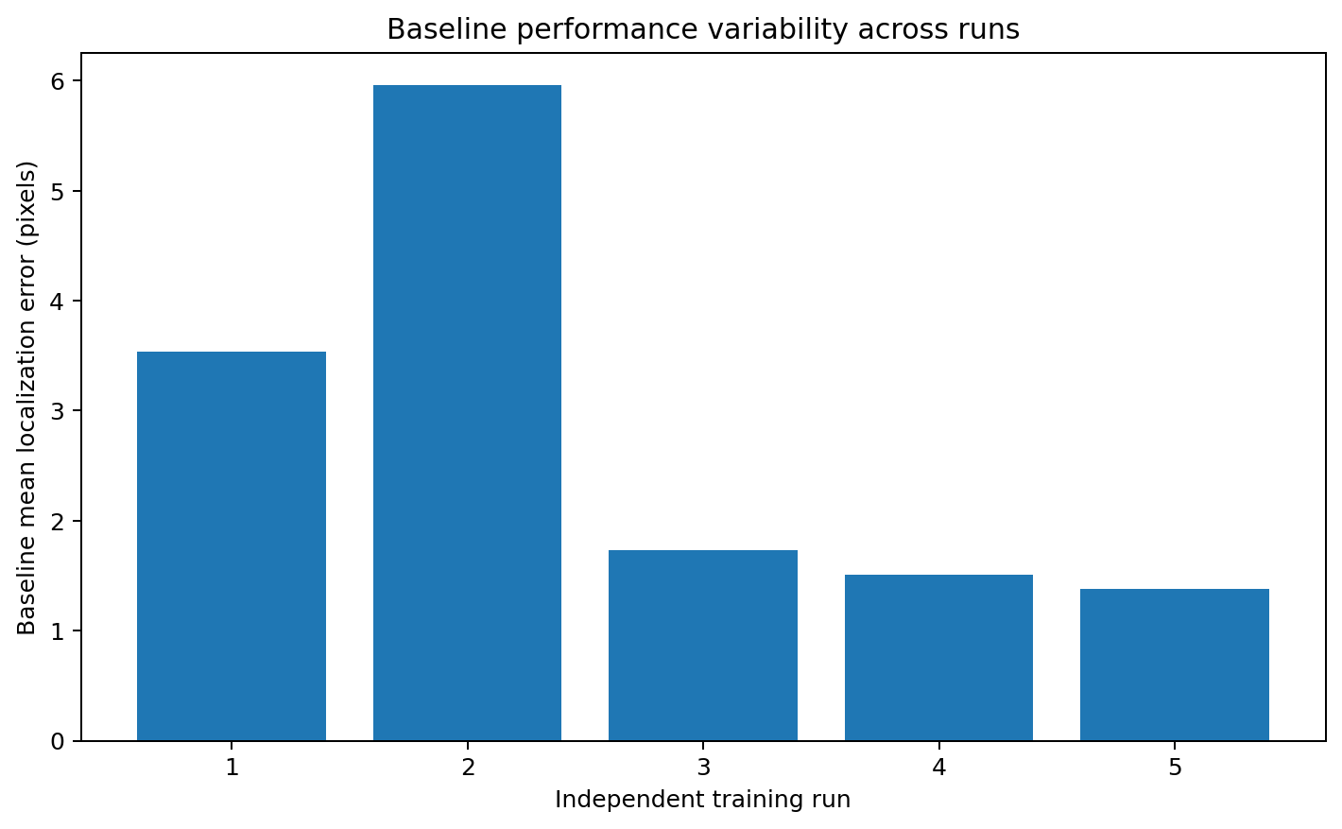
Figure 1. Baseline mean localization error for each independent run.
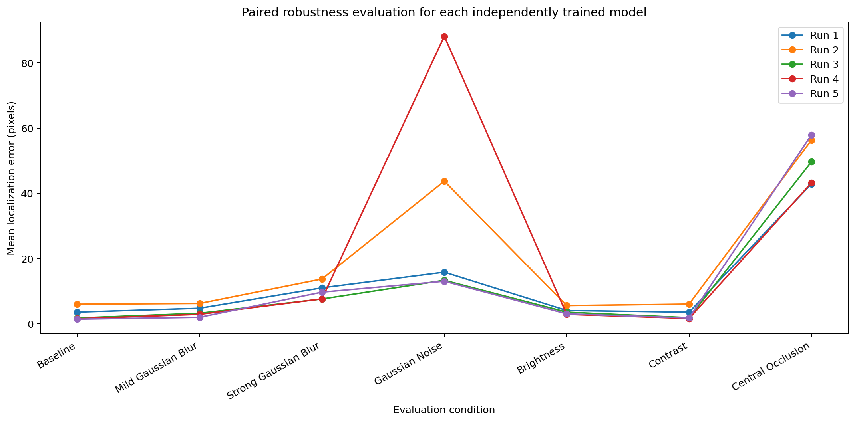
Figure 2. Paired performance of every independently trained model across evaluation conditions.
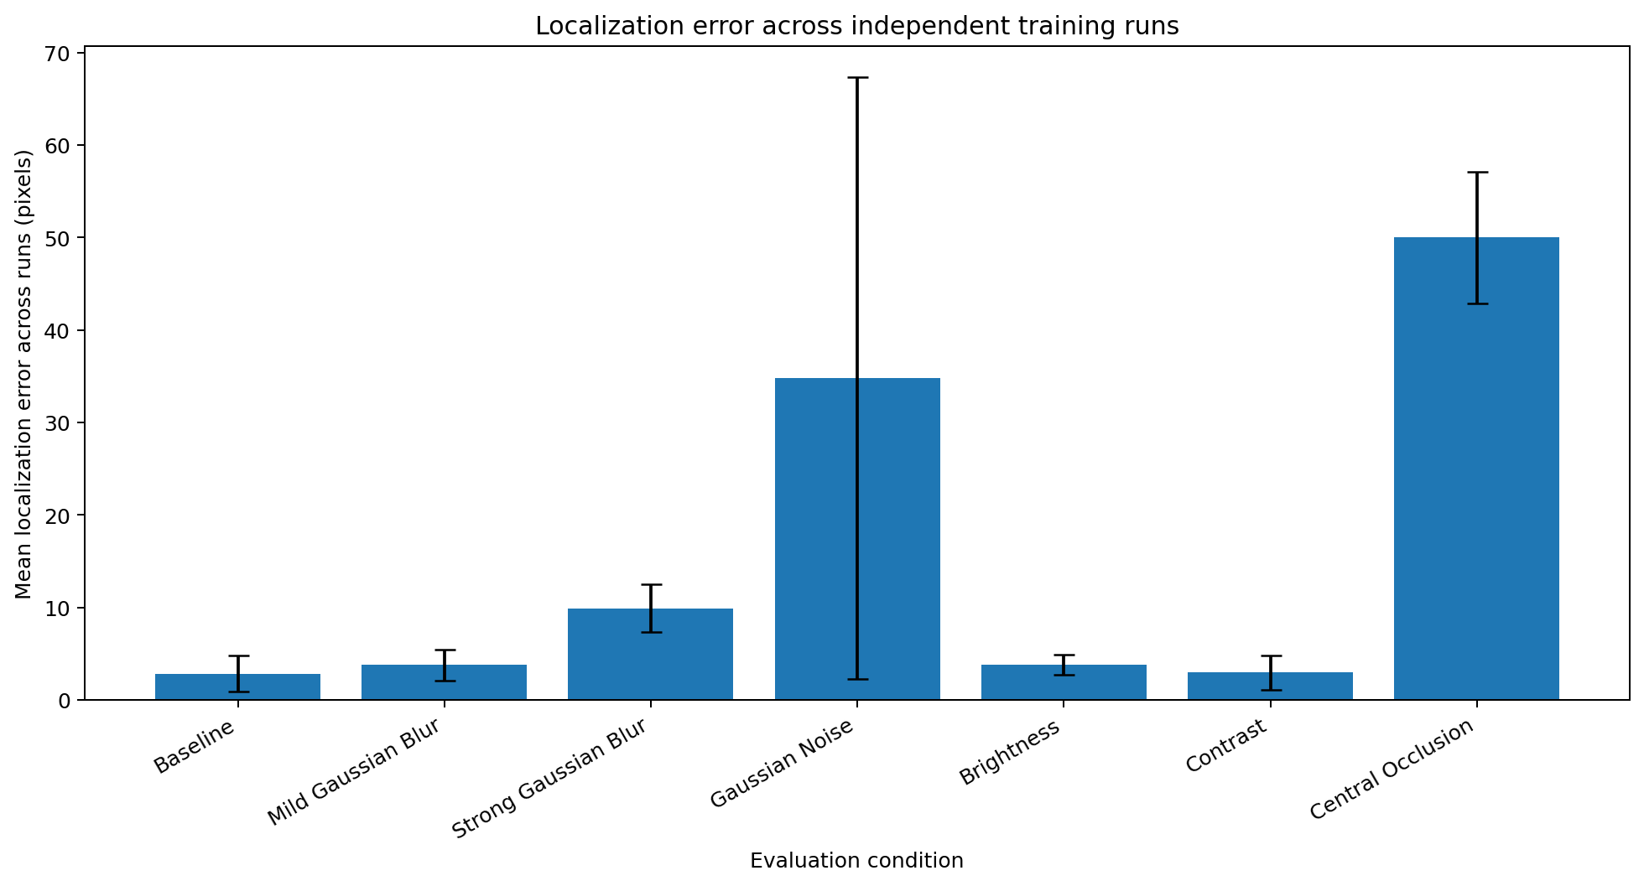
Figure 3. Mean localization error and standard deviation across runs.

5. Paired Robustness Effects
Table 3 shows the change produced by each perturbation relative to the baseline of the same training run.
Table 3. Paired changes relative to baseline.
Run | Seed | Condition | Baseline mean error (px) | Perturbed mean error (px) | Absolute change (px) | Relative change (%)
1 | 11 | Mild Gaussian Blur | 3.536 | 4.713 | 1.177 | 33.290
1 | 11 | Strong Gaussian Blur | 3.536 | 10.984 | 7.449 | 210.659
1 | 11 | Gaussian Noise | 3.536 | 15.790 | 12.255 | 346.579
1 | 11 | Brightness | 3.536 | 4.035 | 0.499 | 14.102
1 | 11 | Contrast | 3.536 | 3.512 | -0.023 | -0.663
1 | 11 | Central Occlusion | 3.536 | 42.852 | 39.316 | 1111.917
2 | 22 | Mild Gaussian Blur | 5.958 | 6.182 | 0.224 | 3.768
2 | 22 | Strong Gaussian Blur | 5.958 | 13.696 | 7.738 | 129.892
2 | 22 | Gaussian Noise | 5.958 | 43.704 | 37.746 | 633.575
2 | 22 | Brightness | 5.958 | 5.533 | -0.425 | -7.133
2 | 22 | Contrast | 5.958 | 5.995 | 0.037 | 0.626
2 | 22 | Central Occlusion | 5.958 | 56.315 | 50.357 | 845.251
3 | 33 | Mild Gaussian Blur | 1.729 | 3.196 | 1.467 | 84.829
3 | 33 | Strong Gaussian Blur | 1.729 | 7.553 | 5.824 | 336.772
3 | 33 | Gaussian Noise | 1.729 | 13.291 | 11.562 | 668.554
3 | 33 | Brightness | 1.729 | 3.522 | 1.793 | 103.677
3 | 33 | Contrast | 1.729 | 1.825 | 0.096 | 5.523
3 | 33 | Central Occlusion | 1.729 | 49.636 | 47.907 | 2770.243
4 | 44 | Mild Gaussian Blur | 1.509 | 2.853 | 1.344 | 89.016
4 | 44 | Strong Gaussian Blur | 1.509 | 7.585 | 6.076 | 402.519
4 | 44 | Gaussian Noise | 1.509 | 88.185 | 86.676 | 5742.125
4 | 44 | Brightness | 1.509 | 2.845 | 1.336 | 88.478
4 | 44 | Contrast | 1.509 | 1.593 | 0.083 | 5.528
4 | 44 | Central Occlusion | 1.509 | 43.177 | 41.667 | 2760.395
5 | 55 | Mild Gaussian Blur | 1.379 | 1.938 | 0.560 | 40.590
5 | 55 | Strong Gaussian Blur | 1.379 | 9.654 | 8.275 | 600.158
5 | 55 | Gaussian Noise | 1.379 | 12.997 | 11.618 | 842.655
5 | 55 | Brightness | 1.379 | 3.003 | 1.624 | 117.818
5 | 55 | Contrast | 1.379 | 1.754 | 0.375 | 27.190
5 | 55 | Central Occlusion | 1.379 | 57.944 | 56.566 | 4102.593
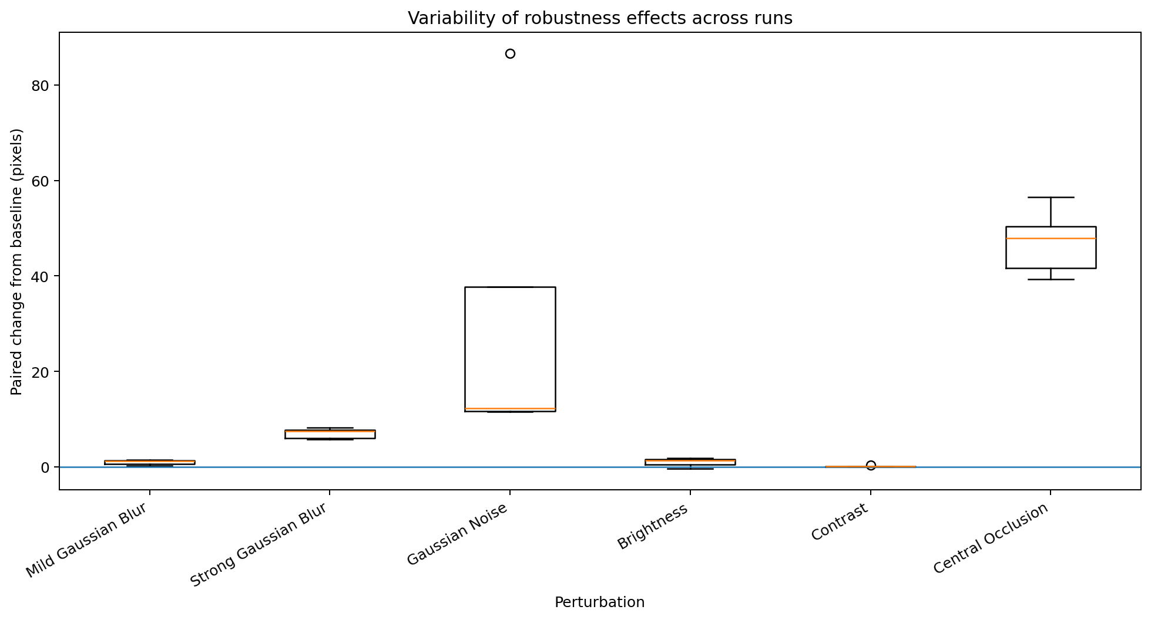
Figure 4. Distribution of paired changes relative to baseline across runs.

6. Landmark-Level Robustness
Table 4 reports landmark-level performance averaged across runs. Positive paired changes indicate increased localization error relative to baseline.
Table 4. Landmark-level robustness summary across runs.
Condition | Landmark | Mean error across runs (px) | SD across runs (px) | Mean paired change vs baseline (px) | SD paired change (px) | Runs with increased error (%)
Brightness | leg_mr_tip | 10.343 | 5.346 | 5.319 | 4.262 | 100.000
Brightness | leg_br_tip | 8.627 | 1.567 | 3.187 | 2.757 | 80.000
Brightness | leg_ml_tip | 8.036 | 3.248 | 3.163 | 2.253 | 100.000
Brightness | leg_bl_tip | 9.289 | 1.828 | 3.001 | 2.904 | 80.000
Brightness | leg_fl_tip | 7.127 | 4.316 | 1.083 | 2.422 | 60.000
Brightness | leg_fr_tip | 7.371 | 4.088 | 0.395 | 4.086 | 60.000
Brightness | leg_mr_c | 1.527 | 0.222 | 0.289 | 0.143 | 100.000
Brightness | abdomen | 1.009 | 0.224 | 0.237 | 0.255 | 80.000
Brightness | leg_mr_in | 1.321 | 0.246 | 0.173 | 0.238 | 80.000
Brightness | leg_ml_c | 1.528 | 0.327 | 0.168 | 0.382 | 60.000
Brightness | head_bl | 1.535 | 0.725 | 0.084 | 0.427 | 60.000
Brightness | leg_ml_in | 1.062 | 0.150 | 0.070 | 0.127 | 60.000
Brightness | thorax_fr | 1.315 | 0.535 | 0.064 | 0.283 | 40.000
Brightness | thorax_bc | 0.990 | 0.221 | 0.015 | 0.043 | 40.000
Brightness | thorax_fl | 0.982 | 0.230 | 0.007 | 0.253 | 40.000
Brightness | head_br | 1.025 | 0.289 | -0.131 | 0.320 | 60.000
Brightness | head_fc | 1.299 | 0.936 | -0.714 | 1.595 | 40.000
Central Occlusion | leg_mr_c | 59.686 | 10.326 | 58.449 | 10.440 | 100.000
Central Occlusion | leg_mr_tip | 63.350 | 22.124 | 58.326 | 25.358 | 100.000
Central Occlusion | leg_br_tip | 62.936 | 22.520 | 57.496 | 24.378 | 100.000
Central Occlusion | head_bl | 58.907 | 32.615 | 57.457 | 32.818 | 100.000
Central Occlusion | head_fc | 58.013 | 41.596 | 55.999 | 39.470 | 100.000
Central Occlusion | thorax_bc | 51.886 | 11.586 | 50.911 | 11.660 | 100.000
Central Occlusion | abdomen | 51.612 | 23.967 | 50.840 | 23.992 | 100.000
Central Occlusion | leg_mr_in | 50.797 | 8.563 | 49.648 | 8.605 | 100.000
Central Occlusion | leg_ml_in | 45.484 | 10.144 | 44.492 | 10.137 | 100.000
Central Occlusion | thorax_fr | 44.441 | 6.877 | 43.189 | 6.596 | 100.000
Central Occlusion | leg_ml_c | 44.365 | 7.426 | 43.005 | 7.525 | 100.000
Central Occlusion | thorax_fl | 43.636 | 9.171 | 42.661 | 9.101 | 100.000
Central Occlusion | head_br | 43.626 | 9.977 | 42.470 | 9.558 | 100.000
Central Occlusion | leg_ml_tip | 44.738 | 17.283 | 39.865 | 13.747 | 100.000
Central Occlusion | leg_fl_tip | 44.238 | 18.360 | 38.194 | 13.672 | 100.000
Central Occlusion | leg_bl_tip | 42.659 | 19.446 | 36.372 | 22.404 | 100.000
Central Occlusion | leg_fr_tip | 39.366 | 10.664 | 32.390 | 10.923 | 100.000
Contrast | leg_mr_tip | 6.049 | 5.999 | 1.025 | 1.898 | 60.000
Contrast | leg_mr_in | 1.490 | 0.509 | 0.341 | 0.373 | 100.000
Contrast | thorax_fr | 1.518 | 0.701 | 0.266 | 0.551 | 80.000
Contrast | thorax_bc | 1.197 | 0.296 | 0.222 | 0.131 | 100.000
Contrast | leg_ml_in | 1.214 | 0.328 | 0.222 | 0.231 | 100.000
Contrast | leg_ml_tip | 5.082 | 4.705 | 0.209 | 0.600 | 60.000
Contrast | leg_mr_c | 1.383 | 0.242 | 0.145 | 0.230 | 80.000
Contrast | leg_bl_tip | 6.407 | 3.737 | 0.120 | 0.511 | 60.000
Contrast | abdomen | 0.889 | 0.126 | 0.117 | 0.118 | 80.000
Contrast | thorax_fl | 1.084 | 0.352 | 0.109 | 0.080 | 100.000
Contrast | leg_br_tip | 5.509 | 3.091 | 0.069 | 0.670 | 40.000
Contrast | leg_ml_c | 1.420 | 0.162 | 0.060 | 0.289 | 60.000
Contrast | head_br | 1.147 | 0.368 | -0.010 | 0.280 | 40.000
Contrast | leg_fl_tip | 6.002 | 6.110 | -0.042 | 1.361 | 60.000
Contrast | head_bl | 1.404 | 0.296 | -0.046 | 0.356 | 40.000
Contrast | head_fc | 1.863 | 2.236 | -0.151 | 0.284 | 60.000
Contrast | leg_fr_tip | 6.251 | 5.855 | -0.724 | 1.535 | 40.000
Gaussian Noise | leg_mr_tip | 48.760 | 25.554 | 43.736 | 25.840 | 100.000
Gaussian Noise | head_fc | 45.711 | 49.600 | 43.697 | 48.699 | 100.000
Gaussian Noise | leg_bl_tip | 49.598 | 35.202 | 43.311 | 37.051 | 100.000
Gaussian Noise | leg_br_tip | 46.695 | 48.758 | 41.255 | 50.608 | 100.000
Gaussian Noise | leg_ml_tip | 44.962 | 41.052 | 40.089 | 42.070 | 100.000
Gaussian Noise | abdomen | 40.559 | 55.464 | 39.787 | 55.457 | 100.000
Gaussian Noise | leg_fl_tip | 43.718 | 32.640 | 37.674 | 31.979 | 100.000
Gaussian Noise | head_br | 37.743 | 44.648 | 36.586 | 44.517 | 100.000
Gaussian Noise | leg_ml_c | 36.750 | 47.672 | 35.390 | 47.584 | 100.000
Gaussian Noise | leg_fr_tip | 40.247 | 33.208 | 33.271 | 33.441 | 100.000
Gaussian Noise | leg_mr_c | 34.470 | 54.006 | 33.232 | 53.970 | 100.000
Gaussian Noise | thorax_fr | 32.213 | 35.233 | 30.961 | 35.267 | 100.000
Gaussian Noise | thorax_bc | 24.964 | 43.744 | 23.988 | 43.774 | 100.000
Gaussian Noise | head_bl | 21.624 | 25.620 | 20.173 | 25.620 | 100.000
Gaussian Noise | leg_mr_in | 18.838 | 23.205 | 17.689 | 23.317 | 100.000
Gaussian Noise | thorax_fl | 12.585 | 19.732 | 11.609 | 19.451 | 100.000
Gaussian Noise | leg_ml_in | 12.053 | 13.913 | 11.061 | 13.880 | 100.000
Mild Gaussian Blur | leg_br_tip | 8.431 | 1.616 | 2.991 | 2.007 | 80.000
Mild Gaussian Blur | leg_bl_tip | 9.042 | 2.433 | 2.755 | 2.532 | 80.000
Mild Gaussian Blur | leg_ml_tip | 7.188 | 4.223 | 2.315 | 2.446 | 100.000
Mild Gaussian Blur | leg_mr_tip | 7.266 | 3.827 | 2.242 | 2.518 | 80.000
Mild Gaussian Blur | leg_fr_tip | 8.809 | 6.213 | 1.833 | 1.342 | 100.000
Mild Gaussian Blur | leg_fl_tip | 7.454 | 5.818 | 1.410 | 0.697 | 100.000
Mild Gaussian Blur | head_fc | 2.632 | 3.013 | 0.618 | 0.649 | 100.000
Mild Gaussian Blur | head_br | 1.549 | 0.959 | 0.393 | 0.508 | 80.000
Mild Gaussian Blur | leg_mr_c | 1.571 | 0.273 | 0.333 | 0.225 | 100.000
Mild Gaussian Blur | leg_mr_in | 1.466 | 0.628 | 0.317 | 0.503 | 80.000
Mild Gaussian Blur | thorax_fr | 1.552 | 0.935 | 0.300 | 0.652 | 60.000
Mild Gaussian Blur | leg_ml_c | 1.622 | 0.361 | 0.262 | 0.235 | 80.000
Mild Gaussian Blur | leg_ml_in | 1.177 | 0.194 | 0.185 | 0.134 | 100.000
Mild Gaussian Blur | thorax_fl | 1.123 | 0.443 | 0.148 | 0.162 | 80.000
Mild Gaussian Blur | thorax_bc | 1.048 | 0.168 | 0.073 | 0.175 | 80.000
Mild Gaussian Blur | abdomen | 0.806 | 0.066 | 0.034 | 0.091 | 80.000
Mild Gaussian Blur | head_bl | 1.466 | 0.336 | 0.015 | 0.527 | 20.000
Strong Gaussian Blur | leg_mr_tip | 17.209 | 4.407 | 12.185 | 8.963 | 80.000
Strong Gaussian Blur | head_fc | 13.548 | 17.277 | 11.535 | 16.941 | 100.000
Strong Gaussian Blur | leg_br_tip | 15.501 | 3.423 | 10.061 | 6.713 | 100.000
Strong Gaussian Blur | leg_ml_tip | 14.809 | 3.875 | 9.936 | 7.916 | 80.000
Strong Gaussian Blur | leg_bl_tip | 16.194 | 4.858 | 9.906 | 7.763 | 80.000
Strong Gaussian Blur | leg_fl_tip | 15.839 | 7.954 | 9.796 | 2.309 | 100.000
Strong Gaussian Blur | leg_fr_tip | 14.281 | 5.831 | 7.305 | 2.635 | 100.000
Strong Gaussian Blur | head_br | 7.903 | 6.826 | 6.746 | 6.322 | 100.000
Strong Gaussian Blur | thorax_fr | 7.770 | 6.264 | 6.519 | 6.006 | 80.000
Strong Gaussian Blur | leg_mr_in | 7.318 | 2.993 | 6.169 | 3.021 | 100.000
Strong Gaussian Blur | head_bl | 7.487 | 7.569 | 6.037 | 7.748 | 80.000
Strong Gaussian Blur | thorax_fl | 6.668 | 6.349 | 5.693 | 6.158 | 100.000
Strong Gaussian Blur | leg_ml_c | 6.938 | 5.206 | 5.578 | 5.173 | 100.000
Strong Gaussian Blur | leg_ml_in | 6.401 | 6.102 | 5.409 | 6.035 | 100.000
Strong Gaussian Blur | leg_mr_c | 6.108 | 1.578 | 4.870 | 1.650 | 100.000
Strong Gaussian Blur | thorax_bc | 3.339 | 1.460 | 2.364 | 1.510 | 100.000
Strong Gaussian Blur | abdomen | 0.894 | 0.196 | 0.122 | 0.237 | 60.000
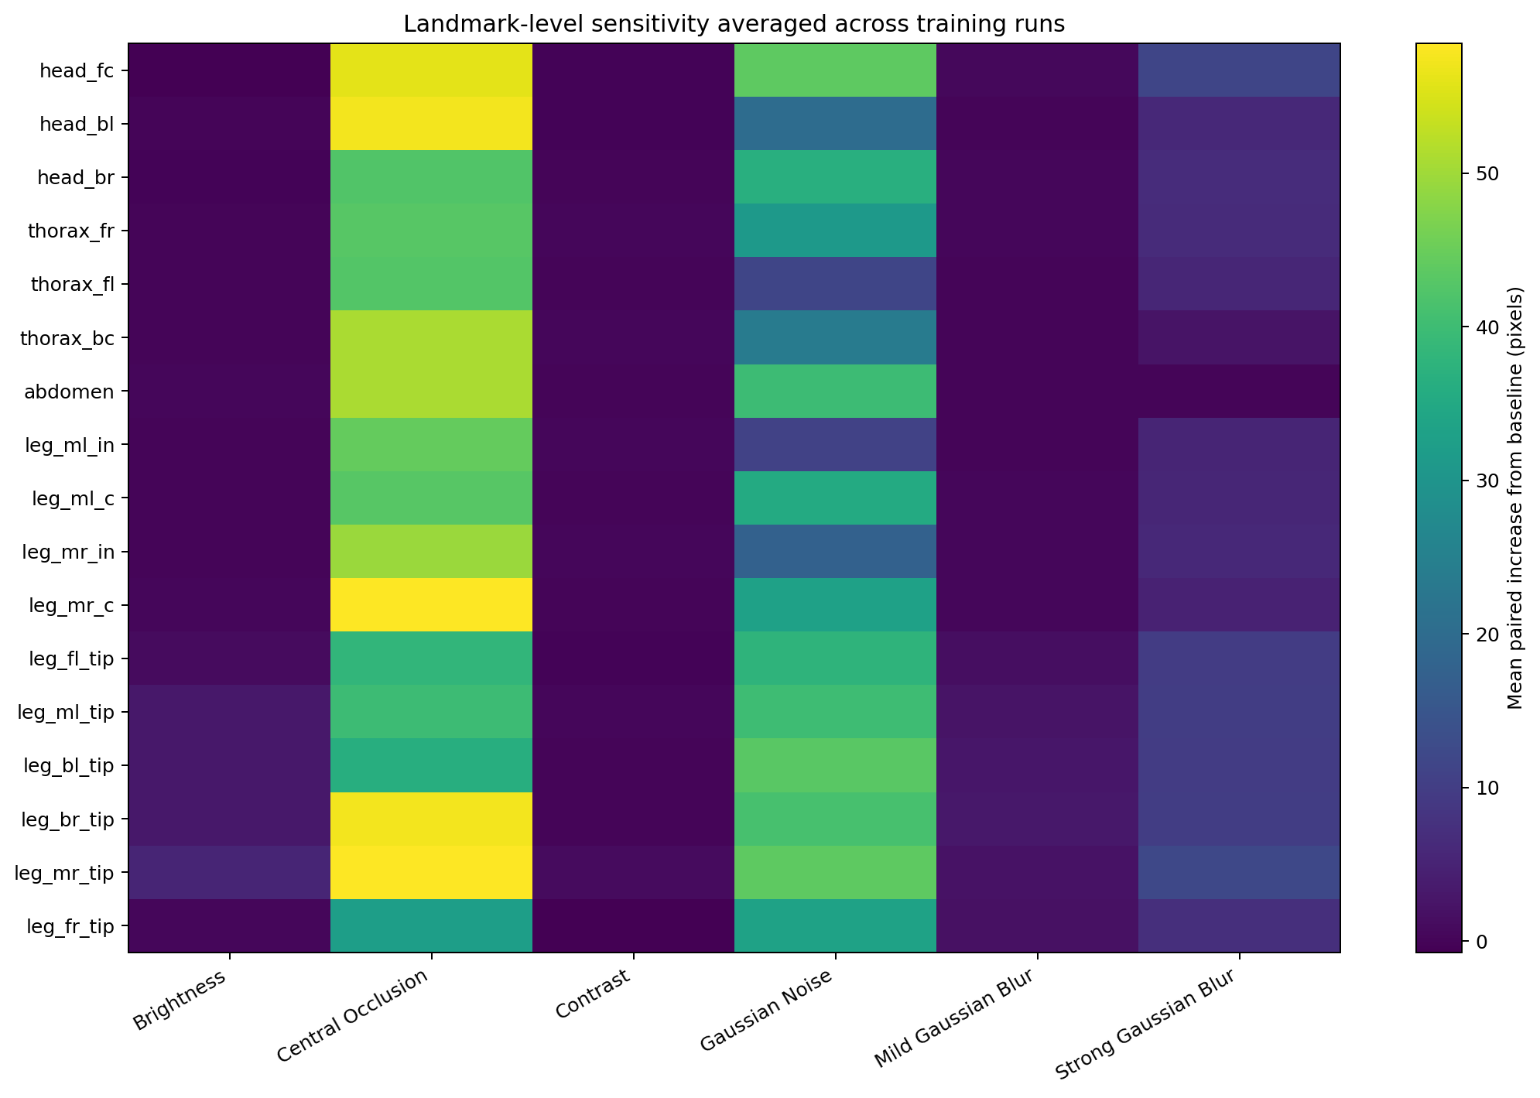
Figure 5. Mean paired increase in localization error for each landmark and perturbation.

7. Statistical Analysis
The paired tests below are exploratory, particularly when only three runs are used. Effect magnitude, variability, and consistency across runs should receive greater emphasis than p-values.
Table 5. Exploratory paired statistical tests.
Condition | Mean paired change (px) | SD paired change (px) | Paired t-test p-value | One-sided Wilcoxon p-value | Runs increased / total
Mild Gaussian Blur | 0.954 | 0.537 | 0.016 | 0.031 | 5/5
Strong Gaussian Blur | 7.072 | 1.070 | 0.000 | 0.031 | 5/5
Gaussian Noise | 31.971 | 32.579 | 0.093 | 0.031 | 5/5
Brightness | 0.965 | 0.923 | 0.079 | 0.062 | 4/5
Contrast | 0.114 | 0.153 | 0.173 | 0.062 | 4/5
Central Occlusion | 47.163 | 6.909 | 0.000 | 0.031 | 5/5

8. Interpretation
Across 5 independently trained models, baseline mean localization error was 2.82 ± 1.96 pixels, and baseline PCK@5 was 87.3 ± 14.9%.
Mild Gaussian Blur produced a mean paired change of +0.95 ± 0.54 pixels and increased error in every run (5/5).
Strong Gaussian Blur produced a mean paired change of +7.07 ± 1.07 pixels and increased error in every run (5/5).
Gaussian Noise produced a mean paired change of +31.97 ± 32.58 pixels and increased error in every run (5/5).
Brightness produced a mean paired change of +0.97 ± 0.92 pixels and increased error in most runs (4/5).
Contrast produced a mean paired change of +0.11 ± 0.15 pixels and increased error in most runs (4/5).
Central Occlusion produced a mean paired change of +47.16 ± 6.91 pixels and increased error in every run (5/5).
The largest average degradation was observed for Central Occlusion (+47.16 pixels relative to baseline).
Across runs, the highest baseline landmark error was observed for leg_fr_tip (6.98 px), while abdomen had the lowest (0.77 px).
A perturbation is interpreted as consistently harmful only when it increases error across all completed independent runs. When effects vary in direction or magnitude, the report describes that variability instead of making a general claim.

9. Limitations
- The study includes 5 independent runs; more runs would provide a more precise estimate of variability.
- Every model was trained for 3 epochs using the original course-scale architecture and training settings.
- Only one predefined severity was used for noise, brightness, contrast, and occlusion, while two blur severities were tested.
- The validation split was fixed to isolate training variability; results may also vary under different data splits.
- The paired statistical tests are exploratory and have limited power with a small number of runs.
- The study evaluates robustness to synthetic perturbations and does not establish performance under all real-world imaging conditions.

10. Conclusion
Across 5 independently trained models, baseline performance showed a mean error of 2.82 ± 1.96 pixels. The following perturbations increased localization error in every completed run: Central Occlusion, Gaussian Noise, Strong Gaussian Blur, Mild Gaussian Blur. The magnitude of the robustness effects varied across models and anatomical landmarks. These multi-run results provide a stronger basis for evaluating robustness than any individual training run.

