1DIANESWARR SHANMUGA SUNDARAM 2 MAGODU BALAJI GANESH KUMAR 3 MANGENENI BALARAM

4Mrs. E. CHITRA, Assistant Professor, Department of Electronics and Communication, SRM Institute of Science and Technology, Chennai.

B. Tech ECE, Department of Electronics and Communication, SRM Institute of Science and Technology, Chennai.

1 [dianyboy@gmail.com,](mailto:ajith.skpt@gmail.com) [2 mbganesh2015@gmail.com,](mailto:2dianyboy@gmail.com,%20) 3 [balaram@gmail.com,](mailto:balaram@gmail.com,%20) 4chitra.e@ktr.srmuniv.ac.in ,

1S.AJITH 2P.JANAKIRAM 3G.KAMAL NIKHIL 4R.AKHIL TEJA 5Mr.S.BHASYAM

5Assitant Professor, Department of Electronics and Communication, Srm Institute of Science and Technology, Chennai.

1,2,3,4B tech ECE, Department of Electronics and Communication, Srm Institute of Science and Technology, Chennai.

1 [ajith.skpt@gmail.com,](mailto:ajith.skpt@gmail.com) [2janakiram161197@gmail.com,](mailto:2janakiram161197@gmail.com) 3 [kamal.nikhil1997@gmail.com,](mailto:kamal.nikhil1997@gmail.com) 4 [akhil.ravuri456@gmail.com](mailto:akhil.ravuri456@gmail.com) ,

5 [bashyam2k11@gmail.com](mailto:bashyam2k11@gmail.com)

**CONTROLLING WEAPONIZED UGV USING HAND GESTURES THROUGH LEAP MOTION CONTROLLER**

[1]

*Abstract*--

**Weaponized UGV’s (unmanned ground vehicle) is used in the military for reconnaissance, surveillance and target acquisition missions. These UGVs can assassinate the enemy with heavy machine guns, grenade launchers and even anti-tank weapons. It is mostly remote-operated by one or two soldiers. Military UGVs use sensors and can respond automatically. But in July 2015, thousands of artificial intelligence signed a ban against the weaponized automated vehicle. But in this paper, weaponized UGV is controlled by hand gestures using the leap motion controller, making it a manual weaponized vehicle. There are several manually controlled UGVs such as remote-controlled and voice-controlled. In remote control, the user has to peep into the remote in search of the buttons. In voice-controlled, external noise may affect the performance of the system. But Leap Motion Controller (LMC) is a new three- dimensional touch-free device which introduces a new gesture and position tracking system with an excellent accuracy level, by using the leap motion controller, we can avoid external noise interference and making it is user-friendly device. Weaponized gesture-controlled UGV can be used to support or replace soldiers at the battlefield and can be used at terror attack where user can monitor and assassinate the subject without taking any damage on to him/her.**

***KEYWORDS- UGV, LMC***

# **Introduction**

A weaponized UGV is robotic equipment that travels across the surface of the ground and used for investigation and to assassinate the opponent. These weaponized UGV’s can replace soldiers in extreme war conditions so that the life loss can be prevented. There are two major types of the human-machine interface where UGV’s is controlled by remote and voice command. In remote controlled UGV’s, every time user as to peep into the remote in search of buttons and voice command mode, external noise can affect the accuracy of the UGV.

The above-stated problem can be solved by using gesture recognition. The most recent technology is the leap motion sensor, opens new doors for gesture recognition.

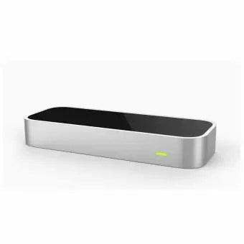

Fig;1 Leap motion Controller

The leap motion controller is a device which locates the position of the fingers and hand orientation using infrared led and two digital cameras. The leap motion controller is proposed instead of other technologies like Microsoft Kinect and Nintendo Wii for detecting the hand movement. While Microsoft Kinect and Nintendo Wii detect the entire user body, the accuracy levels in these devices are deficient. In the proposed leap motion controller, although it has a limited space to work with, position tracking of hand movements is precise when compared to other devices. Left-hand gestures are used to control the motion of the car, and right-hand gestures are used to manage the action of the weaponized robotic arm. This paper goes through the attempt of movement of a gun using a robotic arm and UGV through the acquired data by the leap motion controller.

# **LITERATURE SURVEY**

In [1] The problem of mislabeling, which is caused by executing dynamic hand gesture in positions, is solved using single finger features. Distinguishing different types of interactions between adjacent fingertips can be done using double finger features. The recognition accuracy of 89.5 percentage for the Leap Motion Gesture 3D data-set and 95.0 percentage for the handicraft Gesture data-set can be achieved using a leap motion controller. When compared with the Kinect sensor, the leap motion controller outputs depth data frames which consist of finger position, hand position, scaling data, frame timestamp, rotation extraction is more precise and accurate. Therefore, the feature extraction time of the leap motion controller is less than the Kinect sensor. The features extracted through leap motion sensors are based on palm direction, palm normal, fingertips positions, and palm centre.

In [2] As earlier the Robotic arm was controlled by the remote, where we have to press numerous buttons, which increased the complexity and decreased the accuracy of the movement of the robotic arm but by the use of leap motion technology, the complexity is reduced, and efficiency is increased. The two monochromatic sensors in leap motion controller detect the heat emits from the human hand and infrared led to identify the structure and of the sensor is based on the right-hand Cartesian coordinate system (X, Y, Z), with the origin centred at the top centre of the device.

In [3] The data which is retrieved from the leap motion sensors contains various information from the positioning frame id to the detection of bones and fingers. The leap motion controller can detect a human hand within the distance of one millimetre and consuming time of 300 seconds. A leap motion controller provides an average accuracy of 0.7 millimetres to identify the human hand and can be able to distinguish between two fingers. Hence, this innovation enables five degrees of freedom, which increases the accuracy in the movement of the robotic arm.

In [4] This paper deals with the design and operation of a voice-controlled robotic arm. The robotic arm and UGV’s motion are controlled through voice recognition. A range of 10 to 50 meters is obtained using ZIGBEE transmitter and receiver. The human speech signals are converted into an electrical signal, and then electrical signals are transformed into code patterns to which meanings are allotted.

In [5] It deals with wireless communication using the HC-05 Bluetooth module, the network topology of Bluetooth and interface of Bluetooth with Arduino are discussed.

# **SYSTEM MODEL**

DC motors and Servo motors are used. The motor driver controls DC motors via Arduino mega, and Micro-servo motors are controlled directly by Arduino mega. DC motors are used in UGV, so that forward and backward motion can be implemented, and the weaponized robotic arm is constructed using Micro-servo motors. An external power supply of approximately 5v which is ampliﬁed using DC to DC boosters to 10v, then it is connected to the motor driver, thereby controlling the direction and speed of wheels.

Two Micro-servo motors are used for providing the left, right, up and down movements and One Micro-servo for triggering the gun. These Servo motors are also powered with an external 5v power supply and connected to the Arduino Mega. A Blue- tooth module is used for transmitting the data. Leap Motion Controller is connected to the computer through USB cable, and the leap motion controller recognizes hand gestures. Left-hand gestures are used to control the UGV, right-hand gestures are used to control the movement ﬁrearm, and left-hand grab is used for triggering the firearm.

The program is written in such a way that if left-hand pitch values are higher than the threshold pitch value, the motor driver rotates the dc motor in a clockwise direction making the entire UGV move in the forward direction. If the left-hand pitch value is less than the threshold value, then the motor driver rotates the dc motors in the anti-clockwise direction making the

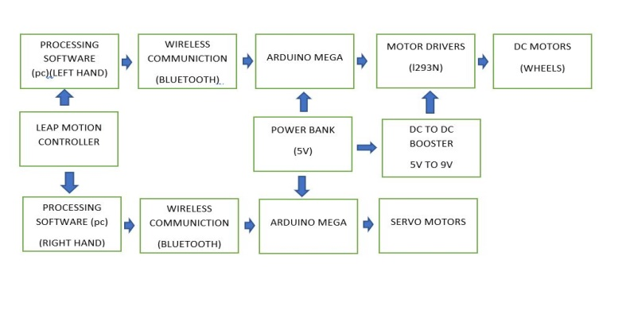

Fig 2. Block diagram

UGV to move in a backward direction. When left-hand roll value is higher than the threshold roll value, the UGV moves in the left direction, and when the left-hand roll is less than the threshold roll value, the UGV moves towards the right. If the left-hand grab is applied, the firearm is triggered.

The horizontal movement of the ﬁrearm is controlled by the yaw values of the right hand, and the vertical movement of the ﬁrearm is controlled by the pitch value of the right hand. If the left-hand grab is applied, then the servo motor connected to the ﬁrearm moves from zero to ninety degrees and back to zero degrees causing the triggering action of the ﬁrearm. The data is transmitted to the Arduino mega in the UGV using a Bluetooth module usually within a range of 10 meters.

From fig.2, Leap motion controller detects the hand and reads the pitch, roll and yaw values of the hands. Processing 3 is the software used to set pitch, roll and yaw thresholds. Then data from processing three is transmitted to Arduino mega via Bluetooth and Arduino mega controls DC and Servo motors.

# **IV.** **experimental setup**

The working of the project mainly depends upon the Leap motion controller, which collects the data from the movement of the hand. Left-hand gestures are used to control the motion of the UGV and firearm triggering, and Right-hand gestures are used to control the progress of the gun. The UGV is controlled through motor drivers via Arduino and these motor drivers powered up through Dc to Dc booster. The 5v from the power bank is amplified to 10v via Dc to Dc booster. The robotic arm has three servo motor, the base servo motor is used to direct the arm left and right, and second servo motor is used to move the arm up and down, and third servo motor is used to pull the trigger. In this experiment, pitch, roll and yaw axis are utilized.

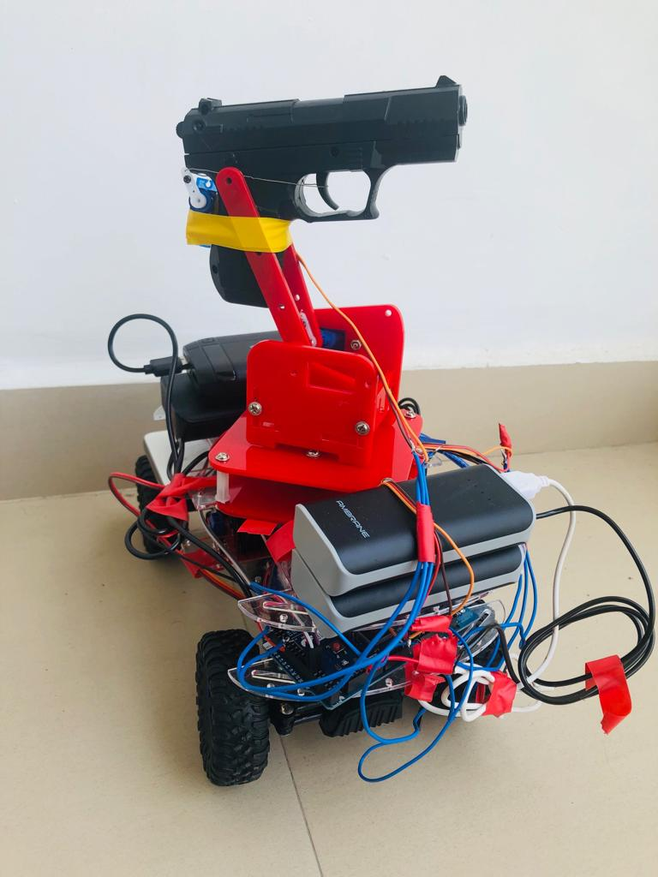

Fig:3 Experimental setup

# **RESULT AND DISCUSSION**

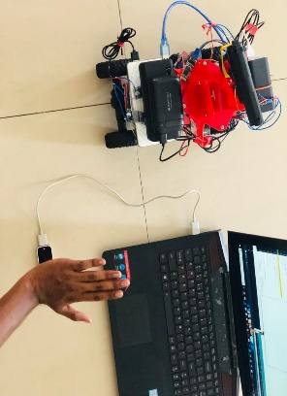

Fig: 4 UGV in the forward direction

Figure 4 shows that when the left hand is tilted upwards,

then UGV goes forward.

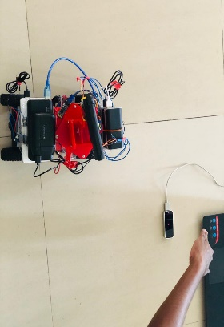

Fig:5 UGV in the backward direction

From the above figure 5, when the left hand is tilted downwards, then UGV goes backwards.

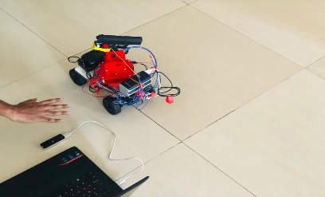

Fig:6 firearm moved to left

The above figure 6, when the motion of the right hand is towards left, then firearm moves left.

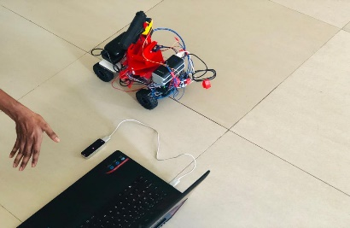

Fig:7 firearm moved to the right

Figure 7 shows that when the motion of the right hand is towards the right, then firearm moves right.

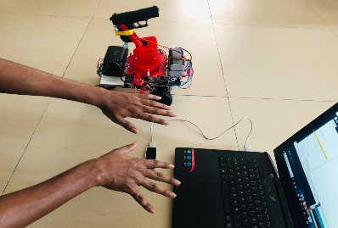

Fig:8 Before triggering

In figure 8, when no left-hand grab is implemented, then no triggering is applied.

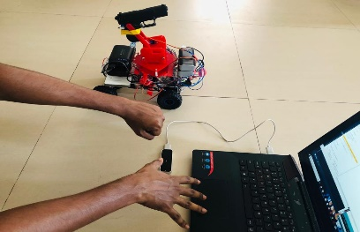

Fig:9 After triggering

In figure 9, when the left hand grab is applied, then the gun is triggered.

.

# **CONCLUSION**

A design and a prototype of weaponized UGV is implemented, and LMC is used to control the same through hand gestures. By using the advantages of single finger features and the ability to distinguish interactions between adjacent fingers, Leap motion controller can recognize hand gestures precisely. As the gesture recognition is emerging technology in the field of UGVs, can serve as a global platform for further research and development. These types of UGVs can be used as a robotic soldier in case of hazardous situations, thereby saving the lives of many soldiers.

# **REFERENCES**

**[1]** Wei Lu, Member, Zheng Tong, and Jinghui Chu, **“Dynamic Hand Gesture Recognition with Leap Motion Controller”**.

**[2]** Sarmad Hameed, Muhammad Ahson Khan, Bhawesh Kumar, Zeeshan Arain and Moez ul Hasan, **“Gesture Controlled Robotic Arm using Leap Motion”,** Indian Journal of Science and Technology, December 2017.

**[3]**Ye Hoon Lee**, “Implementation of Leap Motion Based RC Car Controller”**, IJISET - International Journal of Innovative Science, Engineering & Technology, February 2017.

**[4]** R. Aswinbalaji and A. Arunraja, “**Wireless Voice Controlled Robotic Arm”,** International Journal of Emerging Technology in Computer Science & Electronics (IJETCSE), ISSN: 0976-1353.

**[5]** Mrs. Anisha Cotta, Miss. Naik Trupti Devidas and Miss. Varda Kalidas Naik Ekoskar**, “Wireless Communication using HC-05 Bluetooth module interfaced with Arduino”,** International Journal of Science, Engineering and Technology Research (IJSETR),ISSN: 2278 – 7798.

.

1.