Identity API

- БД Identity
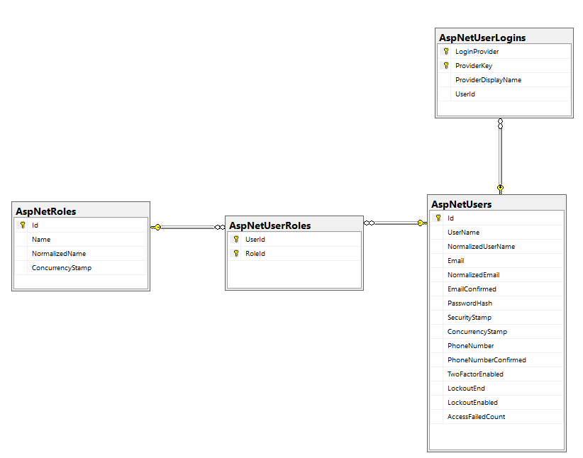
- ORM/Entity Framework: DbContext, Dependency Injection
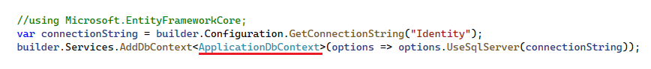
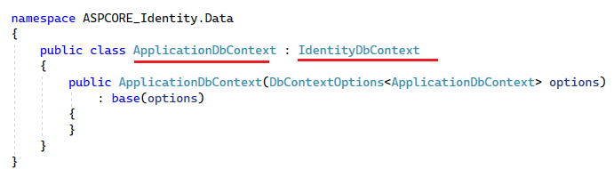

- Users, Roles, User/Roles
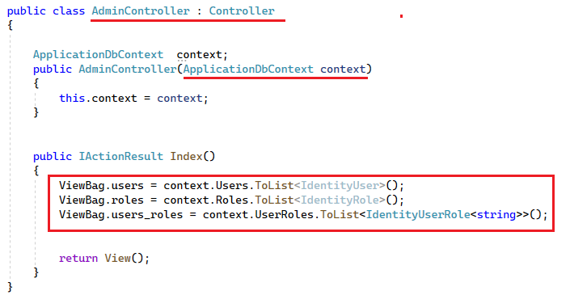
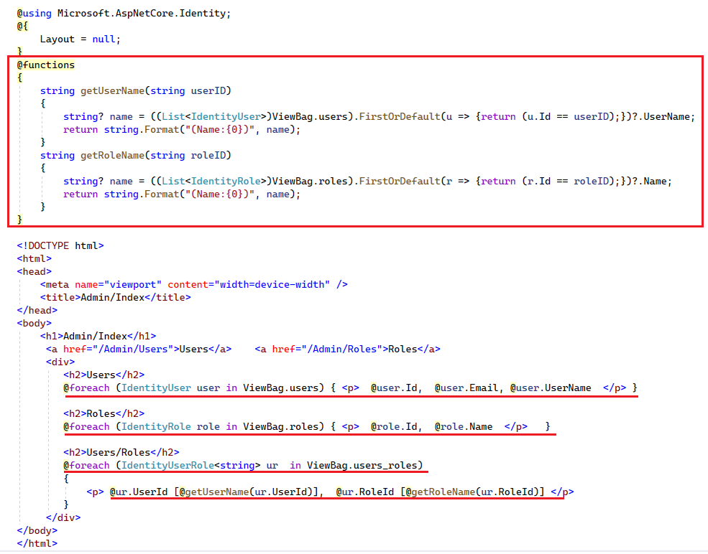

- UserManager: поддержка пользователей, IdentityUser
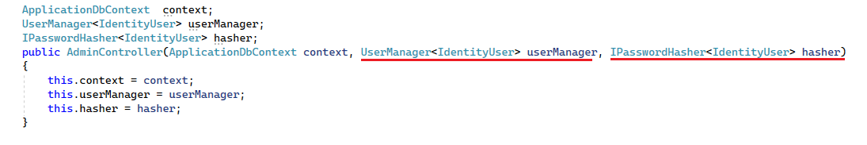
- UserManager/Create
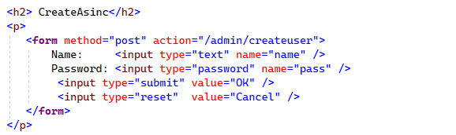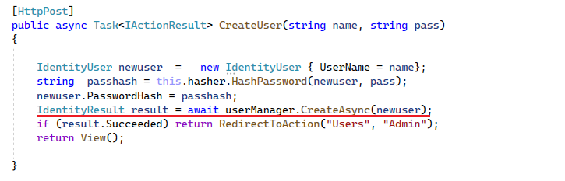
- UserManager/Find…
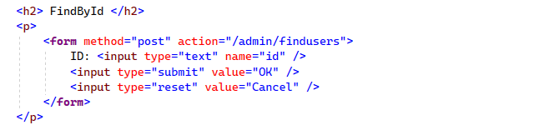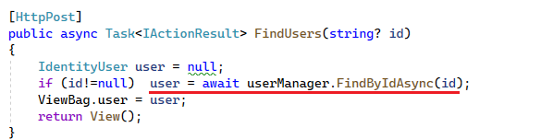
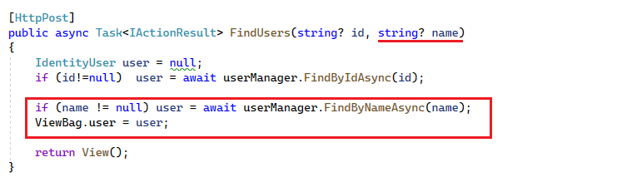

- UserManager/Delete
- UserManager/ChangePasword

- SignInManager: SignIn, SignOut

- Roles
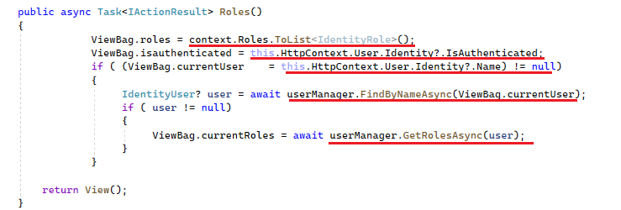
- RoleManager/Create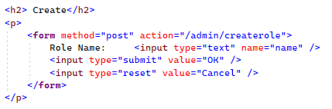

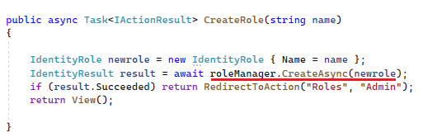
- RoleManager/Delete
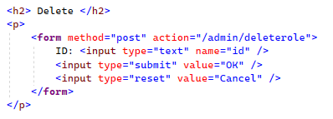
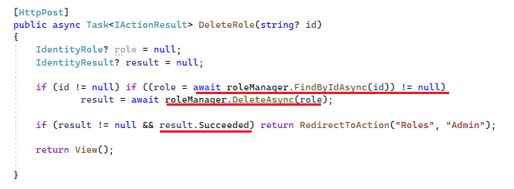

- RoleManager/Find
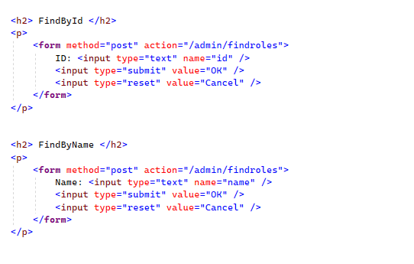
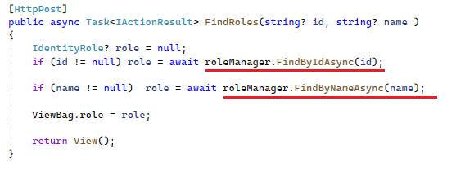

- RoleManager/Exists
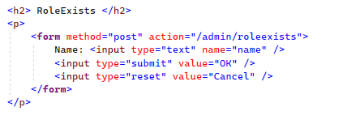
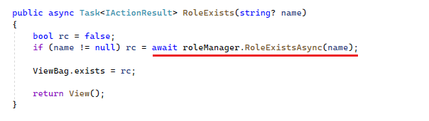
- Инициализатор
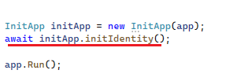
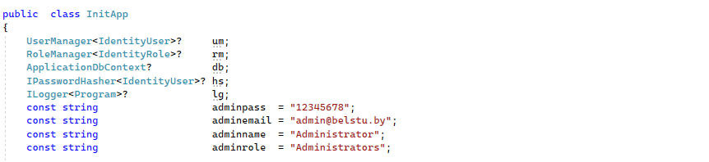
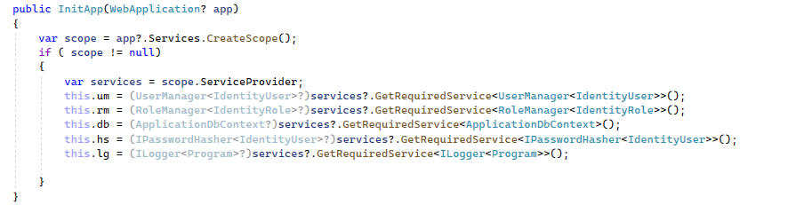
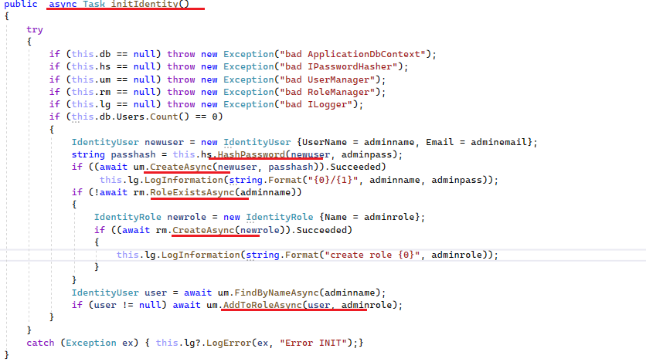

- КОНЕЦ

