Levenshtein.h
#pragma once
int levenshtein(
int lx, // длина слова x
std::string x, // слово длиной lx
int ly, // длина слова y
std::string y // слово y
);
// -- дистанции Левенштeйна (рекурсия)
int levenshtein_r(
int lx, // длина строки x
std::string x, // строка длиной lx
int ly, // длина строки y
std::string y // строка y
);

Levenshtein.cpp
#include <iomanip>
#include <algorithm>
#include "Levenshtein.h"
#define DD(i,j) d[(i)*(ly+1)+(j)]

int min3(int x1, int x2, int x3)
{
return std::min(std::min(x1, x2), x3);
}

int levenshtein(int lx, std::string x, int ly, std::string y)
{
int* d = new int[(lx + 1) * (ly + 1)];
for (int i = 0; i <= lx; i++) DD(i, 0) = i;
for (int j = 0; j <= ly; j++) DD(0, j) = j;
for (int i = 1; i <= lx; i++)
for (int j = 1; j <= ly; j++)
{
DD(i, j) = min3(DD(i - 1, j) + 1, DD(i, j - 1) + 1,
DD(i - 1, j - 1) + (x[i - 1] == y[j - 1] ? 0 : 1));
}
return DD(lx, ly);
}

int levenshtein_r(
int lx, std::string x,
int ly, std::string y
)
{
int rc = 0;
if (lx == 0) rc = ly;
else if (ly == 0) rc = lx;
else if (lx == 1 && ly == 1 && x[0] == y[0]) rc = 0;
else if (lx == 1 && ly == 1 && x[0] != y[0]) rc = 1;
else rc = min3(
levenshtein_r(lx - 1, x, ly, y) + 1,
levenshtein_r(lx, x, ly - 1, y) + 1,
levenshtein_r(lx - 1, x, ly - 1, y) + (x[lx - 1] == y[ly - 1] ? 0 : 1)
);
return rc;
};

main.cpp
#include <algorithm>
#include <iostream>
#include <ctime>
#include <iomanip>
#include "Levenshtein.h"
#include <tchar.h>
#include <random>
#include <string>
#include <chrono>

std::string generateRandomString(int length) {
std::string alphabet = "ABCDEFGHIJKLMNOPQRSTUVWXYZabcdefghijklmnopqrstuvwxyz";
std::string resultString = "";
srand(time(NULL));
for (int i = 0; i < length; i++) {
resultString += alphabet[(((double)rand() / (double)RAND_MAX) * 51)];
}
return resultString;
}

int _tmain(int argc, _TCHAR* argv[])
{
setlocale(LC_ALL, "rus");
clock_t t1 = 0, t2 = 0, t3, t4;
std::string s1 = generateRandomString(300);
std::string s2 = generateRandomString(200);
std::cout << s1 << '\n';
std::cout << s2 << '\n';
std::cout << '\n';
std::cout << "\n-- расстояние Левенштейна -----\n";
std::cout << "\n--длина --- рекурсия -- дин.програм. ---\n";
for (int i = 10; i >= 0; i--)
{
t1 = clock(); levenshtein_r(i, s1, i, s2); t2 = clock();
t3 = clock(); levenshtein(i, s1, i, s2); t4 = clock();
std::cout << std::right << std::setw(2) << i << "/" << std::setw(2) << i
<< " " << std::left << std::setw(10) << (t2 - t1)
<< " " << std::setw(10) << (t4 - t3) << std::endl;
}
system("pause");
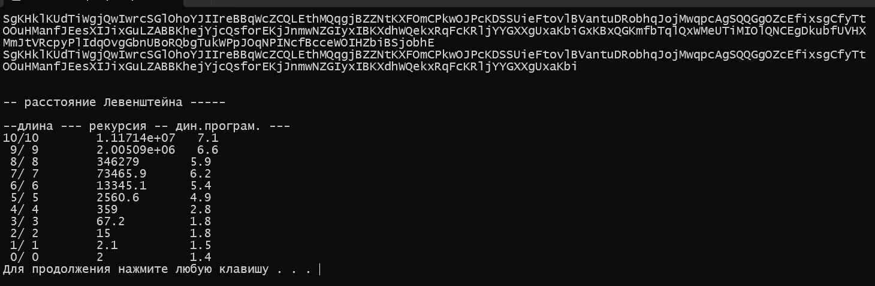
return 0;
}

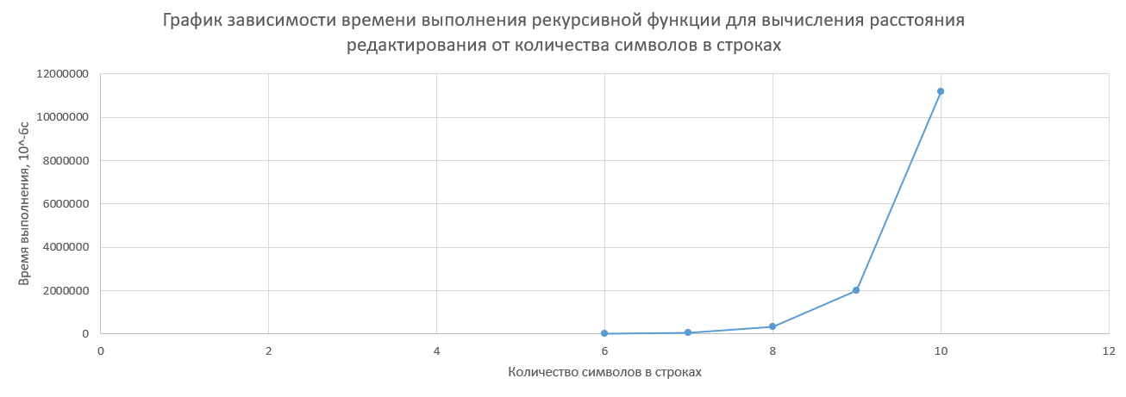

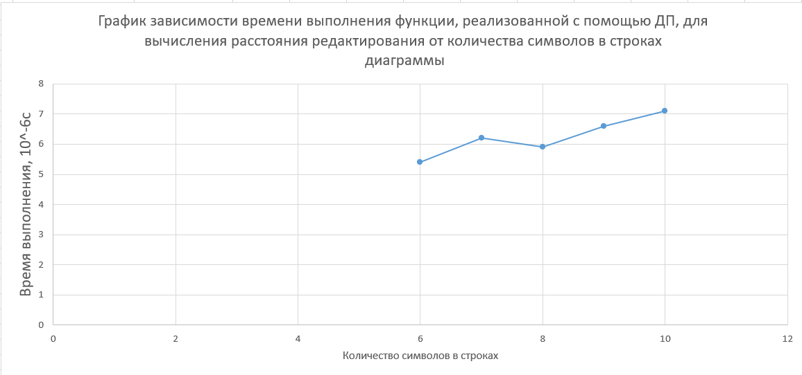

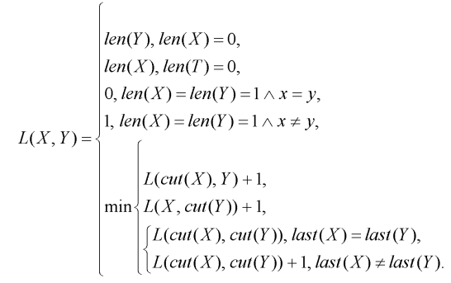
Задание 4

Лот Полет

1) L(“Лот”, “Полет”) = min(
L(“Ло”, “Полет”) + 1,
L(“Лот”, “Поле”) + 1,
L(“Ло”, “Поле”) + 1)
2) L(“Ло”, “Полет”) = min(
L(“Л”, “Полет”) + 1,
L(“Ло”, “Поле”) + 1,
L(“Л”, “Поле”) + 1)
3) L(“Лот”, “Поле”) = min(
L(“Ло”, “Поле”) + 1,
L(“Лот”, “Пол”) + 1,
L(“Ло”, “Пол”) + 1)
4) L(“Ло”, “Поле”) = min(
L(“Л”, “Поле”) + 1,
L(“Ло”, “Пол”) + 1,
L(“Л”, “Пол”) + 1)
5) L(“Л”, “Полет”) = min(
L(“”, “Полет”) + 1,
L(“Л”, “Поле”) + 1,
L(“”, “Поле”) + 1)
L(“”, “Полет”) = 5, L(“”, “Поле”) = 4
6) L(“Л”, “Поле”) = min(
L(“”, “Поле”) + 1,
L(“Л”, “Пол”) + 1,
L(“”, “Пол”) + 1)
L(“”, “Поле”) = 4, L(“”, “Пол”) = 3
7) L(“Лот”, “Пол”) = min(
L(“Ло”, “Пол”) + 1,
L(“Лот”, “По”) + 1,
L(“Ло”, “По”) + 1)
8) L(“Ло”, “Пол”) = min(
L(“Л”, “Пол”) + 1,
L(“Ло”, “По”) + 1,
L(“Л”, “По”) + 1)
9) L(“Л”, “Пол”) = min(
L(“”, “Пол”) + 1,
L(“Л”, “По”) + 1,
L(“”, “По”) + 1)
L(“”, “Пол”) = 3, L(“”, “По”) = 2
10) L(“Лот”, “По”) = min(
L(“Ло”, “По”) + 1,
L(“Лот”, “П”) + 1,
L(“Ло”, “П”) + 1)
11) L(“Ло”, “По”) = min(
L(“Л”, “По”) + 1,
L(“Ло”, “П”) + 1,
L(“Л”, “П”) + 1)
12) L(“Л”, “По”) = min(
L(“”, “По”) + 1,
L(“Л”, “П”) + 1,
L(“”, “П”) + 1)
L(“”, “По”) = 2, L(“”, “П”) = 1
13) L(“Лот”, “П”) = min(
L(“Ло”, “П”) + 1,
L(“Лот”, “”) + 1,
L(“Ло”, “”) + 1)
L(“Лот”, “”) = 3, L(“Ло”, “”) = 2
14) L(“Ло”, “П”) = min(
L(“Л”, “П”) + 1,
L(“Ло”, “”) + 1,
L(“Л”, “”) + 1)
L(“Ло”, “”) = 2, L(“Л”, “”) = 1
15) L(“Л”, “П”) = min(
L(“”, “П”) + 1,
L(“Л”, “”) + 1,
L(“”, “”) + 1)
L(“”, “П”) = 1, L(“Л”, “”) = 1, L(“”, “”) = 0
16) L(“Л”, “П”) = min(2, 2, 1) = 1
17) L(“Ло”, “П”) = min(1, 3, 2) = 1
18) L(“Лот”, “П”) = min(2, 4, 3) = 2
19) L(“Л”, “По”) = min(3, 2, 2) = 2
20) L(“Ло”, “По”) = min(3, 2, 2) = 2
21) L(“Лот”, “По”) = min(3, 3, 2) = 2
22) L(“Л”, “Пол”) = min(4, 3, 3) = 3
23) L(“Ло”, “Пол”) = min(4, 3, 3) = 3
24) L(“Лот”, “Пол”) = min(4, 3, 3) = 3
25) L(“Л”, “Поле”) = min(5, 4, 4) = 4
26) L(“Л”, “Полет”) = min(6, 5, 5) = 5
27) L(“Ло”, “Поле”) = min(5, 4, 4) = 4
28) L(“Лот”, “Поле”) = min(5, 4, 4) = 4
29) L(“Ло”, “Полет”) = min(6, 5, 5) = 5
30) L(“Лот”, “Полет”) = min(6, 5, 5) = 5
Ответ: 5

LCS.h
#pragma once
int lcs(
int lenx, // длина последовательности X
const char x[], // последовательность X
int leny, // длина последовательности Y
const char y[] // последовательность Y
);
int lcsd(
const char x[], // последовательность X
const char y[], // последовательность Y
char z[] // наибольшая общая подпоследовательность
);
LCS.cpp
#include <algorithm>
#include "LCS.h"
int lcs(int lenx, const char x[], int leny, const char y[]) {
int rc = 0;
if (lenx > 0 && leny > 0) {
if (x[lenx - 1] == y[leny - 1]) {
rc = 1 + lcs(lenx - 1, x, leny - 1, y);
}
else {
rc = std::max(lcs(lenx, x, leny - 1, y), lcs(lenx - 1, x, leny, y));
}
}
return rc; // длина LCS
}
#define LCS_C(x1,x2) (C[(x1)*(leny+1)+(x2)])
#define LCS_B(x1,x2) (B[(x1)*(leny+1)+(x2)])
#define LCS_X(i) (x[(i)-1])
#define LCS_Y(i) (y[(i)-1])
#define LCS_Z(i) (z[(i)-1])
enum Dart { TOP, LEFT, LEFTTOP };
void getLCScontent(int lenx, int leny, const char x[],
const Dart* B,
int n, int i, int j, char z[])
{
if ((i > 0 && j > 0 && n > 0))
{
if (LCS_B(i, j) == LEFTTOP)
{
getLCScontent(lenx, leny, x, B, n - 1, i - 1, j - 1, z);
LCS_Z(n) = LCS_X(i);
LCS_Z(n + 1) = 0;
}
else if (LCS_B(i, j) == TOP)
getLCScontent(lenx, leny, x, B, n, i - 1, j, z);
else getLCScontent(lenx, leny, x, B, n, i, j - 1, z);
}
};

int lcsd(const char x[], const char y[], char z[])
{
int n;
int lenx = strlen(x), leny = strlen(x),
* C = new int[(lenx + 1) * (leny + 1)];
Dart* B = new Dart[(lenx + 1) * (leny + 1)];
memset(C, 0, sizeof(int) * (lenx + 1) * (leny + 1));
for (int i = 1; i <= lenx; i++)
for (int j = 1; j <= leny; j++)
if (LCS_X(i) == LCS_Y(j))
{
LCS_C(i, j) = LCS_C(i - 1, j - 1) + 1;
LCS_B(i, j) = LEFTTOP;
}
else if (LCS_C(i - 1, j) >= LCS_C(i, j - 1))
{
LCS_C(i, j) = LCS_C(i - 1, j);
LCS_B(i, j) = TOP;
}
else
{
LCS_C(i, j) = LCS_C(i, j - 1);
LCS_B(i, j) = LEFT;
}
getLCScontent(lenx, leny, x, B, LCS_C(lenx, leny), lenx, leny, z);
return LCS_C(lenx, leny);
}
#undef LCS_Z
#undef LCS_C
#undef LCS_B
#undef LCS_X
#undef LCS_Y
Main.cpp
#include <algorithm>
#include <iostream>
#include <ctime>
#include <iomanip>
#include <tchar.h>
#include <random>
#include <string>
#include <chrono>
#include "Levenshtein.h"
#include "LCS.h"

std::string generateRandomString(int length) {
std::string alphabet = "ABCDEFGHIJKLMNOPQRSTUVWXYZabcdefghijklmnopqrstuvwxyz";
std::string resultString = "";
srand(time(NULL));
for (int i = 0; i < length; i++) {
resultString += alphabet[(((double)rand() / (double)RAND_MAX) * 51)];
}
return resultString;
}

int _tmain(int argc, _TCHAR* argv[])
{
setlocale(LC_ALL, "rus");
clock_t t1 = 0, t2 = 0, t3, t4;
std::string s1 = generateRandomString(300);
std::string s2 = generateRandomString(200);
/*std::cout << s1 << '\n';
std::cout << s2 << '\n';
std::cout << '\n';
std::cout << "\n-- расстояние Левенштейна -----\n";
std::cout << "\n--длина --- рекурсия -- дин.програм. ---\n";
for (int i = 10; i >= 0; i--)
{
auto start1 = std::chrono::high_resolution_clock::now(); levenshtein_r(i, s1, i, s2); auto end1 = std::chrono::high_resolution_clock::now();
auto start2 = std::chrono::high_resolution_clock::now(); levenshtein(i, s1, i, s2); auto end2 = std::chrono::high_resolution_clock::now();
std::chrono::duration<double, std::micro> duration1 = end1 - start1;
std::chrono::duration<double, std::micro> duration2 = end2 - start2;
std::cout << std::right << std::setw(2) << i << "/" << std::setw(2) << i
<< " " << std::left << std::setw(10) << duration1.count()
<< " " << std::setw(10) << duration2.count() << std::endl;
}*/

char x[] = "TOUEXAZ";
char y[] = "HIEHXZ";
char z[100] = ""; char z2[250] = "";

std::cout << "\n-- вычисление длины LCS для X и Y(рекурсия)";
std::cout << "\n-- последовательность X: " << x;
std::cout << "\n-- последовательность Y: " << y;
int s = lcs(
strlen(x), // длина последовательности X
"TOUEXAZ", // последовательность X
strlen(y), // длина последовательности Y
"HIEHXZ" // последовательность Y
);
std::cout << "\n-- длина LCS: " << s << '\n';
int l = lcsd(x, y, z);
std::cout << "\n-- наибольшая общая подпоследовательость - LCS(динамическое программирование)\n";
std::cout << "\nпоследовательность X: " << x;
std::cout << "\nпоследовательность Y: " << y;
std::cout << "\n LCS: " << z;
std::cout << "\n длина LCS: " << l << '\n';

char s3[] = "uNcNshZichvjwyujlu";
char s4[] = "urWRYhgyRdepfsmiyp";
auto start1 = std::chrono::high_resolution_clock::now();
int f = lcs(strlen(s3), s3, strlen(s4), s4);
auto end1 = std::chrono::high_resolution_clock::now();
auto start2 = std::chrono::high_resolution_clock::now();
int k = lcsd(s3, s4, z2);
auto end2 = std::chrono::high_resolution_clock::now();
std::chrono::duration<double, std::micro> duration1 = end1 - start1;
std::chrono::duration<double, std::micro> duration2 = end2 - start2;
std::cout << "Строка 1 " << s3 << '\n';
std::cout << "Строка 2 " << s4 << '\n';
std::cout << "Время рекурсии " << duration1.count() << '\n';
std::cout << "Время ДП " << duration2.count() << '\n';
return 0;
}

