# Puppeteer

# **Quick Guide**

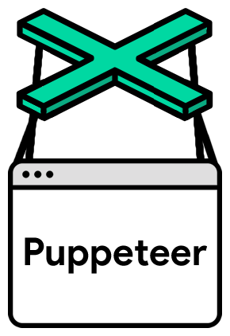Puppeteer is a Node.js library that allows testers to perform headless (no visible UI) browser testing of Google Chrome. Puppeteer testing allows the tester to perform actions such as clicking links, filling out forms, and submitting buttons using JavaScript commands. It also offers high-level APIs for performing automated tests, developing and debugging website features, inspecting elements on a page, and profiling performance.

# **Step 1. Install Node.js**

To install Node.js, go to the official Node.js website - [here](https://nodejs.org/en) and download the latest version or the previous version of Node.js according to your operating system (Windows, Linux / Unix, Mac and OS X) you are going to use:

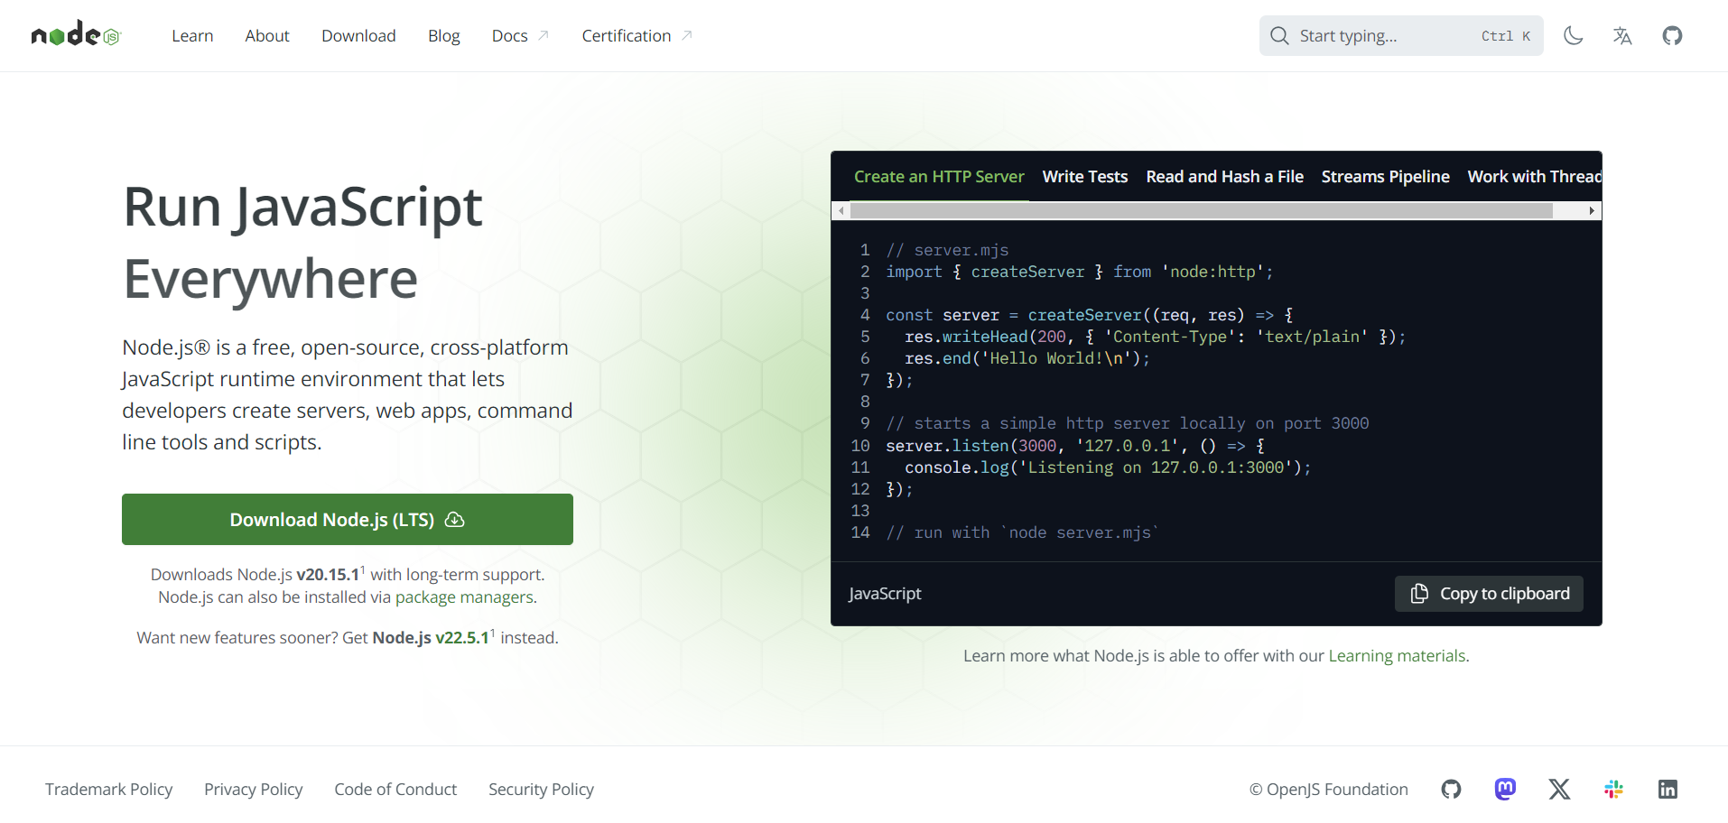

# **Step 2. Create project structure**

Create a new project using the npm init command to initialize a new project, or switch to an existing one.

# **Step 3. Install Puppeteer**

npm i puppeteer

# **Step 4. Create tests**

First, create a new file test.js:

import the Puppeteer library in your script:

const puppeteer = require("puppeteer");