Dianne A. Deiparine  
100217

Analysis of Priority Scheduling Algorithm on the Basis of FCFS & SJF for Similar Priority Jobs Review

In a single-processor system, only one process can run at a time. Others must wait until the CPU is free and can be rescheduled. The objective of multiprogramming is to have some process running at all times to maximize CPU utilization. CPU scheduling is the basis of multiprogrammed operating systems [1]. With this being stated, there also exists a Scheduling Criteria to help choose which Scheduling Algorithm to use to ensure the overall quality of running processes. These are: (a) maximize CPU utilization, i.e. the rate at which the CPU is kept as busy as possible; (b) maximize throughput, i.e. the number of processes completed per unit time; (c) minimize turnaround time, i.e. the interval from the time of submission of a process to the time of completion; (d) minimize waiting time, i.e. the sum of the periods spent waiting in the ready queue; and (e) minimize response time, i.e. the time from the submission of a request until the first response is produced[2]. There are different existing scheduling algorithms that are used to match these criteria and also in order to enhance and maximize the performance of the CPU such as FCFS(First Come First Serve), SJF(Shortest Job First), SRPT(Shortest Remaining Processing Time), RR(Round Robin), just to name a few.

*R. Khan and G. Kakhani*, “Analysis of Priority Scheduling Algorithm on the Basis of FCFS & SJF for Similar Priority Jobs”, 2015[3], proposed a new CPU Scheduling Algorithm, SJF based Priority Scheduling Algorithm. Existing FCFS based Priority Scheduling Algorithm and the proposed algorithm’s performance were compared in terms of their average waiting time and average turnaround time.

By definition, FCFS Scheduling Algorithm executes jobs that arrived at the ready queue first, giving priority to earlier jobs but may result to a large fluctuation on the turnaround time. SJF Scheduling Algorithm gives higher priority to shorter jobs. It attempts to minimize average response time through selecting jobs with the shortest execution time or shortest burst time [4]. Priority Scheduling Algorithms sets or assigns a priority to each process. Higher priority processes or jobs are executed first [3].

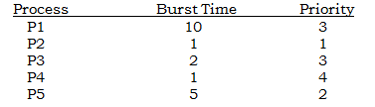The implementation of the existing FCFS based Priority Scheduling Algorithm is defined as a Priority Scheduling Algorithm which executes a job with the highest priority. But if there are jobs given the same level of priority, FCFS algorithm is performed to determine which job to execute first. SJF based Priority Scheduling is still defined as a Priority Scheduling Algorithm but instead of using FCFS in determining which job to execute first given the same level of priority, SJF will be performed, i.e. the job with the lowest burst time among jobs with the same level of priority will be executed first. This proposed algorithm has been implemented and results show reduced figures with regards to the average waiting time and average turnaround time of the tested cases. Below is a sample problem given a set of processes, length of CPU burst time and priority. (Problem adapted from Problem Set 3 given in class)

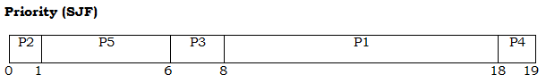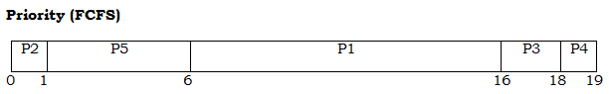

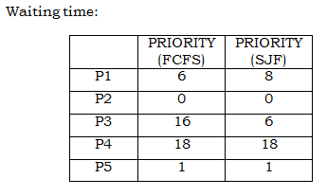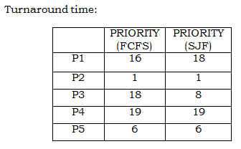

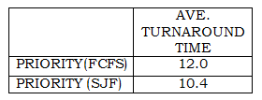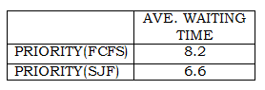

Given 5 processes, turnaround time and waiting time is computed for both FCFS based Priority Scheduling Algorithm and SJF based priority Scheduling Algorithm. It is evident that both the average turnaround time and average waiting time were reduced when SJF based Priority Scheduling Algorithm was implemented. However, we should always remember that scheduling algorithms are ways to better implement processes and meet certain criteria but in fact, still have their own desirable and undesirable features. The proposals of new scheduling algorithms are proofs that there is a desire to discover new implementations that can enhance process management.

References:

[1] Abraham Silberschatz, Peter Baer Galvin, Greg Gagne, *“Operating System Concepts”*, 9th Edition, John Wiley & Sons Inc., 2013.

[2] Sean Monemi, *“Introduction to Operating Systems”*, CS 499: Special Topics in Cyber Security, pp. 57-59.

[3] Rukhsar Khan et al, *“Analysis of Priority Scheduling Algorithm on the Basis of FCFS & SJF for Similar Priority Jobs”*, International Journal of Computer Science and Mobile Computing, Vol.4, Issue 9, pp. 324-331, September 2015.

[4] Paula Esplanada-Mayol, *“Processor Management”*, CMSC 125 Lecture Notes, pp. 75-77, 2017.