Adding Two Numbers

•Pseudocode•

BEGIN

NUMBER s1, s2, sum

OUTPUT("Input number1:")

INPUT s1

OUTPUT("Input number2:")

INPUT s2

sum=s1+s2

OUTPUT sum

END

Area of a Circle

•Pseudocode•

BEGIN

NUMBER r, area

INPUT r

area=3.14*r*r

OUTPUT area

END

A Program that will identify if a number is ODD or EVEN.

**a. Procedure**

Step 1: Start

Step 2: Read: Number

Step 3: Check: If Number%2 == 0 Then

Print : N is an Even Number.

Else

Print : N is an Odd Number.

Step 4: Stop

**b. Flowchart**

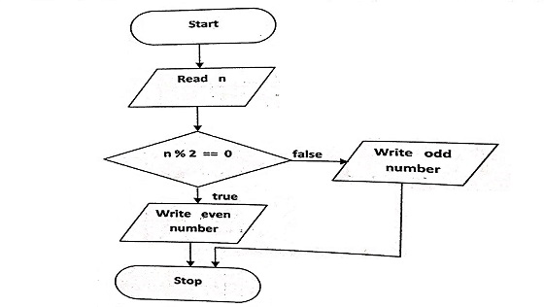

**c. Pseudo-code**

for n in range(1,11):

if (n% 2 == 0):

print n, "is an even number."

else:

print n, "is an odd number."