M1. Adding two numbers

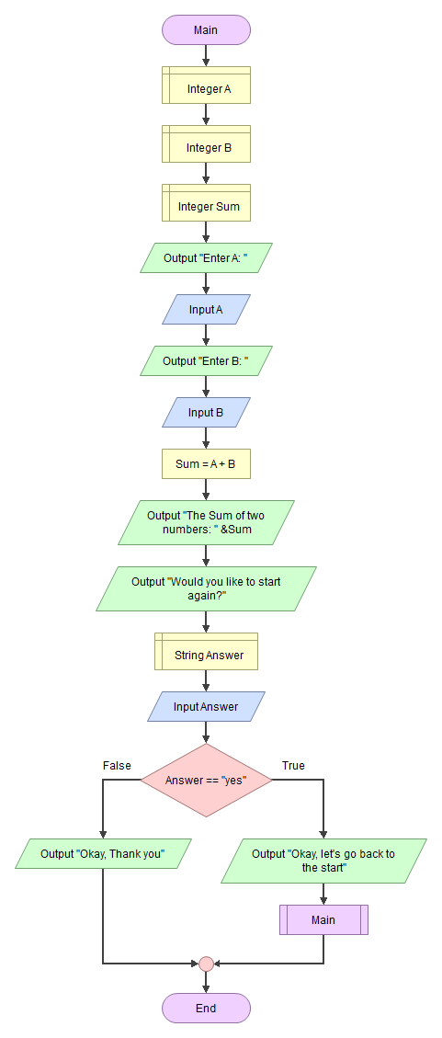

M2. Getting the Area of a Circle using Radius or Diameter

