Results

## General descriptives

As a response to our recruitment call, 1141 researchers signed up to participate in our study. Out of these volunteers, 459 signed up to analyse at least one dataset and submitted their work by the deadline or an extended deadline.

Throughout the project, 509 re-analyses have been submitted. This number is higher than the number of co-analysts as some co-analysts volunteered to analyse more than one dataset.

Out of the submitted analyses 1 of them was omitted from the summary analysis as its analysis failed the peer evaluation and an additional 4 analyses were excluded due to incomplete responses.

As a result, we ended up with 504 re-analyses, submitted by 457 co-analysts.

Although we invited more than 5 co-analysts to each of the 100 studies, due to drop-outs and peer evaluation exclusions the final number of completed analyses ranged between 3 and 7. Table 1 shows the distribution of of the number of analyses for individual studies.

**Table 1. The Distribution of the Number of Analyses for Studies**

| Number of Completed Analyses | Number of Studies |
| --- | --- |
| 3 | 1 |
| 4 | 13 |
| 5 | 69 |
| 6 | 15 |
| 7 | 2 |

## Basic demographics of the co-analysts

Out of all the co-analysts who submitted their work by the deadline, there were 23 professors, 41 associate professors, 105 assistant professors, 107 post-doctoral researchers, 122 doctoral students, 59 from other academic/research positions.

The gender distribution of the co-analysts is as follows: 117 female, 332 male, 1 other, and 7 didn’t want to respond to this question.

The age distribution of the co-analysts is depicted in Figure 1. 375 young adults (-39 years); 81 middle-aged adults (40-59 years); and no old adults (60- years).

|  |
| --- |
| Figure 1: The figure shows the distribution of the analysts’ age. When an analyst submitted more than one re-analysis with more than a year apart, we kept only their age at the time of their first submission. Moreover, one analyst is excluded because they did not disclose their age. |

Regarding the highest level of education, 1 co-analyst reported High-school diploma or equivalent, 18 co-analysts had Bachelor’s degree or equivalent, 135 Master’s degree or equivalent, 303 had Doctoral degree or equivalent. In case the analysts completed more than one re-analysis and they advanced in their studies by the time of their second analysis, we kept only their first response for this comparison.

The country of residence of the co-analysts is shown on the map on Figure 2. Regarding the continents, 1 co-analyst was from Africa, 27 were from Asia, 15 from Oceania, 296 from Europe, 112 from North America, 6 from South America.

|  |
| --- |
| Figure 2: The figure shows the analysts’ country of residence. When an analyst submitted more than one re-analysis and they moved between the submissions, we only kept their first response. |

We asked the co-analysts which discipline is the closest to their research area. The following Table 2 summarizes the distribution of their disciplinary orientation. Co-analysts from Psychology and Economics disciplines participated in the highest ratio in this study.

**Table 2. The Distribution of Co-analysts’ Disciplinary Orientation**

| Discipline | Count | Percentage |
| --- | --- | --- |
| Psychology | 264 | 57.77 |
| Economics | 74 | 16.19 |
| Political Science | 34 | 7.44 |
| Business Studies | 27 | 5.91 |
| Sociology | 19 | 4.16 |
| Computer Science/Statistics/Data Science | 16 | 3.50 |
| Public Policy | 3 | 0.66 |
| Anthropology | 1 | 0.22 |
| International Relations | 1 | 0.22 |
| Other | 18 | 3.94 |
| Note: Whenever the respondents provided more than one field we only kept their first responses. | | |

The distribution of the years of experience with data analysis is depicted on Figure 3. The median time of experience with data analysis was 8 years among our co-analysts.

|  |
| --- |
| Figure 3: The figure shows the analysts’ years of experience with data analysis. When an analyst submitted more than one re-analysis and a year passed between the responses we only kept their first response. |

We asked our co-analysts how regularly they perform data analysis. Figure 4 shows that the most frequent category was 2-3 times a week.

|  |
| --- |
| Figure 4: The figure shows how regularly the analysts perform data analysis. |

We also asked them how they rated their level of expertise in data analysis between Beginner (1) and Expert (10). The distribution on Figure 5 shows that the most prevalent answer was 8 .

|  |
| --- |
| Figure 5: The figure shows the analysts’ self-rated level of expertise in data analysis. When an analyst submitted more than one re-analysis we only kept their first response. |

In 8.13 % (41 out of 504) of the cases, the co-analysts were familiar with the paper that the provided dataset belongs to before beginning their work on the project.

All co-analyst reported that they have not communicated about the details of their analysis with other co-analysts working with the same dataset.

We asked the co-analysts what programming language/software/tool they used in their data analysis during Task 1 and Task 2. The following figure indicates that R (62.53%), STATA (16.86%), and SPSS (7.02%) were the most popular responses. Figure 6 shows the distribution of these responses.

|  |
| --- |
| Figure 6: The figure shows which software the analysts used for their re-analysis tasks. In case an analyst completed multiple re-analyses or reported the use of multiple software we kept all their responses for this figure. The figure shows only software that was used by more than 1% of the analysts. |

## Descriptives of the statistical analyses

A difference in Task 2 compared to Task 1 was that the co-analysts received some constraints for their analysis to make their result comparable to a single result in the original study (see Methods for more details).

In Task 2, when we asked the co-analysts to present one main statistical result, in 97.62% of the analyses (492 out of 504), conclusion was based on the p-value. Bayes Factor was used in 2.38% of the cases (12 out of 504).

For 47.82 % (241 out of 504) of the analyses, the co-analysts reported having to make additional calculations in Task 2 compared to Task 1. In the remaining 52.18% (263 out of 504) of the cases, the co-analysts indicated that despite the requirements of the instructions, they could conduct the same analyses as in Task 1.

In Task 2, 12.7% of the results (64 out of 504) were in the opposite direction as claimed by the original study, disregarding whether the effect was conclusive/significant.

The co-analysts were asked to estimate the time they spent performing Task 1 and Task 2 together. The median value of their response is 6 hours (Figure 7).

|  |
| --- |
| Figure 7: The figure shows the reported total hours the analyst spent on Task 1 and Task 2 together. In case an analyst completed multiple re-analyses, we kept all their responses for this figure. One response was excluded due to being an outlier (999 hours). |

In Task 2 91% of the co-analyst used unique analytical pipelines based on the statistical test family and the value of the test statistics they arrived at. In total 82% of the papers had completely unique reanalysis attempts.

## Peer evaluation

### Peer evaluators

#### Basic demographics of the peer evaluators

Figure 8 shows that most peer evaluators have many years of experience with conducting statistical analysis.

|  |
| --- |
| Figure 8: The figure shows the peer evaluators’ years of experience with data analysis. When a peer evaluator submitted more than one evaluation and a year passed between the responses, we kept only their first response. |

Figure 9 indicates that peer evaluators regularly perform data analysis.

|  |
| --- |
| Figure 9: The figure shows how regularly the peer evaluators perform data analysis. |

Figure 10 indicates that most peer evaluators rate themselves close to expert level in data analysis.

|  |
| --- |
| Figure 10: The figure shows the peer evaluators’ self-rated level of expertise in data analysis. When a peer evaluator submitted more than one re-analysis, we kept only their first response. |

### Peer evaluations

#### Descriptives of peer evaluations

In total, we received 490 peer evaluation reports. One peer evaluation was removed because the ID of the analyst was not provided, and as such, we could not verify with certainty which re-analysis was being evaluated leaving us with a total of 489 peer evaluation reports on 73 different papers. After the panel member review of the peer evaluations (see Peer Evaluation: Review and Decisions’ supplement for all decisions and reasoning behind each case), the final result of the peer evaluation was the following.

At the end of the peer evaluation process, one analysis was deemed to contain an unacceptable analysis pipeline. Therefore, we removed this single analysis from our results. For the remaining analyses, it was determined that all Task 1 and Task 2 analysis pipelines were acceptable. Furthermore, all remaining Task 1 conclusions were considered to accurately follow on from the results, and the analysts self-categorization of the results were considered adequate.

204 analytical reproducibility checks were successfully conducted which identified mismatches in 19 analyses. In all of these cases we verified that that the mismatches did not have a meaningful impact on the reported conclusion, categorization, or effect size.

## Inferential robustness: The robust of the conclusions to analytical choices published in social sciences

Do different analysts arrive at the same conclusions as the analysts of the original study?

### Task 1 Survey results

In Task 1, the co-analysts were asked to conduct any statistical analysis to arrive at a single conclusion. Out of 100 re-analysed studies, the conclusions of 34% (34) remained robust to independent re-analysis, so all assigned co-analysts arrived at the same conclusion as reported in the article of the original study (inferential robustness; see Figure 11). With alternative definitions of analytical robustness, this value was 57% when 80% and 80% when 60% reanalysis agreement with the original conclusion defined analytical robustness. For one study (1%), all co-analysts reported no effect or an inconclusive conclusion.

|  |
| --- |
| Figure 11: The figure shows the proportion of the inferentially robust and not robust studies. |

Figure 12 shows the histogram display of the different and identical conclusions resulting from the re-analysis of each of the studies.

|  |
| --- |
| Figure 12: The figure shows the percentage of identical, inconclusive, and different conclusions for each study. Study numbers correspond to studies listed in Table S1. |

Across all the re-analyses, 73.61 % (371 out of 504) of them arrived at the same conclusion; 24.21% (122 out of 504) to no effects, and 2.18% (11 out of 504) to opposite effect compared to the original conclusion.

#### Inferential robustness by discipline

We were interested to see whether the above results show a different pattern when inspecting them in different disciplines. Figure 13 shows that for the fields with more than 10 studies in our collection (Economics, Political Science, and Psychology) the pattern was comparably similar. We found no outstanding differences between the discipline regarding the percentage of different and identical conclusions either (see Figure 14).

|  |
| --- |
| Figure 13: The figure shows the inferential robustness of the studies by major disciplines (more than 10 studies in our collection). |

|  |
| --- |
| Figure 14: The figure shows the percentage of identical, inconclusive, and different conclusions of the studies by major disciplines. The figure displays the count of re-analyses next to each discipline name. |

#### Inferential robustness by study type (observational, experimental)

Here, we were interested to see whether these results show a different pattern when separating them by study type. Figure 15 illustrates that nearly half of the results from experimental studies remained robust upon independent re-analysis, whereas only one-third of observational studies yielded robust conclusions. Moreover, Figure 16 indicates that, for both study types, the majority of the re-analyses reached the same conclusions as the original study.

|  |
| --- |
| Figure 15: The figure shows the inferential robustness of the studies by study type (experimental or observational). The figure displays the count of re-analyses next to each study type name. |

|  |
| --- |
| Figure 16: The figure shows percentage of same conclusion, no effect/inconclusive, and opposite effect of the re-analyses by study type (experimental, observational). |

#### Inferential robustness by expertise (self-reported expertise in data analysis)

Here, we were interested to see whether these results show a different pattern when inspecting them along the reported expertise of the co-analysts. Figure 17 shows these results.

|  |
| --- |
| Figure 17: The figure shows the percentage of same conclusion, no effect/inconclusive, and opposite effect of the re-analyses by self-rated expertise (on a scale of 1 (Beginner) to 10 (Expert)). The figure does not display the bottom two categories where fewer than 3 responses were collected for each. |

#### Inferential robustness by peer evaluations

Figure 18 shows the inferential robustness of the studies by the acceptability of the analysis pipelines according to the peer evaluators.

|  |
| --- |
| Figure 18: The figure shows the inferential robustness of the studies by the acceptability of the analysis pipelines according to the peer evaluators. For this figure we only included studies with more than one peer evaluation and where the peer evaluators agreed on their rating. The figure shows only the studies with a medium and high quality of analysis pipelines. |

#### Inferential robustness by prior familiarity with the dataset

Here, we were interested to see whether these results show a different pattern when inspecting them along their prior familiarity with the dataset. Figure 19 shows that for these results.

|  |
| --- |
| Figure 19: The figure shows the percentage of same conclusion, no effect/inconclusive, and opposite effect of the re-analyses by declared familiarity with the study. |

#### Inferential robustness by the level of confidence with the suitability of the analysis

The following Table 3 shows the percentage of same conclusion, no effect/inconclusive, and opposite effect of the re-analyses by the analyst’s level of confidence with the suitability of the analysis.

**Table 3. Inferential Robustness by the Level of Confidence with the Suitability of the Analysis**

| Confidence rating | Direction of the conclusion | Count | Percentage |
| --- | --- | --- | --- |
| 1 Not confident at all | Same conclusion | 1 / 3 | 33% |
| 1 Not confident at all | No effect/inconclusive | 2 / 3 | 67% |
| 1 Not confident at all | Opposite effect | 0 / 3 | 0% |
| 2 | Same conclusion | 11 / 15 | 73% |
| 2 | No effect/inconclusive | 4 / 15 | 27% |
| 2 | Opposite effect | 0 / 15 | 0% |
| 3 | Same conclusion | 43 / 81 | 53% |
| 3 | No effect/inconclusive | 35 / 81 | 43% |
| 3 | Opposite effect | 3 / 81 | 4% |
| 4 | Same conclusion | 165 / 228 | 72% |
| 4 | No effect/inconclusive | 57 / 228 | 25% |
| 4 | Opposite effect | 6 / 228 | 3% |
| 5 Very confident | Same conclusion | 151 / 177 | 85% |
| 5 Very confident | No effect/inconclusive | 24 / 177 | 14% |
| 5 Very confident | Opposite effect | 2 / 177 | 1% |

#### Inferential robustness by the sample size

Here, in Figure 20 we were interested to see whether these results show a different pattern when considering sample size.

[1] 446

[1] 345

|  |
| --- |
| Figure 20: This raincloud figure shows the distribution of the sample sizes of the re-analyses resulting in same conclusion, no effect/inconclusive, and opposite effects. |

#### Estimate robustness: robust of the statistical findings published in social sciences to analytical choices

A main question of our study was whether different analysts arrive at the same effect estimates (+/- 0.05 Cohen’s d) as the analyst of the original study? Figure 21 shows percentages of the effect sizes falling within the preset tolerance range (+/- 0.05 Cohen’s d) for each study. The figure displays 447 re-analysis effect size estimates. For 57 re-analyses, the reported effect size was not convertible to Cohen’s d. The figure does not show 5 re-analysed effect sizes which are higher than 5 or lower than -5 Cohen’s d (study 042: 13.147; study 026: 12.055; study 053: 60.578; study 029: 6.835; study 057: 37.234). For the 7 studies listed in the bottom of the graph, we could not determine the original effect size due to missing information.

|  |
| --- |
| Figure 21: The figure shows the effect size of the original result (black square) and the effect sizes of the re-analyses (green dot) for each study after conversions to Cohen’s d. Study numbers correspond to studies listed in Table S1. |

# Based on: https://github.com/CenterForOpenScience/rpp  
colors <- c("Original" = "#440154FF", "Replication" = "#FDE725FF")  
  
effec_size_corr_plot_data <-  
 reanalysis_data |>  
 dplyr::filter(!is.na(effect_size)) |>  
 dplyr::filter(effect_size <= 5 & effect_size >= -5) |>  
 dplyr::filter(original_cohens_d != -Inf)  
  
# Median  
round(median(effec_size_corr_plot_data$effect_size), 2)

[1] 0.34

round(median(effec_size_corr_plot_data$original_cohens_d), 2)

[1] 0.43

# Mean  
round(mean(effec_size_corr_plot_data$effect_size), 2)

[1] 0.48

round(mean(effec_size_corr_plot_data$original_cohens_d), 2)

[1] 0.72

scatter <-  
 effec_size_corr_plot_data |>   
 ggplot(aes(x = original_cohens_d, y = effect_size, color = as.factor(colors))) +  
 geom_point(color = "Grey30",  
 shape = 21,  
 alpha = .8) +  
 geom_smooth(  
 method = "lm",  
 se = FALSE,  
 color = "black",  
 alpha = 0.2  
 ) +  
 geom_rug(  
 aes(color = "Original"),  
 size = 1,  
 sides = "b",  
 alpha = .6  
 ) +  
 geom_rug(  
 aes(color = "Replication"),  
 size = 1,  
 sides = "l",  
 alpha = .6  
 ) +  
 scale_color_manual(values = colors) +   
 geom_hline(aes(yintercept = 0), linetype = 2) +  
 geom_abline(intercept = 0,  
 slope = 1,  
 color = "Grey60") +  
 scale_x_continuous(  
 limits = c(0, 5),  
 breaks = c(0, .5, 1, 1.5, 2, 2.5, 3, 3.5, 4, 4.5, 5)  
 ) +  
 scale_y_continuous(  
 limits = c(-5, 5),  
 breaks = c(-5, -4.5, -4, -3.5, -3, -2.5, -2, -1.5, -1, -0.5, 0, .5, 1, 1.5, 2, 2.5, 3, 3.5, 4, 4.5, 5)  
 ) +  
 labs(  
 x = "Original effect size in Cohen's d",  
 y = "Reanalysis effect size in Cohen's d"  
 ) +  
 theme(  
 panel.background = element_blank(),  
 panel.grid = element_blank(),  
 axis.line = element_line(color = "black"),  
 legend.position = "none",  
 axis.title = element_text(size = 25),  
 axis.text = element_text(size = 20)  
 )  
  
# Add reference lines for alignment checking  
# x_dense <- x_dense + geom_vline(xintercept = c(0, 2.5, 5), linetype = "dashed", color = "red")  
# y_dense <- y_dense + geom_vline(xintercept = c(-5, 0, 5), linetype = "dashed", color = "blue") + coord_flip()  
# scatter <- scatter + geom_vline(xintercept = c(0, 2.5, 5), linetype = "dashed", color = "red") +  
# geom_hline(yintercept = c(-5, 0, 5), linetype = "dashed", color = "blue")  
  
effec_size_corr_plot <- ggExtra::ggMarginal(scatter, type = "density", margins = "both", xparams = list(fill = colors["Original"], alpha = 0.5), yparams = list(fill = colors["Replication"], alpha = 0.5))

`geom_smooth()` using formula = 'y ~ x'  
`geom_smooth()` using formula = 'y ~ x'

scatter_zoomed <-  
 effec_size_corr_plot_data |>   
 dplyr::filter(effect_size <= 1 & effect_size >= -1) |>  
 dplyr::filter(original_cohens_d <= 1 & original_cohens_d >= -1) |>   
 ggplot(aes(x = original_cohens_d, y = effect_size, color = as.factor(colors))) +  
 geom_point(color = "Grey30",  
 shape = 21,  
 alpha = .8) +  
 geom_smooth(  
 method = "lm",  
 se = FALSE,  
 color = "black",  
 alpha = 0.2  
 ) +  
 geom_rug(  
 aes(color = "Original"),  
 size = 1,  
 sides = "b",  
 alpha = .6  
 ) +  
 geom_rug(  
 aes(color = "Replication"),  
 size = 1,  
 sides = "l",  
 alpha = .6  
 ) +  
 scale_color_manual(values = colors) +   
 geom_hline(aes(yintercept = 0), linetype = 2) +  
 geom_abline(intercept = 0,  
 slope = 1,  
 color = "Grey60") +  
 scale_x_continuous(  
 limits = c(0, 1),  
 breaks = c(0, .5, 1)  
 ) +  
 scale_y_continuous(  
 limits = c(-1, 1),  
 breaks = c(-1, -0.5, 0, .5, 1)  
 ) +  
 labs(  
 x = "Original effect size in Cohen's d",  
 y = "Reanalysis effect size in Cohen's d"  
 ) +  
 theme(  
 panel.background = element_blank(),  
 panel.grid = element_blank(),  
 axis.line = element_line(color = "black"),  
 legend.position = "none",  
 axis.title = element_text(size = 25),  
 axis.text = element_text(size = 20)  
 )  
  
effec_size_corr_plot_zoomed <- ggExtra::ggMarginal(scatter_zoomed, type = "density", margins = "both", xparams = list(fill = colors["Original"], alpha = 0.5), yparams = list(fill = colors["Replication"], alpha = 0.5))

`geom_smooth()` using formula = 'y ~ x'  
`geom_smooth()` using formula = 'y ~ x'

# Save plot  
ggplot2::ggsave(here::here("figures/effec_size_corr_plot.jpg"), plot = effec_size_corr_plot,  
 width = 13, height = 10,  
 dpi = 300)  
  
ggplot2::ggsave(here::here("figures/effec_size_corr_plot_zoomed.jpg"), plot = effec_size_corr_plot_zoomed,  
 width = 13, height = 10,  
 dpi = 300)  
  
effec_size_corr_plot  
  
effec_size_corr_plot_zoomed

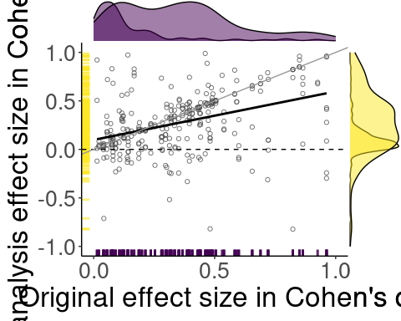

We found that 96% (89 out of 93) of the studies contained at least one re-analysis result where the effect size was beyond the tolerance region (+/- 0.05 Cohen’s d) of the result of the original study (Figure 22). Out of the 417 available reanalysis effect sizes 68.59% (286) were outside of the tolerance region.

|  |
| --- |
| Figure 22: The figure shows percentages of the effect sizes falling within the preset tolerance range (+/- 0.05 Cohen’s d) for each study. Study numbers correspond to studies listed in Table S1. |

To investigate the robustness of our tolerance region threshold we calculated the proportion of reanalysis effect size estimates within the tolerance region for a range of thresholds between 0.05 and 0.1.

thresholds <- seq(0.01, 0.2, by = 0.001)  
  
threshold_robustness_plot_data <- map_df(thresholds, ~ calculate_tolerance_region_proportions(processed, threshold = .x, weight = NULL))  
  
threshold_robustness_plot_data <-  
 threshold_robustness_plot_data |>   
 dplyr::mutate(  
 tolerance_region = threshold * 2  
 ) |>   
 pivot_longer(  
 cols = c(analysis_percentage, paper_percentage),  
 names_to = "type",  
 values_to = "value",  
 names_prefix = "_percentage"  
 ) |>   
 dplyr::mutate(  
 type = stringr::str_replace(type, "_percentage", ""),  
 type = dplyr::case_when(  
 type == "analysis" ~ "Re-analysis effect sizes",  
 type == "paper" ~ "Studies"  
 )  
 )

threshold_robustness_plot <-  
 threshold_robustness_plot_data |>   
 ggplot() +  
 aes(  
 x = tolerance_region,  
 y = value,  
 linetype = type  
 ) +  
 geom_vline(xintercept = 0.1, color = "#440154FF", linetype = "dashed") +  
 geom_line() +  
 scale_x_continuous(breaks = c(0.01, seq(0.05, 0.2, by = 0.05)) * 2, expand = c(0.05, 0)) +  
 scale_y_continuous(labels = scales::percent_format(scale = 1), breaks = seq(0, 100, 10), limits = c(0, 100)) +  
 viridis::scale_fill_viridis(discrete = TRUE) +  
 labs(  
 x = "Width of the Cohen's d tolerance region",  
 y = "Percentage within the tolerance region",  
 linetype = "Percentage of"  
 ) +  
 ggplot2::theme(  
 panel.background = element_blank(),  
 panel.grid = element_blank(),  
 axis.line = element_line(color = "black"),  
 legend.position = c(0.8, 0.8)  
 )

Warning: A numeric `legend.position` argument in `theme()` was deprecated in ggplot2  
3.5.0.  
ℹ Please use the `legend.position.inside` argument of `theme()` instead.

ggplot2::ggsave(here::here("figures/threshold_robustness_plot.jpg"), threshold_robustness_plot, height = 4, dpi = 300)

Saving 5 x 4 in image

threshold_robustness_plot

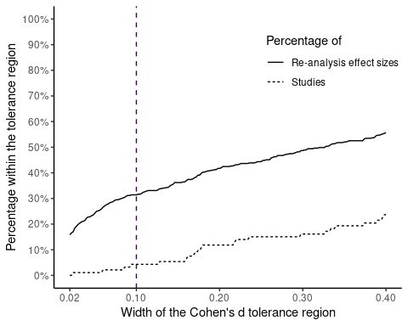

weights <- seq(0.05, 0.2, by = 0.001)  
  
threshold_weighted_robustness_plot_data <- map_df(weights, ~ calculate_tolerance_region_proportions(processed, threshold = NULL, weight = .x))  
  
threshold_weighted_robustness_plot_data <-  
 threshold_weighted_robustness_plot_data |>   
 pivot_longer(  
 cols = c(analysis_percentage, paper_percentage),  
 names_to = "type",  
 values_to = "value",  
 names_prefix = "_percentage"  
 ) |>   
 dplyr::mutate(  
 type = stringr::str_replace(type, "_percentage", ""),  
 type = dplyr::case_when(  
 type == "analysis" ~ "Re-analysis effect sizes",  
 type == "paper" ~ "Studies"  
 )  
 )

threshold_weighted_robustness_plot <-  
 threshold_weighted_robustness_plot_data |>   
 ggplot() +  
 aes(  
 x = weight,  
 y = value,  
 linetype = type  
 ) +  
 geom_line() +  
 scale_x_continuous(breaks = seq(0.05, 0.2, by = 0.05), labels = scales::percent_format(scale = 100), expand = c(0.05, 0)) +  
 scale_y_continuous(labels = scales::percent_format(scale = 1), breaks = seq(0, 100, 10), limits = c(0, 100)) +  
 viridis::scale_fill_viridis(discrete = TRUE) +  
 labs(  
 x = "Percentage of original study's Cohen's d used\nto calculate tolerance region",  
 y = "Percentage within the tolerance region",  
 linetype = "Percentage of"  
 ) +  
 ggplot2::theme(  
 panel.background = element_blank(),  
 panel.grid = element_blank(),  
 axis.line = element_line(color = "black"),  
 legend.position = c(0.8, 0.8)  
 )  
  
ggplot2::ggsave(here::here("figures/threshold_weighted_robustness_plot.jpg"), threshold_weighted_robustness_plot, height = 4, dpi = 300)

Saving 5 x 4 in image

threshold_weighted_robustness_plot

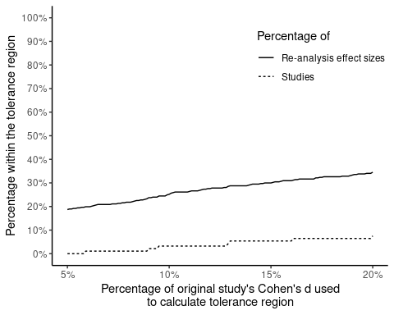

##### Estimate robustness by discipline

We were interested to see whether these robustness results show a different pattern when inspecting separately by the disciplines of the studies. Figure 23 and Figure 24 show that for the major disciplines (>=10 studies).

|  |
| --- |
| Figure 23: The figure shows the percentage of re-analysis results falling within or outside of the tolerance region of the original results of the studies by major disciplines. The figure displays the count of re-analyses next to each discipline name. |

|  |
| --- |
| Figure 24: This raincloud figure shows for each major discipline the distributions of effect size estimate ranges (lowest to highest) calculated per study. |

##### Estimate robustness by study design (observational, experimental)

Here (Figure 25 and Figure 26), we were interested to see whether these results show a different pattern when separating them by study type.

|  |
| --- |
| Figure 25: The figure shows the percentage of re-analysis results falling within or outside of the tolerance region of the original results of the studies by study type. The figure displays the count of re-analyses next to each discipline name. |

|  |
| --- |
| Figure 26: This raincloud figure shows for each study type the distribution of effect size estimate ranges (lowest to highest) calculated per study. |

##### Estimate robustness by expertise

Here (Figure 27), we were interested to see whether these results show a different pattern when inspecting them along the reported expertise of the co-analysts.

|  |
| --- |
| Figure 27: The figure shows the percentage of re-analysis results falling within or outside of the tolerance region of the original results of the studies by self-rated expertise (on a scale of 1 (Beginner) to 10 (Expert)). |

##### Estimate robustness by prior familiarity with the dataset

Here, we were interested to see whether these results show a different pattern when inspecting them along their prior familiarity with the dataset. Figure 28 shows that for these results.

|  |
| --- |
| Figure 28: The figure shows the percentage of re-analysis results falling within or outside of the tolerance region of the original results of the studies by declared familiarity with the study. |

##### Estimate robustness by the level of confidence with the suitability of the analysis

Here (Table 4), we were interested to see whether these results show a different pattern when inspecting them along their level of confidence with the suitability of the analysis.

**Table 4. Estimate Robustness by the Level of Confidence with the Suitability of the Analysis**

| Confidence rating | Is the estimate within the tolerance region? | Count | Percentage |
| --- | --- | --- | --- |
| 1 Not confident at all | Yes | 2 / 3 | 66.67% |
| 1 Not confident at all | No | 1 / 3 | 33.33% |
| 2 | Yes | 5 / 13 | 38.46% |
| 2 | No | 8 / 13 | 61.54% |
| 3 | Yes | 14 / 68 | 20.59% |
| 3 | No | 54 / 68 | 79.41% |
| 4 | Yes | 51 / 192 | 26.56% |
| 4 | No | 141 / 192 | 73.44% |
| 5 Very confident | Yes | 59 / 141 | 41.84% |
| 5 Very confident | No | 82 / 141 | 58.16% |

##### Estimate robustness by the sample size

Here, we were interested to see whether these results show a different pattern when considering sample size. The following Figure 29 shows no remarkable differences between the two categories.

|  |
| --- |
| Figure 29: The figure shows the distribution of sample sizes separately for re-analysis effect sizes falling within or outside of the tolerance region of the original results. In this figure, we could not include those studies where the original effect sizes were missing, and cases where the re-analysis effect size or sample size were missing. |

df_region_data <-  
 processed |>  
 dplyr::select(  
 paper_id,  
 analyst_id,  
 reanalysis_degrees_of_freedom_1,  
 reanalysis_degrees_of_freedom_2,  
 original_cohens_d,  
 reanalysis_cohens_d  
 ) |>  
 dplyr::mutate(  
 reanalysis_degrees_of_freedom_1 = dplyr::case_when(  
 !is.na(reanalysis_degrees_of_freedom_2) ~ reanalysis_degrees_of_freedom_2,  
 is.na(reanalysis_degrees_of_freedom_2) ~ reanalysis_degrees_of_freedom_1  
 )  
 ) |>  
 dplyr::select(-reanalysis_degrees_of_freedom_2) |>  
 dplyr::filter(  
 !is.na(original_cohens_d),!is.na(reanalysis_cohens_d),!is.na(reanalysis_degrees_of_freedom_1)  
 ) |>  
 dplyr::mutate(  
 tolarence_region_lower = original_cohens_d - 0.05,  
 tolarence_region_upper = original_cohens_d + 0.05,  
 is_within_region = dplyr::case_when(  
 reanalysis_cohens_d <= tolarence_region_lower |  
 reanalysis_cohens_d >= tolarence_region_upper ~ "No",  
 reanalysis_cohens_d >= tolarence_region_lower |  
 reanalysis_cohens_d <= tolarence_region_upper ~ "Yes"  
 ),  
 is_within_region = factor(is_within_region, levels = c("Yes", "No"))  
 )  
  
  
df_region_plot <-  
 plot_rain(  
 data = df_region_data,  
 grouping_var = is_within_region,  
 response_var = reanalysis_degrees_of_freedom_1,  
 y_lab = "Log10 degrees of freedom",  
 x_lab = "Is the re-analysis effect size\nwithin the tolerance region?",  
 trans = "log10",  
 breaks = c(10, 100, 1000, 10000, 100000)  
 ) +  
 ggplot2::coord_flip() +  
 ggplot2::theme(  
 axis.title = element_text(size = 9)  
 )  
  
ggplot2::ggsave(here::here("figures/effect_region_df_plot.jpg"), df_region_plot, dpi = 300)

Saving 5 x 4 in image

df_region_plot

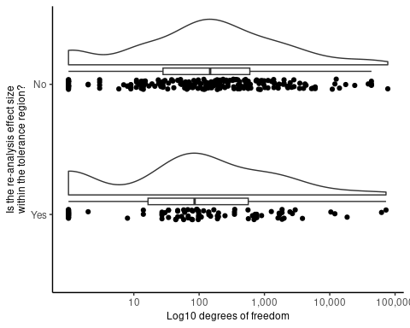

#### Additional analyses

While Cohen’s d has the advantage of being easily interpretable and comparable across different analyses, it was designed to compare the means of two groups and its calculation relies on assumptions that can be compromised in more complex designs. Following the conduct of the present project, Kümpel & Hoffmann (2022) proposed a formal definition of generalized marginal effects (gMEs) which measure is comparable across different statistical models. When standardized, the value of gMEs is equal to the value of Cohen’s d where the latter effect size measure is strictly applicable. Since we had not originally planned to calculate standardized gMEs, we did not collect all required analysis outputs to compute them. As a result, we calculated gMEs only for a sub-sample of the 100 studies. See Figure 30 for the results of the gME calculation for our sub-sample of studies.

|  |
| --- |
| Figure 30: For each original and re-analysis of papers 22, 40, 63, and 75, this figure shows a forest-density plot of non-standardized gME values as defined by Kümpel & Hoffmann (2022). Specifically, the black dots give the point estimates of the average change in target expectation attributed to the regressor of interest by each analysis, while the thicker and thinner lines visualize the 0.66 and 0.95 quantiles of the corresponding densities. Study numbers correspond to studies listed in Table S1. |

# Panel figures for Nature  
## Inferential robustness  
inferential_panel <- (  
 conclusion_main_plot +  
 (  
 conclusions_discipline_robustness_plot +  
 conclusions_discipline_plot +  
 conclusions_studytype_robustness_plot +  
 conclusions_studytype_plot +  
 conclusions_expertise_plot +  
 peer_eval_subset_task1_plot +  
 conclusions_familiarity_plot +  
 conclusions_samplesize_plot  
 )  
) +  
 plot_layout(widths = c(1, 3)) +   
 plot_annotation(tag_levels = 'a')  
  
  
inferential_panel

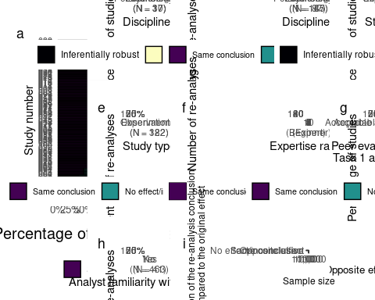

ggsave(here::here("figures/inferential_panel.png"), inferential_panel, width = 22, height = 14, dpi = 300)  
  
# Estimate robustness  
# effec_size_corr_plot_gg <- ggplotify::as.ggplot(effec_size_corr_plot) +  
# ggplot2::theme(plot.margin = margin(t = 0, r = 0, b = -2, l = 0, "cm"))  
# effec_size_corr_plot_gg  
main_section <-   
 effect_main_plot +  
 effect_region_all_plot +  
 plot_layout(widths = c(2, 1))  
  
# Define the remaining plots section  
small_plot_section <-  
 (  
 effect_region_discipline_plot |  
 effect_robustness_discipline_plot   
 ) /  
 ( effect_region_studytype_plot | effect_robustness_studytype_plot) /  
 (effect_region_expertise_plot |  
 effect_region_familiarity_plot | samplesize_region_plot) +  
 plot_layout(ncol = 1, nrow = 3)  
  
small_plot_section

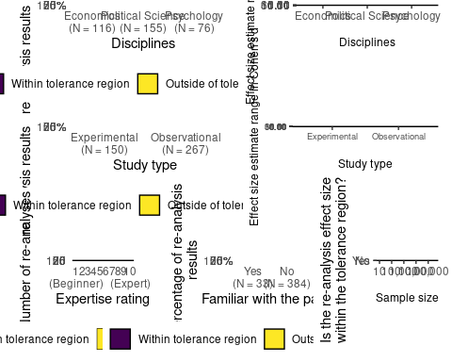

# Combine the main section and the remaining plots section  
estimate_panel <-  
 (main_section | small_plot_section) + plot_annotation(tag_levels = 'a')  
  
estimate_panel

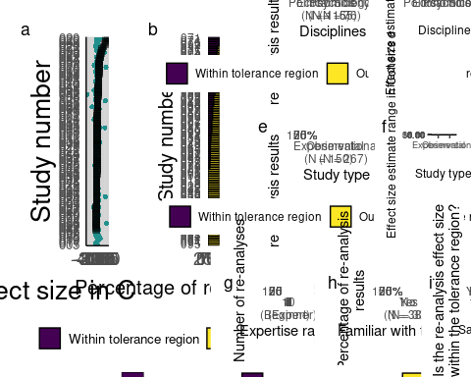

ggsave(here::here("figures/estimate_panel.png"), estimate_panel, width = 30, height = 14, dpi = 300)