# PHYS2020: Thermoelectric Effects

PHYS2020

# Preface

These are the laboratory notes for The University of Queensland’s PHYS2020 Thermoelectric Effects experiment.

These notes should be read before attending the lab to maximise time spent on completing your experiment.

# Introduction

The phenomena linking thermal energy transport and electrical currents within solid materials are known as the *thermoelectric effects*. You should already know that electrical currents in a wire follow *Ohm’s law* (Knight 2016)

### 𝐼 = 1 Δ𝑉 (1.1)

𝑅

where is the electrical current intensity, is the electrical resistance of a wire, and

𝐼 𝑅 > 0 Δ𝑉

is the potential difference between the endpoints of a wire. Consider a slab of a conducting materials as shown in Figure 1.1.

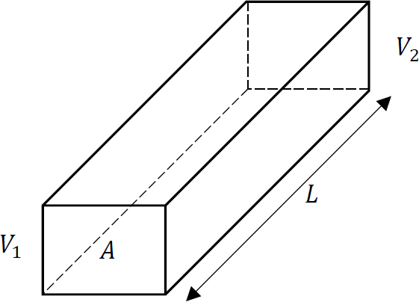

Figure 1.1: Figure 1: A slab with two ends held at different electrical potentials.

In this case the electrical current can be expressed as

### 𝐼 = 𝜎 𝐴Δ𝑉 (1.2)

𝐿

where is the surface area of the slab cross-section, L is its length, and is the electrical conductivity of the material. The electrical resistance of the slab can be obtained as follows

𝐴 𝜎

𝐿

𝑅 =

𝜎𝐴

(1.3)

A similar equation can be obtained for heat transport through the slab. If the two ends of the slab are kept at different temperatures, the heat flow 𝑄 (𝑊 ) is proportional to Δ𝑇 via(Segrè

2004)

### 𝑄 = 𝜅 𝐴Δ𝑇 (1.4)

𝐿

Where is the thermal conductivity ( −1 −1), and is the temperature difference. Note the electrons are the main carriers of heat and electrical transport in metals. These sim- ilarities hint that there should be a connection between electrical and thermal currents. This connection is summarised by the thermoelectric effects. This phenomena has been confirmed experimentally.

𝜅 > 0 𝑊 𝑚 𝐾 Δ𝑇

## History

In 1841, James Prescott Joule realised that an electric current has an inherent thermal effect, called the Joule effect (Martins 2022). Later in 1851, William Thomson realised that passing an electrical current through an unequally heated conductor released or absorbed heat depending on the direction of the heat and electrical currents and the type of material (Thomson 1856). The irreversible Joule effect is about two orders of magnitude larger than the reversible Thom- son effect, but both occur simultaneously while a current passes through a material (Macia 2015). These thermoelectric effects make up the backbone for how we got to heat engines and heat pumps from thermoelectric materials.

It was Thomas Johann Seebeck who first observed that if you connect three homogenous conductors connected in series, each at a different temperature, an electric current flows around the closed circuit (Engel and Reid 2013). The circuit is known as thermoelectric (TE) circuit. Hence, the *Seebeck effect* describes the conversion of thermal energy into electrical energy in the form of an electrical current.

The *Seebeck Voltage* Δ𝑉𝑆 of a TE circuit is proportional to the temperature difference of 𝑇𝐻

and 𝑇𝐶 (Macia 2015)

### Δ𝑉𝑠 = 𝑆Δ𝑇 (1.5)

where 𝑆(𝑇 ) is a temperature dependent property of the junction materials, with units 𝑉 𝐾−1.

Jean Charles Peltier reported that passing a current across a junction at thermal equilibrium caused it to absorb heat from the surroundings , while if you reversed the current the junction released heat to the environment (Segrè 2004). This *Peltier Effect* was illustrated nicely by Friedrich Emil Lenz in 1838, who placed a drop of water on the junction of bismuth and antimony wires (Macia 2015). When Lenz passed a current through the junction, the water froze; then when Lenz reversed the current, the ice melted. This was the first demonstration of TE refrigeration. The *Peltier Heat* is proportional to current 𝐼, duration Δ𝑡 of the current applied via

(Δ𝑄𝑃 < 0)

(Δ𝑄𝑃 < 0)

### Δ𝑄𝑃 = Π(𝑇 )𝐼Δ𝑡 (1.6)

Where Π(𝑇 ) is called the Peltier coeﬀicient (Engel and Reid 2013).

# Thermoelectric Devices

Thermoelectric devices are small, solid-state devices used in small-scale power generation and refrigeration applications. A thermal gradient generates an electric current (TE generator, TEG) or a DC current is applied to remove heat from the cold side (TE cooler, TEC). Ther- moelectric devices generally consist of a relative large number of thermocouples associated electrically in series and thermally in parallel.

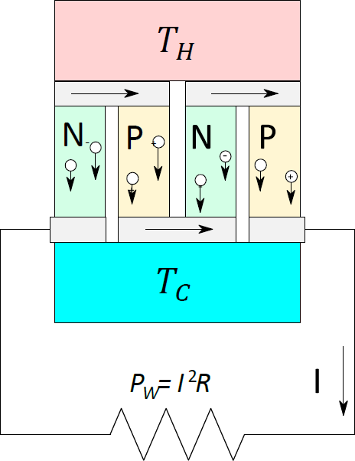

Figure 2.1: A thermoelectric generator made of two thermocouples

Where would you find TECs/TEGs in practice? What are the advantages of TE devices compared to other energy technologies? What are their drawbacks? Note: include your answer in the Introduction/Theory

Ď Question 1

A thermocouple is formed by a n-type and a p-type thermoelement (in what is a called a leg or branch). A n-type leg or branch has length 𝐿𝑛 and cross-section 𝐴𝑛. The two legs are connected by a conductor at the hot end (𝑇𝐻) that is assumed to have negligible electrical and thermal resistance. To close the circuit a load resistor, with a resistance 𝑅, is connected between the cold end of the thermoelements (𝑇𝐶).

𝑇𝐻 − 𝑇𝐶 ≡ Δ𝑇 > 0 Δ𝑉 =

The temperature difference generates the Seebeck Voltage

(𝑆𝑝 − 𝑆𝑛) Δ𝑇 𝑆𝑝 > 0 𝑆𝑛 < 0

at the hot junction, where and are the Seebeck coeﬀicients of the p-type and n-type thermoelements, respectively (Macia 2015; Engel and Reid 2013). The internal electrical resistance of the thermopile shown in Figure 2.1 is

𝐿

𝑟 = 2 ( 𝑛

+ 𝑝

𝜎𝑛𝐴𝑛

where 𝜎𝑛 and 𝜎𝑝 are the legs conductivities.

𝐿

𝜎𝑝𝐴𝑝

) (2.1)

Explain how Equation 2.1 has been derived. You need to recall connection of resistors in series and in parallel.

Ď Question 2

From an electrical point of view, a thermoelectric generator can be replaced with a voltage source and a resistor in series. Therefore, the entire device shown in Figure 2 is equivalent to the electric circuit shown in Figure 2.2.

The electrical current in the circuit is

### Δ𝑉

𝐼 = 𝑆

𝑟 + 𝑅

(2.2)

Explain how Equation 2.2 is obtained.

Ď Question 3

The power delivered to external load is given by

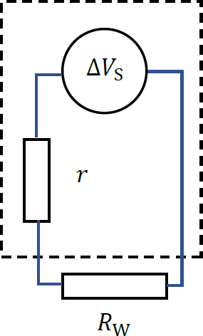

Figure 2.2: Equivalent electrical circuit for a thermoelectric generator.

𝑊 = Δ𝑉𝑆2𝑅2 (2.3)

(𝑟 + 𝑅)

This can also be written as

### 𝑊 = 𝐼Δ𝑉𝑆 − 𝑟𝐼2 (2.4)

where the first term can be interpreted as the electric power due to the Seebeck effect, and the second term is the power lost by Joule heating due to the internal resistance.

Recall how to calculate electrical power delivered to a resistor (this electrical power is converted back to heat but if the resistor is replaced by an electrical motor, it can be converted into work) and derive Equation 2.3 and obtain Equation 2.4.

Ď Question 4

Use what you have learned in calculus about finding a maximum (minimum) of a function and obtain the maximum output power for a TE device.

Ď Question 5

Assuming symmetry between thermocouple legs, derive the maximum output power in

terms of the design parameters 𝐴, 𝐿.

Ď Question 6

## Thermoelectric Eﬀiciency

In this experiment, all measurements will be in terms of power rather than energy. A ther- moelectric generator is a type of heat engine, which means the eﬀiciency is defined by the ratio

𝑊

𝜂 = ̇

𝑄𝐻

where is the power delivered to the external load and ̇ is the heat power (measured in W) entering the hot junction (source). However, some heat exits the engine at the cold junction (sink).

𝑊 𝑄

The overall Heat power 𝑄̇𝐻 = 𝑄̇𝑃 + 𝑄̇𝑛 can be expressed in the form

### 𝑄̇𝐻 = 𝐼𝑇𝐻 (𝑆𝑝 − 𝑆𝑛) + 𝜅Δ𝑇 − 𝐼2 𝑟

2

where the first term is the reversible heat release, and the last two terms are irreversible: Fourier diffusion and the Joule effect.

Assume there are no irreversible effects, show that the expression 𝜂 = 𝑊 /𝑄̇𝐻 will reduce

to the Carnot limit 𝜂𝑐 = Δ𝑇/𝑇𝐻.

Ď Question 7 (Advanced)

A thermoelectric cooler’s performance can be analysed in a similar way to TEGs (as above). The difference lies in an external battery driving the electrons in the n-type leg and holes in the p-type leg away from the cold junction to the hot one. Hence, the heat power is determined by the opposite contributions stemming from Fourier flow and the Peltier effect. The electric power 𝑊𝐶 consumed by the battery feeding the thermocouple is given by

### 𝑊𝐶 = 𝐼Δ𝑉 + 𝑟𝐼2

The eﬀiciency is expressed in terms of the coeﬀicient of performance (COP)

𝜙 = 𝑄𝐶

𝑊𝐶

Note a COP of 0 is the maximum cooling temperature difference a TEC can reach. A COP of infinity is the theoretical maximum eﬀiciency.

# Experiment

Your assignment is to investigate the thermoelectric effects – Seebeck and Peltier – and write a lab report on your findings. You will be required to come up with your own experiment. However, it is recommended to follow through the guided exploration below first.

The experiment has two parts: the heat engine (Seebeck) and heat pump (Peltier). This experiment uses the following equipment:

* Peltier device
* Alpha immersion thermostat w/ thermal bath
* Two thermometers
* 4 multimeters
* A power supply capable of running 0V → 18V DC (max current 5A) and stepped-down 2V → 15V AC voltage (max current 5A) simultaneously
* A variable resistor (0Ω → 33Ω)
* A basic resistor breadboard
* Assorted resistors: (1.0 ± 2%) Ω, (2.0 ± 2%) Ω, (5.0 ± 5%) Ω, and (10.0 ± 2%) Ω
* Cables

## Power supply

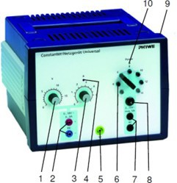

* + 1. (DC) Voltage adjustment knob 2.(DC) Output

1. (DC) Current limiter knob
2. Indicator light - operating at maxi- mum limited current
3. Earthed lead
4. (AC) Selection of voltage step
5. (AC) Output
6. (AC) Overload circuit breaker
7. On/off switch and fuse holder
8. Operation indicator light

The DC output of the power supply must only be used as an input for the Peltier Device. The AC output of the power supply must only be used as an input for the heating coil

(maximum 4 V). To change the AC output, use the rheostat to change the reistance

according to 𝑉 = 𝐼𝑅.

ĺ Warning

## Alpha immersion thermostat

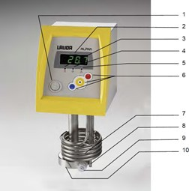

* + 1. Power Switch
    2. Temperature controller with four segment LED display
    3. Heater indicator light (yellow LED)
    4. Cooler indicator light (blue LED)
    5. Error indicator light (red LED)
    6. Menu functions, select and enter keys
    7. Tubular heater
    8. Temperature probe Pt100
    9. Pump outflow or pressure outlet with pump outflow reducer
    10. Pump housing

Because the thermostat is used as the hot reservoir (up to 80°C), please exercise caution to avoid burning yourself. Wear the provided gloves if handling any of the heated-up equipment.

ĺ Warning

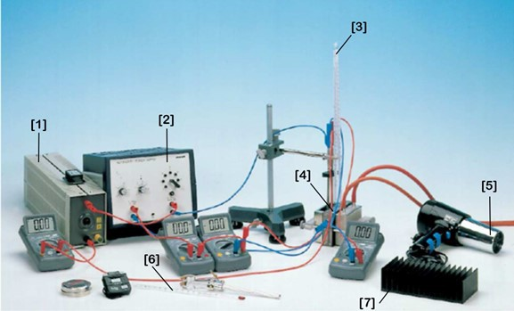

Figure 3.1: This figure displays the setup for the Peltier (cooling) Experiment

## Peltier Experiment Apparatus

* + 1. Variable resistor
    2. Power supply
    3. Thermometer (slots into Peltier device holes)
    4. Peltier device (Thermoelectric device)
    5. Blower
    6. Second thermometer (can sit in reservoir of still water)
    7. Heat sink

To keep yourself safe and the equipment undamaged, please consult with the tutors before turning on any of the equipment.

ĺ Warning

𝑅

60

# Guided Exploration

## Thermoelectric Generator (TEG)

To start, we’ll be looking at a thermoelectric generator (heat engine). In other words, we will look at how much electrical energy (power) is produced from the thermoelectric device at varying temperature differences of 𝑇𝐻 and 𝑇𝐶.

Connect the Thermostat water bath to the TEG device, making sure that the black cover- ing (on the TEG) is flush with the metal water container as to not leak water. Place both thermometers into the designated and holes (add thermo-paste into the hole for better thermal contact). Then connect a voltmeter (in parallel) and an ammeter (in series). Turn on the thermostat (hot reservoir) and allow for water to be pumped into the TEG. Also turn on the water pump in the large barrel. Both the cold reservoir (from the water barrel) and hot reservoir (thermostat bath) should be at room temperature to start. Note, if any, electrical energy is being produced from the TEG at Δ𝑇 ≈ 0.

𝑇𝐻 𝑇𝐶

Let’s first find the Seebeck coeﬀicient. To do this, we will need to run our circuit **without** a load resistor. This circuit has approximately zero resistance.

Measure the no-load voltage and short-circuit current of the circuit (without a load

of the semiconductor combination (Hint: there are 142 thermocouple elements connected in series within the device). You must include uncertainty propagation and an evaluation of your result. After plotting the measurements, what does this relationship tell us about the internal resistance of the TEG device? (Hint: consider Ohm’s law).

resistor) at varying temperature differences up to 𝑇𝐻 = 60∘𝐶. Find the Seebeck coeﬀicient

Task 1

Next, we will connect the rheostat (load resistor) with resistance to the TEG (or the breadboard if you’re comfortable with it). Our goal here is to find the value of the internal resistance of the TEG device. The thermostat temperature should still be at ∘C from the previous task. While not necessary for this part, it is a good idea to know what resistance your rheostat is set to at each measurement. However, we will only be measuring current and voltage here.

Measure the voltage and current of the circuit at a constant temperature difference (record your error/uncertainty) at different load resistances. Find the maximum Seebeck voltage

as well as the internal resistance of the TEG device. Propagate your uncertain

𝑉 (𝐼 = 0), available at this temperature difference and the short circuit current 𝐼 (𝑉 = 0),

ties.

𝑠

Task 2

Finally, we will be calculating the heat 𝑄̇𝐻 flowing through the generator in unit time according

to 𝑑𝑑𝑄𝑡 = 𝑄̇𝐻 = 𝑚𝑤𝑐𝑤 ( 𝑑Δ𝑑𝑡𝑇 ). And we’ll also calculate the electrical power, measured at

constant load, 𝑊 . You will need to estimate the mass of the water 𝑚𝑤 in the container.

Task 3

Set the Rheostat resistance to equal the internal resistance of the TEG device (you found in Task 2). Record the temperature of both sides of the TEG device over time as you go from ∘ to ∘ . Then turn off the thermostat heat bath and continue recording the temperature for the next 10-15 minutes as it cools. Record the current and voltage output at each increment too. Find the maximum eﬀiciency 𝜂∗.

Summary: We’ve observed how a thermoelectric device has operated as a heat engine. We’ve calculated the Seebeck Coeﬀicient, the internal resistance of the TEG device, and used it to find the maximum eﬀiciency of the device. We should know what properties a TEG device should have to run at an optimal level and what its drawbacks are.

60 𝐶 80 𝐶

## Thermoelectric Cooler (TEC)

First, let’s figure out which way we need to pass the current through the TEC to make it cool the correct side. Fix the water container with the hole in the top (for the heating coil) instead of the thermostat container. Fill it with room temperature water. Connect the TEC device to the power supply through the DC side. Turn it on. You should now see on the thermometers which side is heating up and which side is cooling down. Swap the positive/negative cables to make the heating-coil side cool down.

𝑅𝑐𝑜𝑖𝑙 ≈ 3Ω

Now add the heating coil ( ) to the water container. Make sure it is submerged in the water and not touching the sides before turning it on. It must be connected to the AC and not higher than 3.5 A of current.

𝑄𝐶

Our goal is to calculate the cooling capacity ̇ . A nifty way to do this is to match the cooling capacity with the heating of the coil. This means that the cooling effect of the Peltier is balancing out the heating of the coil. Hence, the temperature of both sides shouldn’t change.

Match the heating output of the heating coil with the cooling output of the TEC at multiple TEC current inputs, i.e., set the input DC current of the cooling device; match the heating coil input to achieve zero temperature difference by changing the resistance of

the rheostat. Measure the heater current and voltage, the operating current and voltage,

and the temperatures 𝑇𝐻 and 𝑇𝐶. Find the COP 𝜙 at multiple input DC currents.

Task 4

Students should check their progress with their tutors before proceeding any further.

Á Note

# Your own experiment

Take some time now to formulate what your own investigation will be. Discuss your plans with a tutor before you start. Here are two example extensions to focus on; however, you are welcome to propose your own experiment to the tutors.

## Heating and Cooling Eﬀiciency

If you run the apparatus as a heat pump, you could investigate the maximum coeﬀicient of performance that could be achieved, and what the main factors that limit this performance. To measure the COP, you will need to find a way to measure the power extracted from the cold reservoir or added to the hot reservoir (depending on whether you are interested in cooling the cold reservoir or heating the hot). Note this will be similar to Task 3.

You will need to know that the total heat capacity of the copper block, brass bath, and water is 𝐶𝑡𝑜𝑡 ≈ 1100 ± 50 𝑘𝑔𝐽𝐾 .

Similar to the maximum eﬀiciency for TEG devices, we can have a maximum eﬀiciency for cooling. First show that if there were no irreversible transport effects, we get the

eﬀiciency is equivalent to the Carnot eﬀiciency for cooling, 𝜙𝑐𝑎𝑟𝑛𝑜𝑡 ≡ 𝑇𝐶/𝑑Δ𝑄𝐶𝑇 . Then

derive the optimal current value 𝐼𝐶∗ by imposing the extremum condition

𝑑𝐼

= 0 on

Then find the maximum COP 𝜙𝐼∗ = 𝑄∗𝐶 /𝑊𝐶 by imposing 𝑑𝜙𝐼 . It may be handy to write

𝑄𝐶. Hint: you should be able to figure out the expression of 𝑄𝐶 from Question 4 & 5.

your answer in terms of the material figure of merit (FOM) 𝑍 ≡ 𝜎𝜅𝑆2 .

Ď Question 8 (Advanced)

## Air-Cooled Hot-Side

Here you’ll investigate the temperature behaviour when the pump is used for cooling, with the hot side air-cooled. A water bath will be cooled by the TEC device and the other side will heat an air cooler. Measure the temperature of the cold side as a function of time, with the air cooler in either static atmospheric air or force-cooled with the hair-dryer. Why might a force-cooled TEC device be useful and where would you find one? Calculate the eﬀiciency.

Make sure you clearly identify the idea, hypothesis, or relationship that your investigation is testing. Explain and justify your choice of method in your report. Remember to esti- mate/calculate the uncertainty in all measured quantities and use the appropriate formulas to combine them for the uncertainties in final values. Finally, in your conclusions, draw out the implications of your results (bigger picture).

# Conclusion and Tips

As per the criteria sheet, a grade of 4 requires that “The student has completed the experiment and written a full report demonstrating an understanding of key concepts, careful experimen- tation, good data analysis and evaluation skills, and an ability to write a clear well-structured report. Some deficiency in one or more of these aspects is evident.”. The expectation is that you have completed the guided exploration and attempted your own experiment. To show originality or insight (for a 6 or 7), we hope that you complete, to an advanced level, any or multiple of the following:

* Derive an expression from first principles, mentioning the appropriate assumptions, and use it to support your hypothesis (such as the eﬀiciency).
* Conduct an experiment with high attention to detail and comprehensive uncertainty analysis.
* Undertake high-level analysis and critical evaluation of your results by comparing at least two analysis methods.

# References

Engel, Thomas, and Philip Reid. 2013. *Thermodynamics, Statistical Thermodynamics, & Kinetics*. Book. Harlow: Pearson Education UK.

Knight, Randall. 2016. *Physics for Scientists and Engineers: A Strategic Approach with Modern Physics, Global Edition*. Book. Harlow, UNITED KINGDOM: Pearson Education, Limited. <http://ebookcentral.proquest.com/lib/uql/detail.action?docID=5187910>.

Macia, Enrique. 2015. *Thermoelectric Materials: Advances and Applications*. Book. [https:](https://doi.org/10.1201/b18439)

[//doi.org/10.1201/b18439](https://doi.org/10.1201/b18439).

Martins, Roberto de Andrade. 2022. “Joule’s 1840 Manuscript on the Production of Heat by Voltaic Electricity.” Journal Article. *Notes and Records: The Royal Society Journal of the History of Science* 76 (1): 117–54. https://doi.org/doi:10.1098/rsnr.2020.0027.

Segrè, Gino. 2004. *Einstein’s Refrigerator : Tales of the Hot and Cold*. Book. London:

Penguin Books.

Thomson, William. 1856. “I. Account of Researches in Thermo-Electricity.” Journal Article. *Proceedings of the Royal Society of London* 7: 49–58. https://doi.org/doi:10.1098/rspl.1854. 0016.