Przykładowe wpisanie danych do programu oraz wyświetlanie informacji o ich poprawności:

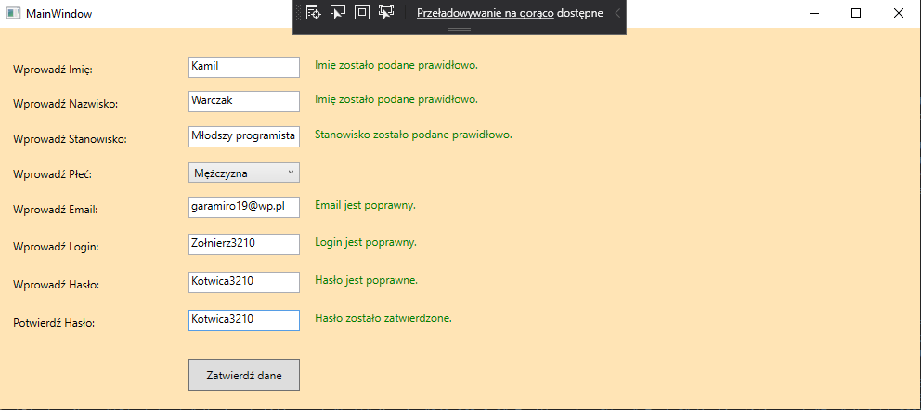

Okno programu:

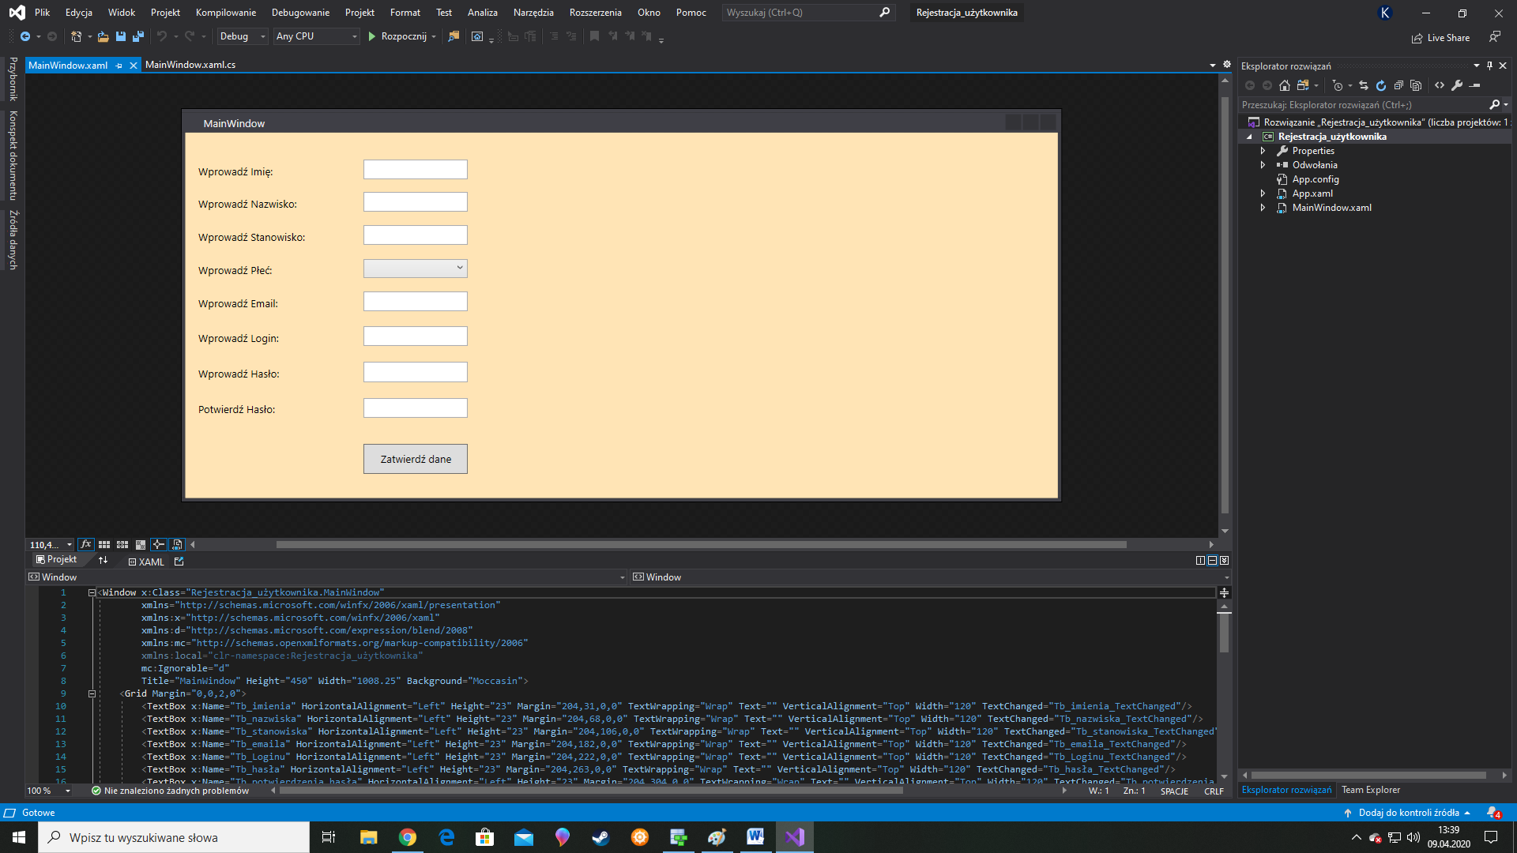

Diagram relacyjno-obiektowy:

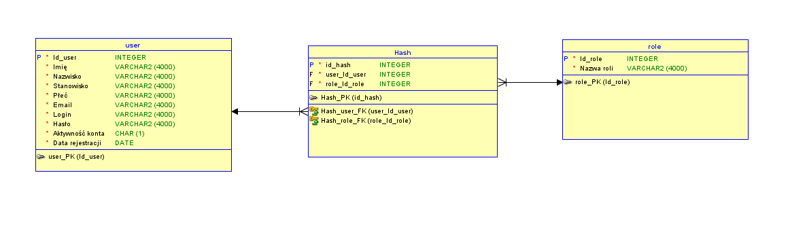

Poniżej wstawiam, również kod z xamla:

<Window x:Class="Rejestracja_użytkownika.MainWindow"

xmlns="http://schemas.microsoft.com/winfx/2006/xaml/presentation"

xmlns:x="http://schemas.microsoft.com/winfx/2006/xaml"

xmlns:d="http://schemas.microsoft.com/expression/blend/2008"

xmlns:mc="http://schemas.openxmlformats.org/markup-compatibility/2006"

xmlns:local="clr-namespace:Rejestracja_użytkownika"

mc:Ignorable="d"

Title="MainWindow" Height="450" Width="1008.25" Background="Moccasin">

<Grid Margin="0,0,2,0">

<TextBox x:Name="Tb_imienia" HorizontalAlignment="Left" Height="23" Margin="204,31,0,0" TextWrapping="Wrap" Text="" VerticalAlignment="Top" Width="120" TextChanged="Tb_imienia_TextChanged"/>

<TextBox x:Name="Tb_nazwiska" HorizontalAlignment="Left" Height="23" Margin="204,68,0,0" TextWrapping="Wrap" Text="" VerticalAlignment="Top" Width="120" TextChanged="Tb_nazwiska_TextChanged"/>

<TextBox x:Name="Tb_stanowiska" HorizontalAlignment="Left" Height="23" Margin="204,106,0,0" TextWrapping="Wrap" Text="" VerticalAlignment="Top" Width="120" TextChanged="Tb_stanowiska_TextChanged"/>

<TextBox x:Name="Tb_emaila" HorizontalAlignment="Left" Height="23" Margin="204,182,0,0" TextWrapping="Wrap" Text="" VerticalAlignment="Top" Width="120" TextChanged="Tb_emaila_TextChanged"/>

<TextBox x:Name="Tb_Loginu" HorizontalAlignment="Left" Height="23" Margin="204,222,0,0" TextWrapping="Wrap" Text="" VerticalAlignment="Top" Width="120" TextChanged="Tb_Loginu_TextChanged"/>

<TextBox x:Name="Tb_hasła" HorizontalAlignment="Left" Height="23" Margin="204,263,0,0" TextWrapping="Wrap" Text="" VerticalAlignment="Top" Width="120" TextChanged="Tb_hasła_TextChanged"/>

<TextBox x:Name="Tb_potwierdzenia_hasła" HorizontalAlignment="Left" Height="23" Margin="204,304,0,0" TextWrapping="Wrap" Text="" VerticalAlignment="Top" Width="120" TextChanged="Tb_potwierdzenia_hasła_TextChanged"/>

<Label Content="Wprowadź Imię:" HorizontalAlignment="Left" Margin="10,31,0,0" VerticalAlignment="Top" Height="32" Width="189"/>

<Label Content="Wprowadź Nazwisko:" HorizontalAlignment="Left" Margin="10,68,0,0" VerticalAlignment="Top" Height="33" Width="189"/>

<Label Content="Wprowadź Stanowisko:" HorizontalAlignment="Left" Margin="10,106,0,0" VerticalAlignment="Top" Height="33" Width="189"/>

<Label Content="Wprowadź Płeć:" HorizontalAlignment="Left" Margin="10,144,0,0" VerticalAlignment="Top" Height="33" Width="189"/>

<Label Content="Wprowadź Email:" HorizontalAlignment="Left" Margin="10,182,0,0" VerticalAlignment="Top" Height="35" Width="189"/>

<Label Content="Wprowadź Login:" HorizontalAlignment="Left" Margin="10,222,0,0" VerticalAlignment="Top" Height="36" Width="189"/>

<Label Content="Wprowadź Hasło:" HorizontalAlignment="Left" Margin="10,263,0,0" VerticalAlignment="Top" Height="36" Width="189"/>

<Label Content="Potwierdź Hasło:" HorizontalAlignment="Left" Margin="10,304,0,0" VerticalAlignment="Top" Height="33" Width="189"/>

<TextBlock x:Name="tBlock_imienia" HorizontalAlignment="Left" Margin="340,31,0,0" TextWrapping="Wrap" Text="" VerticalAlignment="Top" Height="23" Width="425"/>

<TextBlock x:Name="tBlock_nazwiska" HorizontalAlignment="Left" Margin="340,68,0,0" TextWrapping="Wrap" Text="" VerticalAlignment="Top" Height="23" Width="425"/>

<TextBlock x:Name="tBlock_stanowiska" HorizontalAlignment="Left" Margin="340,106,0,0" TextWrapping="Wrap" Text="" VerticalAlignment="Top" Height="23" Width="425"/>

<TextBlock x:Name="tBlock_płci" HorizontalAlignment="Left" Margin="340,144,0,0" TextWrapping="Wrap" Text="" VerticalAlignment="Top" Height="23" Width="425"/>

<TextBlock x:Name="tBlock_emailu" HorizontalAlignment="Left" Margin="340,182,0,0" TextWrapping="Wrap" Text="" VerticalAlignment="Top" Height="23" Width="425"/>

<TextBlock x:Name="tBlock_Loginu" HorizontalAlignment="Left" Margin="340,222,0,0" TextWrapping="Wrap" Text="" VerticalAlignment="Top" Height="23" Width="425"/>

<TextBlock x:Name="tBlock_hasła" HorizontalAlignment="Left" Margin="340,263,0,0" TextWrapping="Wrap" Text="" VerticalAlignment="Top" Height="23" Width="425"/>

<TextBlock x:Name="tBlock_potwierdzenia_hasła" HorizontalAlignment="Left" Margin="340,304,0,0" TextWrapping="Wrap" Text="" VerticalAlignment="Top" Height="23" Width="425"/>

<Button Content="Zatwierdź dane" HorizontalAlignment="Left" Margin="204,357,0,0" VerticalAlignment="Top" Width="120" Height="34"/>

<ComboBox HorizontalAlignment="Left" Margin="204,145,0,0" VerticalAlignment="Top" Width="120" >

<ComboBoxItem>

Mężczyzna

</ComboBoxItem>

<ComboBoxItem>

Kobieta

</ComboBoxItem>

</ComboBox>

</Grid>

</Window>